1. Your Favorite Watershed - Watershed Assessment Report

Carl Schwarz

2017-05-06

Table of Contents

# Background

"How are the fish in my river and streams doing?" We need this answer to set appropriate fishing regulations, to understand and correct any problems with fish habitat and to guard against invasive species.

A healthy fish population and fish community means we can all enjoy the benefits of sustainable fisheries and healthy ecosystems. A standard method of assessing the status of fish populations is necessary to allow comparisons of fish sustainability across the years in a watershed, and to compare to other watersheds in the province. In Alberta, we use accepted standard sampling methods for watershed fisheries assessments. These methods provide the necessary data on fish abundance, biological data (such as genetic information, age and sex), and species diversity to assess sustainability over time and space.

# Watershed Assessments

Alberta Environment and Parks monitor fish in flowing waters using standardized electrofishing and habitat surveys techniques. Surveys often occur during the summer when river and stream flows are lower to allow for safe working conditions and high visibility of observed fish. Although information is collected from all species, assessments often focus on species such as Westslope Cutthroat Trout (*Oncorhynchus clarkii lewisi*), Bull Trout (*Salvelinus confluentus*), Arctic Grayling (*Thymallus arcticus*), Athabasca Rainbow Trout (*Oncorhynchus mykiss*), and Mountain Whitefish (*Prosopium williamsoni*).

Watersheds are defined by the Hydrologic Unit Code (HUC) 10 watershed boundary, as identified by the HUC Watersheds of Alberta system of classification system (reference? AB or USGS?). Within the study area, **999999999** potential sampling locations were randomly chosen using ArcGIS (ESRI, 2013) and R (R Core Team, 2015) using generalized random tessellation stratified (GRTS) sampling (Stevens and Olsen, 2004; Reilly, 2016). Sites were further removed from consideration if they were observed or strongly suspected to be dry or if there were access limitations that prevented crews from reaching the sites. In total, 8 sites were sampled in the Quirk Creek watershed as shown on the Figure 1.

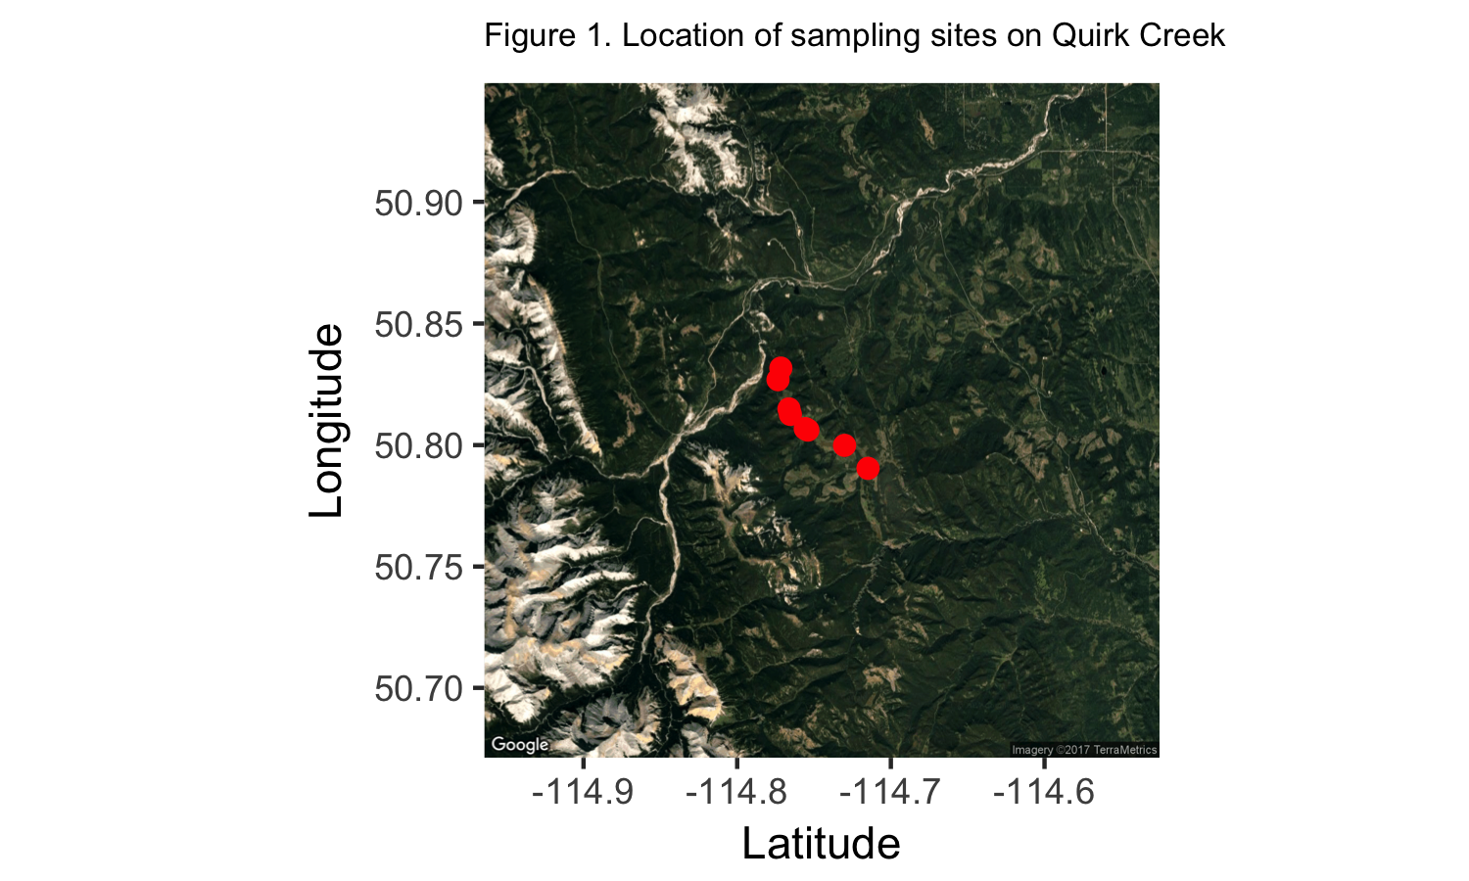

The set of unique TTM co-ordinates for the plot above are:

## TTM.Easting TTM.Northing Longitude Latitude  
## 516486.5 5626823 -114.7659 50.81318  
## 515890.8 5628428 -114.7743 50.82763  
## 517387.6 5626193 -114.7531 50.80748  
## 517301.5 5626173 -114.7544 50.80730  
## 516353.9 5626988 -114.7678 50.81466  
## 519109.2 5625374 -114.7287 50.80006  
## 516076.1 5628730 -114.7716 50.83034  
## 519998.2 5624313 -114.7162 50.79048

Fish sampling protocols followed existing flowing water fish survey standards.Specifically, we used backpack or boat electrofishing to capture fish in wadeable streams and rivers respectively. Sampling effort was recorded and fish were measured. If required, fin clips were taken for genetic analyses.

## How is this information used?

Catch rates (i.e., backpack electrofishing: number of fish per 300 meters, boat electrofishing: number of fish per 1 km) of fish species are an index of the populations' abundance, with higher catch rates meaning there are more fish in a stream or river. The sizes and age of fish also tell us if problems with overharvest (e.g. too few fish living to old age) or habitat (e.g., poor spawning success) are a concern. Biologists use this information, as well as a variety of data on water quality, access, development, and habitat threats as part of Alberta’s Fish Sustainability Index (FSI) and evaluation of species recovery work.

# Results

Fish and habitat sampling was conducted at 8 sites within the Quirk Creek (HUC 04021001) from 1987-08-27 to 2013-08-28. This watershed is found approximately **999999999 km northwest from the city of Calgary**.

There were 4 species of fish were captured over this period and the mean fork length, size range, and mean catch rates for all captured fish over this period are summarized in Table 1.

Table 1. Summary statistics on species of fish captured in Quirk Creek

|  |  |  |  |  |
| --- | --- | --- | --- | --- |
| Species Code | n | Mean fork length mm | Min fork length mm | Max fork length mm |
| BKTR | 2912 | 127 | 37 | 327 |
| BLBK | 138 | 139 | 82 | 312 |
| BLTR | 246 | 188 | 90 | 495 |
| CTTR | 1972 | 132 | 22 | 401 |

Catch per unit effort (CPUE) was computed for each species for each year as follows:

* The distance sampled (m) and count by species was extracted for each *Inventory Survey ID*.
* The distance sampled and count by species were summed over multiple *Inventory Survey IDs* for a location. A location was defined by the combination of TTM Easting and TTM Northing.
* The CPUE was computed as total count / total distance 300 m to standardize to a per 300 m basis.

A Bayesian analysis was used to compute the posterior probability of belonging to each FIS Category based on the yearly trend in the median CPUE accounting for within-year sampling variation, site-to-site random variation, and year-specific effects (process error) as described in Schwarz (2017).

In the following sections, a more detailed investigation of the status of each of the above species will be provided.

# Summary

**Describe where fish are found in the watershed (general statement for all game fish species) For each game species interpret the catch rate and size distribution. What does this mean for the population? Did any environmental factors potentially influence assessment e.g. flood? What kind of conservation actions need to be taken?**

# References

Alberta Biodiversity Monitoring Institute and Alberta Sustainable Resource Development (ABMI and ASRD). 2014.

Fish Survey Methods for Rivers: ABMI and ASRD Collaboration. Written by Jim Schiek and edited by M.G. Sullivan. Prepared for Alberta Biodiversity Monitoring Institute andAlberta Sustainable Resource Development. 20 pp.

Alberta Fisheries Management Branch. 2013. Standard for sampling of small streams in Alberta. Alberta Environment and Sustainable Resource Development, Fisheries Management Standards Committee. 19 pp.

Environmental Systems Research Institute (ESRI). 2013. ArcGIS Desktop: Version 10.2. Redlands , CA: Environmental Systems Research Institute.

R Core Team. 2015. R: A language and environment for statistical computing. R Foundation forStatistical Computing, Vienna, Austria. URL [(http://www.R-project.org/](http://www.R-project.org/).

Mackay, W.C., G.R. Ash, H.J. Norris. 1990. Fish ageing methods for Alberta. R.L. & L. Environmental Services Ltd. In assoc. with Alberta Fish and Wildlife Division and University of Alberta, Edmonton. 113 pp.

Microsoft Corporation. 2010. Microsoft Excel, version 14.0.7145.5000.  
Part of Microsoft Office Professional Plus 2010. Redmond Washington.

Reilly, J. 2016. GRTS: User friendly method for busy biologists. Alberta Environment and Parks. 4 pp.

Schwarz, C.J. 2017. Bayesian classification into the Alberta FWIS Categories. Unpublished report.

Statistical Analysis Software (SAS) Institute Inc. 2016. JMP Statistical Discovery, version 13.0.0. SAS Campus Drive, Cary, North Carolina 27513, USA.

Slipke, J.W. 2010. Fishery Analyses and Modeling Simulator (FAMS). Version 1.0.

Alberta Sustainable Resource Development (ASRD). 2008. Electrofishing Certification and Safety Standard. Alberta Sustainable Resource Development, Fish and Wildlife Division. Edmonton, AB. 76 pp.

Stevens, D.L., A.R. Olsen. 2004. Spatially balanced sampling of natural resources. Journal of the American Statistical Association 99(465):262-278.

Watkins, O.B., S.C. Spencer. 2009. Collection, preparation and ageing of walleye otoliths. Alberta Sustainable Resource Development, Fish and Wildlife Division. Spruce Grove, AB. 26 pp.