MTH 247: Introduction to Regression Analysis
Fall 2012

INSTRUCTIONS FOR FINAL REPORT

PART I: GENERAL INSTRUCTIONS

A. The report is to be word-processed, double spaced with 1 1/2 inch margins, and page numbers on each page in the upper right-hand corner.

- All relevant tables and graphs should be included in the body of the text in an appropriate location near the text that refers to it. Label tables as "Table 1", "Table 2", etc. and refer to them in the text as "Table 1", "Table 2", etc. Similarly, label graphs as "Figure 1", "Figure 2, etc.

C. The report should have the following format (selected items will be discussed in more detail following the outline):

1. Title page containing:
Title of report
Authors’ names
Course name and number
Date completed
2. Executive Summary
3. Text containing:
Introduction
Methods
Results
Discussion
4. References

PART II: INSTRUCTIONS FOR SPECIFIC SECTIONS OF THE REPORT

A. EXECUTIVE SUMMARY: This is a report to an intelligent, non-technical reader who has NOT taken a statistics course. Assume that this reader will not read your full report, but s/he needs to know what you studied and what you found. Be succinct.

Prepare a summary of NO LONGER THAN ONE PAGE of your project and its findings, answering the following questions. Use numbered paragraphs, one paragraph for each of the following points. This part, only, of the final report may be typed, single-spaced, but use triple spacing between paragraphs.
1. What research question did you study?

2. Briefly, what methods did you use for your study?

3. What are your findings? What do they mean? How do they compare to what you expected to find? Comment on any differences seen.

4. What action(s) do you recommend on the basis of your study and its findings?

B. TEXT: This is a report to a statistician or technical supervisor, and it should contain four main sections: Introduction, Methods, Results, and Discussion. Be concise; however, there is no specific page limit. Address each of the following questions or requests in your report.

1. Introduction: In one or two paragraphs explain why you chose this research question. Explain to the reader why your question and results might be of any importance or interest to anyone else. If others have studied this problem, briefly give a history of the problem and what they have found.

2. Methods: Describe the population of elements you studied (define a unit of the population, the population size, its location in time and geography). Describe the sampling plan you used. Explain what random variables were measured on each sampled element. Give the full regression model you planned to test, and describe the initial analyses you used to examine your data. Describe the regression techniques you used to select your final model, and explain the diagnostic techniques you used to check that your model is valid. If you have any missing data describe how you handled them in your analysis. If you recoded any variables for the analysis explain what you did and why it was necessary (if you used dummy variables explain how they were coded).

3. Results:
A. Data Description: This is a summary of your data.
(a) Present descriptive statistics for all continuous variables measured. Present frequency tables for all discrete variables measured.
(b) Present histograms or stem-and-leaf plots for each continuous variable.
(c) Present a correlation matrix of all continuous variables and a matrix plot of the variables.
(d) Discuss any unusual values you found and what you did, if anything, with them at this stage in your analysis. (Did you find any obvious errors?)
B. Final Model: This is a summary of your best model.
(a) Present your final regression model and its and accompanying statistics (parameter estimates, their standard errors, R², and S). Give the complete ANOVA table.
(b) Present your analyses of the model fit and whatever graphs or tables you believe provide supporting evidence.

Note that do not include the details of all the models you tried. You describe, in the methods section, what methods you used to find your best model, but do not include all those intermediate models in the paper.
Note that each table you include in your paper must have a table number and a title that explains as clearly as possible the information the table provides. For example:

“Table 3: The matrix of simple correlations between all pairs of continuous variables.”

Titles should be placed at the top of the table. Tables may have footnotes explaining unusual values in the table or providing critical values for test statistics reported in the body of the table. Footnotes can also be used to explain how to read a complex table.

Graphs must have titles, and labels and scales on each axis. Include a key to explain any symbols used in the graph. Refer to your graphs in the text as Figure 1, Figure 2, etc. Put the title, including the figure number, underneath the graph. For example:

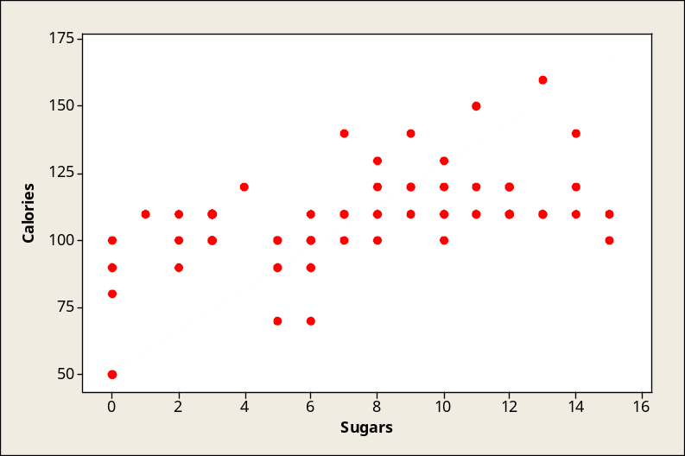

Figure 1: Scatterplot of Calories by Grams of Sugar in Breakfast Cereals”

Put the graph above the title. Graphs may have footnotes that provide source information, references, or explanations.

4. Discussion: What are your findings? (Interpret your model.) Using technical statistical terminology, state the generalizations you can make from your sample results. What limitations are there on these generalizations?

Suppose that at some time in the future you confront a question similar to the one that gave rise to this project. What have you learned from this project that will influence your approach to the future question?

C. REFERENCES: Provide references for any secondary data used or citations made. Include your textbook. Order references alphabetically by first letter of last name of first author.

