**The Basics**The Pokémon battle starts with two Pokémon being sent out, one Pokémon for each player. Following this, each Pokémon has 4 moves to choose from, and the possibility to switch to a different Pokémon (when applicable). After both players make a decision, the moves are weighted for priority and speed to determine the order of play. Typically, if both players decide not to switch, one Pokémon will attack the other. If the Pokémon being attacked has not fainted from the first move, it will execute its own move. After each move has been executed the turn ends. The process continues until one of the Pokémon faints, prompting the player whose Pokémon fainted to select another Pokémon from the bench. The first player to lose all of their Pokémon loses the battle.

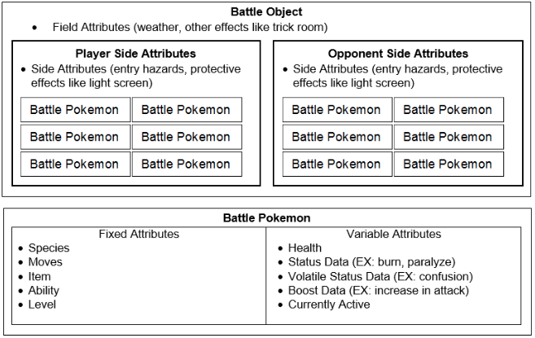

*Figure 1: Battle Object Description of Pokémon Battling*The figure above indicates the typical team composition, namely teams composed of six Pokémon. However, there are additional factors to consider beyond move choices. The two categories of interest are labeled as “Fixed” and “Variable” attributes.

**Fixed Attributes**The former of these categories are characteristics of the Pokémon that are static and unable to change (for our purposes). Concerning the species of Pokémon, each Pokémon can have at most two static types. If a Pokémon uses a moves whose type corresponds to its own, it received a same-type attack bonus, or “stab”. This move will do 50% more damage and 100% more damage if the Pokémon has the ability Adaptability. Implicit in the “stab” bonus and species are Pokémon types. The different Pokémon types are given below.

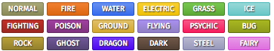

*Figure 2: Pokémon Types*

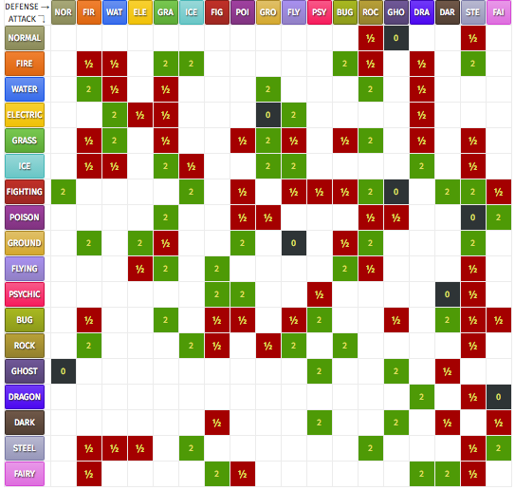

*Figure 3: Weakness Chart*

Another factor that takes front and center in Pokémon battling is type strengths and weaknesses. Each Pokémon type is super effective and not very effective to other types. When a move is super effective, it will do x2 damage; by contrast, a not very effective move will do x.5 damage. An interesting feature is that will the inclusions of dual-typing moves are able to amplify or cancel out. By amplify, I mean to say that if a move is super effective to both types it does x4 damage, whereas a doubly not very effective move will only do x.25 damage. Additionally if the two types cancel out, i.e. one is super effective and the other is not very effective, the damage will simply be x1. The “simple” weakness chart is included following the type list.

Before continuing past the Pokémon types, it is important to note a few special cases. For fighting and normal type Pokémon, ghost-type moves will do no damage and vice versa. Additionally psychic-type moves will do no damage to dark-type Pokémon, but dark is super effective to psychic Pokémon. Additionally, dragon-type moves do not affect fairy Pokémon and electric-type moves do not affect ground Pokémon. Lastly, ground-type moves do not affect flying Pokémon. There are also specific abilities that will negate singular type-specific moves.

Before continuing into the next category, it is important to briefly mention Pokémon abilities, items, and attributes. The former of these terms simply indicates a latent ability of a Pokémon. While some Pokémon have more than one potential ability, some are only able to have one. Additionally each Pokémon can only have one active ability. In *Pokémon Showdown* the list of potential abilities is always available. Each Pokémon can also only have one held item at a time. There are many different types of items, but the most frequently used items are either Pokémon-specific or belong to a list of about 25.

The last point to note is attributes; in a proper sense characteristics are Pokémon’s attributes. The six main characteristics are Health, Attack, Defense, Special Attack, Special Defense, and Speed. Each Pokémon move that does damage is either based on “physical” Attack or Special Attack. Additionally, each Pokémon can have a nature that will slightly boost one characteristic and decrease another. While the value of each of the six categories is static at the beginning of the battle, each characteristic can be influenced by certain moves. But more on this to come.

**Variable Attributes**Variable Attributes are the opposite of Fixed; these attributes do not carry over from battle to battle for our purposes. Each component of variable attributes can be manipulated through different moves. The most obvious variable that changes is a given Pokémon’s health. This is able to vary from 100% to 0%, or from when a Pokémon is sent out to when it faints. However, an even more pressing consideration is the role of Status Data and Volatile Status. The latter of these components involves the status of a Pokémon. The non-volatile statuses include burn, freeze, paralysis, poison (and toxic), and sleep. Each status will cause continual damage, inability to perform an action for a turn, or reduction in a Pokémon’s attribute, or some combination of the three.

The more differential statuses are the volatile statuses. These statuses include confusion, flinching, taunt, and a number of other distinctions. While each of these statuses apply to the currently used Pokémon, simply switching to a different Pokémon (when possible) will negate the influence of the given volatile status. A distinguishing feature of both volatile and non-volatile statuses is the inclusion of damaging moves into the equation. Certain moves will cause damage and have an assigned probability to cause some status to the defending Pokémon. Similarly some moves will cause damage and have the chance of increasing the attacking Pokémon’s attributes.

One last distinction between variable statuses is the ability to boost, or lower, certain attributes of the active Pokémon. Some moves will raise certain attributes. For example, using Sword’s Dance will increase the attack of Pokémon that used it, making all its attacks do x2 attack. On the flip side, moves such as Close Combat will do a great deal of damage but make the Pokémon that used it have 2/3rds its previous defense and special defense. Additionally some moves will recover a percentage of health in a turn. The potential downside to each of these moves is that the player runs the risk of “wasting” their Pokémon for a perceived boost.

**Battle Formats**There are a number of different formats to Pokémon battling. The two included in the data I have are “Random” battles and “Over Used”. The latter format is abbreviated OU. The distinguishing factor between the two battle formats is that the players do not compose their teams for Random battles; instead, the teams are randomly created from predefined Pokémon templates. There is a general pattern to each Pokémon and it’s type and item set, especially for Random battles. However, this information may only be taken for granted in special instances.

By comparison OU involves an additional level of choice for the player: each team must meet the OU criteria. The restrictions imposed involve the exclusion of specific Pokémon and moves. Similar to Random battles, specific Pokémon builds and item choice can be surmised when they make certain decisions; though, again similar to Random battles, such interpretations infer likelihoods based on personal battling experiences.