December 6, 2017

## UCLA MC S6 LX100 rev 1 Assembly Information

## XP1-XP4: Connectors must be seated flatly against the PCB, no tilting allowed

1. These connectors must mate precisely with off-board objects and must be installed flatly against the PCB to ensure alignment.
2. Care should be taken during soldering to minimize board work

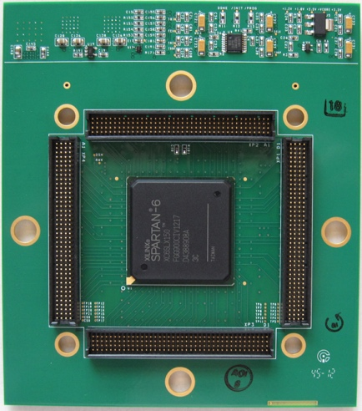

Connectors seated flatly

against PCB, no tilting

Keep contact pins clean

## Screw holes will be used for mounting and should be kept clean

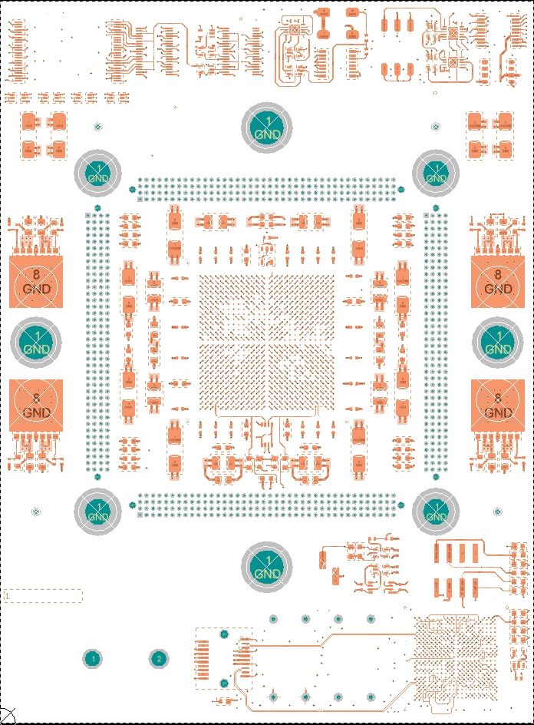

Keep screw holes clear

## Shipping

1. Please pack assembled boards carefully
2. Show the UCLA PO number on the packing list
3. Ship Fedex ground prepaid to

UCLA Physics Department

Knudsen Hall 1-129

475 Portola Plaza

Los Angeles, CA 90095-1547