Versatile Link Plus Technical Specification, part 1
System
Abstract
This document describes the system level power, jitter and environmental specifications of the Versatile Link Plus common project for optical transmissions in HL-LHC detectors.
Prepared by :  Alan Prosser  Fermilab  Pine and Kirk Roads  Batavia, IL  [aprosser@fnal.gov] | Checked by :  VL+ project team | Approved on:

History of Changes

Rev No. | Date | Pages | Description of Changes
1.0 | 20 Apr 2017 |  | First version
1.1 | 2 May 2017 |  | VL+ Face to Face Meeting
1.2 | 8 Aug 2017 |  | FV, refresh, all corrections and comments flattened, cleanup.
1.3 | 14 Aug 2017 |  | Modified jitter and masks; added link penalty spreadsheet plots
1.4 | 03 Sept 2017 |  | Referenced ps in Jitter and Mask tables (AGP). Updates to power budget and other clean up (FV)
1.5 | 04 Sept. 2017 |  | Correction to X2 Table 7.2, 7.2.3
1.6 | 06 Sept. 2017 |  | Typos and power budget statement
1.7 | 06 Sept 2017 |  | Updated power budget and section 10 plots (AGP), Mask Parameter Corrections (FV)
1.8 | 11 Sept 2017 |  | Corrected Typos in section 5.1
1.9 | 19 Sept 2017 |  | Added Power Budget Tables
1.10 | 08 Nov. 2017 |  | Updated Power Penalty Calculations (AGP, TW)
2.0 | 11 Dec 2017 |  | Included Downlink Power Penalty Updates

Specification Tree

The hierarchy of the Versatile Link Plus (VL+) system specification is shown below. The position of the present specification document is highlighted in bold. Line items in italic will not result in specification documents but are shown to ease understanding of the structure.

EDMS Document Number

Part 1 System 1719328
Part 2 Components
Part 2.1 Front-end Transceiver Module 1719329
Part 2.1.1 Laser diode (VCSEL) die 1762631
Part 2.1.2 Photodiode die 1762632
Part 2.1.3 Laser Driver 1719330
Part 2.1.4 Transimpedance Amplifier 1719333
Part 2.2 Back-end Components 1762899

Part 2.3 Passive Optical Components 1762900
Part 2.3.1 Optical Fibre TBD
Part 2.3.2 Optical Connectors TBD

Table of Contents

1. Introduction 5
2. nomenclaTure 6
3. general Specifications 7
4. Environmental Specifications 8
4.1 Radiation Field 8
4.2 Temperature Range 8
4.3 Magnetic Field 8
4.4 EMI 8
5. Power budget 9
5.1 Link penalties 9
5.2 RadiatioN degradation 10
5.3 Transceiver customization Power Requirements 11
5.4 Attenuation and insertion loss 12
6. jitter budget 13
6.1 Test points 13
6.2 jitter outputs and jitter contributions 13
7. electrical and optical eye masks 15
8. Reliability Guideline 18
9. References 18
10. Appendix 19
10.1 power penalty model 19
10.2 components radation degradation 20

Introduction
The Versatile Link Plus (VL+) project [1] aims to provide a multi-gigabit per second optical physical data transmission layer for the readout and control of High Luminosity LHC (HL-LHC) experiments. The implementation of these links is flexible and can be configured at build time or by masking unused channels designated by the user. A basic point-to-point bidirectional system architecture is proposed for which components are currently being assessed and developed. One example is shown in Figure 1.

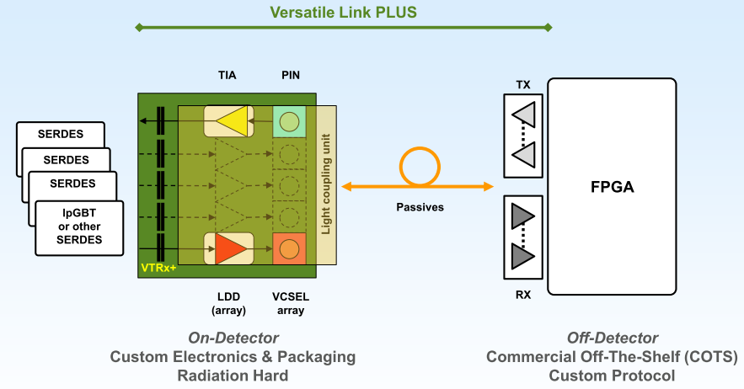

Figure 1: Versatile Link Plus (VL+) Architecture
The link components consist of electro-optical transmitters, receivers and transceivers, fiber cables and other passive components such as connectors and splitters.
The VL+ front-end components are placed on detector, at the front-end, and are therefore subjected to the harshest environmental conditions and must be capable of reliable operation in those conditions.

The VTRx+ modules may contain the following custom developed or qualified parts (depending upon VTRx+ variant) and channel location (Tx = transmitter, Rx = receiver, TRx = transceiver):

- A VCSEL laser diode or VCSEL laser diode array (Tx)
- Radiation tolerant laser driver ASICs in single channel or array format (Tx).
- A single channel PIN diode (Rx)
- A single channel radiation tolerant transimpedance amplifier (TIA) (Rx).

Back-end components are placed off detector, outside the harsh radiation and magnetic field environments to which the front-end components are subjected. No specific form factor is required by the project – the user is free to select from a variety of commercially available products which however must meet the VL+ performance specfications for back-end components. A variety of devices are expected to be available for use as parallel back-end components and these have been evaluated for recommendations for edge mounted and mid-board mounted products. All back-end Tx, Rx, and TRx modules are commercial devices compliant to 10 Gbps standards. When used in the VL+, the Rx channels operate at data rates up to 10 Gbps in the uplink direction (in which signals propagate from front-end to back-end) and Tx channels operate nominally at 2.5 Gbps in the downlink direction (in which signals propagate from back-end to front-end).
The link supports multi-mode (MM) operation with a center-wavelength of 850nm. The fiber cables are commercial laser optimized MM fibers, with an eventual radiation resistant section inside the detector.
The link is naturally bi-directional. However, matching the number of front-end to back-end (uplink) and back-end to front-end (downlink) transmissions is not a requirement. It is therefore possible to have separate multi-channel front-end transmitters and single-channel front-end transceivers in the system.

nomenclaTure
The VL+ system can be characterized by the following parameters:

- Multimode Fiber Plant
- Configurable assemblies of front-end transceivers (VTRx+) with variable numbers of Tx devices plus an optional Rx device in the assembled component
- Tracker grade radiation tolerance
- Custom miniature front-end assembly footprint
- Asymmetrical uplink and downlink data rates (5-10 Gbps uplink, 2.5 Gbps downlink)

Table 2.1 Versatile Link Plus characteristics and device families

 | Link direction | Transmission | passives | VTRx+ Module | Back-end TRx
2.1.1 | VTx+ to  COTS Rx | Uplink | 850nm,  MMF  OM3 or equivalent | VL+ LDQ10 850 VCSEL  single channel or array | 10GBASE-SR  40GBASE-SR4  100GBASE-SR10  Opto Engine  separate Tx/Rx modules or TRx
2.1.2 | COTS Tx to  VRx+ | Downlink | 850nm,  MMF  OM3 or equivalent | GBTIA+GaAs PIN  GBTIA+InGaAs PIN  single channel only

Uplink:
VTx+ to COTS Rx

Front-End
COTS
Rx
COTS
Tx
LDQ10
PIN
Lasers

Back-End
2.1.1
2.1.2
TIA
Passives
Downlink:
COTS Tx to VRx+

Figure 2.1 Uplink and Downlink Architecture Components

general Specifications

Table 3.1 VL+ general specification

 | Parameter | Symbol | Min | Typ | Max | Units
3.1.1 | Bit Rate (uplink) | BR(U) | 5.0 |  | 10.0 | Gbps
3.1.2 | Bit Rate (downlink) | BR(D) |  | 2.5 | TBD | Gbps
3.1.3 | Bit Error Ratio¹ | BER |  |  | 10⁻¹²
3.1.4 | Link length² | L |  | 50 | 150 | meter

Note 1: Test pattern for the BER measurement should be reasonably stressful. Thus PRBS23-1 pattern or longer record length are preferred.
Note 2: Power budget margin for 150m uplink may be marginal, depending on radiation environment and link speed (see section 5).

Environmental Specifications

Radiation Field
Table 4.1.1 shows the VL+ radiation resistance requirements.

Table 4.1.1 Versatile Link Plus environmental requirements

 | Tolerance level | Dose and  fluence¹(1Mev neutron equivalent)
4.1.1.1 | Tracker-grade | 1 MGy  1 x 10¹⁵ neutrons/cm²  1 x 10¹⁵ hadrons/cm²
Note 1: The fluence level requirement depends on the particle type and energy. A scaling factor should be established if using different particles and energies for testing. For example, the tracker grade fluence test level would be 3 x 10¹⁵ n/cm² for 20MeV neutron.

Temperature Range
Front-end components, i.e., VTRx+ and the first meters of the fiber cable plant should meet an extended temperature range specification as low as -35°C. Back-end components only need to comply with commercial standards for indoor operation. No special storage temperature and relative humidity specifications are foreseen and are therefore set to the lower limits of the constituting components. The link power and jitter margins should be maintained throughout the temperature range.

Table 4.2.1 Component operation temperature range (ambient)

 | component | Min | Typ | Max | units
4.2.1.1 | VL+ Front-end | -35 |  | 60 | °C
4.2.1.2 | Passives in-detector | -35 |  | 60 | °C
4.2.1.3 | Passives off-detector | 0 |  | 70 | °C
4.2.1.4 | Backend | 0 |  | 70 | °C

Magnetic Field
4.3.1 - Magnetic field at front-end: 4T
Use of non-magnetic materials is mandatory for front-end electro-optic assemblies and front-end passive components, unless technically impossible.

EMI
4.4.1 - EMI requirement for back-end: FCC class 2.

Power budget
The optical power budget for the VL+ system is shown in table 5.1. All power levels are specified to meet target performance of bit error ratio better than 10⁻¹².

Table 5.1 Versatile Link Plus Power Budget

 | VTx+_Rx (10Gbps) | Tx_VRx+ (2.5Gbps)
Tx OMA | > -5.2 dBm | > -1.6 dBm
Rx sensitivity | < -11.5 dBm | < -13.1 dBm
Power budget | > 6.3 dB | > 11.5 dB
Fiber attenuation (50m/100m/150m) | <0.125 / 0.25 dB / 0.375 | < 0.375 dB
Insertion loss | < 1.75 dB | < 1.75 dB
Link penalties¹ (50m/100m/150m) | 1.5 dB / 1.7 dB / 2.1 dB | < 0.5 dB
Tx radiation penalty | 1.0 dB | NA
Rx radiation penalty | NA | < 5.4 dB
Fiber radiation penalty | < 1.5 dB | < 1.5 dB
Margin  (50m/100m/150m) | 0.425/0.1/-0.425 | > 1.975 dB
Coding Gain² | >1dB (TBC) | >3dB (TBC)
Note 1: The link lengths represented here represent the actual link length where the first 7 meters consists of radiation hard OM2 fiber. For example, the length of 100 m is an overall link length of 100, which includes 7 m of OM2 fiber followed by 100 – 7 = 93 m of OM3 fiber,

Note 2: Error coding scheme, for example, the lpGBT FEC coding will result in an additional gain in margin.

The combined constraints of high bitrate (10Gbps), long MM fibre length (150m) and strong radiation penalties result in a very small operational margin in the uplink. It is expected that most (if not all) applications will be able to gain margin by relaxing radiation constraints, reducing link length, limiting number of patch-panels and/or using 10Gbps only where effectively needed. An additional handle to limit link penalties at 10Gbps is to install OM4 fibre (instead of OM3) where link lengths are long.

Link penalties, radiation degradation, fibre attenuation and insertion loss are detailed in the following sections.

Link penalties
The 10GbE link model [2], a physical layer power calculation model developed by the IEEE 802 standard working group, is adopted to specify the Versatile Link Plus penalties. Appendix 10.1 illustrates the worksheets with input and output of link penalty simulations. Principal link parameters are summarized in table 5.1. The maximum link penalty is 2.1 dB for a 150m uplink.

Table 5.1.1 Key characteristics in support of Versatile Link Plus model simulation

 | Parameter
 | Data rate, Uplink (Gbps) | 10
 | Data rate, Downlink (Gbps) | 2.5
 | Link length (m) | 50/100/150
 | Center wavelength (nm) | 850
5.1.1.1 | RMS spectral width (nm) | 0.65
5.1.1.2 | Optical rise/fall time (ps) (TP2) | 41¹
 | Relative intensity noise (dB/Hz) | -130
 | Mode partition noise coefficient (dB) | 0.3
 | Reflection coefficient | 0
5.1.1.3 | Link penalties (50m/100m/150m) (10 Gbps)² | 1.5 dB/1.7 dB/2.1 dB
5.1.1.4 | Link penalties (2.5 Gbps)² | <0.5
Note 1. Measured at TP2, 20%-80% (see Fig 6.1.1). Power penalties are sensitive to the optical rise/fall time.

Note 2. See section 10

RadiatioN degradation
While operating in the radiation environment described in section 4, link components situated at the front-end (i.e., VTRx+ and fiber) shall maintain the target bit error rate performance through the designed life cycle of the detectors. Power penalties allocated to the cumulative degradations are listed in table 5.2.1. Appendix 11.2 describes the derivations of the maximum values induced by radiation.

Table 5.2.1. Power penalties allocated to cumulative radiation degradation

 | Component | Radiation degradation (dB)
5.2.1.1 | VL+_Tx¹ | 1.0
5.2.1.2 | VL+_Rx² | 5.4
5.2.1.3 | MMF³ | 1.5
Note 1. Transmitter output power shall not decrease by more than 1dB with radiation. Adequate drive current shall be provided to compensate radiation degradations that include raised threshold and reduced slope efficiency of laser.
Note 2. Receiver penalty includes the effect of reduced responsivity and increased dark current of the PIN diode.
Note 3. Radiation induced attenuation in multi-mode fibers represents the maximum allowed value for highest dose rate and lowest temperature.

Transceiver customization Power Requirements
VL+ transceiver power levels shall comply with table 5.3.1. Power requirements of backend TRx transceivers may be higher than that of the commercial standards.

Table 5.3.1 Transceiver power levels

 | Component | Tx_OMA_min (dBm) | Rx_sensitivity_max (dBm)
5.3.1.1 | VTRx+ | -5.2 | -13.1 @ 2.5Gbps
5.3.1.2 | Backend_TRx | -1.6 | -11.5 @ 10Gbps
For comparison | Typical 10GbE devices | -5.6 | -10.3 to -12

Attenuation and insertion loss
5.4.1 - The fibre attenuation is based on the maximum link distance of 150 meters. 0.375 dB is allocated to MMF with 2.5 dB/km of attenuation.

5.4.2 - The insertion loss is specified for a number of connections and splices. For example, 1.75dB is allocated to MM link in support of up to five (four or three) connector pairs or splices, with an insertion loss of 0.35 dB (0.44dB or 0.58dB) each.

jitter budget

Test points
Jitter allocation is specified at test points (interoperability points) along a complete data link. There are four test points defined in the VL+, as illustrated in figure 6.1.1. The up- and down-stream serializing and deserializing ICs interfacing with the Versatile Link Plus are likely implemented in FPGAs and ASICs such as Lp-GBT. The rest of this specification assumes that the output requirement of up-stream IC and the input requirement of down-stream IC comply with GbE standards [3].

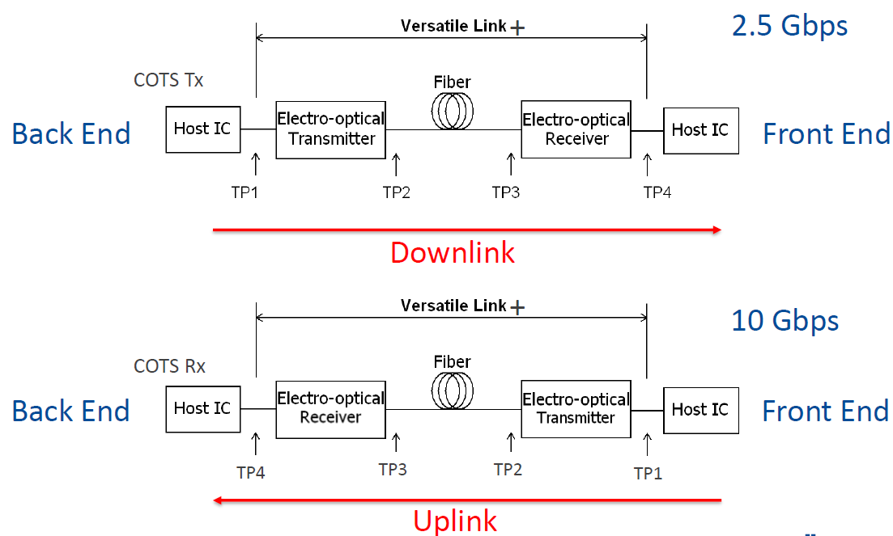
Figure 6.1.1 Test points in Versatile Link+ for jitter specification

jitter outputs and jitter contributions
The output jitter specification along the link test points are listed in Table 6.2.1 where total jitter (TJ) is broken down into deterministic jitter (DJ) and random jitter (RJ).
DJ is measured as a Dual-Dirac model (dd) value and RJ is measured as RMS value (one σ of a Gaussian distribution. At the target BER of 10⁻¹², the confidence interval required is 14.1 σ).
TJ = DJ + RJ = DJ + 14.1* RJ_{rms}

In addition, we derive the Versatile Link Plus component jitter contributions in the following equations.
DJ_{output} = DJ_{input} + DJ_{contribution}
RJ_{output} = SQRT ( RJ_{input} ^2 + RJ_{contribution} ^2)

Table 6.2.1. Jitter budget component contributions

 |  | TJ (ps) | DJ (ps)  (dd) | RJ (ps)  14.1σ | Comment
6.2.1.1 |  |  | 14 | 12 | PLL, SerDes
6.2.1.1 | TP1 | 26 | 14 | 12 | PLL, serdes
6.2.1.2 |  |  | 12 | 13 | OE transmitter contribution  At 10 Gbps, the OE maximum transmitter contributed jitter contributions are (for VL+_Tx):  12 ps DJ d-d  0.95 ps RJ rms
6.2.1.3 | TP2 | 44 | 26 | 18
6.2.1.3 |  |  | 2 | 9 | Fiber contribution
6.2.1.4 | TP3 | 48 | 28 | 20
6.2.2.4 |  |  | 14 | 20 | EO receiver contribution  At 10 Gbps, the OE maximum receiver contributed jitter contributions are (for Rx):  14 ps DJ d-d  1.41 ps RJ rms
6.2.1.6 | TP4 | 70 | 42 | 28
6.2.2.5 |  |  | 13 | 12 | Serdes, CDR
6.2.2.6 |  |  | 15 | 0 | tolerance margin
 | Total | 100 | 70 | 30

electrical and optical eye masks
In addition to the amplitude, jitter and sensitivity parameter requirements listed in section 5 and 6, the input and output electrical/optical waveforms at the link test points shall also comply with the eye mask specifications to assure target BER performance.
The following shows the eye mask specifications for VTRx+ and Back-end TRx modules.

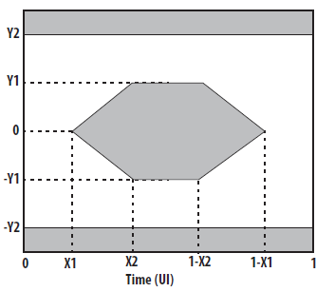

Figure 7.1 Mask 1

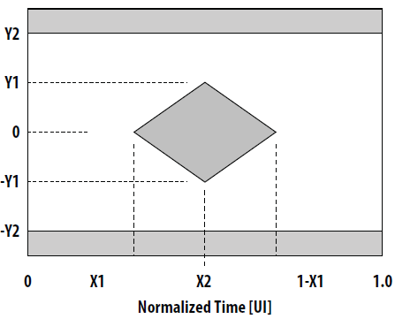

Figure 7.2 Mask 2

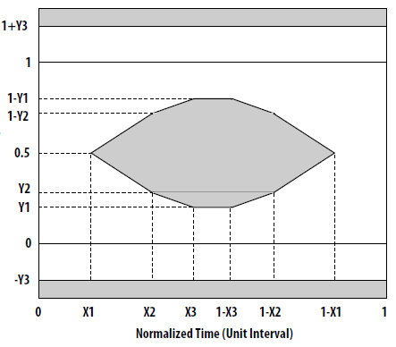

Figure 7.3 Mask 3

Table 7.1. Downlink Electrical and optical eye mask for VTRx+ and TRx
(UI = 400 ps)

7.1.1 | COTS Tx Elec. Input@TP1  (Mask 1, Fig. 7.1) | X1 | X2 | X3 | Y1 | Y2 | Y3
7.1.1 | Value | 11 | 31 |  | 95 | 350
7.1.1 | Unit | ps | ps |  | mV | mV
7.1.2 | COTS Tx Optical Output @TP2  (Mask 3, Fig. 7.3)
7.1.2 | Value | 23 | 34 | 43 | 0.20 | 0.8
7.1.2 | Unit | ps | ps | ps | Norm. Amp.* | Norm.  Amp.*
7.1.3 | VRx+ Elec. Output @ TP4  (Mask 2, Fig. 7.2)
7.1.3 | Value | 29 | 50 |  | 95 | 350
7.1.3 | Unit | ps | ps |  | mV | mV

Table 7.2. Uplink Electrical and optical eye mask for VTRx+ and TRx
(UI = 100 ps)

7.2.1 | VTx+ Elec. Input @TP1; (Mask 1, Fig. 7.1) | X1 | X2 | X3 | Y1 | Y2 | Y3
7.2.1 | Value | 11 | 31 |  | 95 | 350
7.2.1 | Unit | ps | ps |  | mV | mV
7.2.2 | VTx+ Optical Output @TP2  (Mask 3, Fig. 7.3)
7.2.2 | Value | 23 | 34 | 43 | 0.27 | 0.35 | 0.40
7.2.2 | Unit | ps | ps | ps | Norm. Amp.* | Norm. Amp.* | Norm. Amp.*
7.2.3 | COTS Rx Elec. Output @TP4  (Mask 2, Fig. 7.2)
7.2.3 | Value | 29 | 50 |  | 150 | 425
7.2.3 | Unit | ps | ps |  | mV | mV

*Normalized Amplitude

Reliability Guideline
Reliability must be ensured against targeted environmental stresses. These include internally and externally induced effects on optical coupling, thermal path and mechanical strain. An example system failure rate budget is assigned as follows:

Table 8.1. Example system failure rate allocation.

 | Component | Type | FIT¹
8.1.1 | VTRx+ | On detector transceiver  laser with driver/PIN with amplifier | 250³
8.1.2 | TRx | Off detector transceiver module | 200²
8.1.3 | Other components | Connector  Fiber cable | 25  25
8.1.4 | Link | duplex | 500⁴

Note 1: Failure is defined as link BER exceeding 10⁻¹². FIT is one failure in billion (10⁹) device-hours.
Note 2: TRx FIT of 200 is allocated after Telcordia (SR-332, issue 2, 2006).
Note 3: VTRx+ FIT is allocated assuming similar sub-device reliability, reduced part count, and extra margin for customized assembly.
Note 4: For 10 years of detector operation, 500 FIT is equivalent to 5% channel failure. Some of which (the front-end portion) are not accessible.

References

[1] “The Versatile Link Plus Project”, Francois Vasey, et. al., V2.3 24.07.15
https://espace.cern.ch/project-Versatile-Link-Plus/SitePages/Home.aspx
[2] The 10G Ethernet Link Model
http://ieee802.org/3/ae/public/adhoc/serial_pmd/documents/10GEPBud3_1_16a.xls
[3] 802.3ae-2008, clause 52,
http://standards.ieee.org/getieee802/download/802.3-2008_section4.pdf
[4] Reference for PIN diode degradation
[5] Reference for Fiber RIA
[6] “High-Speed Signal Propagation”, Howard Johnson, Martin Graham, Prentice Hall, 2003
[7] “ONIDS2002: Review of the 10 Gigabit Ethernet Link Model”, David Cunningham, Piers Dawe, Avago Tehcnologies. 2005

Appendix

power penalty model
Link model spread sheet download link in reference [3].

The approach to modelling the link power penalties required that 2 sections of fibers be considered for both uplink and downlink directions. In the uplink at 10 Gbps, the transmitter channel of a VTRX+ launches the optical signal into 7 meters of OM2 fiber which is followed by a much longer length of OM3 fiber. In the downlink at 2.5 Gbps, the signal from the back-end transmitter is launched into a relatively long length of OM3 fiber which is followed by a 7 meter length of OM2 fiber (which delivers the optical signal to the receiver channel of a VTRx+).

For the uplink calculations, the procedure followed was:

- Compute the fiber exit response (at 10 Gbps) of the 7 meters of OM2 fiber to determine the characteristics of the optical signal being delivered to the OM3 fiber length.
- Use the exit response as the input stimulus for various OM3 lengths to determine the overall power penalties for the composite link

For the downlink calculations, a different approach was followed:

- The fiber exit responses (at 2.5 Gbps) of various lengths of the OM3 fiber were calculated. These responses represent the various input stimuli for the representative lengths of OM3 fiber from which the optical signal is launched into a 7 meter length of radiation hard OM2 fiber
- Use the spreadsheet results for a fixed length of 7 meter of the OM2 fiber (with a range of input stimuli from step 1) to determine the power penalties

10.1.1. Link penalty calculation of MM_VL (Uplink @ 10 Gbps)

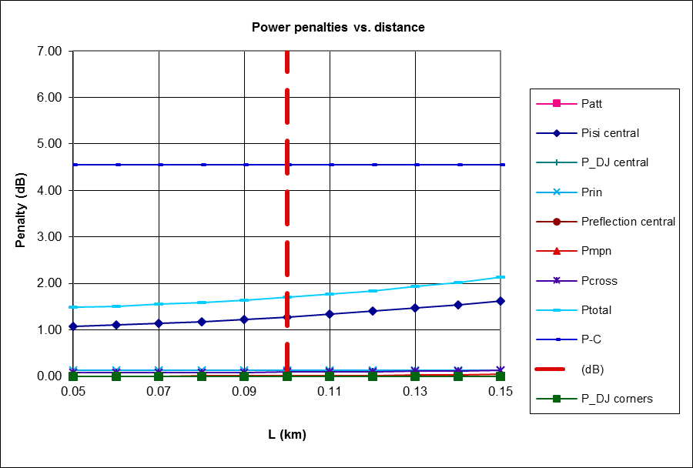

The length parameter in the preceeding plot represents the total length of the OM3 fiber with a constant length of 7 meter length of radiation hard OM2 fiber preceeding it in the uplink path. For example, the values at 0.1 km have passed through 7 meters of OM2 fiber and 93 meters of OM3 fiber.
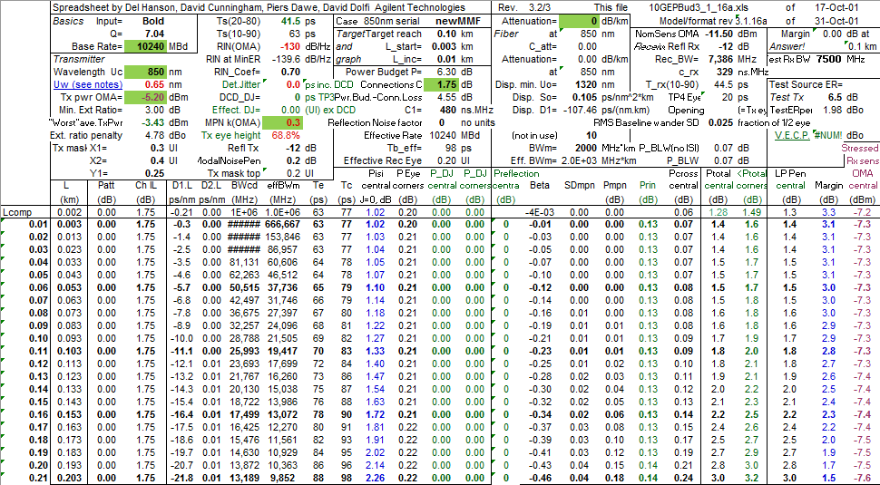

Parameters for calculation:
Base rate = 10240 MBd
Wavelength = 850 nm
Spectral Width σ_{rms} = 0.65 nm
Tx OMA = -5.2 dBm
Mode Partition Noise Coefficient (k_{OMA}) = 0.3
Connector Losses = 1.75 dB
Attenuation = 0 dB

10.1.2. Link penalty calculation of MM_VL (Downlink @ 2.5 Gbps)
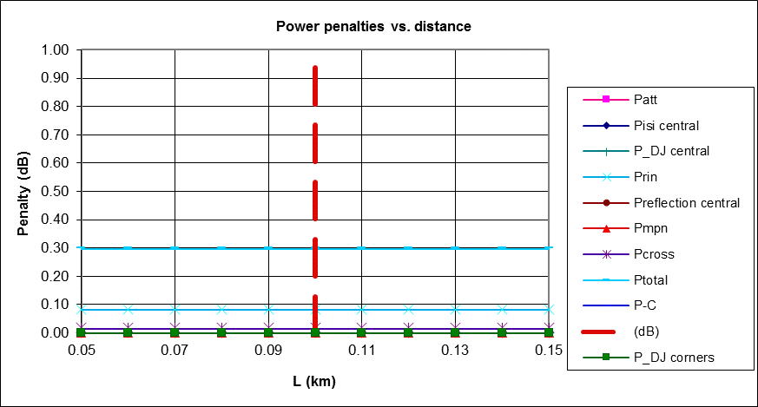

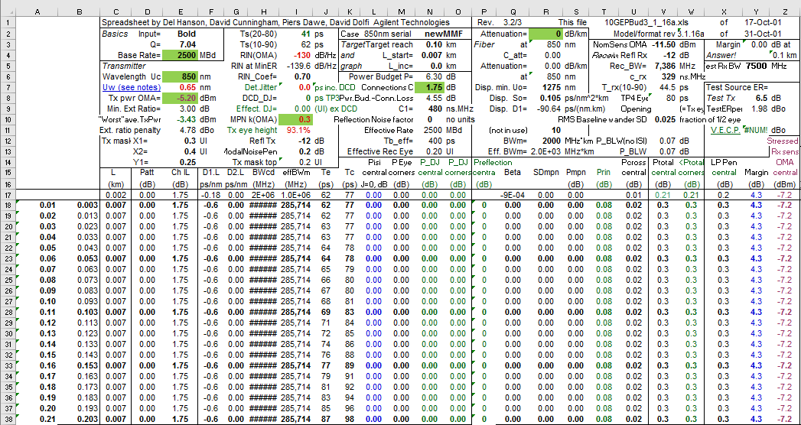

Parameters for calculation:
Base rate = 2500 MBd
Wavelength = 850 nm
Spectral Width σ_{rms} = 0.65 nm
Tx OMA = -1.6 dBm
Mode Partition Noise Coefficient = 0.3
Connector Losses = 1.75 dB
Attenuation = 0 dB

The length parameter in the preceeding plot again represents the total length of the OM3 fiber with a constant length of 7 meter length of radiation hard OM2 fiber preceeding it in the downlink path. For example, the values at 0.1 km have passed through 7 meters of OM2 fiber and 93 meters of OM3 fiber. This is the length captured in column A in the preceding image.

components radation degradation

10.2.1. PIN degradation with cumulative radation at a glance

Detail results are discussed in reference [4]

10.2.2. Fiber degradation with cumulative radiation at a glance

Detail results are discussed in reference [5]

Fit function to calculate the total RIA

