Start address begins with lower half address(0x04100000)

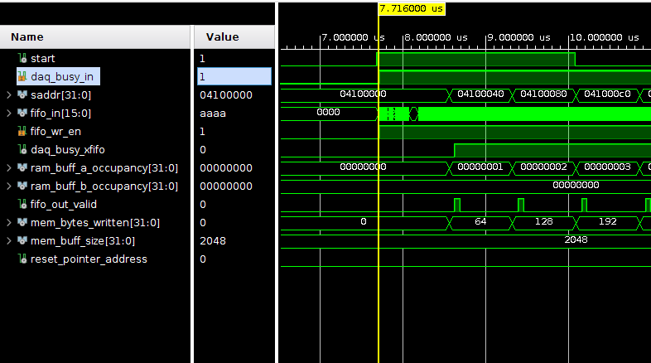

Start address points to top half address(0x08100000) when bytes exceed bram size threshold.

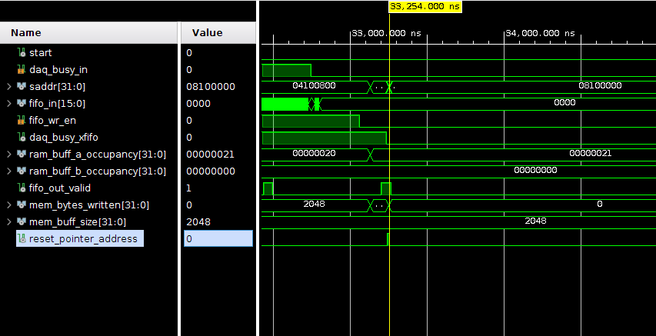

Ram occupancy is tracked for both lower and top address regions.



