JEJE KESIENA

Furniture Maker | Furniture Installer & Assembly Specialist
UK Phone & WhatsApp: +447364286871
WhatsApp number: +234 810 412 4252
Email: kessyafricana@gmail.com
Location: Delta State, Nigeria

BUSINESS REGISTRATION
Business Registration Certificate
A copy of the official business registration certificate is provided as supporting documentation for DJJ's Furniture World.
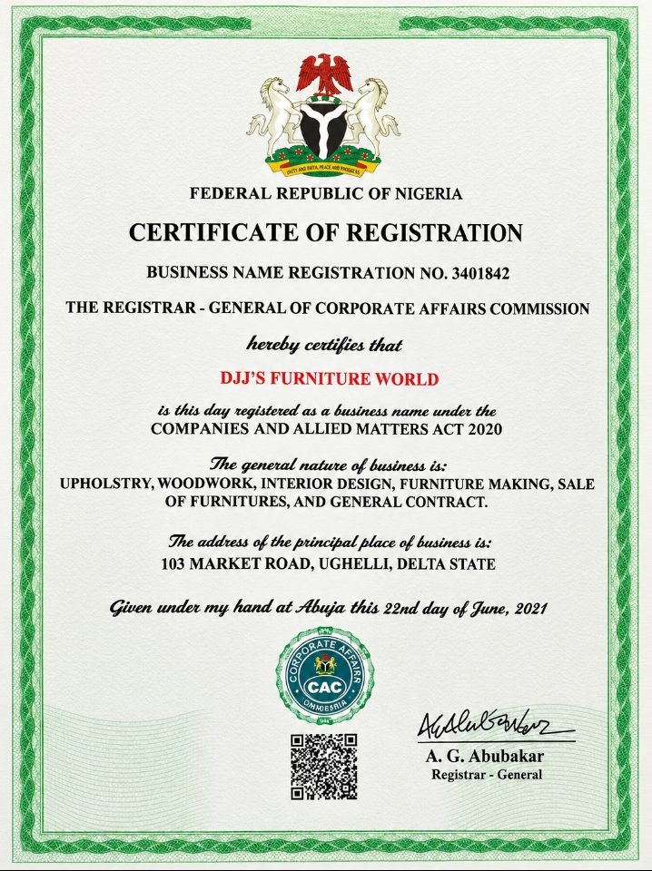

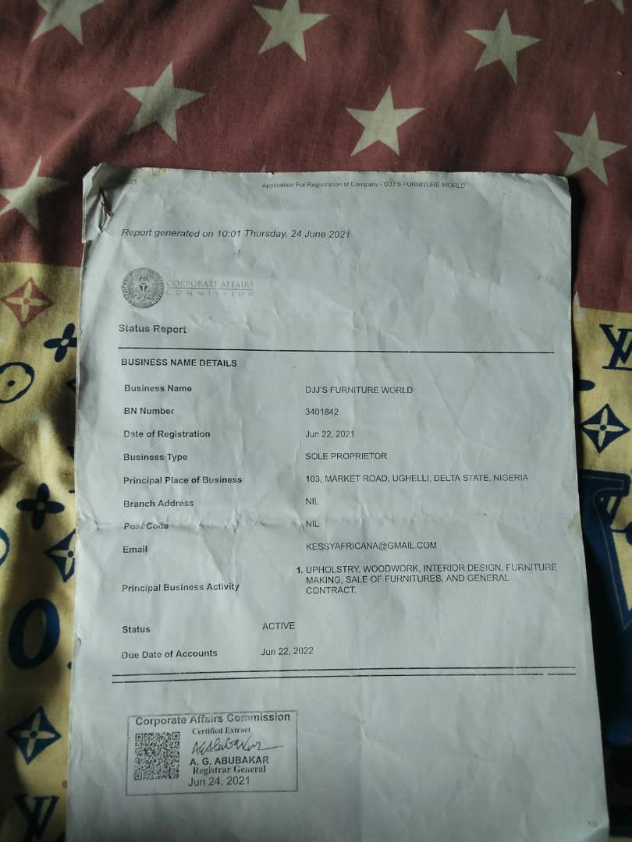

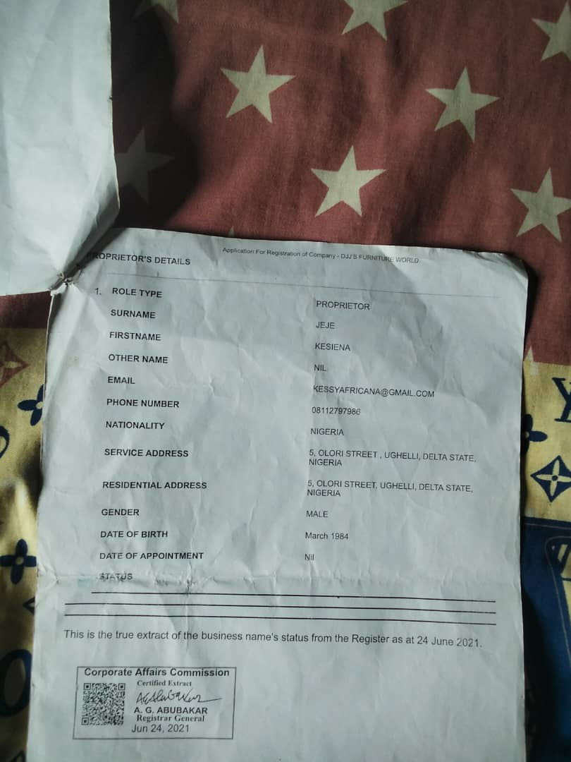

PROFESSIONAL SUMMARY
Experienced Furniture Maker, Installer and Assembly Specialist with 16 years of practical experience in furniture production, installation, assembly, repairs and maintenance.
Skilled in making and installing a wide range of furniture for homes, offices, hotels and companies. Experienced in both independent work and working on projects for businesses and organizations.
Areas of experience include wardrobes, beds, dining tables, chairs, TV consoles, kitchen cabinets and office furniture. Known for careful measurement, proper fitting, attention to detail, problem-solving and quality workmanship.

WORK EXPERIENCE

Furniture Installation & Maintenance Specialist
DJJ's Furniture World
16 Years of Experience
DJJ's Furniture World provides furniture making, installation, assembly, furnishing, maintenance and repair services for residential, commercial and hospitality spaces. Work has included projects for hotels, apartments, businesses and private clients.

Selected Projects
Gares Hotel — Upgrading & Maintenance Project
Ughelli Main Town, Delta State, along Ughelli–Warri Expressway
30 March 2026 – 30 July 2026
- Completed furniture upgrading and maintenance work across over 60 hotel rooms.
- Installed and assembled furniture and fittings as required throughout the project.
- Carried out furniture repairs, adjustments and maintenance work.
- Ensured furniture was properly measured, fitted, aligned and securely installed.
- Worked as part of the project team to complete the assigned work within the project period.
Gares Hotel Apartment — Furnishing Project
Ughelli Main Town, Delta State, along Ughelli–Warri Expressway
- Furnished the Gares Hotel Apartment as part of DJJ's Furniture World's project work.
- Installed and fitted furniture and related fittings according to the requirements of the space.
- Ensured completed furniture work was properly fitted and presented with attention to detail.
Gares Apartment — Furnishing Project
GRA, Port Harcourt, Rivers State — Opposite Polo Club
- Carried out furnishing work for Gares Apartment.
- Installed and fitted furniture according to the requirements of the apartment.
- Ensured quality workmanship, proper fitting and finishing throughout the project.
Black Penny Fast Food & Hotel — Furnishing Project
Oviri-Ogor, Ughelli, Delta State
- Carried out furniture furnishing work for the Black Penny Fast Food & Hotel.
- Installed and fitted furniture and related fittings for the premises.
- Maintained attention to detail and quality workmanship throughout the project.

CORE SKILLS
- Furniture Making
- Furniture Assembly
- Furniture Installation
- Furniture Repair & Maintenance
- Furniture Adjustment
- Measuring & Fitting
- Wardrobe Installation
- Kitchen Cabinet Installation
- Bed Assembly
- Table & Chair Assembly
- TV Console Installation
- Upholstery & Chair Fabric Sewing
- Hand Tool Operation
- Power Tool Operation
- Reading Furniture Assembly Instructions
- Problem Solving
- Attention to Detail
- Customer Service
- Teamwork

7. References
References available upon request.

