Precarious employment - descriptive analysis (unweighted)

Andrew Pulford

*UNWEIGHTED RESULTS - FOR ILLUSTRATIVE PURPOSES ONLY*

## Sample description

A total of 63,660 individuals participated in UKHLS waves 3-6 and 49,028 in waves 7-10 (Figure 1). We excluded 13,258 and 9,751 individuals respectively for not being aged 20-64 at the end point of the study period; plus 4,835 and 8,375 individuals respectively who did not have valid weights. From eligible populations of 23,555 and 19,732 we excluded 5,938 and 5,175 retired individuals; and 1,456 and 1,594 individuals who reported missing data for key exposure and outcomes of interest at waves 6 or 10 respectively. Table 1 presents key characteristics of the analytic sample at baseline by employment contract status (UKHLS wave 2).

**Figure 1: Flowcharts for inclusion and exclusion of UKHLS respondents to create analytic sample**

**(a) Sample A (waves 3-6)** 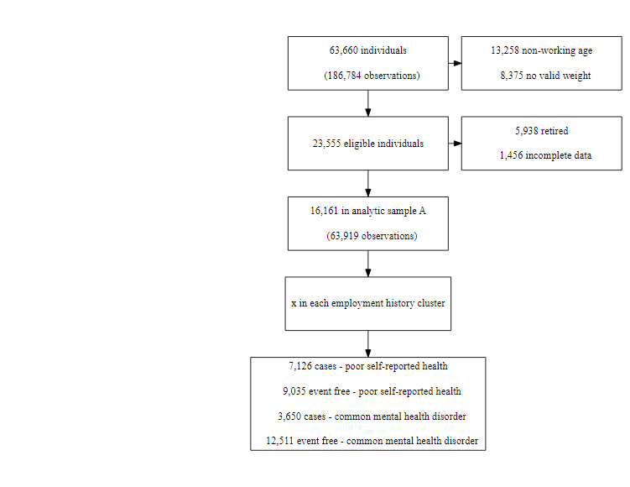

**(b) Sample B (waves 7-10)** 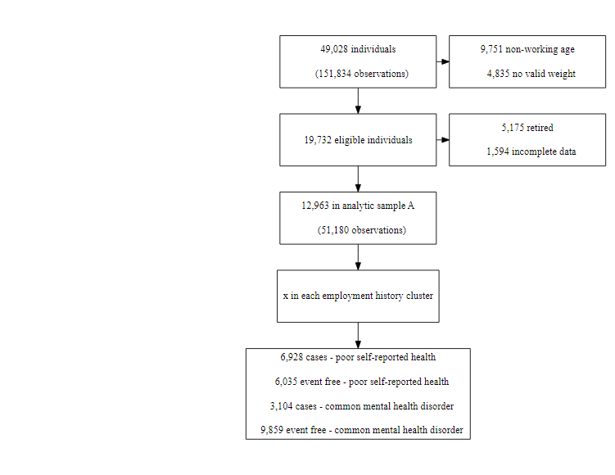

## [1] "Sample A - boxes AA and B to not equal box A"

## [1] "Sample B - boxes AA and B to not equal box A"

**Table 1: Analytic sample characteristics at study endpoint (UKHLS waves 6 and 10)**

| Variable | Measure | n (wave 6) | % (wave 6) | n (wave 10) | % (wave 10) |
| --- | --- | --- | --- | --- | --- |
| Sex | female | 9,024 | 55.8 | 7,306 | 56.4 |
|  | male | 7,137 | 44.2 | 5,657 | 43.6 |
| Age | mean |  | 36.9 |  | 38.3 |
| Ethnicity | white | 14,017 | 86.7 | 10,819 | 83.5 |
|  | non-white | 2,102 | 13.0 | 2,119 | 16.3 |
|  | missing | 42 | 0.3 | 25 | 0.2 |
| Marital status | married/civil partnership | 10,306 | 63.8 | 8,476 | 65.4 |
|  | divorced/separated/widowed | 2,432 | 15.0 | 1,839 | 14.2 |
|  | single | 3,362 | 20.8 | 2,583 | 19.9 |
|  | missing | 61 | 0.4 | 65 | 0.5 |
| Educational attainment | inapplicable | 25 | 0.2 | 195 | 1.5 |
|  | degree | 5,123 | 31.7 | 4,459 | 34.4 |
|  | other higher degree | 2,083 | 12.9 | 1,697 | 13.1 |
|  | a-level etc | 3,222 | 19.9 | 2,465 | 19.0 |
|  | gcse etc | 3,358 | 20.8 | 2,550 | 19.7 |
|  | other qualification | 1,351 | 8.4 | 1,001 | 7.7 |
|  | no qualification | 999 | 6.2 | 596 | 4.6 |
| Region | missing | - | 0.0 | - | 0.1 |
|  | north east | 612 | 3.8 | 447 | 3.4 |
|  | north west | 1,647 | 10.2 | 1,440 | 11.1 |
|  | yorkshire and the humber | 1,257 | 7.8 | 1,104 | 8.5 |
|  | east midlands | 1,278 | 7.9 | 971 | 7.5 |
|  | west midlands | 1,284 | 7.9 | 1,068 | 8.2 |
|  | east of england | 1,440 | 8.9 | 1,122 | 8.7 |
|  | london | 1,639 | 10.1 | 1,451 | 11.2 |
|  | south east | 2,024 | 12.5 | 1,560 | 12.0 |
|  | south west | 1,397 | 8.6 | 1,079 | 8.3 |
|  | wales | 1,074 | 6.6 | 797 | 6.1 |
|  | scotland | 1,440 | 8.9 | 1,100 | 8.5 |
|  | northern ireland | 1,064 | 6.6 | 817 | 6.3 |
| Employment contract | fixed-term | 786 | 4.9 | 801 | 6.2 |
|  | permanent | 12,840 | 79.5 | 10,162 | 78.4 |
|  | non-employment | 2,535 | 15.7 | 2,000 | 15.4 |
| Broken employment | unbroken employment | 12,841 | 79.5 | 10,391 | 80.2 |
|  | broken employment | 1,513 | 9.4 | 1,069 | 8.2 |
|  | no employment spells | 1,807 | 11.2 | 1,503 | 11.6 |
| Perceived job security | very likely | 239 | 1.5 | 210 | 1.6 |
|  | likely | 510 | 3.2 | 396 | 3.1 |
|  | unlikely | 3,602 | 22.3 | 3,886 | 30.0 |
|  | very unlikely | 6,457 | 40.0 | 4,693 | 36.2 |
|  | missing | 5,353 | 33.1 | 3,778 | 29.1 |
| Multiple jobs | no | 14,964 | 92.6 | 12,045 | 92.9 |
|  | yes | 1,197 | 7.4 | 918 | 7.1 |
| Monthly net income (£) | 25% quantile |  | 1026.9 |  | 1078.5 |
|  | median |  | 1573.5 |  | 1654.7 |
|  | 75% quantile |  | 2260.8 |  | 2409.7 |
| Self-rated health | excellent | 2,983 | 18.5 | 1,408 | 10.9 |
|  | very good | 6,052 | 37.4 | 4,627 | 35.7 |
|  | good | 4,394 | 27.2 | 4,289 | 33.1 |
|  | fair | 1,949 | 12.1 | 1,925 | 14.8 |
|  | poor | 783 | 4.8 | 714 | 5.5 |
| GHQ12 score | 0-3 | 13,163 | 81.4 | 10,378 | 80.1 |
|  | 4 or more | 2,998 | 18.6 | 2,585 | 19.9 |

## Missing data

Responses to all four waves in the study period were provided by 96.4% of analytic sample A and 95.7% of analytic sample B (Figure 2). Valid response sequences ascending in order of frequency are presented in Figure 3.

**Figure 2: Number of waves responded to by percentage of the analytic sample** 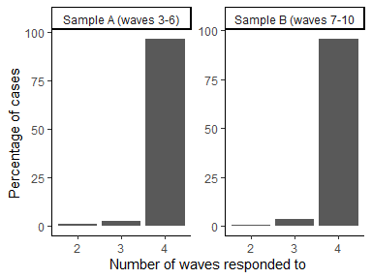

**Figure 3: Valid response sequences ascending in order of frequency**

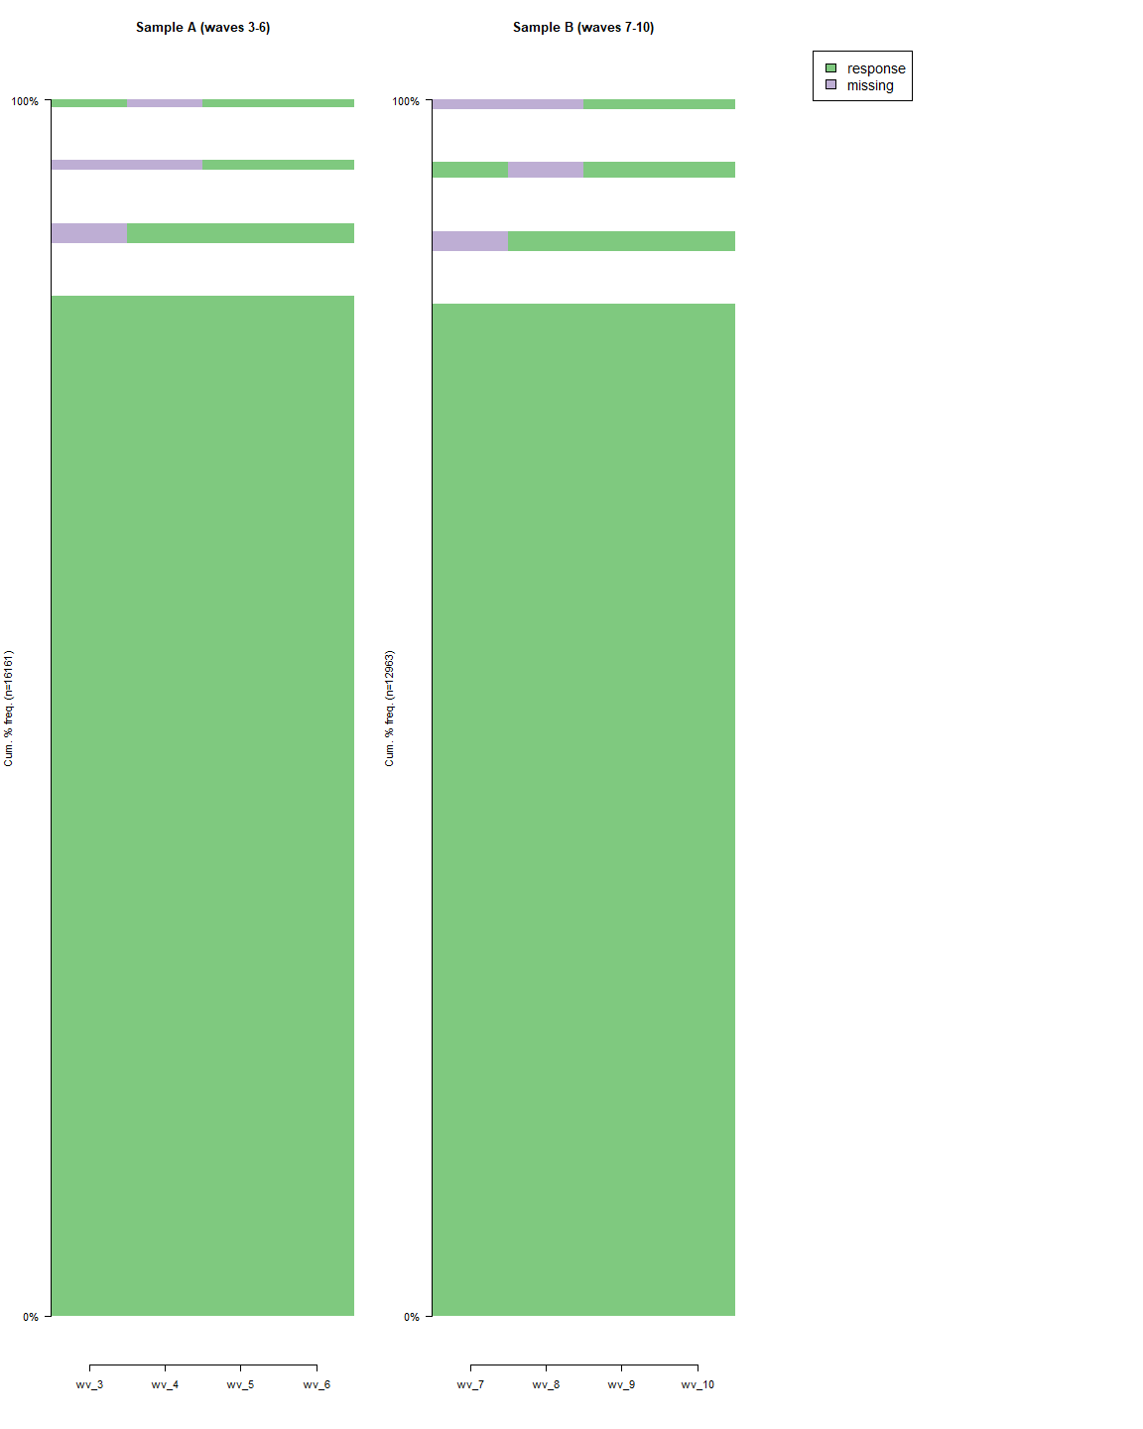

## Sequence analysis of precrious employment exposures of interest

### Employment contract

Figure 4 presents employment contract sequences ascending in order of frequency and Table 2 present frequencies and percentages of manually calculated grouping based on assumptions of likely grouping made a priori to sequence analysis of the data. The majority of participants were found to be in steady permanent employment in both analytic samples (11.6% in Sample A and 11.4% in Sample B). Under one percent of either sample reported steady non-permanent employment (0.4% in Sample A and 0.9% in Sample B). A larger proportion of the analytic samples were classed as a “blip” (one wave of non-permanent employment and three waves of permanent employment) (0.6% in Sample A and 0.4% in Sample B); or as “churning” between employment contract states (86.4% in Sample A and 86.1% in Sample B).

**Figure 4: Employment contract sequences ascending in order of frequency** 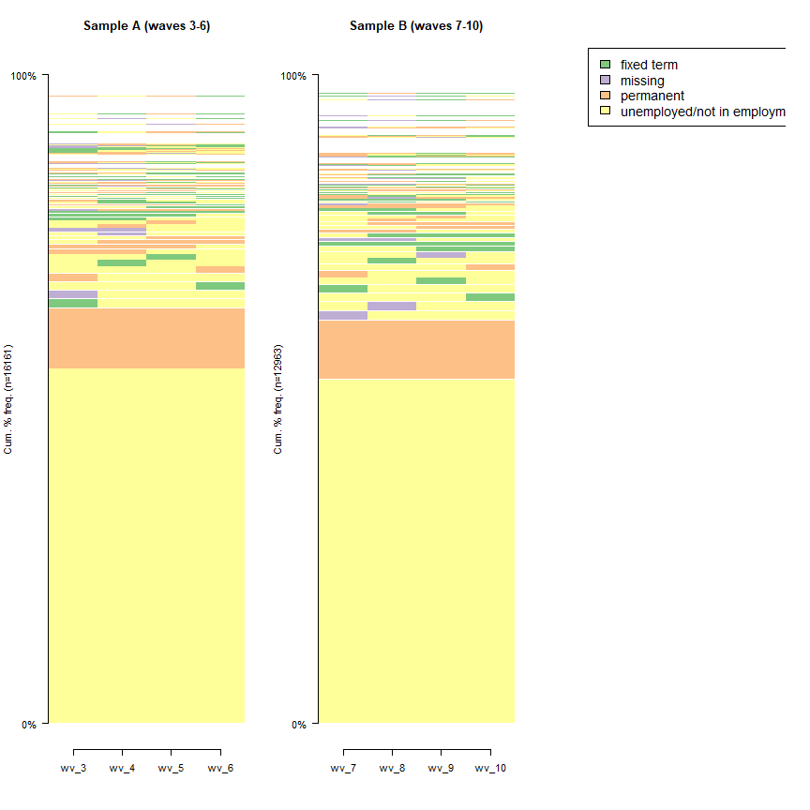

**Table 2: A priori employment contract history groupings**

| A priori employment contract grouping | n (Sample A) | % (Sample A) | n (Sample B) | % (Sample B) |
| --- | --- | --- | --- | --- |
| steady: permanent | 1,878 | 11.6 | 1,479 | 11.4 |
| steady: non-permanent | 61 | 0.4 | 111 | 0.9 |
| churn | 13,956 | 86.4 | 11,163 | 86.1 |
| blip: non-permanent | 97 | 0.6 | 52 | 0.4 |
| incomplete | 169 | 1.0 | 158 | 1.2 |

### Employment spells

Figure 5 presents employment spell sequences ascending in order of frequency and Table 3 present frequencies and percentages of manually calculated grouping based on a priori assumptions of likely groupings. The majority of participants were found to be in steady unbroken employment in both analytic samples (65.6% in Sample A and 67.1% in Sample B). Under one percent of either sample reported steady broken employment (0.5% in Sample A and 0.4% in Sample B). A larger proportion of the analytic samples were classed as a “blip” (one wave of broken employment and three waves of unbroken employment) (4.6% in Sample A and 4.6% in Sample B); or as “churning” between employment spells states (16.4% in Sample A and 14.3% in Sample B).

**Figure 5: Employment spell sequences ascending in order of frequency** 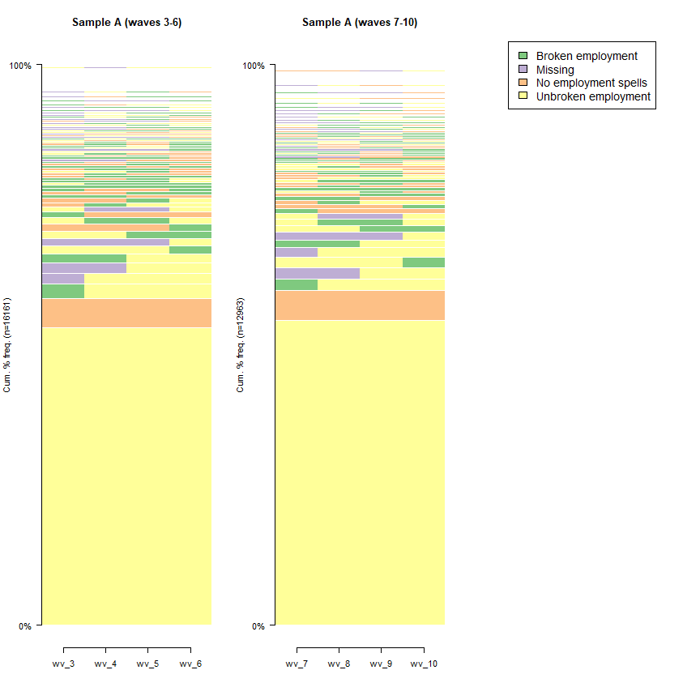

**Table 3: A priori employment spells history groupings**

| A priori broken employment spells grouping | n (Sample A) | % (Sample A) | n (Sample B) | % (Sample B) |
| --- | --- | --- | --- | --- |
| steady: unbroken | 10,599 | 65.6 | 8,701 | 67.1 |
| steady: broken | 75 | 0.5 | 58 | 0.4 |
| steady: no employment | 1,002 | 6.2 | 821 | 6.3 |
| churn | 2,653 | 16.4 | 1,850 | 14.3 |
| blip: broken | 739 | 4.6 | 593 | 4.6 |
| blip: no employment | 124 | 0.8 | 149 | 1.1 |
| incomplete | 969 | 6.0 | 791 | 6.1 |

### Multiple jobs

Figure 6 presents mutliple job sequences ascending in order of frequency and Table 4 present frequencies and percentages of manually calculated grouping based on a priori assumptions of likely groupings. Multiple jobs were relatively uncommon in both analytic samples. Steady multiple employment was reported in % in Sample A and % in Sample B. A larger proportion of the analytic samples were classed as a “blip” (one wave of multiple employment and three waves without) (% in Sample A and % in Sample B); or as “churning” between multiple employment states (99% in Sample A and 98.8% in Sample B).

**Figure 6: Multiple job sequences ascending in order of frequency 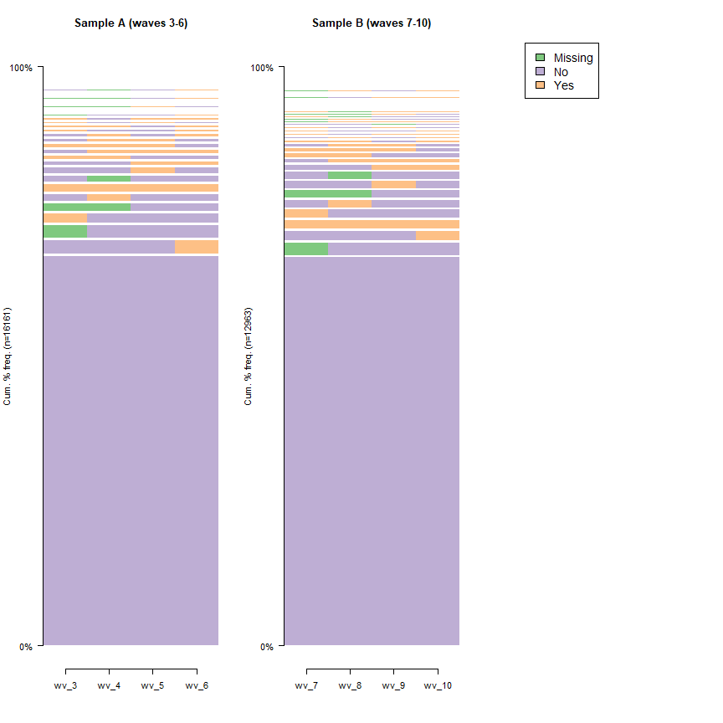 Table 4: A priori multiple employment history groupings**

| A priori multiple grouping | n (Sample A) | % (Sample A) | n (Sample B) | % (Sample B) |
| --- | --- | --- | --- | --- |
| churn | 15,998 | 99 | 12,808 | 99 |
| incomplete | 163 | 1 | 155 | 1 |

## Latent class analaysis

### Emploment contract - Sample A

| X | nclass | bic | aic | Gsq | Chisq | entropy | sample_grp |
| --- | --- | --- | --- | --- | --- | --- | --- |
| 1 | 2 | 54153 | 54022 | 4255 | 53906 | 2 | 2011-2015: |
| high unemployment/low income period |  |  |  |  |  |  |  |
| 2 | 3 | 50857 | 50657 | 1022 | 1435 | 2 | 2011-2015: |
| high unemployment/low income period |  |  |  |  |  |  |  |
| 3 | 4 | 50508 | 50239 | 586 | 652 | 2 | 2011-2015: |
| high unemployment/low income period |  |  |  |  |  |  |  |
| 4 | 5 | 50177 | 49838 | 171 | 179 | 2 | 2011-2015: |
| high unemployment/low income period |  |  |  |  |  |  |  |
| 5 | 6 | 50209 | 49801 | 117 | 117 | 2 | 2011-2015: |
| high unemployment/low income period |  |  |  |  |  |  |  |
| 6 | 7 | 50229 | 49752 | 51 | 51 | 2 | 2011-2015: |
| high unemployment/low income period |  |  |  |  |  |  |  |
| 7 | 8 | 50314 | 49768 | 49 | 48 | 2 | 2011-2015: |
| high unemployment/low income period |  |  |  |  |  |  |  |

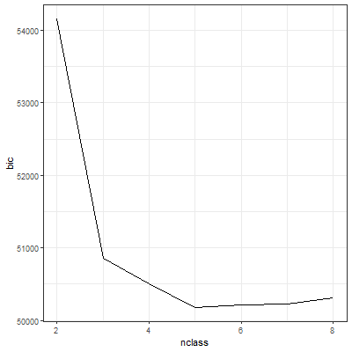

#### Sample A - five class model

## Conditional item response (column) probabilities,  
## by outcome variable, for each class (row)   
##   
## $wv_3  
## Pr(1) Pr(2) Pr(3)  
## class 1: 0.487 0.40 0.11  
## class 2: 0.020 0.96 0.02  
## class 3: 0.014 0.04 0.94  
## class 4: 0.003 0.17 0.83  
## class 5: 0.040 0.82 0.14  
##   
## $wv_4  
## Pr(1) Pr(2) Pr(3)  
## class 1: 0.601 0.340 0.059  
## class 2: 0.011 0.983 0.005  
## class 3: 0.008 0.001 0.991  
## class 4: 0.144 0.000 0.856  
## class 5: 0.000 0.840 0.160  
##   
## $wv_5  
## Pr(1) Pr(2) Pr(3)  
## class 1: 0.505 0.438 0.06  
## class 2: 0.011 0.989 0.00  
## class 3: 0.003 0.001 1.00  
## class 4: 0.217 0.682 0.10  
## class 5: 0.060 0.284 0.66  
##   
## $wv_6  
## Pr(1) Pr(2) Pr(3)  
## class 1: 0.42 0.53 0.05  
## class 2: 0.02 0.97 0.01  
## class 3: 0.03 0.05 0.92  
## class 4: 0.14 0.75 0.10  
## class 5: 0.11 0.41 0.48  
##   
## Estimated class population shares   
## 0.06 0.7 0.1 0.02 0.03   
##   
## Predicted class memberships (by modal posterior prob.)   
## 0.05 0.8 0.1 0.02 0.02   
##   
## =========================================================   
## Fit for 5 latent classes:   
## =========================================================   
## number of observations: 16161   
## number of fully observed cases: 15344   
## number of estimated parameters: 44   
## residual degrees of freedom: 36   
## maximum log-likelihood: -24875   
##   
## AIC(5): 49838  
## BIC(5): 50177  
## G^2(5): 171 (Likelihood ratio/deviance statistic)   
## X^2(5): 179 (Chi-square goodness of fit)   
##

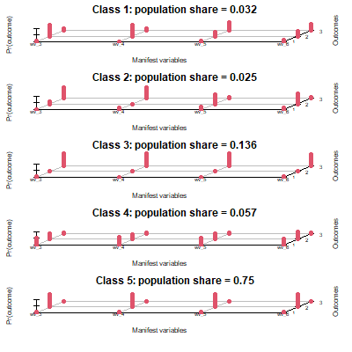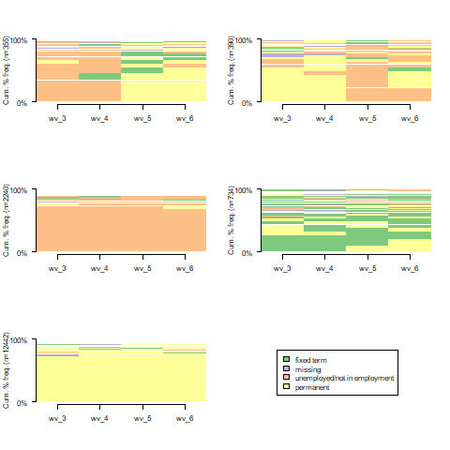

### Emploment contract - Sample B

| X | nclass | bic | aic | Gsq | Chisq | entropy | sample_grp |
| --- | --- | --- | --- | --- | --- | --- | --- |
| 1 | 2 | 44090 | 43963 | 4279 | 67193 | 2 | 2015-2019: |
| lower unemployment/stagnant income period |  |  |  |  |  |  |  |
| 2 | 3 | 40593 | 40399 | 930 | 1681 | 2 | 2015-2019: |
| lower unemployment/stagnant income period |  |  |  |  |  |  |  |
| 3 | 4 | 40223 | 39962 | 472 | 523 | 2 | 2015-2019: |
| lower unemployment/stagnant income period |  |  |  |  |  |  |  |
| 4 | 5 | 40017 | 39689 | 194 | 206 | 2 | 2015-2019: |
| lower unemployment/stagnant income period |  |  |  |  |  |  |  |
| 5 | 6 | 40026 | 39631 | 124 | 123 | 2 | 2015-2019: |
| lower unemployment/stagnant income period |  |  |  |  |  |  |  |
| 6 | 7 | 40046 | 39583 | 61 | 66 | 2 | 2015-2019: |
| lower unemployment/stagnant income period |  |  |  |  |  |  |  |
| 7 | 8 | 40125 | 39594 | 52 | 55 | 2 | 2015-2019: |
| lower unemployment/stagnant income period |  |  |  |  |  |  |  |

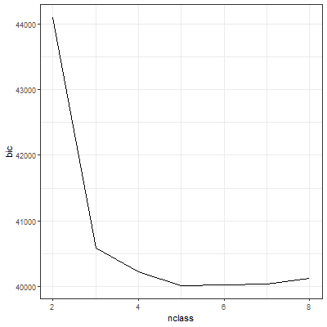

#### Sample B - five class model

## Conditional item response (column) probabilities,  
## by outcome variable, for each class (row)   
##   
## $wv_7  
## Pr(1) Pr(2) Pr(3)  
## class 1: 0.358 0.597 0.04  
## class 2: 0.020 0.964 0.02  
## class 3: 0.008 0.003 0.99  
## class 4: 0.166 0.109 0.73  
## class 5: 0.074 0.785 0.14  
##   
## $wv_8  
## Pr(1) Pr(2) Pr(3)  
## class 1: 0.564 0.4 0.039  
## class 2: 0.013 1.0 0.007  
## class 3: 0.004 0.0 0.996  
## class 4: 0.307 0.1 0.573  
## class 5: 0.095 0.5 0.434  
##   
## $wv_9  
## Pr(1) Pr(2) Pr(3)  
## class 1: 0.707 0.27 0.020  
## class 2: 0.014 0.98 0.006  
## class 3: 0.004 0.00 0.996  
## class 4: 0.219 0.78 0.000  
## class 5: 0.053 0.05 0.898  
##   
## $wv_10  
## Pr(1) Pr(2) Pr(3)  
## class 1: 0.61 0.35 0.04  
## class 2: 0.02 0.96 0.02  
## class 3: 0.01 0.03 0.95  
## class 4: 0.09 0.77 0.14  
## class 5: 0.11 0.18 0.71  
##   
## Estimated class population shares   
## 0.07 0.8 0.1 0.02 0.03   
##   
## Predicted class memberships (by modal posterior prob.)   
## 0.06 0.8 0.1 0.02 0.02   
##   
## =========================================================   
## Fit for 5 latent classes:   
## =========================================================   
## number of observations: 12963   
## number of fully observed cases: 11949   
## number of estimated parameters: 44   
## residual degrees of freedom: 36   
## maximum log-likelihood: -19800   
##   
## AIC(5): 39689  
## BIC(5): 40017  
## G^2(5): 194 (Likelihood ratio/deviance statistic)   
## X^2(5): 206 (Chi-square goodness of fit)   
##

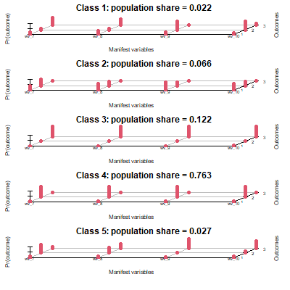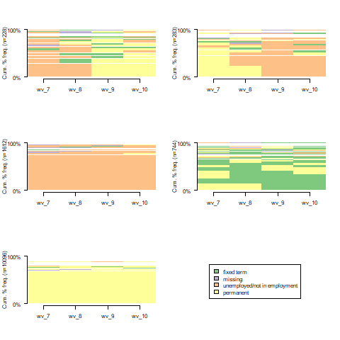

### Prevalence of outcomes of interest

#### Common mental health disorders

**Figure x: Prevalence of common mental health disorder (Sample A) 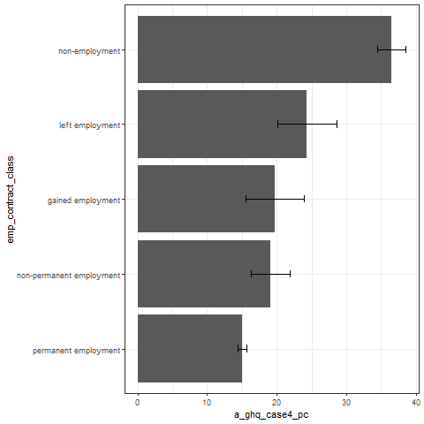

**Figure x: Prevalence of common mental health disorder (Sample B) 