Introduction
I chose to build a database for a manufacturing execution system. Manufacturing execution systems are used in manufacturing to document the personnel and materials that were used to build a final product. To determine the cause of defects, materials and products are grouped into batches. The pessimistic plan was to simply build the database with the tables, example values, and constraints. The optimistic Plan was to add time-based reporting, start and end quantity, and cost. I managed to get time-based reporting done done but decided against doing any of the other stretch goals.
Exploring
I started the semester with academic experience in Microsoft SQL Server. It was a while ago though, so I needed to shake off the rust and adapt to the slightly different syntax. When the project was revealed, I knew which topic to choose immediately. I work in medical device assembly and rely on MES to complete our tasks.
Building:
I began the process by thinking about what data I needed to store and how it should be related. After writing out the entity relationships, I realized that I wanted employees, product types, and component types to be the entities that the rest of the table depends on. There are many containers of components. At least one employee works on every batch and each employee can work on many batches. There can be many batches of a specific type of product. Each batch has at least one container of components used to build it. The database can be best illustrated by this ER Diagram. 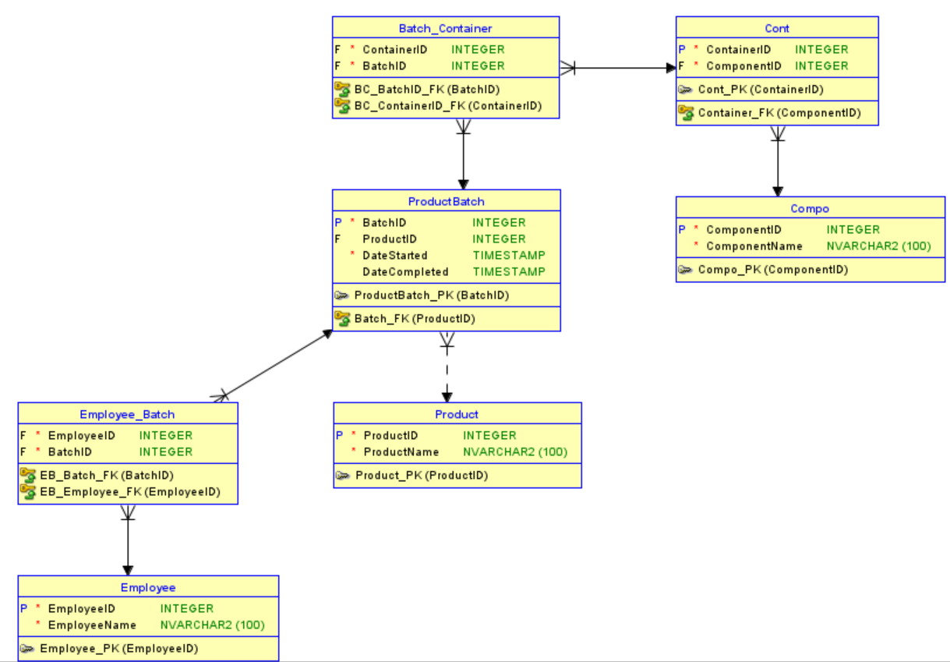

I chose to write the DDL to generate the database manually because it lets me control naming and write legible code. The data was generated by ChatGPT because the design is more interesting to me. I tried to include some realism in the data by putting in some null values in sensible locations.
Discovering
Before this course, I didn’t know anything about procedural SQL. As a result, I had to reference the documentation for PL/SQL multiple times during the implementation of my functions. Some problems I encountered were:
- Distinguishing functional and procedural syntax
- Select… Into only works on single values without bulk collect
- Record Definition can only occur in blocks (must be object type at schema level).
Overall, the project gave me a stronger grasp of PL/SQL.
Topics:
Normalization: My project illustrates normalization because the non-intersection tables are all in first normal form.
DDL: You can find data definition language in my createtables file, since creating tables are a part of SQL data definition language.
DML: The populatedata file is an example of data manipulation language since I’m inserting values into the tables.
PSM: MakeTypes and CreateReports are an example of PSM since they are written in PL/SQL and create artifacts on the database to be run or referenced later.
Views: CreateViews, is an example of creating Views, hence the name.
Limitations
Due to time constraints, my database doesn’t have a front end. Ideally, employees would access the front end through a browser or bespoke app on local intranet or internet. There are no permissions set since I’m the only one running this, but they should be on an actual system. The database hasn’t been tested on real data and thus requires validation. The on delete actions are currently default, but a more complex system would be necessary for a real-world product.

