Bullish (BLSH)
Week 2 — Landscape & Comparable Companies Analysis
Hedge fund pitch research workstream · prepared for internal use

Executive Synthesis
Right now the market is pricing BLSH almost entirely off Bucket A logic — a crypto-native trading multiple, sensitive to trading volume and BTC price, the same bucket as Coinbase, Kraken, and Gemini. BLSH's 10.8x/9.4x EV/Revenue sits alongside Coinbase's 6.9x/5.4x, nowhere near Bucket C infrastructure multiples on a comparable basis.
The Robinhood and Gemini cases both argue the market is slow to re-rate a trading business toward a hybrid multiple even when the recurring-revenue story is real. Robinhood only earns a rich multiple because its non-crypto base (net interest income, prediction markets) has grown large and fast; Gemini's diversification into OTC, credit card, and predictions hasn't moved its multiple yet because the recurring base is still small relative to the whole company.
That is the mispricing window the pitch depends on. BLSH's Equiniti acquisition is a much larger, much faster jump in recurring-revenue mix than either Robinhood or Gemini achieved organically — closer in kind to what let Coinbase earn a blended multiple once its subscription and services revenue crossed roughly 44% of the total. If the market is still pricing BLSH as pure Bucket A while the revenue mix is shifting toward Bucket C economics, that gap is the thesis.

Landscape & Valuation Logic Map
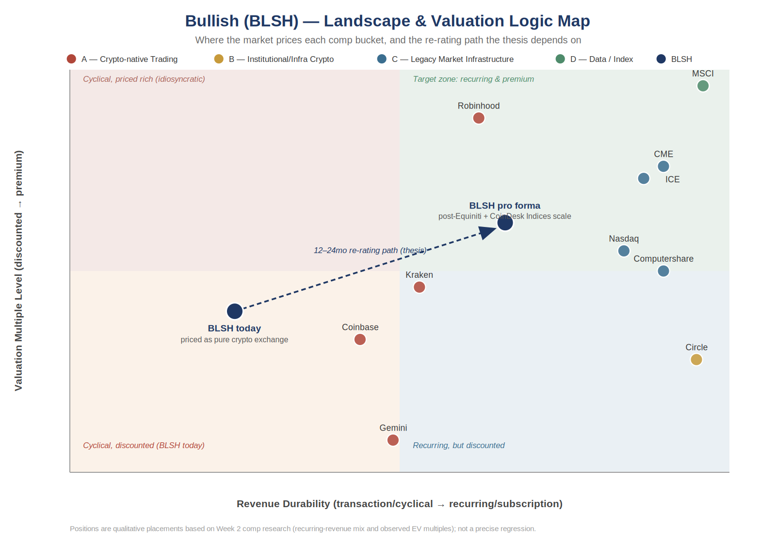
Quadrant map of all ten comps by revenue durability (x-axis) and valuation multiple level (y-axis). BLSH today sits in the cyclical/discounted quadrant; the thesis argues for migration toward the recurring/premium quadrant over a 12–24 month horizon as Equiniti closes and CoinDesk Indices scales.

Position in the Capital Markets Value Chain
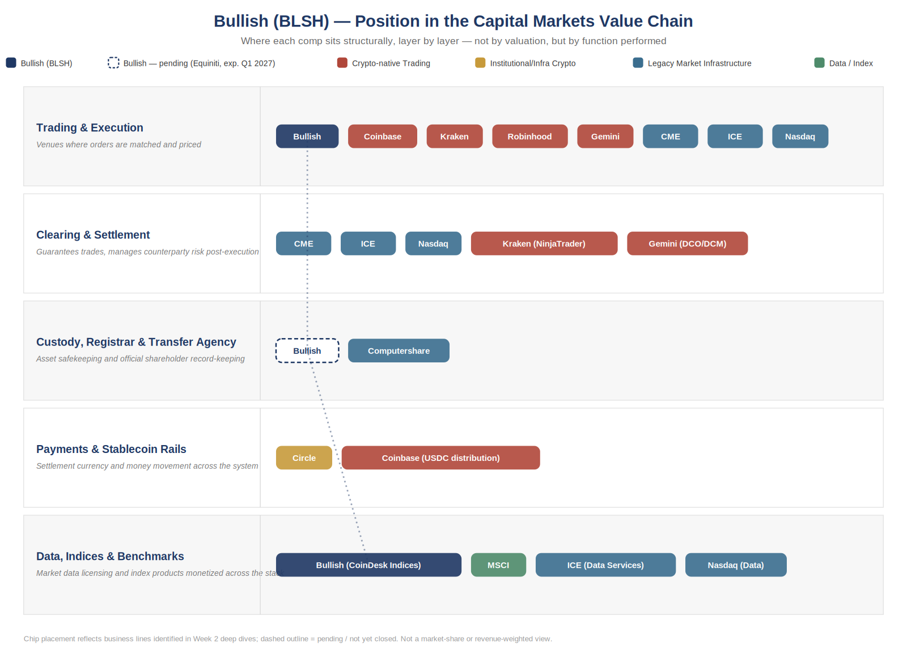
Functional stack view — where each comp actually operates, layer by layer, independent of valuation. BLSH is the only name spanning three layers at once (Trading & Execution, Data/Indices, and pending Custody/Transfer Agency via Equiniti), shown by the dashed connector.

Bucketed Comparable Companies
Comps are grouped by valuation logic rather than sector alone, since mixing crypto-native trading multiples with legacy infrastructure or subscription-based data multiples muddies the sum-of-the-parts read. Full live workbook (BLSH_Comps_Output.xlsx) has the complete multiple set including gross profit, revenue growth, and margin columns.
Bucket A/C — Traditional Exchanges
Company | Mkt Val ($mm) | EV ($mm) | EV/Rev CY26E | EV/Rev CY27E | EV/EBITDA CY26E | EV/EBITDA CY27E
ICE | 76,595 | 96,801 | 8.8x | 8.4x | 13.1x | 12.5x
NASDAQ | 49,516 | 58,523 | 10.1x | 9.3x | 17.1x | 15.7x
Robinhood | 104,761 | 110,373 | 21.8x | 17.5x | 42.2x | 31.3x
Median | — | — | 10.1x | 9.3x | 17.1x | 15.7x
Mean | — | — | 13.6x | 11.7x | 24.1x | 19.8x
Bucket A — Crypto-native Exchanges
Company | Mkt Val ($mm) | EV ($mm) | EV/Rev CY26E | EV/Rev CY27E | EV/EBITDA CY26E | EV/EBITDA CY27E
Bullish (BLSH) | 3,794 | 4,013 | 10.8x | 9.4x | 26.9x | 21.2x
Coinbase | 44,227 | 41,753 | 6.9x | 5.4x | 21.9x | 13.1x
Gemini | 507 | 785 | 3.9x | 2.9x | nm | nm
Median | — | — | 6.9x | 5.4x | 24.4x | 17.1x
Mean | — | — | 7.2x | 5.9x | 24.4x | 17.1x
Bucket C — Transfer Agents
Company | Mkt Val ($mm) | EV ($mm) | EV/Rev CY26E | EV/Rev CY27E | EV/EBITDA CY26E | EV/EBITDA CY27E
Computershare | 15,833 | 16,595 | 5.2x | 5.0x | 13.0x | 12.6x
Equiniti (at announcement, $38.48/sh) | 2,350 | 4,200 | 4.6x | na | 10.2x | na
Equiniti (today, $24.80/sh) | 1,515 | 3,365 | 3.7x | na | 8.2x | na
Median (Excl. Equiniti) | — | — | 5.2x | 5.0x | 13.0x | 12.6x
Bucket B — Stablecoin Issuer
Company | Mkt Val ($mm) | EV ($mm) | EV/Rev CY26E | EV/Rev CY27E | EV/EBITDA CY26E | EV/EBITDA CY27E
Circle | 16,212 | 14,711 | 4.8x | 3.6x | 23.1x | 15.7x
Median | — | — | 4.8x | 3.6x | 23.1x | 15.7x
Bucket D — Tokenization Infrastructure
Company | Mkt Val ($mm) | EV ($mm) | EV/Rev CY26E | EV/Rev CY27E | EV/EBITDA CY26E | EV/EBITDA CY27E
Securitize | 1,276 | 1,276 | na | na | na | na
Median | — | — | na | na | na | na

Company Deep Dives
Eight comps researched at ~1-page depth each, covering business model, margin structure, how the market prices the stock, and the specific read-through for the BLSH thesis.

Coinbase (COIN) — Bucket A
Business model & revenue mix: Two-engine model: Q1 2026 transaction revenue of $755.8mm (consumer $566.9mm, institutional $135.7mm) plus subscription & services revenue of $583.5mm — 44% of total net revenue. Stablecoin revenue ($305mm) is the largest subscription component, driven by USDC scale; Coinbase captures roughly 50% of total USDC economics.
Margin structure: Q1 2026 total revenue fell 31% YoY to $1.41bn on a >20% decline in crypto market cap, illustrating the model's cyclicality. Adjusted EBITDA was $303mm — the 13th consecutive quarter of positive adjusted EBITDA — with net loss driven mostly by mark-to-market swings, not operations.
How the market prices it: Blended — priced on forward revenue and EBITDA multiples, not a pure trading-volume multiple, specifically because subscription/services revenue is now large enough to earn a quasi-recurring premium.
Read-through for BLSH: Coinbase is proof a crypto exchange can earn a blended multiple once recurring revenue crosses a critical mass (~44% here). BLSH's Equiniti-driven recurring base is the same play, just achieved via acquisition rather than organic build, and much faster.

Robinhood (HOOD) — Bucket A / Traditional Exchanges (as bucketed)
Business model & revenue mix: Q1 2026: crypto revenue fell 47% YoY to $134mm (from $252mm) as trading volume dropped 48%; total company revenue still grew 15% to $1.07bn on event contracts (+320% to $147mm) and net interest income (+24% to $359mm).
Margin structure: Crypto is now a shrinking slice of a growing pie — the 'Other' category (Gold subscriptions, banking, Bitstamp, predictions) grew from $54mm to $85mm YoY.
How the market prices it: Priced as a diversified fintech/brokerage, not a crypto pure-play — the market rewards the non-crypto growth engines and largely shrugs off crypto-segment volatility.
Read-through for BLSH: The market will look past a shrinking crypto segment if other recurring lines are growing fast enough — reinforcing the case that BLSH's transfer-agent income could get similar credit once it is large enough to move the mix.

Kraken (private) — Bucket A
Business model & revenue mix: FY2025 revenue ~$2.2bn (+33% YoY), adjusted EBITDA ~$531mm (~24% margin). Private marks have ranged from $20bn (Nov 2025 raise) down to ~$12–13bn on secondaries by mid-2026 — trading around 8–10x revenue / 25–35x EBITDA, a premium to Coinbase's public multiples.
Margin structure: Revenue historically volatile: fell 31% in 2023 before rebounding 138% in 2024. About 47% of 2024 revenue came from trading fees; the rest (custody, staking, payments, financing) is more durable.
How the market prices it: Private-market multiples set by funding rounds and secondary trades rather than public price discovery — inherently noisier and lagged.
Read-through for BLSH: Kraken's private multiples are a useful upper-bound sanity check for crypto-exchange comps, but the ~40% valuation swing in under a year underscores exactly the multiple instability the sum-of-the-parts thesis needs to underwrite around.

Gemini (GEMI) — Bucket A
Business model & revenue mix: Q1 2026 total revenue $50.3mm (+42% YoY) despite exchange/trading revenue falling 27% to $17.2mm — growth driven by OTC ($6.3mm, up from $0.1mm), credit card, and prediction markets. Services & interest income now 49% of revenue vs. 31% a year ago.
Margin structure: Still loss-making (Q1 2026 net loss $109.0mm); diversification is real but revenue base is still small in absolute terms.
How the market prices it: Stock down roughly 30% since IPO, tracking Bitcoin's decline — the market is still treating it as a crypto-beta name despite the diversification narrative.
Read-through for BLSH: A cautionary case: Gemini is telling the same 'we're diversifying beyond trading' story BLSH will need to tell, but the market has not re-rated it yet. Says the narrative alone is not enough — the diversified revenue needs to reach real scale before the multiple moves.

Circle (CRCL) — Bucket B
Business model & revenue mix: Q1 2026 revenue $694mm (+20% YoY), 94% of it reserve income on USDC/EURC reserves. USDC in circulation reached $77bn (+28% YoY); USDC onchain transaction volume rose 263% to $21.5 trillion.
Margin structure: Adjusted EBITDA $151mm (+24% YoY), revenue-less-distribution-cost margin of 41.4%.
How the market prices it: Priced on USDC circulation growth and reserve-rate durability, not trading volume — a fundamentally different valuation logic than an exchange.
Read-through for BLSH: Confirms Bucket B needs its own multiple framework (asset base × rate spread), not a revenue or EBITDA multiple borrowed from exchanges — don't let Circle's multiple bleed into the exchange comp set.

CME Group — Bucket C
Business model & revenue mix: Diversified derivatives exchange and clearinghouse; EV/EBITDA currently ~13–15x, below its 10-year median of ~17.9x. TTM EBITDA ~$6.1bn; ~$117bn market cap.
Margin structure: High-margin, highly recurring clearing and data revenue with low cyclicality relative to crypto or even cash equities trading.
How the market prices it: Priced on clearing/data recurring revenue with high visibility — the reference case for market-infrastructure-grade multiples.
Read-through for BLSH: The ceiling case if BLSH's data/infrastructure business someday earns infrastructure-grade credit — though CME's own multiple compression this year (13–15x vs. an 18x median) is a reminder that legacy infrastructure multiples are not static either.

ICE — Bucket C
Business model & revenue mix: Diversified across exchanges, fixed income data, and mortgage technology; strong profitability with net margin around 38% in Q1 2026.
Margin structure: Blended data + transaction revenue model gives ICE more balance than a single-line exchange.
How the market prices it: Priced on that blended model — closer analog to BLSH's CoinDesk Indices ambition than a pure-play exchange like CME.
Read-through for BLSH: ICE is the best 'hybrid' precedent — proof the market will pay up for a transaction business with a genuine data arm attached, which is exactly the CoinDesk Indices bet.

MSCI — Bucket D
Business model & revenue mix: Q1 2026 revenue $850.8mm (+14.1%), with asset-based fees (+26.6%) and recurring subscription revenue (+8.6%) both contributing; retention rate 95.4%.
Margin structure: Adjusted EBITDA margin 59.3% — among the highest-margin business models in this comp set.
How the market prices it: Priced almost entirely on recurring subscription and asset-based fee durability, not on any transaction volume; commands a premium multiple specifically because of that durability.
Read-through for BLSH: This is the multiple CoinDesk Indices could command standalone — but only once it has MSCI-style retention and run-rate visibility, which it does not have yet. Useful as a ceiling case, not a near-term comp.

Methodology & Sourcing Notes
- Comps figures per S&P Capital IQ consensus estimates unless noted; CY26E/CY27E = calendar year 2026E/2027E forward estimates.
- Company deep dives sourced from Q1 2026 earnings releases, 10-Q/8-K filings, and earnings call transcripts (see individual citations retained in research chat log).
- Equiniti 'at announcement' uses the $38.48/share BLSH deal price (Aug 2025); 'today' uses $24.80/share — reflects the re-rating downside since announcement.
- Transfer Agent median excludes both Equiniti rows given deal-specific distortion; Computershare is the sole clean read-through comp.
- Securitize (tokenization infrastructure) has no public consensus estimates (na); included for qualitative moat/comp context only, not multiple triangulation.
- Landscape map and stack diagram positions are qualitative placements based on this research, not a modeled regression — treat as directional, not precise.
- Full live comps workbook: BLSH_Comps_Output.xlsx (companion file).

