ESF Comments

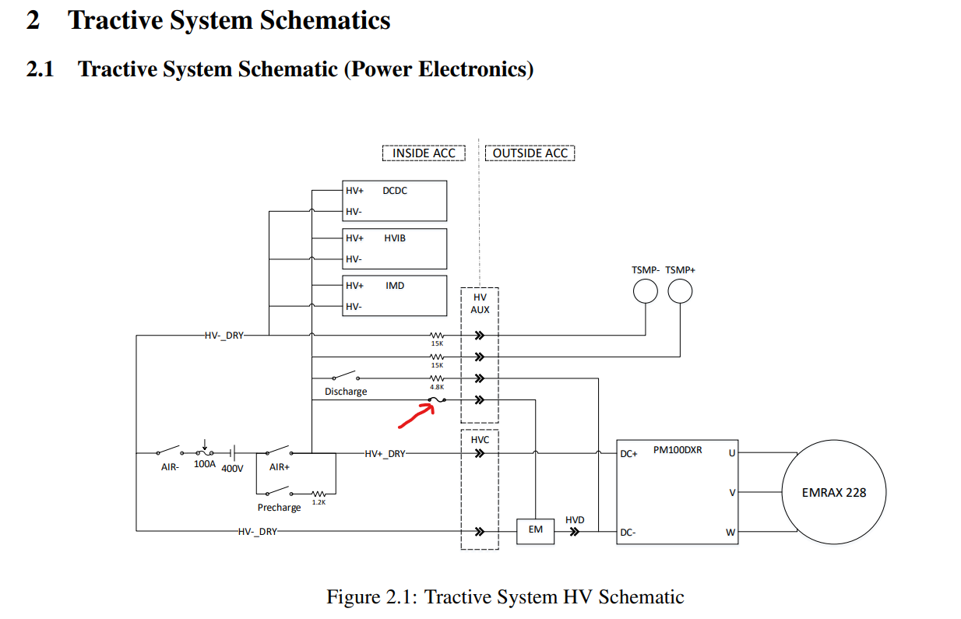

No rating on this fuse

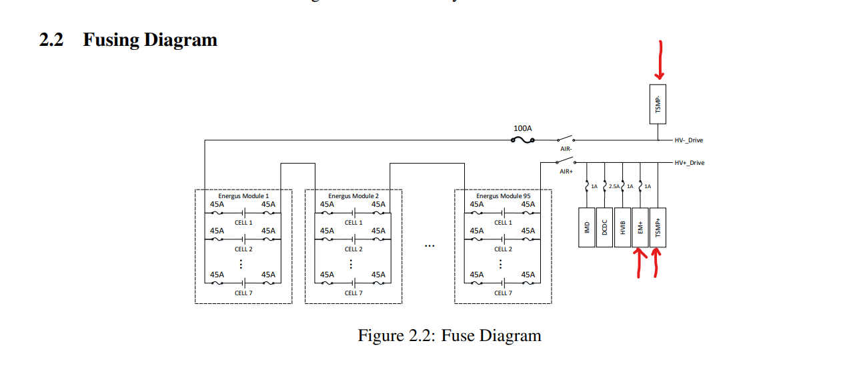These are outside of the accumulator, not inside. Would be good to distinguish.  
  
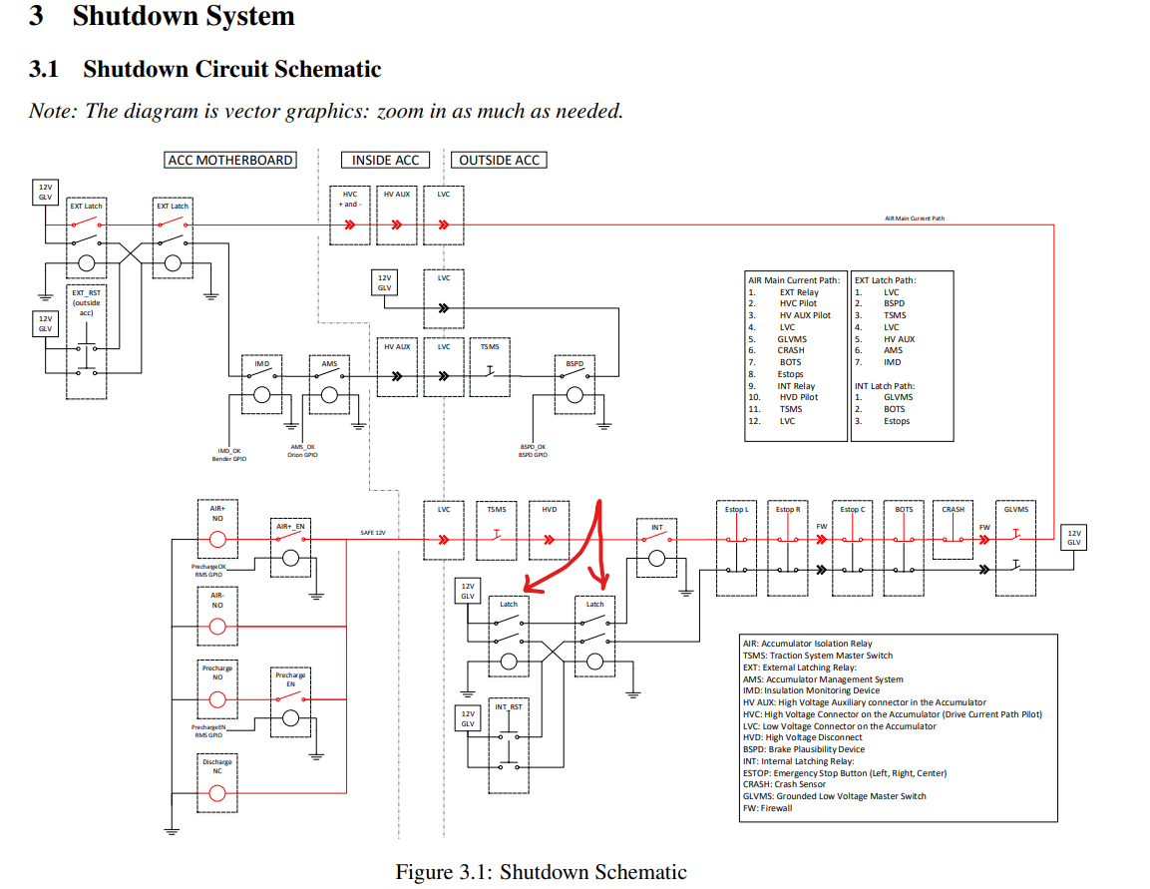

Maybe call this INT latch instead of just latch

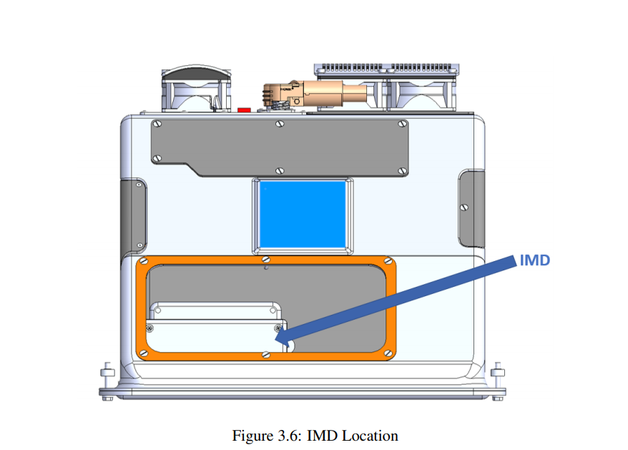  
I thought the IMD was on the motherboard now?