**Andrew Morrison**

**Exercise 2 HW 3**

**AI Design and Process**

After rethinking the problem several times, I trashed my old plans for this AI. They didn’t make sense in practice. I came up with two heuristics that worked much better.

**Heuristic 1:**

The main heuristic would calculate the amount of threats on the board. It would do this by finding n-in-a-row pieces that were not blocked.

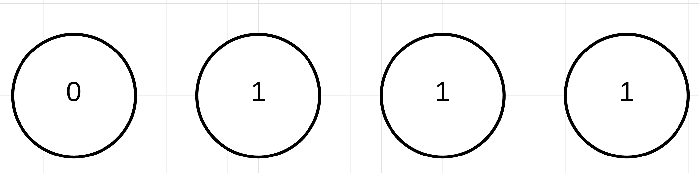**The example above is considered a three-in-a-row threat**

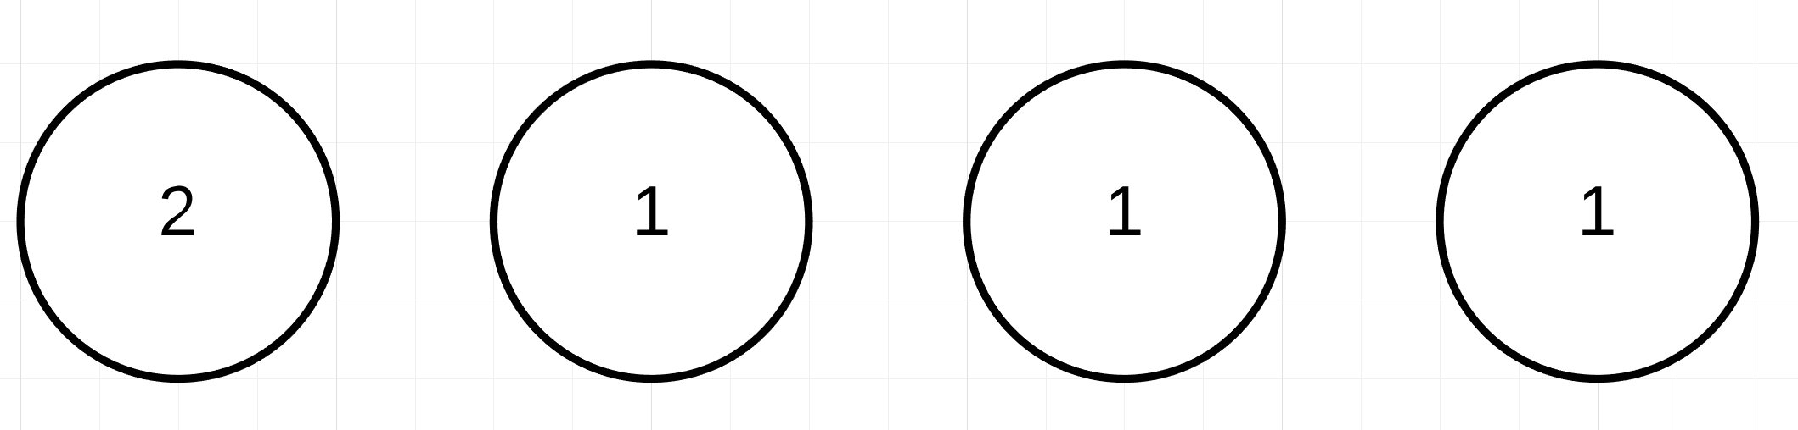

**The example above is not a threat (the ones blocked by the 2 and vise versa)**

The heuristic counted all the threats on the board and presented two values. The threats of the player and the threats of the opponent. The threat score was weighted by a function that would dramatically increase for each piece in a row. This would encourage pieces to be placed next to each other, while further encouraging multiple pieces being placed next to each other. Once all the threats were calculated, I performed this function (defense is a multiplier from 0.0 to 1.0 given by the class)

Total = threatPlayer – (threatOpponent * defense)

**Heuristic 2:**

|  |  |  |  |  |
| --- | --- | --- | --- | --- |
| 0 | 1 | 2 | 1 | 0 |
| 0 | 1 | 2 | 1 | 0 |
| 0 | 1 | 2 | 1 | 0 |

This heuristic was more creative. I noticed that pieces placed near the middle of the board opened up more opportunities than ones placed near the side. I developed a table to reference based on the board size. The worth of each slot increases towards the center.

Table Example

Whenever a threat is found, I reference this table at the location of the open spaces in the threat. I then create a multiplier from this number and one from a given value in the agent class. I then use this value to weight the worth of the threat.

**Testing:**

To test my agents I tested them against multiple random agents and slightly altered agents of my own. Since I gave two variables to affect the AI’s behavior, I was able to fine-tune them after each test. The two variables were the defensive multiplier (tendency to block the opponent) and the middle multiplier (tendency to place pieces towards the middle).

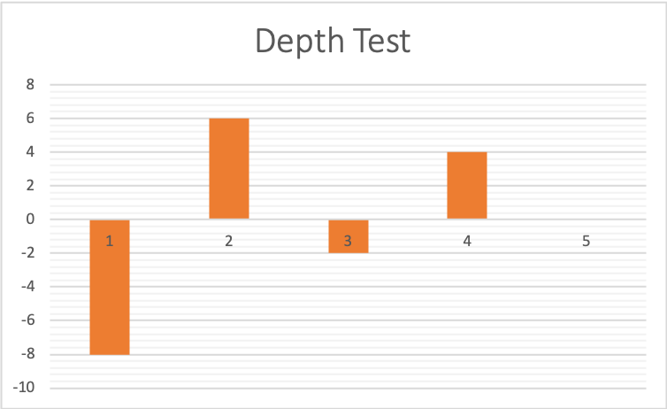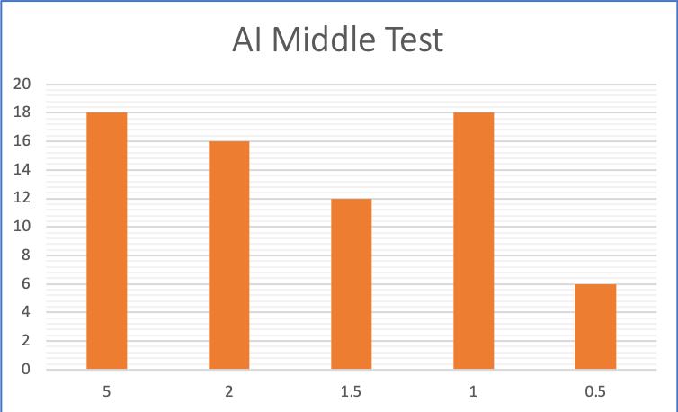

**Improvement:**

I wish I had more time to work on this assignment. There are a lot of things that I would have liked to try implementing, but getting the first heuristics to work was difficult. A heuristic that evaluates for win-win conditions would be the next thing I would add.