**Andrew Morrison**

**Intro to AI**

**Homework 4**



Variables: A (Alice), B (Bob), C (Charlie)

Initial Domain: [Salad, Pizza, Burger]

Constraints:

1. *Alice is a vegetarian:*
   1. A ∈ [Salad, Pizza]
2. *Charlie hates Italian food:*
   1. C ∈ [Salad, Burger]
3. *Alice, Bob, and Charlie never order the same food*
   1. A != B, B != C, A != C
4. *Bob always spends more on food than Charlie:*
   1. (B, C) ∈ [(Burger, Salad), (Burger, Pizza), (Pizza, Salad)]
5. Constraint graph:

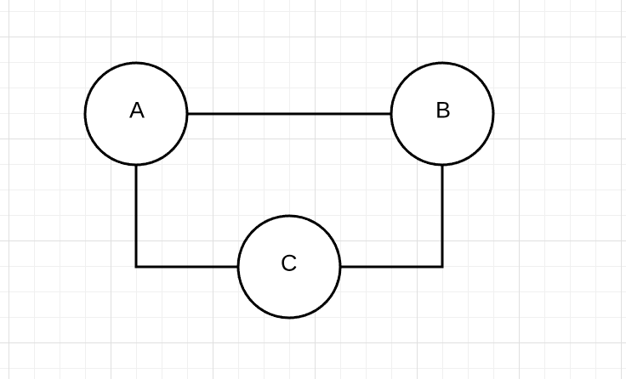

1. The variables are *not* arc consistent at first.
   1. Apply constraint one: A ∈ [Salad, Pizza]
   2. Apply constraint two: C ∈ [Salad, Burger]
   3. Apply constraint three: A != B, B != C, A != C
   4. Apply constraint four: (B, C) ∈ [(Burger, Salad)]

With the provided constraints, a solution can be found. Since Bob and Charlie must order a burger and salad respectively, Alice must order the Pizza.