DataMAX Software Group, Inc.

El Dorado Hills, CA 95762

USA



BUSINESS ANALYSIS WORKSHOP

RFgen Software Solutions

2019

|  |  |  |  |  |  |
| --- | --- | --- | --- | --- | --- |
| **Client Name** | <<COMPANY>> | | | | |
| **Transaction ID** |  | | | | |
| **Document Title** | BAW Specification | | | | |
| **Objective** | Specifications for <<COMPANY>> | | | | |
| **Platform** | <<ERP>> | | | | |
| **Author** |  | **Email** |  | **Phone** |  |
| **Submitted By** |  | **Email** |  | **Phone** |  |
| **Lead Developer** |  | **Email** |  | **Phone** |  |



|  |  |  |  |  |
| --- | --- | --- | --- | --- |
| **Revision ID** | **Date** | **User** | **Form/BAS** | **Description** |
| 001 | 01-01-17 | Your Name Here |  | Add description here |
|  |  |  |  |  |
|  |  |  |  |  |
|  |  |  |  |  |
|  |  |  |  |  |

TABLE OF CONTENTS

OVERVIEW OF REQUIREMENTS 3

GENERAL IMPLEMENTATION INFORMATION 3

INTEGRATION AND INFRASTRUCTURE FLOWCHART 4

APPLICATION OVERVIEW 5

HARDWARE INFORMATION 6

SETUP / ASSUMPTIONS 7

DETAILED APPLICATION SPECIFICATIONS 8

INVENTORY APPLICATIONS 8

Inventory Transfer 8

Business Scenario 8

Inventory Transfer (JDE:P4113) 8

Custom Requirements 8

Inventory Transfer (RFgen Prototype Layout) 9

Device Type Specifications 9

Inventory Transfer Flowchart 10

VALIDATION CASES **Error! Bookmark not defined.**

IMPLEMENTATION ESTIMATE 11

CUSTOMER APPROVAL 12

PROJECT SCOPE SUMMARY AND CLOSING COMMENTS 13

# OVERVIEW OF REQUIREMENTS

This specification document outlines the applications to be implemented by the RFgen Implementation Project. The information presented in this document has been collected through meetings and discussions between RFgen Software and <<Company Name>>.

The purpose of this document is to provide <<Company Name>> with a clear understanding of how the application workflows have been defined for their business environment. Essentially, this document seeks to define the gap between existing RFgen open source applications and the specific needs of the customer.

|  |  |  |  |
| --- | --- | --- | --- |
|  |  |  |  |

# GENERAL IMPLEMENTATION INFORMATION

<<Company Name>> is undergoing an upgrade of their JD Edwards system. At the time of the creation of this BAW document, the planned go-live date of the upgrade is December 1, 2014. The goal of the RFgen project is to enhance the operations by implementing Advanced Data Collection (ADC) in Receiving, Inventory, Manufacturing, and Shipping for improved inventory accuracy and visibility.

<<Company Name>> is a world leader in vehicle safety systems, providing a wide range of components for original equipment manufacturers and the vehicle aftermarket.

There are five separate facilities that will use RFgen:

* <<Company Name>> Headquarters - Madison, IN USA
* <<Company Name>> Mexico - Monterey Mexico
* <<Company Name>> Electronics - Waterloo Canada
* <<Company Name>> Canada - Toronto Canada
* <<Company Name>> Europe - Niederwinkling Germany

<<Company Name>> does not currently use lot control. However, they plan to move in that direction. At that time, the standard RFgen applications for JD Edwards will support lot control.

<<Company Name>> will use RFgen License Plating for their outbound pick/pack/ship operations. They will also use the RFgen Warehouse Director to direct put away and replenishment activities in warehouses wherever JD Edwards Advanced Warehouse Management is not used. Currently, the only location that uses AWM is Madison.

GENERAL IMPLEMENTATION INFORMATION (continued)

<<Company Name>> Industries will utilize the direct connect method between RFgen and JD Edwards. This method provides real-time data collection with instantaneous results in JD Edwards. It does not provide for 24x7 operations via RFgen High Availability.

# INTEGRATION AND INFRASTRUCTURE FLOWCHART

**LAN**

**CUSTOMER**

**RFGEN**

**TRANSACTION**

**MANAGER**

**LOFTWARE**

**LABEL**

**MANAGEMENT**

**SERVER**

**RFGEN**

**CUSTOMER**

**ERP SYSTEM**

**SAP BAPI**

**-or-**

**JDE BSNF**

**-or-**

**???**

**RF NETWORK**

# APPLICATION OVERVIEW

As result of the Business Analysis Workshop conducted on <<date>>, the following applications will be implemented at <<Company Name>>:

|  |  |
| --- | --- |
| APPLICATION DESCRIPTION |  |

Phase 1

|  |
| --- |
| Inventory |
| IM – Inventory Transfer |
| IM – Inventory Transfer with Location Verify |
| IM – Inventory Issue |
| Inbound |
| PO – PO Receipt by Item |
| PO – PO Receipt by Line |
| PO – Receiving Discrepancies |
|  |
|  |

# HARDWARE INFORMATION

Please select those options applicable, and/or provide additional comments regarding hardware requirements. Check all that apply:

Comments:

OS Preference:  Android  iOS  Windows (Mobile/CE)  No Preference

Device Type:  Handheld  Tablet  VMU

Connectivity type required:  WiFi  Cellular  Offline

Special Considerations: Intrinsically Safe  Severe Temps  Other (comment below)

Camera Required:  Yes  No

2D Barcode ability:  Yes  No

Label printers needed:  Yes  No

# SETUP / ASSUMPTIONS

The following setups need to be considered during design:

* RFgen users will be created for each <<ERP>> system user and the employee ID will be assigned to the user profile. We will be using <<ERP>> credentials for login.
* Each RFgen user will be assigned to a default warehouse in the user setup and this can be changed by the RFgen admin.

# DETAILED APPLICATION SPECIFICATIONS

The following section outlines detailed specifications for each of the applications <<Company Name>> will be implementing.

# INVENTORY APPLICATIONS

## Inventory Transfer

Business Scenario

<<Company Name>> will move non-license plated inventory between warehouse locations. The standard inventory transfer will be used to execute this movement in JD Edwards.

Inventory Transfer (JDE:P4113)

REPLACE SCREEN SHOT WITH NEW THEME FROM JUDIE

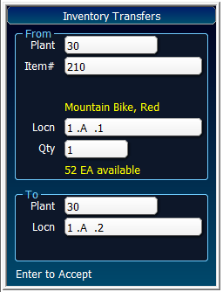

This application transfers inventory from a warehouse to another warehouse or from one location to another location within a warehouse. An Inventory Transfer record is recorded and the Item Ledger (Cardex) is updated in JD Edwards EnterpriseOne.

Custom Requirements

* Only allow transfers to a primary location if the item/location relationship exists.

Inventory Transfer (RFgen Prototype Layout)

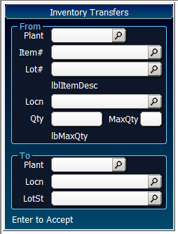

Plant defaults from user account

Enter/Scan the item number

Enter/Scan the lot number (if lot control is enabled)

Displays the item description

Enter/Scan the FROM location

Displays the maximum available quantity (depends on the JDE version settings)

Enter the quantity to transfer.

Enter/Scan the TO Plant

Enter/Scan the TO location

Enter the lot status (if lot control and P/O is enabled)

Enter to post transaction to JDE.

Device Type Specifications

* Device Type

INVENTORY APPLICATIONS (continued)

### Inventory Transfer Flowchart

REPLACE FLOWCHART WITH NEW STYLE FROM JUDIE LEW

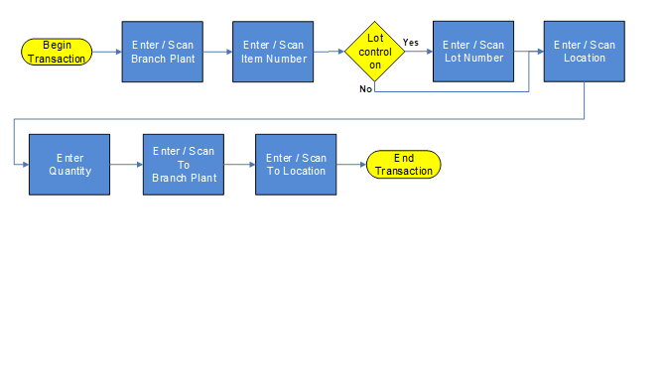

# IMPLEMENTATION ESTIMATE

This estimated effort is an estimate based on the understanding of the business requirements at the time of the creation of this BAW document. It is an estimate and is not intended to be a fixed or a “do not exceed” quote.

|  |  |  |
| --- | --- | --- |
| APPLICATION DESCRIPTION | SALES QUOTE (DAYS) | BAW ESTIMATE (DAYS) |
| Phase 1 | | |
| Inventory |  |  |
| IM – Inventory Transfer |  |  |
| IM – Inventory Transfer with Location Verify |  |  |
| IM – Inventory Issue |  |  |
| Inbound |  |  |
| PO – PO Receipt by Item |  |  |
| PO – PO Receipt by Line |  |  |
| PO – Receiving Discrepancies |  |  |
|  |  |  |
|  |  |  |
|  |  |  |
|  |  |  |
|  |  |  |
|  |  |  |
|  |  |  |
| Installation, Setup, UAT |  |  |
| Estimated Days Total |  |  |
| Day Rate | | $1,480.00 |
| SUBTOTAL | | $0.00 |
|  | | |
| PROJECT MANAGEMENT | | |
| Project Management (15%) | | $0.00 |
| SUBTOTAL | | $0.00 |
|  | **TOTAL** | $0.00 |

# CUSTOMER APPROVAL

By signing this document, both parties agree that the specifications detailed in this section constitutes the work to be delivered to client as part of its' existing “Professional Services Agreement” with RFgen Software, A Division of the DataMAX Software Group, Inc.

All hours provided are best estimates based on the information provided by the customer during the design of this change control. Additions and/or changes to this specification will require a change order signed by both parties.

This quote is good through ## Month 2019.

Client: <<Company Name>>

(Signature of Authorized Representative)

Print Name

Title

Date

Approved PO Number

Date

RFgen Software

A Division of the DataMAX Software Group, Inc.

(Signature of Authorized Representative)

Print Name

Title

# PROJECT SCOPE SUMMARY AND CLOSING COMMENTS

RFgen delivers mobility on-time and on-budget. Project durations are measured in days and weeks, not months and years. Our implementation consultants have years of industry experience as well as a deep understanding of your <<ERP>> system. Using this experience and the RFgen mobility solution we can certainly improve your business processes. <<Company Name>> can rest assured that they are partnering with a company that has a proven track record of providing the best mobile platform available on the market today.

RFgen is committed to delivering the best solution for your requirements. With a growing base of customers through 30+ years of experience, we are 100% committed to serving the needs of <<Company Name>> today and in the future.

As your RFgen implementation consultant, I want to thank you for the opportunity to present this information. If you have any questions or if there is anything we can do to earn your business, please do not hesitate to contact me at 916-939-4065 x000 or via email at [xxx@rfgen.com](mailto:xxx@rfgen.com).

Sincerely,

[Add an image of your signature]

<<Author>>

RFgen Software

<<Author Phone>>

<<Author Email>>



1101 Investment Blvd, Suite 250

El Dorado Hills, CA 95762

(888) 426-2286

www.rfgen.com

**Statement of confidently** © 2019 RFgen Software. A division of DataMAX Software Group, Inc. All Rights Reserved. All other product, brand, and company name and logos are trademarks or registered trademarks of their respective owners.