# 

# RFGEN RECOMMENDATIONS

## Server Recommendations

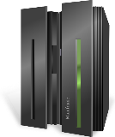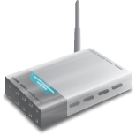

**Wi-Fi**

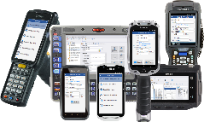

**Mobile Devices**

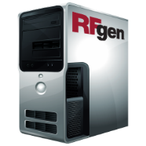

**RFgen**

**Enterprise**

**Server**

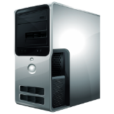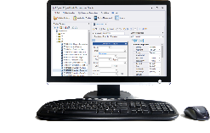

**Desktop PC**

**Additional Production/**

**Load Balancing Server**

**(optional)**



**Memory**

* The RFgen server will use up to 15 megabytes of memory.
* Each active client will use up to 10 megabytes of memory.
* Each active database connection will use up to 10 megabytes of memory.
* Each active Screen Mapping connection will use up to 25 megabytes of memory.
* Each active JD Edwards connection will use up to 100 megabytes of memory.

**Supported Operating Systems**

* Windows Server 2008, Windows Server 2012, Windows Server 2016, Windows 7, Windows 8 and Windows 10.
* VMware Server: configure to use just one CPU. From experience, RFgen and JD Edwards work faster and more reliable on one CPU.

**CPU**

* 2 GHz or better, Intel or AMD chip.

**Hard Drive**

* An RFgen installation can use up to 500 megabytes of hard drive space depending on how many options are installed.
* If the server stores any additional data, then consider space for it.

**Other**

* RFgen recommends the purchase of an RFgen Development/Test Server. This server is not for production, but for application development and testing purposes only. The configuration of the Development/Test Server will follow the same configuration as above.