|  |
| --- |
| **RFgen Mobile Foundations for**  **Oracle’s JD Edwards World**  **Mobile Data Collection Software Solutions**  **Proposal** |

**Prepared for:**

|  |
| --- |
| **Company Name** |

**Represented by:**

<<Contact Name>>

<<Title>>

**Prepared by:**

<<Sales Reps Name>>

Regional Sales Manager

RFgen Software

|  |  |
| --- | --- |
| Proposal Revision | 001 |
| Proposal Created | Month 00, 2014 |
| Proposal Expiration | Month 00, 2014 |

1101 Investment Blvd., Suite 250

El Dorado Hills, CA 95762

<<Sales Reps Phone>>

<<Sales Reps Email>>

**TABLE OF CONTENTS**

1 EXECUTIVE SUMMARY 3

2 ABOUT RFGEN SOFTWARE 5

3 RFGEN MOBILE FOUNDATIONS FOR ORACLE’S JD EDWARDS OVERVIEW 6

4 HOW RFGEN INTEGRATES WITH JD EDWARDS WORLD 7

5 SERVER RECOMMENDATIONS 11

6 THE THREE COMPONENTS OF THE RFGEN MOBILE FRAMEWORK 12

7 RFGEN SOFTWARE MAINTENANCE PLAN 14

8 RFGEN SERVICES 15

9 ENTERPRISE LABELING SOFTWARE OPTIONS 17

10 HARDWARE AND DEVICE RECOMMENDATIONS 17

11 RFGEN IMPLEMENTATION METHODOLOGY 18

12 IMPLEMENTATION TIMELINE 19

13 INVESTMENT SUMMARY 20

14 APPENDIX A⎯RFGEN IMPLEMENTATION METHODOLOGY DETAILS 22

15 APPENDIX B⎯SCOPE CHANGE MANAGEMENT 26

16 APPENDIX C⎯RFGEN ARCHITECTURE OVERVIEW 28

17 APPENDIX D⎯JD EDWARDS INTEGRATION VALIDATION CERTIFICATE 32

# EXECUTIVE SUMMARY

The following proposal, specifically prepared for <<COMPANY NAME>>, outlines RFgen Software’s recommendations for the development and implementation of a mobile data collection software solution that seamlessly integrates with <<COMPANY NAME>>’s JD Edwards World system.

**<<COMPANY NAME>>’s Business Challenge**

* Establish the need or the problem
* Why is the company looking for a solution?
* What are the pain points?
* What is this problem costing the business?
* Any other pertinent info gathered during discover that conveys we understand the problem

**Goals and Objectives**

* List the company’s goals and objectives

**Ideal Situation/Recommended Solution**

Give a firm clear recommendation. Be brief though and explain more details are in the proposal.

**Expected Results (or ROI)**

Provide substantiation, expected ROI if you can calculate it, expected performance metrics (e.g. 99.9% accuracy, etc.)

**Investment and Timeframe**

Give a brief one paragraph overview of the timeframe for implementation, high-level investment requirements.

**Total Cost of Ownership**

Not only is RFgen an affordably priced comprehensive mobile data collection system that can help <<COMPANY NAME>> increase productivity, gain efficiency and reduce operating costs, it also provides the following TCO benefits:

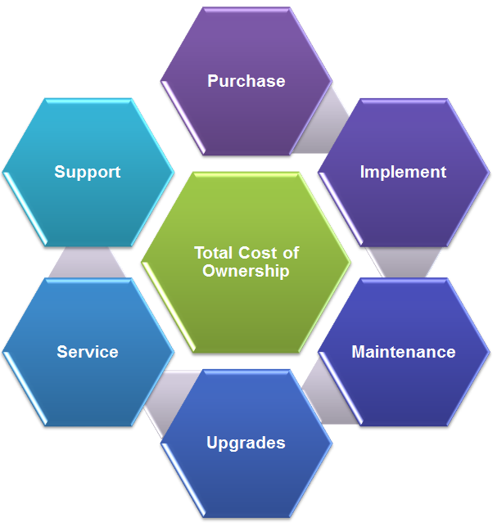

* RFgen is designed for rapid and cost-effective implementation taking in some cases weeks where other solutions may take months and many professional services hours to deploy.
* The system is easy to learn and use with training taking just 2-3 days.
* The RFgen Mobile Development Studio allows your internal IT staff to modify and create new applications in-house, expediting deployment time and saving you thousands of dollars in professional services fees.
* RFgen is version independent and does not install on your JD Edwards server or modify your environment, saving you time and money when it's time to upgrade your JD Edwards system.
* An active RFgen Software Maintenance Plan provides long-term investment protection and includes software upgrades, technical support and services for as long as you own the solution.

All this adds up to <<COMPANY NAME>> realizing the financial benefit of a complete automated data collection solution with a low total cost of ownership.

# ABOUT RFGEN SOFTWARE

RFgen Software, a division of the DataMAX Software Group, Inc., is an industry leading mobile data collection software firm that helps organizations reduce supply chain implementation costs and increase accuracy and efficiency with the industry’s most reliable and flexible wireless and mobile automated data collection software and open source mobile computing solutions.

In business since 1983, RFgen is known for its solid, high-quality products and high customer satisfaction ratings among its more than 2,800 customers. With a global reach and local touch, RFgen and its network of 140 certified solution partners can service and support <<COMPANY NAME>> no matter where its operations are located around the world.

**Why RFgen Software?**

* **Provides you with a suite of pre-written, pre-tested mobile applications and integration expertise for JD Edwards**, as well as other ERP systems, databases, and Web services.
* **Empowers you with the flexibility you need now and in the future.**
  + You can customize device screens using control image themes.
  + You have unlimited connectivity to any ERP system, screen mapping, OLEDB/ODBC database, and Web services.
  + You can scale to thousands of users.

*“Choose a mobile solution that is flexible. That is probably the most important thing. Something that you can use to modify, expand and improve your operations."*

Jim Kruse

Board Secretary & Controller

Blue Bell Creameries

* + You have unlimited connectivity to Windows, Android and iOS based devices (barcode scanners, smart phones, tablets, handheld computers, voice devices, RFID, printers, scales, carousels, vehicle mounts, and more.)
  + You can automate your entire operation:
    - Receiving, inventory movement, manufacturing and shipping.
    - Field services, fixed assets, 3PLs, yards, freezers, and more, where wireless coverage is limited.
    - Remote or off-shore locations in regions with limited or no wireless coverage.
* **Voice-enables your warehouse.** RFgen is a Vocollect-certified partner providing Oracle-validated voice recognition technology connectivity to JD Edwards. This is unique to RFgen.
* **Makes mobile app development easy,** dramatically reducing implementation timeframes. RFgen is based on Open Source standards. RFgen includes a full development studio that makes customizing RFgen mobile apps easy and cost-effective.
* **Enables your IT staff to modify or create new mobile apps in-house, saving you time and money in the long run.** RFgen is a mobile application development platform (MADP). If you desire vendor independence, the RFgen MADP platform enables your in-house IT staff to quickly and easily create custom mobile apps that are tailored to your specific needs. With RFgen, not only can your IT staff develop their own mobile apps code, but once developed, your company owns the "code" and at no time does it become the property of RFgen. No other mobile data collection software vendor can make this claim.

# RFGEN MOBILE FOUNDATIONS FOR ORACLE’S JD EDWARDS OVERVIEW

To achieve <<COMPANY NAME>>’s goals and objectives, RFgen recommends the implementation of the RFgen Mobile Foundations for Oracle’s JD Edwards World solution. This solution includes a suite of pre-written, Oracle-validated mobile applications that feature real-time, bi-directional information exchange with JD Edwards.

RFgen's JD Edwards enterprise mobility solution supports real-time voice integration, wireless barcoding, and mobile applications. This mobile data collection solution can be easily and quickly adapted to <<COMPANY NAME>>'s unique workflows and will help <<COMPANY NAME>>:

* **Drive greater efficiency** with faster, automated transactions for inventory, discrete manufacturing, plant maintenance and more.
* **Increase worker productivity and reduce errors** by eliminating the need to re-key data with real-time information exchange between barcode scanners, wireless tablets, mobile devices, and voice-data collection devices and your JD Edwards system.
* **Go hands-free and eyes-free** in your warehouse with RFgen-Vocollect Voice Solutions and boost productivity up to an additional 25% or more.
* **Automate remote warehouses and field operations** with support for roaming or occasionally-connected data collection using on-demand cellular/Wi-Fi connectivity to JD Edwards. RFgen also supports fully disconnected batch scenarios where data is pre-loaded on the device, remote activities are locally validated, and transactions are exchanged with JD Edwards periodically.
* **Maintain data integrity** between the mobile device and server to prevent user errors when in an always-connected environment using RFgen's guaranteed packet delivery protocol.

**Validated Integration with JD Edwards World**

* **Validated connectivity—**RFgen integration is validated by Oracle for JD Edwards World versions A7.3 to A9.3 (see Appendix E).
* **Version independent**—RFgen is version independent and does not install on your JD Edwards server or modify your environment, so there's no hassle when it's time to upgrade.
* **Flexible developer productivity tools**—the integrated development environment enables <<COMPANY NAME>>’s internal IT staff to rapidly customize and create new workflows, saving both time and money. For example, workflows only need to be created once using a drag and drop form designer, after that they can be quickly and easily configured with endless variations of language and screen sizes.
* **Easy to support**—RFgen administration tools enable your IT and helpdesk teams to shadow users and see their screens in the console. You can also take control remotely and show users exactly how to perform a task.
* **Rapid ROI**—RFgen deploys rapidly (usually twice as quickly as other systems), is considerably less expensive to maintain than other systems and is easy to learn to use, delivering <<COMPANY NAME>> a proven ROI.

# HOW RFGEN INTEGRATES WITH JD EDWARDS WORLD

RFgen has built-in integration capabilities that have been validated by Oracle to work with <<COMPANY NAME>>’s JD Edwards World system. RFgen’s JD Edwards Open Source Mobile Application Suite integrates within JD Edwards supply chain processes.

Internally, JD Edwards contains Business Functions that encapsulate the business rules. With RFgen, JD Edwards users can discover, manage, integrate, and actually embed business functions directly into their data collection processing flows forming an ‘intuitive software environment’ that provides the lowest total cost of ownership available for data collection systems in a supply chain environment.

**RFgen-JD Edwards Integration Diagram**

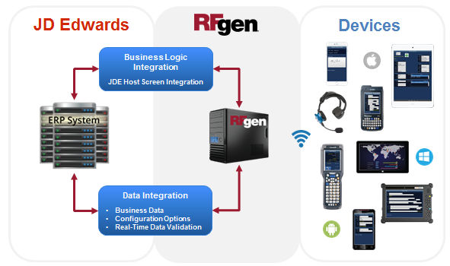

**RFgen Integration vs Other Vendors Integration for JD Edwards World**

RFgen is a leader in the JD Edwards World automated data collection solutions market. RFgen uses Oracle-validated JD Edwards connector technology combined with screen mapping technology to create the premier solution for JD Edwards World users.

RFgen can provide you with a license plating and/or directed inventory movements solution, easily add a voice picking solution, create a 24/7 high-availability environment, or make any process you have in your JD Edwards system mobile. All of this can be accomplished without having to stress the back-end database (AS/400) with too many connections, modify RPG code, or install anything on your JD Edwards system server. This keeps your barcoding and automation solution upgrade and enhancement ready without sacrificing performance. In fact, this integration method is show to be the most effective method for automated data collection into JD Edwards World.

Below you’ll find some of the key benefits of RFgen that you won’t find with other vendor’s solutions:

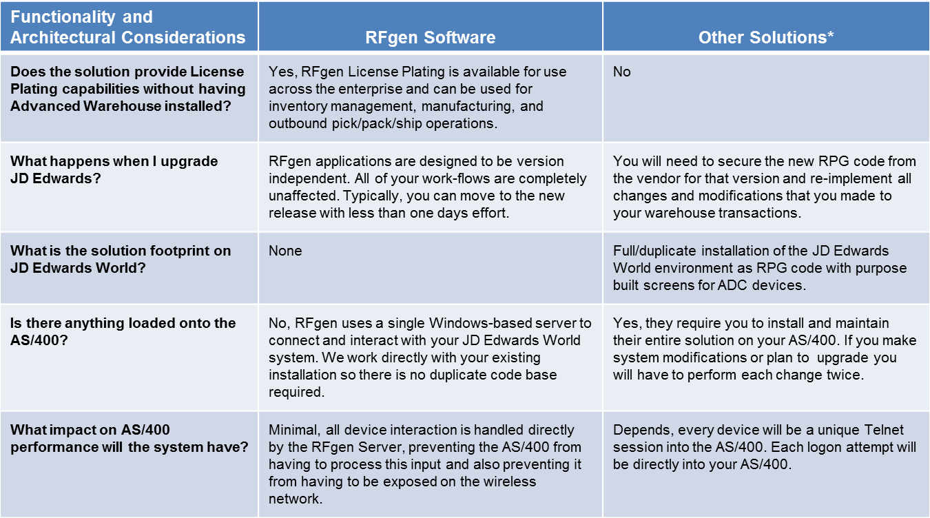

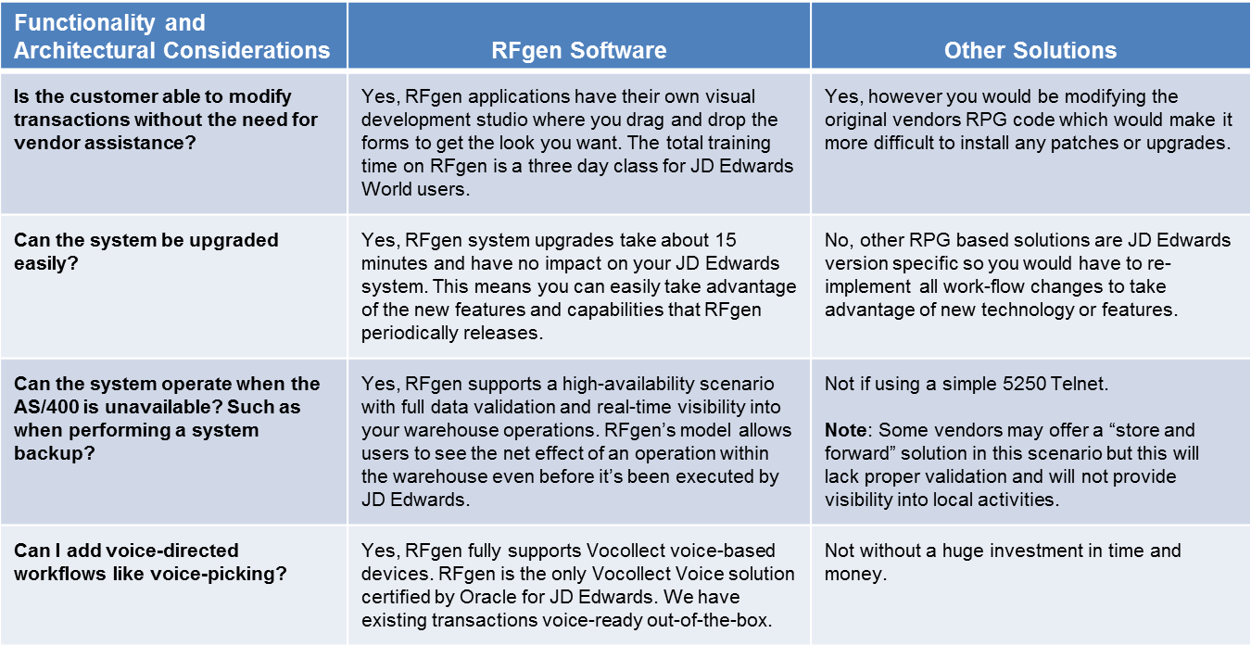

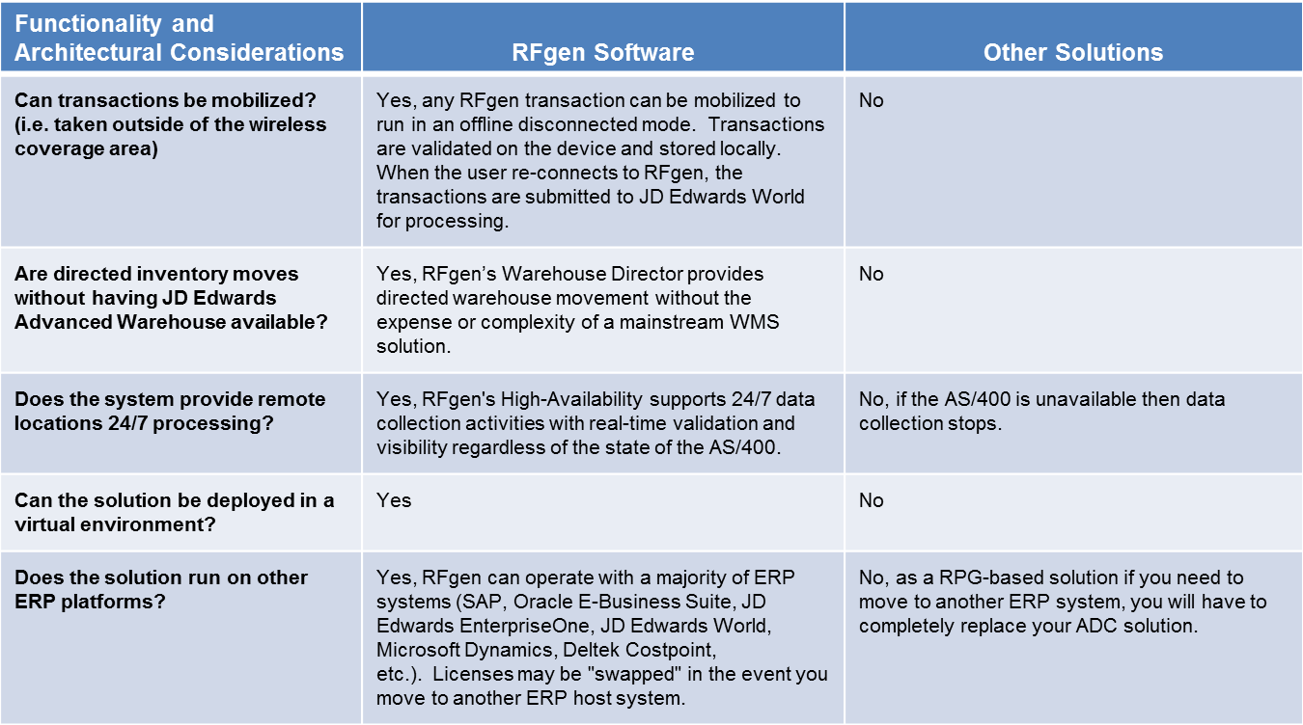

**Upgrading Your JD Edwards System**

Eventually, <<COMPANY NAME>> will upgrade to a new JD Edwards version. RFgen is version independent and does not install on your JD Edwards server or modify your environment, making upgrading JD Edwards fast and easy. As long as <<COMPANY NAME>> has an active RFgen Software Maintenance Plan, there is no RFgen upgrade fee required. There may be configuration changes in the RFgen JD Edwards Open Source Mobile Application Suite to accommodate a JD Edwards upgrade.. RFgen is validated by Oracle for JD Edwards World versions A7.3 to A9.3 (see Appendix E).

# SERVER RECOMMENDATIONS

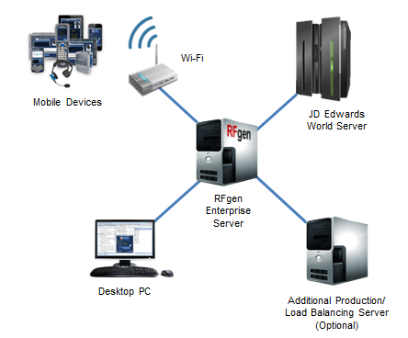

* **Memory**
  + The RFgen server will use up to 15 megabytes of memory.
  + Each active client will use up to 10 megabytes of memory.
  + Each active database connection will use up to 10 megabytes of memory.
  + Each active Screen Mapping connection will use up to 25 megabytes of memory.
  + Each active JD Edwards connection will use up to 100 megabytes of memory.
* **Supported Operating Systems**
  + Windows Server 2008, Windows Server 2012, Windows Server 2016, Windows 7, Windows 8 and Windows 10.
  + VMware Server: configure to use just one CPU. From experience, RFgen and JD Edwards work faster and more reliable on one CPU.
* **CPU**
  + 2 GHz or better, Intel or AMD chip.
* **Hard Drive**
  + An RFgen installation can use up to 500 megabytes of hard drive space depending on how many options are installed.
  + If the server stores any additional data, then consider space for it.
* **Other**

RFgen recommends the purchase of an RFgen Development/Test Server. This server is not for production, but for application development and testing purposes only. The configuration of the Development/Test Server will follow the same configuration as above.

# THE THREE COMPONENTS OF THE RFGEN MOBILE FRAMEWORK

The RFgen Mobile Framework is designed to maximize the productivity of <<COMPANY NAME>>’s development staff, as well as simplify management and support tasks after deployment. In fact, RFgen is so easy to use that many customers decide to take in-house ownership of the solution and realize significant savings over time. The RFgen Mobile Framework includes the following:

**1. Built-In Runtime Environment**

Unlike other mobile data collection software providers, RFgen is a single-source turnkey application that eliminates the need to purchase additional third-party products, thus saving you time and money. The RFgen Runtime Environment includes the following:

* **RFgen Mobile Framework Services** manage all of the communications required between devices and JD Edwards in a manner that provides guaranteed delivery of information. RFgen acts as a gateway for all client requests working on their behalf to serve real-time, on-demand information as well as managing the processing of remote transactions into JD Edwards.
* **Mobile Enterprise Dashboard** is an easy-to-use administration interface that allows your IT staff to actively track all operations occurring within the mobile and wireless environment. Using the dashboard, any RFgen mobile session can be viewed or modified in an interactive mode allowing IT personnel to see what's occurring on the device in real-time and to remotely support or train the user.
* **Built-in Network Device Management** allows administrators to quickly query which devices are on their networks as well as to query data on the devices and even push new data or updates to the devices. Additionally, RFgen supports a two-way mirror of the user's session allowing support personnel to quickly and easily respond to device issues in the field.

**2. Mobile Application Development Platform**

The RFgen Mobile Development Studio is an integrated mobile application development platform that enables developers to rapidly create and maintain mobile application solutions for Windows, Android and iOS based devices. With RFgen, <<COMPANY NAME>>’s developers can easily connect to their existing system(s) and quickly design, test and deploy mobile enabled applications.

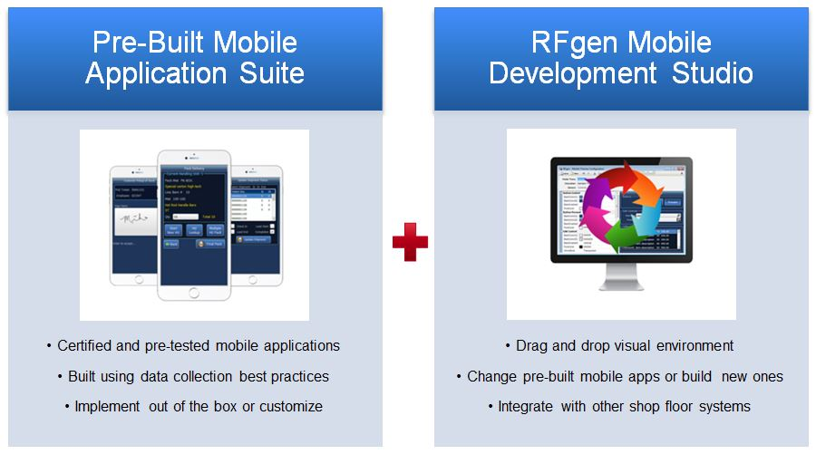

RFgen supports the ability to "paint" the user interface for each application in multiple styles to fit different device display themes and sizes. Additionally, each prompt can be defined in multiple languages which will activate based upon the workers profile while the underlying code base remains the same—this allows developers to maintain a single set of business rules.

**3. JD Edwards Open Source Mobile Application Suite**

RFgen Mobile Foundations for Oracle’s JD Edwards World includes a package of Oracle-validated, ready-to-use mobile applications. In addition, the flexibility and ease-of-use of the RFgen mobile application development platform enables <<COMPANY NAME>>’s internal IT staff to easily modify these applications or create new ones on an in-house basis⎯saving <<COMPANY NAME>> both time and money.

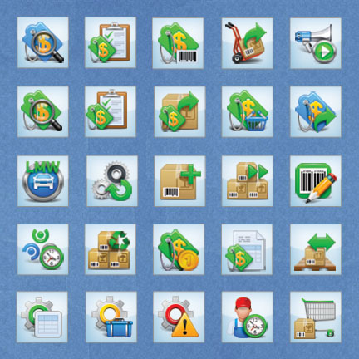

To get you up and running fast, RFgen has dozens of out-of-the-box pre-written and pre-tested mobile apps for JD Edwards, including:

* Equipment and Plant Maintenance
* Fixed Assets
* HR
* Inventory Management
* Kanban
* License Plating
* Manufacturing
* Purchase Order Processing
* Sales Order Processing
* Warehouse Management
* And More

# RFGEN SOFTWARE MAINTENANCE PLAN

An RFgen Software Maintenance Plan complements your RFgen software purchase. It includes both product upgrades and technical support, and helps to guarantee successful software deployments and stable production environments. With an RFgen Software Maintenance Plan, you get complete access to the latest RFgen product versions, technology enhancements and enterprise mobile application releases.

With an active plan <<COMPANY NAME>> can upgrade to new releases and new versions as the needs of your business dictate. Our technical support experts are here to help keep your users up and running wherever they’re working in the world. This is our way of making sure you’re covered with the technical support you need, and it’s your way of getting an increased return on your RFgen investment.

**The RFgen Software Maintenance Plan Includes**

* On-call technical support from skilled and experienced product specialists.
* 24/7 priority support for mission critical cases.
* Unlimited access to RFgen’s self-service customer support portal(s) and knowledgebase.
* Access to the latest version, product upgrades, enhancements and new capabilities.
* Advance and exclusive notification of software promotions, when offered.
* Access to hundreds of Validated, enterprise-ready mobile apps.
* A no cost system health check and upgrade assistance.

Activated at the time of purchase, RFgen Software Maintenance Plans are renewable annual plans. All RFgen product purchases require the purchase of an RFgen Software Maintenance Plan for the first year and can be renewed on a single or multi-year plan basis. Choosing to renew on a multi-year plan basis can save you time and money as RFgen offers discounts on multi-year plans as they reduce paperwork and simplify operational budgeting.

# RFGEN SERVICES

RFgen has a proven method for the successful installation and deployment of RFgen. The implementation methodology has been developed over years using the experiences gathered from hundreds of implementations. The following outlines RFgen’s recommended services for the successful installation of RFgen at <<COMPANY NAME>>.

**RFgen Professional Services**

An expedited and successful installation of your RFgen software solution means a rapid ROI for <<COMPANY NAME>>. To accomplish this, the RFgen Professional Services team will work closely with <<COMPANY NAME>>’s internal team as follows:

* **RFgen Professional Services Resource Allocation**

For the <<COMPANY NAME>> project, RFgen will dedicate a JD Edwards development team and an RFgen Project Manager. There will be a minimum of one Senior ERP Consultant and a backup Consultant assigned to the project. Consultants will bring in additional JD Edwards-specific team members to assist with the project as needed. The RFgen Project Manager will:

* + Facilitate communication between all parties
  + Track project timelines, open tasks, completed tasks, etc.
  + Report project status to <<COMPANY NAME>> and RFgen management
  + Keep the project on schedule and on budget

The estimated number of hours for professional services can be found in the investment summary.

* **<<COMPANY NAME>> Resource Requirements**

To effectively complete the RFgen installation, the RFgen Project Manager and Consultant(s) will require participation from the following <<COMPANY NAME>> resources:

* + Project manager (primary RFgen contact)
  + Operational/Subject matter expert (SME)
  + Network administrator
  + JD Edwards technical expert
  + System testers

**RFgen Training Services**

To ensure maximum return on your software investment, RFgen will provide designated <<COMPANY NAME>> employees with the necessary training they need to successfully manage <<COMPANY NAME>>’s RFgen solution. The RFgen Total Knowledge Transfer Training Program is composed of two courses:

* **Introduction to RFgen Functional Training Course**

This course provides RFgen basic system concepts, functionalities, and components. This course provides the fundamental skills new users need to begin navigating the system.

* **RFgen Technical Training Course**

*(Prerequisite: Introduction to RFgen Functional Training Course)*

This course is for new and experienced developers and technical administrators who are responsible for installing, customizing, upgrading and maintaining <<COMPANY NAME>>’s RFgen solution.

Because we know our customers have different training needs, we offer two training program formats—classroom and web-based. For <<COMPANY NAME>>, RFgen recommends the following training program format.

* **RFgen Total Knowledge Transfer Classroom Training**

This intensive two to three day classroom training program can be conducted at an RFgen office or <<COMPANY NAME>>’s location. Students will enjoy face-to-face interaction with an RFgen instructor, as well as complete hands-on exercises to help them master concepts and pick up insider shortcuts.

Deliverables include:

* + Classroom training at an RFgen office or <<COMPANY NAME>>’s location
  + Two to three days of instruction
  + Training for up to two students
  + Training materials

Note: Students are expected to bring their own laptop for a full training experience. The cost for adding more students is additional. Travel expenses are additional.

* **Web-Based Training**

RFgen’s Web-Based Training combines the benefits of live instruction with the convenience and affordability of online education. With this course, students will meet with an RFgen instructor online at a specified date and time to attend class. There are three two-hour training modules that are included in the Web-Based Training curriculum. This training may be split into multiple days, if required. The total training time varies based on the Q&A sessions, but generally requires six to eight hours in total to complete.

Deliverables include:

* + Online training via WebEx
  + Three two-hour training modules
  + Training for one to two students
  + Training materials

# ENTERPRISE LABELING SOFTWARE OPTIONS

RFgen has built-in integration to all of the major enterprise labeling software solutions on the market and can provide a connection to these applications enabling your users to generate the desired barcode label design formats they need for various functions. This means, you can research and select the enterprise labeling solution that best suits your needs and RFgen can easily integrate with your chosen solution.

**RFgen is a Loftware Enterprise Labeling Solutions Reseller**

[Loftware, Inc.](http://www.loftware.com/) is a global market leader in Enterprise Labeling Solutions with more than 5,000 customers in over 100 countries. Because of Loftware’s company and product strengths, RFgen exclusively resells Loftware solutions and if desired can provide you with a separate quote for a Loftware enterprise labeling solution for your needs. Think of RFgen and your total solution provider.

# HARDWARE AND DEVICE RECOMMENDATIONS

As your single-source mobile computing solutions provider, RFgen not only delivers the most reliable and flexible mobile data collection software and services on the market today, but we can also provide <<COMPANY NAME>> with the mobile technology, hardware and devices you need to automate your entire operation. This single source approach provides a single point of contact for your entire data collection and mobility solution.

RFgen has strategic partner relationships with the industry’s leading mobile computing technology providers and can provide you with the right hardware and mobile devices for your specific requirements, including mobile computers, barcode scanners, voice technology, RFID, printers and media and networking.

RFgen recommends the following hardware and devices for <<COMPANY NAME>>:

* Product
* Product
* Product

A <<VENDOR NAME>> data sheet for <<PRODUCT NAME>> will be provided separately.

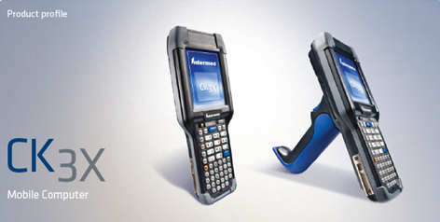

# RFGEN IMPLEMENTATION METHODOLOGY

RFgen’s implementation methodology is a repeatable approach to mobile data collection software implementation. This approach helps to mitigate risks associated with any software installation.

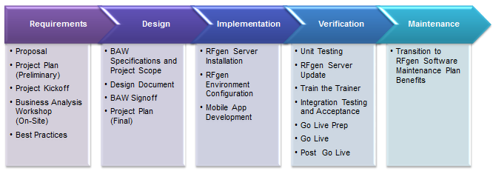

(Note: See Appendix A for additional details of each implementation step.)

Our software development approach is driven by an integrated methodology offering well established project management and technical delivery methods. These proven methods provide the framework for managing the RFgen project team and helping to keep the project on track. RFgen’s project management methods address key management concerns and are designed to provide the following high quality deliverables:

* Scope and change management
* Project planning
* Risk mitigation
* Deliverables management
* Configuration management
* Issues and actions
* Quality control
* Communication

**Business Analysis Workshop (BAW)**

Specific to RFgen implementations is the Business Analysis Workshop (BAW). This is the first step of any RFgen software implementation. This is an on-site event where the RFgen JD Edwards consultant/s comes to your facility, tours your operations, and meets with business stakeholders. The RFgen JD Edwards consultant/s will do a complete needs analysis and will examine the RFgen JD Edwards suite of mobile applications as they exist today and determine how the applications need to be modified to meet your specific requirements (as-is versus to-be). A virtual WebEx version of this workshop is also available when needed.

Following the stakeholder meetings, your RFgen consultant/s will document any mobile application additions and/or modifications that need to be developed and will discuss any unique requirements. At the end of this engagement, the RFgen consultant/s will put together a complete and detailed scope of work document that outlines your entire mobile data collection solution. The BAW is the single most important factor for a successful data collection solution implementation.

**Technical Methodology**

In addition to the BAW, RFgen’s implementation methodology employs a technical methodology to engineering quality solutions and provides a flexible project approach that utilizes proven development methods and processes for building customer application solutions. Specifically it:

* Is focused on project output and the RFgen project team will work to fine tune the solution to meet your specific requirements.
* Helps provide a basis that is designed to reduce classic development mistakes such as insufficient planning and/or risk management, scope creep, failure under pressure, and a lack of management controls.
* Is adaptable to project phases, enabling discipline to be applied even when joining a project mid-phase.
* Provides a positive basis for project management, sound estimation techniques, repeatability and the leveraged reuse of project outputs.

# IMPLEMENTATION TIMELINE

Based on our current understanding of <<COMPNY NAME>>’s requirements, we project a complete implementation to take XX weeks. We will be able to furnish a more accurate timeline once we have jointly completed a Business Analysis Workshop (BAW), explained in more detail in Appendix A-RFgen Implementation Methodology Details.

Should <<COMPANY NAME>> wish to rollout RFgen to additional sites (and site-specific changes are required), either RFgen or your internal IT staff can make the necessary software modifications. For site rollouts that do not require site-specific changes, <<COMPANY NAME>> may need to purchase additional RFgen user licenses.

|  |  |  |  |  |  |  |  |  |  |  |  |  |  |  |  |  |  |  |
| --- | --- | --- | --- | --- | --- | --- | --- | --- | --- | --- | --- | --- | --- | --- | --- | --- | --- | --- |
| **Phase** | **1** | **2** | **3** | **4** | **5** | **6** | **7** | **8** | **9** | **10** | **11** | **12** | **13** | **14** | **15** | **16** | **17** | **18** |
| **Requirements** |  |  |  |  |  |  |  |  |  |  |  |  |  |  |  |  |  |  |
| **Design** |  |  |  |  |  |  |  |  |  |  |  |  |  |  |  |  |  |  |
| **Implementation** |  |  |  |  |  |  |  |  |  |  |  |  |  |  |  |  |  |  |
| **Verification** |  |  |  |  |  |  |  |  |  |  |  |  |  |  |  |  |  |  |
| **Go Live** |  |  |  |  |  |  |  |  |  |  |  |  |  |  |  |  |  |  |
| **Maintenance** |  |  |  |  |  |  |  |  |  |  |  |  |  |  |  |  |  |  |

# INVESTMENT SUMMARY

<<Insert Investment Summary table from Excel Workbook>>

|  |
| --- |
| **APPENDIX** |

# APPENDIX A⎯RFGEN IMPLEMENTATION METHODOLOGY DETAILS

RFgen’s approach to designing and developing enterprise mobility solutions is multi-phased. Each phase building on those that preceded it. The major implementation phases for an RFgen installation are described below.

**Requirements**

The Requirements Phase is the first part of the RFgen mobile data collection software implementation. It is a key phase in organizing the team, providing basic product education, and further defining the scope, project plan, and approach to the project, as well as defining business goals that will drive the objectives of the implementation team.

* **Proposal**

The proposal outlines the investment required for the RFgen licenses, hardware, and other third-party licenses. It also shows a best guess estimate of hours for professional services and project management based on <<COMPANY NAME>>’s, requirements as outlined in the JD Edwards Mobile Applications Checklist and/or RFP.

* **Project Plan (Preliminary)**

RFgen’s Project Manager will create a project plan according to the estimated hours from the proposal. The plan outlines every step of the project as well as key milestones. Because the estimated effort is subject to change after the Business Analysis Workshop (BAW), the project plan is preliminary during this phase of the project.

* **Project Kickoff**

RFgen’s Project Manager will schedule an online WebEx meeting to introduce the project team to the <<COMPANY NAME>> team. Topics to discuss include:

* + Project definition
  + Roles and responsibilities
  + Implementation methodology
  + Project plan (preliminary)
  + Estimated hours
* **Business Analysis Workshop (BAW)**

An RFgen Business Analyst will visit the <<COMPANY NAME>> site to learn about its business processes. The goal is to create a gap analysis document between the RFgen Templates (As Is) and <<COMPANY NAME>>’s requirements (To Be).

**Design**

The Design Phase is composed of a series of events which allow for the rapid discovery of:

* <<COMPANY NAME>>’s current business processes (As Is)
* The development of future business processes (To Be)
* The establishment of critical enterprise foundation data elements
* The presentation of (To Be) models for management approval

This phase is accelerated by the use of RFgen’s standard business process models, which are validated and refined based on customer business process constraints and future business goals.

Our standard business process models combine RFgen’s business intelligence with industry best practices and are the basis for linking a company’s business objectives to the activities which drive them and the underlying software functionality. Finally, a checkpoint exists at the end of this phase to review <<COMPANY NAME>>’s business objectives and make sure they remain the focus of the implementation team.

* **BAW Specification and Project Scope**

The RFgen Business Analyst creates a document to specify the gaps between the RFgen JD Edwards Open Source Mobile Application Suite and <<COMPANY NAME>>’s requirements. The Business Analyst also reviews the estimated hours from the proposal and may adjust the hours, depending on the actual requirements identified during the BAW process.

The BAW document contains the following, but is not limited to:

* + A description of the overall business process (As Is) and for each transaction to be implemented
  + A description, screen shot, flow chart, link to the related RFgen JD Edwards Open Source Mobile Application Suite documentation (if applicable)
  + Customer business scenario and requirements (To Be)
  + RFgen prototype screen shot (To Be)
  + Flowchart (To Be)
  + Test plan
* **Design Document**

The RFgen Business Analyst creates a more technical document to specify the details like:

* + Required data touch points
  + Required validation
  + Required edits and defaults
  + Required JD Edwards Business Functions, host screens
  + Required changes in JD Edwards configuration (if applicable)
  + RFgen setup (named users/pooling, high-availability, multi-locations)
  + Adjusted estimated hours
* **BAW Signoff**

Once the BAW and Design document is complete, the RFgen Project Manager will send the BAW document to <<COMPANY NAME>> for review and approval. <<COMPANY NAME>> must review and approve the document before the implementation can proceed. If <<COMPANY NAME>> has any concerns or additional requirements, the BAW document goes back to the Business Analyst to be revised.

* **Project Plan (Final)**

<<COMPANY NAME>> and the RFgen Project Manager will revisit the preliminary project plan and adjust the project plan according to the findings of the BAW and Design.

**Implementation**

The objective of this phase is to complete the software configuration based upon the business requirements defined during the Design Phase. Once configuration is complete, it is validated during a series of process workshops. The process workshops bring the necessary resources together to validate the business processes and configuration according to the BAW and Design and to resolve any remaining issues.

* **RFgen Server Installation**

<<COMPANY NAME>> will provide the server including all required software to communicate with the JD Edwards PY (CRP/Test) environment. RFgen personnel will install the RFgen Mobile Development Studio and the RFgen Communication Server. The connectivity to JD Edwards will also be configured. If High-Availability is required, the data replication tools will be installed and the servers will be configured for High-Availability. By default, the initial installation will be a simple one location approach unless otherwise specified by the BAW and Design.

* **RFgen Environment Configuration**

RFgen will install the RFgen JD Edwards Open Source Mobile Application Suite and configure it to the custom JD Edwards environment.

* **Mobile App Development**

The RFgen Software Developer creates custom mobile application solutions according to the requirements specified by the BAW and Design.

**Verification**

Verification of the configured system is completed during the Verification Phase through the Conference Room Pilot (CRP). The CRP provides an assessment of the readiness of the system by the core implementation team and <<COMPANY NAME>>. This series of events is designed to validate business processes, software configuration, menus and security. Go live support of the system also occurs during this phase, as well as the checkpoint for business objectives.

* **Mobile App Unit Testing**

The RFgen Software Developer and Business Analyst will perform a code review and unit testing of the mobile applications included in the implementation. Unit testing checks the program logic, validation, the successful result of the integration with JD Edwards. It also checks that all requirements in the BAW and Design are met. If unit testing fails, the process will go back to the requirements for confirmation or back to RFgen development for debug and rework. This may be a recurring process until the unit test is successful.

* **RFgen Server Update**

The RFgen core application will be updated to the latest available version. This will affect the server as well as the handheld units.

* **Train the Trainer**

After all requirements are unit tested, RFgen will configure a custom menu to make the mobile applications available to <<COMPANY NAME>>. RFgen will train the administrator to setup users and menu structures. RFgen will also train the administrator to train key super users and supervisors on how to properly use the RFgen mobile applications.

* **Integration Testing and Acceptance**

<<COMPANY NAME>> will perform Integration Testing to ensure that all of their requirements are met. In order to perform complete Integration Testing, <<COMPANY NAME>> will need to supply the testing data (e.g., Items, Quantities, Sales, Purchase Orders and Work Orders, etc.). RFgen can provide resources to help develop detailed test scripts.

RFgen will not support any Go Live activities without a successful integration test and signed testing (acceptance) documents. If Integrated Testing fails, the process will go back to the requirements for confirmation or back to RFgen development for debug and rework. This may be a recurring process until the unit test is successful.

* **Go Live Prep**

<<COMPANY NAME>> will provide the server including all required software to communicate with the JD Edwards PD (production) environment. RFgen will install the production server with a copy of the development server and configure RFgen to work with the JD Edwards PD database and environment. RFgen expects <<COMPANY NAME>> to take ownership at this point of the project. RFgen is not responsible for production data.

* **Go Live**

RFgen will support <<COMPANY NAME>> during Go Live by providing necessary support in the first few days of Go Live.

* **Post Go Live**

RFgen will provide <<COMPANY NAME>> a 90-day warranty for the mobile applications developed and installed by RFgen. In case of an issue, RFgen will analyze the cause and determine if the issue falls within the scope of the warranty. Issues not covered under warranty include <<COMPANY NAME>> changing the JD Edwards configuration or any other configuration that was previously agreed to in the BAW and Design.

**Maintenance**

* **Transition to RFgen Software Maintenance Plan Benefits**

After Go Live, <<COMPANY NAME>> software maintenance and technical support services will be transitioned to the RFgen technical support team. From that time on, level one technical support will be performed by the RFgen Helpdesk. After transition, the RFgen Software Developer and Business Analyst previously assigned to the <<COMPANY NAME>> development project should not be contacted directly. If needed, the RFgen Helpdesk will contact the Software Developer and/or Business Analyst for assistance in resolving an issue.

# APPENDIX B⎯SCOPE CHANGE MANAGEMENT

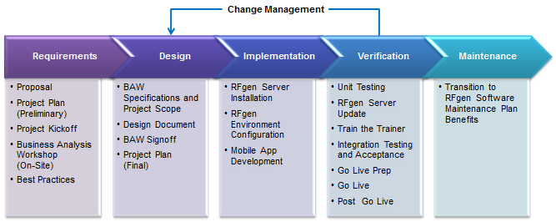

Scope Change Management is the formal process through which changes to the scope of the project are managed. The BAW document specifies the original scope agreement and Change Requests are created to document any subsequent change to this baseline scope and are tracked using the Change Request Log.

Scope Change Management is important because changes in the project scope often occur and need to be managed so as to ensure that they are properly controlled and regulated, and that they do not impede the development of the overall project in any way.

To ensure that the goals and objectives of this project are achieved, it is important that any changes that are suggested are managed and only adopted after thorough investigation and appropriate management approval has been given.

Anyone involved with the project may identify any request for change to the scope. Because scope changes have interdependencies, Change Requests are to be assessed in terms of their impact on the:

* Project deliverables
* Work effort
* Project budget
* Project work plan (timeline)
* Any other implications

All proposed changes should be documented as Change Requests and screened by the Project Managers. If evaluation of the Change Request itself has an impact on the project or program (e.g. using project resources), this will be brought to the attention of the Project Sponsor and noted on the Change Request.

The change may require clarification prior to investigation and resolution. In other situations, it may be assigned for investigation immediately. When the investigation is complete, the change is either approved or rejected by the Project Sponsor. If the change is approved, the Project Plan is adjusted accordingly.

The Project Charter will be updated to a new version only if there is significant alteration to scope. If the change is rejected, the reason for rejection is recorded with the Change Request. At any point within the project, the scope will be as defined in the Project Charter plus approved change requests.

The Project Sponsors are the only people who can accept responsibility for changing the scope. The Project Director must ensure that the sponsors are aware of all the impacts that a change will have to the existing project. Both Project Managers will study the proposed change and approve it for further investigation or rejection. RFgen will specify any charges for such investigation. If the investigation is authorized, the Project Managers will sign the Change Request, which will constitute approval for the investigation charges. The investigation will determine the effect that the implementation of the Change Request will have on the price, schedule, and other terms and conditions of the Agreement.

A written Change Authorization must be signed by both parties to authorize implementation of the investigated changes.

# APPENDIX C⎯RFGEN ARCHITECTURE OVERVIEW

**RFgen Mobile Application Development Platform**

* **RFgen On-premise - Scenario 1**

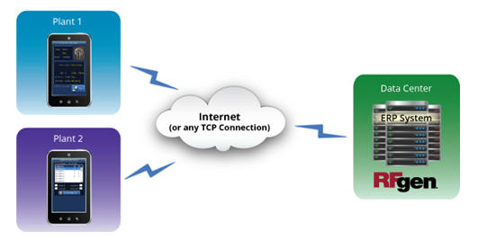

* **RFgen On-premise - Scenario 2**

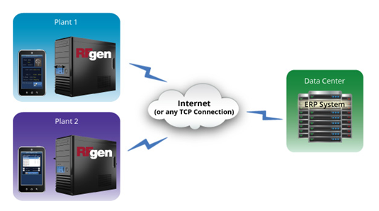

* **RFgen in the Cloud**

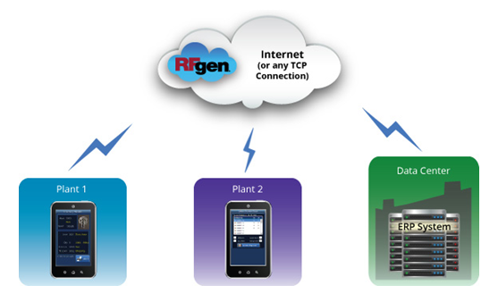

* **RFgen Connectivity Scenarios (RFgen in or near the plant)**

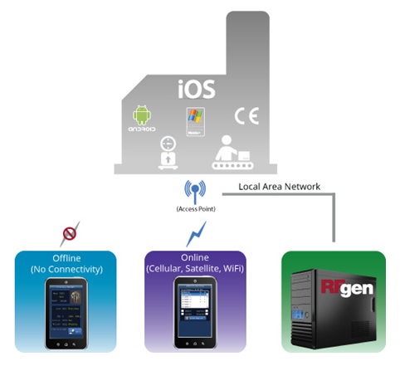

**RFgen Application Framework**

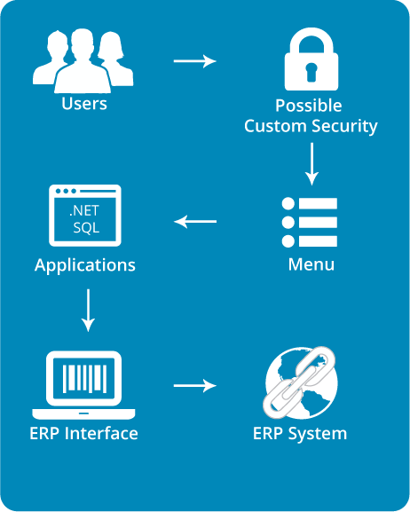

* **User Login**—Perform user/password validation and deliver menus based upon valid roles attached to user.
* **Customer Defined Security**—Logic to perform additional security checks or access 3rd party systems.
* **Menus**—Role-based menus providing access to applications stored on the device.
* **Applications**—The primary form of user interaction with the system, applications drive the presentation layer, prompt defaults, input validation and real-time execution of the transaction.
* **VBA Event Scripting**—Interface to respond to data collection events (scan, enter, etc.) so additional validation or updates can occur.
* **Query/Validation**—Integrated objects provide real-time validation of logic when connected or access to local datasets stored on the device if off-line.
* **Transactions**—Logical code block that contains all the code necessary perform a specific type of update into an Enterprise system.
* **Embedded Procedure—**Script based object that provides the ability to dynamically setup and execute business function calls for multiple ERP systems**.**

# APPENDIX D⎯JD EDWARDS INTEGRATION VALIDATION CERTIFICATE

