|  |
| --- |
| **RFgen Mobile Foundations for**  **SAP Business One**  **Mobile Data Collection Software Solutions**  **Proposal** |

**Prepared for:**

|  |
| --- |
| **Company Name** |

**Represented by:**

<<Contact Name>>

<<Title>>

**Prepared by:**

<<Sales Reps Name>>

Regional Sales Manager

RFgen Software

|  |  |
| --- | --- |
| Proposal Revision | 001 |
| Proposal Created | Month 00, 2014 |
| Proposal Expiration | Month 00, 2014 |

1101 Investment Blvd., Suite 250

El Dorado Hills, CA 95762

<<Sales Reps Phone>>

<<Sales Reps Email>>

**TABLE OF CONTENTS**

1 EXECUTIVE SUMMARY 3

2 ABOUT RFGEN SOFTWARE 5

3 RFGEN MOBILE FOUNDATIONS FOR SAP BUSINESS ONE OVERVIEW 6

4 HOW RFGEN INTEGRATES WITH SAP BUSINESS ONE 8

5 SERVER RECOMMENDATIONS 9

6 THE THREE COMPONENTS OF THE RFGEN MOBILE FRAMEWORK 10

7 RFGEN SOFTWARE MAINTENANCE PLAN 12

8 RFGEN SERVICES 13

9 ENTERPRISE LABELING SOFTWARE OPTIONS 15

10 HARDWARE AND DEVICE RECOMMENDATIONS 15

11 INVESTMENT SUMMARY 16

12 APPENDIX A⎯CERTIFICATION 18

# EXECUTIVE SUMMARY

The following proposal, specifically prepared for <<COMPANY NAME>>, outlines RFgen Software’s recommendations for the development and implementation of a mobile data collection software solution that seamlessly integrates with <<COMPANY NAME>>’s SAP Business One system.

**<<COMPANY NAME>>’s Business Challenge**

* Establish the need or the problem
* Why is the company looking for a solution?
* What are the pain points?
* What is this problem costing the business?
* Any other pertinent info gathered during discover that conveys we understand the problem

**Example business challenge; tailor to specific business:**

<<COMPANY NAME>> is currently experiencing issues with inventory management. All activities today are paper-based and data is manually entered into SAP Business One, introducing the possibility for human error and delays. The lack of real-time, accurate visibility into their inventory makes it hard to manage appropriate supply levels and keep down costs.

The challenge for <<COMPANY NAME>> is to evaluate and improve each process as much as possible by adding an automated data collection solution (barcoding). This is not a simple software decision; it’s about picking a vendor who knows supply chain automation and SAP Business One, who can provide a consultative approach on industry best practices, user efficiency, and generate ideas that will meet and exceed all expected deliverables for this project while providing a seamless integration to <<COMPANY NAME>>’s SAP Business One system.

**Goals and Objectives**

* List the company’s goals and objectives
* **Example**
* Get rid of manual, paper-based processes at <<number>> facilities with barcoding and mobile applications that enable real-time, reliable updates to <<COMPANY>>’s SAP Business One system.
* Optimize existing processes like picking, packing, receiving, transfers, and more to be more efficient and intuitive on a mobile scanning device.
* Acquire mobile scanning devices that meet <<COMPANY NAME>>’s technical, architecture, automation and budget requirements.

**Expected Results (or ROI)**

Provide substantiation, expected ROI if you can calculate it, expected performance metrics (e.g. 99.9% accuracy, etc.)

**Total Cost of Ownership**

Not only is RFgen an affordably priced comprehensive mobile data collection system that can help <<COMPANY NAME>> increase productivity, gain efficiency and reduce operating costs, it also provides the following TCO benefits:

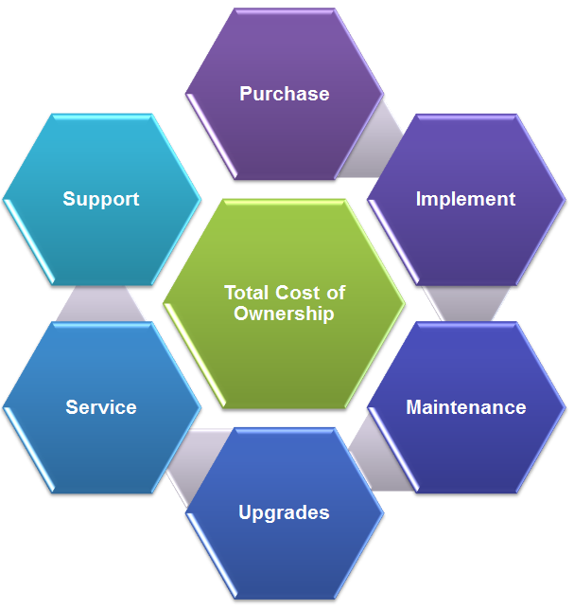

* RFgen is fast to deploy, taking days or weeks where other solutions may take months and many professional services hours to deploy.
* RFgen solutions can be rolled out in phases, one process at a time, allowing you to control the impact to your business.
* You own the source code for all mobile applications. The RFgen Mobile Development Studio allows you to modify and create new mobile applications in-house, expediting deployment time and avoiding professional services fees.
* Unlike other SAP Business One add-ons, RFgen does not install on your SAP Business One server or modify your ERP environment, saving you time and money when it's time to upgrade your SAP Business One server.
* An active RFgen Software Maintenance Plan provides long-term investment protection and includes software upgrades, technical support and services for as long as you own the solution.

All this adds up to <<COMPANY NAME>> realizing the financial benefit of a complete automated data collection solution with a low total cost of ownership.

# ABOUT RFGEN SOFTWARE

RFgen Software, a division of the DataMAX Software Group, Inc., is an industry leading mobile data collection software firm that helps organizations reduce supply chain implementation costs and increase accuracy and efficiency with the industry’s most reliable and flexible wireless and mobile automated data collection software and open source mobile computing solutions.

In business since 1983, RFgen is known for its solid, high-quality products and high customer satisfaction ratings among its more than 2,800 customers. With a global reach and local touch, RFgen and its network of 140 certified solution partners can service and support <<COMPANY NAME>> no matter where its operations are located around the world.

**Why RFgen Software?**

* **Provides you with a suite of pre-written, pre-tested mobile applications and integration expertise for SAP Business One** that handle the most common use cases including sales orders, purchase orders, transfers, packing, shipping, cycle counting and other key inventory transactions.
* **Empowers you with the flexibility you need now and in the future.**
  + You can customize device screens using control image themes.
  + You have unlimited connectivity to any ERP system, screen mapping, OLEDB/ODBC database, and Web services.
  + You can easily add new users and devices.

*“Choose a mobile solution that is flexible. That is probably the most important thing. Something that you can use to modify, expand and fix your operations."*

Jim Kruse

Board Secretary & Controller

Blue Bell Creameries

* + You have unlimited connectivity to Windows, Android and iOS based devices (barcode scanners, smart phones, tablets, handheld computers, voice devices, RFID, printers, scales, carousels, vehicle mounts, and more.)
* **Easily facilitates offline mobility.** RFgen allows your mobile device users to work in a disconnected state, with automatic updates to your ERP when back in range.
* **Makes mobile app development easy,** dramatically reducing implementation timeframes. RFgen is based on Open Source standards. RFgen includes a full development studio that makes customizing RFgen mobile apps easy and cost-effective.
* **Enables your IT staff to modify or create new mobile apps in-house, saving you time and money in the long run.** RFgen is a mobile application development platform (MADP). If you desire vendor independence, the RFgen MADP platform enables your in-house IT staff to quickly and easily create custom mobile apps that are tailored to your specific needs. With RFgen, not only can your IT staff develop their own mobile apps code, but once developed, your company owns the code and at no time does it become the property of RFgen.

# RFGEN MOBILE FOUNDATIONS FOR SAP BUSINESS ONE OVERVIEW

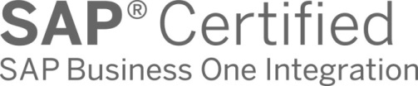To achieve <<COMPANY NAME>>’s goals and objectives, RFgen recommends the implementation of the RFgen Mobile Foundations for SAP Business One solution. This solution includes a suite of pre-written, SAP-certified mobile applications that feature real-time, bi-directional information exchange with your SAP Business One system.

RFgen's SAP Business One mobility solution supports real-time wireless barcoding and mobile applications. This mobile data collection solution can be easily and quickly adapted to <<COMPANY NAME>>'s unique workflows and will help <<COMPANY NAME>>:

* **Provide accurate, up-to-date visibility** into your operations and inventory with immediate updates from anywhere in your business⎯the warehouse, a stock room, at a retail location, the manufacturing floor, or in the field. This allows for better supply forecasts, improved turn-around on orders, fewer returns and faster response to audits or recalls.
* **Increase worker productivity and reduce errors** by eliminating the need to re-key data with real-time information exchange between barcode scanners, tablets, mobile computing devices and your SAP Business One system.
* **Automate remote locations and field sales/service operations** with support for roaming, occasionally-connected data collection using on-demand cellular/Wi-Fi connectivity to SAP Business One. RFgen also supports fully disconnected scenarios where data is pre-loaded on the device, remote activities are locally validated, and transactions are exchanged with SAP Business One at various intervals.
* **Maintain data integrity** between the mobile device and server to prevent user errors when in an always-connected environment using RFgen's guaranteed packet delivery protocol.

**Certified Integration with SAP Business One**

RFgen Mobile Foundations for SAP Business One provides <<COMPANY NAME>> with:

* **Certified connectivity**—RFgen integration using the DI SDK is certified by SAP for versions 9.1 (see Appendix A) and has been internally validated by RFgen for versions 8.8 and 9.0.
* **Version independent**—RFgen does not install on your SAP Business One server or modify your environment, so there's no hassle when it's time to upgrade your ERP system.
* **Pre-built suite of mobile applications** using the SAP certified integration for real-time updates to your SAP Business One system, as well as the option for offline or disconnected mobile computing. The suite includes transactions for sales orders, purchase orders, inventory movement and adjustments, cycle count, packing and shipping.
* **Flexible developer productivity tools**—the integrated development environment enables <<COMPANY NAME>>’s internal IT staff to rapidly customize and create new workflows, saving both time and money. For example, workflows only need to be created once using a drag and drop form designer, after that they can be quickly and easily configured with endless variations of language and screen sizes.
* **Consultants with expertise in supply chain automation and SAP Business One** are available to evaluate, advise on and develop additional custom mobile applications to meet your exact requirements.
* **Easy to support**—RFgen administration tools enable your IT and helpdesk teams to shadow users and see their screens in the console. You can also take control remotely and show users exactly how to perform a task.

# HOW RFGEN INTEGRATES WITH SAP BUSINESS ONE

RFgen has built-in integration capabilities that have been certified by SAP to work with <<COMPANY NAME>>’s SAP Business One system. RFgen’s SAP Business One Open Source Mobile Application Suite integrates within SAP Business One supply chain processes using the SAP Business One DI SDK connector as illustrated below.

**RFgen-SAP Business One Integration Diagram**

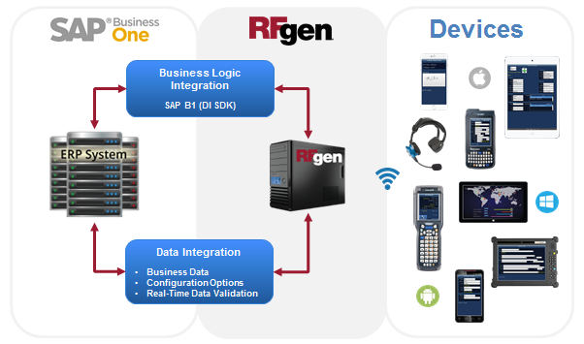

**Upgrading Your SAP Business One System**

Eventually, <<COMPANY NAME>> will upgrade to a new SAP Business One version. RFgen is version independent and does not install on your SAP Business One server or modify your environment, making upgrading SAP Business One fast and easy. As long as <<COMPANY NAME>> has an active RFgen Software Maintenance Plan, there is no RFgen upgrade fee required. There may be configuration changes in the RFgen SAP Business One Open Source Mobile Application Suite to accommodate an SAP Business One upgrade. <<COMPANY NAME>> may elect to make those modifications in-house using the RFgen Mobile Development Studio or engage RFgen’s professional services team. RFgen is certified by SAP Business One version 9.1 (see Appendix E).

# SERVER RECOMMENDATIONS

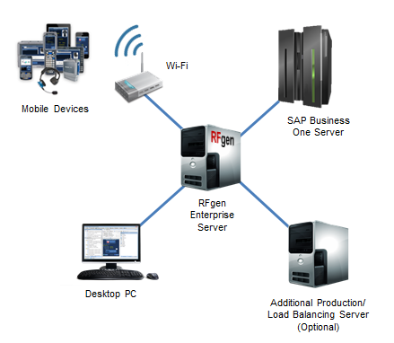

* **Memory**
  + The RFgen server will use up to 15 megabytes of memory.
  + Each active client will use up to 10 megabytes of memory.
  + Each active database connection will use up to 10 megabytes of memory.
  + Each active SAP Business One connection will use up to 30 megabytes of memory.
* **Supported Operating Systems**
  + Windows Server 2008, Windows Server 2012, Windows Server 2016, Windows 7, Windows 8 and Windows 10.
  + VMware Server: configure to use just one CPU. From experience, RFgen and SAP Business One work faster and more reliable on one CPU.
* **CPU**
  + 2 GHz or better, Intel or AMD chip.
* **Hard Drive**
  + An RFgen installation can use up to 500 megabytes of hard drive space depending on how many options are installed.
  + If the server stores any additional data, then consider space for it.
* **Other**

RFgen recommends the purchase of an RFgen Development/Test Server. This server is not for production, but for application development and testing purposes only. The configuration of the Development/Test Server will follow the same configuration as above.

# THE THREE COMPONENTS OF THE RFGEN MOBILE FRAMEWORK

The RFgen Mobile Framework is designed to maximize the productivity of <<COMPANY NAME>>’s development staff, as well as simplify management and support tasks after deployment. In fact, RFgen is so easy to use that many customers decide to take in-house ownership of the solution and realize significant savings over time. The RFgen Mobile Framework includes the following:

**1. Built-In Runtime Environment**

Unlike other mobile data collection software providers, RFgen is a single-source turnkey application that eliminates the need to purchase additional third-party products, thus saving you time and money. The RFgen Runtime Environment includes the following:

* **RFgen Mobile Framework Services** manage all of the communications required between devices and SAP Business One in a manner that provides guaranteed delivery of information. RFgen acts as a gateway for all client requests working on their behalf to serve real-time, on-demand information as well as managing the processing of remote transactions into SAP Business One.
* **Mobile Enterprise Dashboard** is an easy-to-use administration interface that allows your IT staff to actively track all operations occurring within the mobile and wireless environment. Using the dashboard, any RFgen mobile session can be viewed or modified in an interactive mode allowing IT personnel to see what's occurring on the device in real-time and to remotely support or train the user.
* **Built-in Network Device Management** allows administrators to quickly query which devices are on their networks as well as to query data on the devices and even push new data or updates to the devices. Additionally, RFgen supports a two-way mirror of the user's session allowing support personnel to quickly and easily respond to device issues in the field.

**2. Mobile Application Development Platform**

The RFgen Mobile Development Studio is an integrated mobile application development platform that enables developers to rapidly create and maintain mobile application solutions for Windows, Android and iOS based devices. With RFgen, <<COMPANY NAME>>’s developers can easily connect to their existing system(s) and quickly design, test and deploy mobile enabled applications.

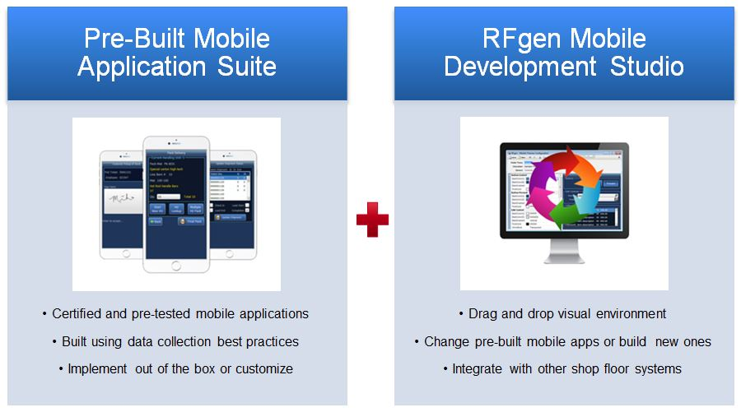

RFgen supports the ability to "paint" the user interface for each application in multiple styles to fit different device display themes and sizes. Additionally, each prompt can be defined in multiple languages which will activate based upon the workers profile while the underlying code base remains the same—this allows developers to maintain a single set of business rules.

**3. SAP Business One Open Source Mobile Application Suite**

RFgen Mobile Foundations for SAP Business One includes a package of SAP-certified, ready-to-use mobile applications. In addition, the flexibility and ease-of-use of the RFgen mobile application development platform enables <<COMPANY NAME>>’s internal IT staff to easily modify these applications or create new ones on an in-house basis⎯saving <<COMPANY NAME>> both time and money.

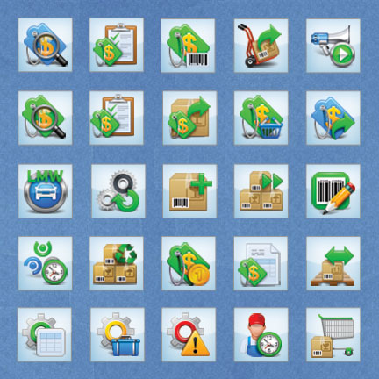

To get you up and running fast, RFgen has out-of-the-box pre-written and pre-tested mobile apps for SAP Business One, including:

* Inventory Management
* Purchase Order Processing
* Sales Order Processing
* And More

# RFGEN SOFTWARE MAINTENANCE PLAN

An RFgen Software Maintenance Plan complements your RFgen software purchase. It includes both product upgrades and technical support, and helps to guarantee successful software deployments and stable production environments. With an RFgen Software Maintenance Plan, you get complete access to the latest RFgen product versions, technology enhancements and enterprise mobile application releases.

With an active plan <<COMPANY NAME>> can upgrade to new releases and new versions as the needs of your business dictate. Our technical support experts are here to help keep your users up and running wherever they’re working in the world. This is our way of making sure you’re covered with the technical support you need, and it’s your way of getting an increased return on your RFgen investment.

**The RFgen Software Maintenance Plan Includes**

* On-call technical support from skilled and experienced product specialists.
* 24/7 priority support for mission critical cases.
* Access to the latest version, product upgrades, enhancements and new capabilities.
* Advance and exclusive notification of software promotions, when offered.
* Access to hundreds of certified, enterprise-ready mobile apps.
* A no cost system health check and upgrade assistance.

Activated at the time of purchase, RFgen Software Maintenance Plans are renewable annual plans. All RFgen product purchases require the purchase of an RFgen Software Maintenance Plan for the first year and can be renewed on a single or multi-year plan basis. Choosing to renew on a multi-year plan basis can save you time and money as RFgen offers discounts on multi-year plans as they reduce paperwork and simplify operational budgeting.

# RFGEN SERVICES

RFgen has a proven method for the successful installation and deployment of RFgen. The implementation methodology has been developed over years using the experiences gathered from hundreds of implementations. The following outlines RFgen’s recommended services for the successful installation of RFgen at <<COMPANY NAME>>.

**RFgen Professional Services**

An expedited and successful installation of your RFgen software solution means a rapid ROI for <<COMPANY NAME>>. To accomplish this, the RFgen Professional Services team will work closely with <<COMPANY NAME>>’s internal team as follows:

* **RFgen Professional Services Resource Allocation**

For the <<COMPANY NAME>> project, RFgen will dedicate an SAP Business One development team and an RFgen Project Manager. There will be a minimum of one Senior ERP Consultant and a backup Consultant assigned to the project. Consultants will bring in additional SAP Business One-specific team members to assist with the project as needed. The RFgen Project Manager will:

* + Facilitate communication between all parties
  + Track project timelines, open tasks, completed tasks, etc.
  + Report project status to <<COMPANY NAME>> and RFgen management
  + Keep the project on schedule and on budget

The estimated number of hours for professional services can be found in the investment summary.

* **<<COMPANY NAME>> Resource Requirements**

To effectively complete the RFgen installation, the RFgen Project Manager and Consultant(s) will require participation from the following <<COMPANY NAME>> resources:

* + Project manager (primary RFgen contact)
  + Operational/Subject matter expert (SME)
  + Network administrator
  + SAP Business One technical expert
  + System testers

**RFgen Training Services**

To ensure maximum return on your software investment, RFgen will provide designated <<COMPANY NAME>> employees with the necessary training they need to successfully manage <<COMPANY NAME>>’s RFgen solution. The RFgen Total Knowledge Transfer Training Program is composed of two courses:

* **Introduction to RFgen Functional Training Course**

This course provides RFgen basic system concepts, functionalities, and components. This course provides the fundamental skills new users need to begin navigating the system.

* **RFgen Technical Training Course**

*(Prerequisite: Introduction to RFgen Functional Training Course)*

This course is for new and experienced developers and technical administrators who are responsible for installing, customizing, upgrading and maintaining <<COMPANY NAME>>’s RFgen solution.

Because we know our customers have different training needs, we offer two training program formats—classroom and web-based. For <<COMPANY NAME>>, RFgen recommends the following training program format.

* **RFgen Total Knowledge Transfer Classroom Training**

This intensive two to three day classroom training program can be conducted at an RFgen office or <<COMPANY NAME>>’s location. Students will enjoy face-to-face interaction with an RFgen instructor, as well as complete hands-on exercises to help them master concepts and pick up insider shortcuts.

Deliverables include:

* + Classroom training at an RFgen office or <<COMPANY NAME>>’s location
  + Two to three days of instruction
  + Training for up to two students
  + Training materials

Note: Students are expected to bring their own laptop for a full training experience. The cost for adding more students is additional. Travel expenses are additional.

* **Web-Based Training**

RFgen’s Web-Based Training combines the benefits of live instruction with the convenience and affordability of online education. With this course, students will meet with an RFgen instructor online at a specified date and time to attend class. There are three two-hour training modules that are included in the Web-Based Training curriculum. This training may be split into multiple days, if required. The total training time varies based on the Q&A sessions, but generally requires six to eight hours in total to complete.

Deliverables include:

* + Online training via WebEx
  + Three two-hour training modules
  + Training for one to two students
  + Training materials

# ENTERPRISE LABELING SOFTWARE OPTIONS

RFgen has built-in integration to all of the major enterprise labeling software solutions on the market and can provide a connection to these applications enabling your users to generate the desired barcode label design formats they need for various functions. This means, you can research and select the enterprise labeling solution that best suits your needs and RFgen can easily integrate with your chosen solution.

**RFgen is a Loftware Enterprise Labeling Solutions Reseller**

[Loftware, Inc.](http://www.loftware.com/) is a global market leader in Enterprise Labeling Solutions with more than 5,000 customers in over 100 countries. Because of Loftware’s company and product strengths, RFgen exclusively resells Loftware solutions and if desired can provide you with a separate quote for a Loftware enterprise labeling solution for your needs. Think of RFgen and your total solution provider.

# HARDWARE AND DEVICE RECOMMENDATIONS

As your single-source mobile computing solutions provider, RFgen not only delivers the most reliable and flexible mobile data collection software and services on the market today, but we can also provide <<COMPANY NAME>> with the mobile technology, hardware and devices you need to automate your entire operation. This single source approach provides a single point of contact for your entire data collection and mobility solution.

RFgen has strategic partner relationships with the industry’s leading mobile computing technology providers and can provide you with the right hardware and mobile devices for your specific requirements, including mobile computers, barcode scanners, voice technology, RFID, printers and media and networking.

RFgen recommends the following hardware and devices for <<COMPANY NAME>>:

* Product
* Product
* Product

A <<VENDOR NAME>> data sheet for <<PRODUCT NAME>> will be provided separately.

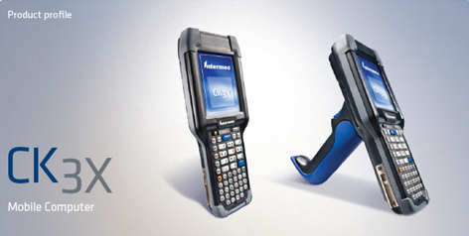

# INVESTMENT SUMMARY

<<Insert Investment Summary table from Excel Workbook>>

|  |
| --- |
| **APPENDIX** |

# APPENDIX A⎯CERTIFICATION

