1. What is the topic area and problem of interest

The topic area is the movements and distributions of people using physical measurements. Using cranial measurements and demographic data from 1909, I seek to identify spatial relationships between geographical and ancestral groups in India at that time.

Problem of interest: Do cranial measurements correlate spatially to ancestral and geographical groups?

2. Why are you interested in this problem/area

Much of my past research has been in the natural resources domain. I’m interested in this project because it allows me to explore the spatial aspect of forensic anthropology. In addition, the research has the opportunity to end in publishing with Dr. Belcher of UNL and Dr. Hefner from MSU.

3. How your proposed project will make the task more efficient, more accurate, more consistent, or easier.

The task will be more efficient due to the replicability that comes along with programmatically approaching spatial analysis. With using one program to perform both spatial and data analysis, accuracy and efficiency should increase. Finally, the other researchers on the project are using R so data communication will be easier.

4. Why the problem/task cannot be solved using standard "out-of-the-box" tools from ESRI or other GIS software packages/modules.

The best part of using R and R Studio compared with GIS GUI programs or even Python is that at it’s base it’s used for statistical analysis. So, being able to complete spatial and statistical analysis easily in one program makes R and R Studio a great option.

5. What you expect the outcome of the project will be. Note, you will always provide your code, so think about how you would define "success" for your objective (e.g., a measurement of efficiency, a completed task, completed analysis)

I will identify the spatial relationships between geographical and cultural groups in India based on cranium measurements and demographics. The final manuscript will be used for publication in Spring 2022.

6. Preliminary or sample data

7. Any preliminary work (strongly encouraged)

Preliminary work has resulted in a couple early obstacles. The first is the dataset from Dr. Belcher is still being compiled. What I show above for preliminary data is the first 11 rows of 166 are complete. Since all the rows had the Indian state filled out, I was going to start working on locating the subjects spatially and do some exploratory spatial data analysis. However, the roadblock I’m running into is that India has not allowed spatial data from their government to be made available to those outside of India, specifically foreign companies or individuals. I found layers from ESRI in the Living Atlas with the states and districts of India but ESRI denotes that these can only be used in ArcGIS Online. When I attempted to use the *arcbindings* library to bring the AGOL layers into R Studio, I would get error messages like below:

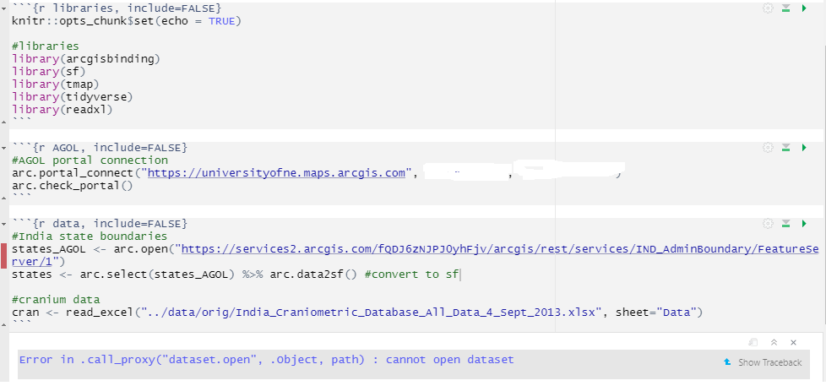

I’ve figured out a way around this in AGOL but, with this being publishable research, I will have to communicate this issue with Dr. Belcher and see if he as any contacts with the Indian government.