Where have you been?

I’d like to propose another article for your Maker Space section. In it I’d cover the design, construction and software development of a GPS based location recorder.

The unit records its GPS location and records it in FLASH memory. The unit is battery powered and is about the size of a small matchbox. It can be attached to an animal, a package, a car or suitcase, for example. Once recovered, the unit can be recharged by plugging it into a USB port on a Linux computer. A GTK-based application can the be used to recover the data, which can be presented graphically on top of a map loaded from OpenStreetMaps.

I would describe the design of the host application, how it communicated with the device over the USB connection, How it loads the correct maps and plots the position data on top of the map.

I would then discuss hardware and firmware requirements for such a unit along with the the choice of components, development tools and construction methods, with an emphasis on FOSS and Linux tools.

Further, I would present the electronic design with full schematic, and describe the essential details of the operating firmware and its interaction with the host.

These design operation would of course, utilize Linux tools, demonstrating Linux’s prowess as a platform for product design. I anticipate the article would be 5 to 6 pages, depending on the number of photos and diagrams, and the level of detail required.

Here is a 3D model of the unit electronics and an indication of the case it fits into:
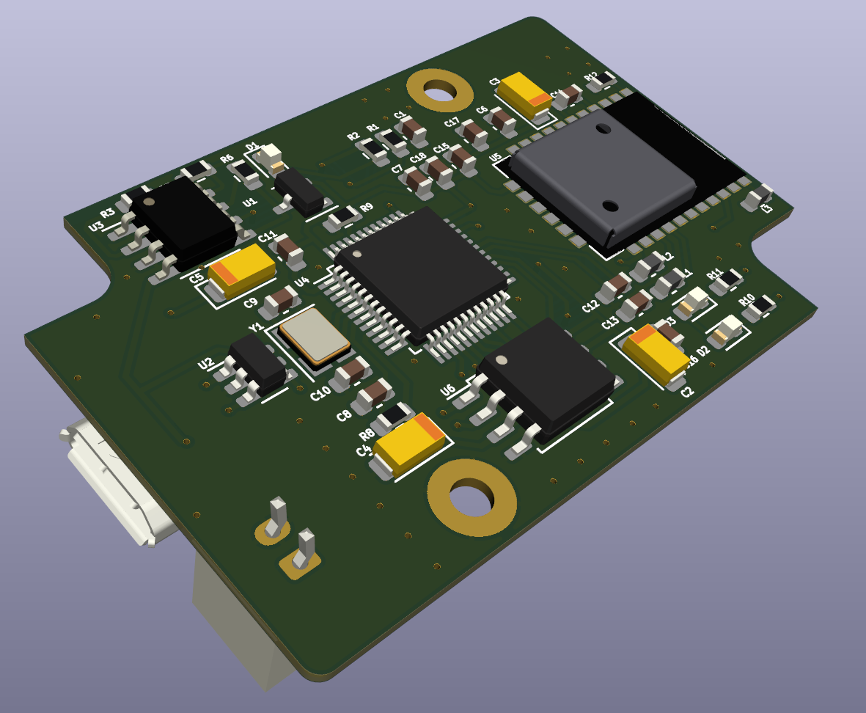
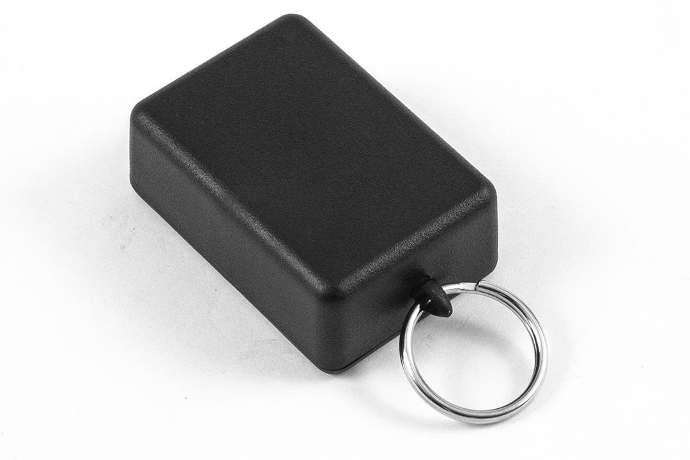
and here is an early prototype of the Linux GPS mapping application
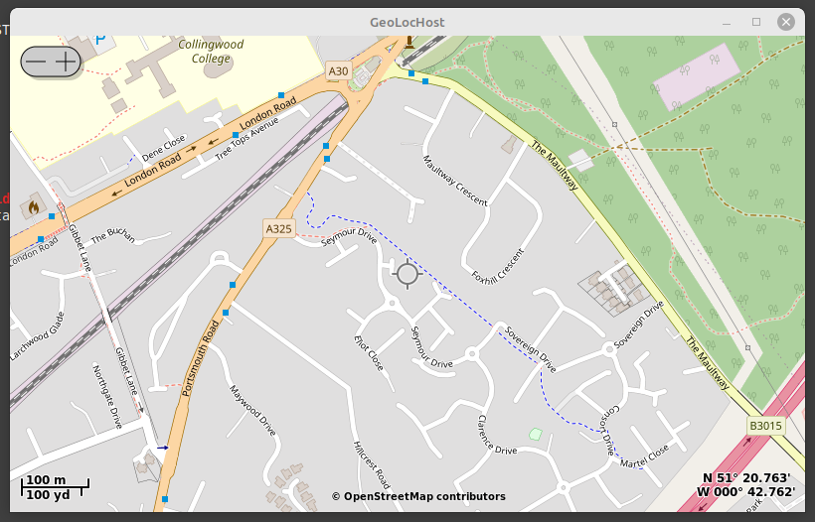

I can supply any further details should you require them. I look forward to your views on this.

Regards

Andrew Malcolm (Ceng, MIEE). 7th December 2023

