Clocking on

I’d like to propose another article for your Maker Space section. In it I’d cover the design, construction and software development of a retro-style LED bedside clock.

I would discuss requirements for such a clock along with the the choice of components, development tools and construction methods, with an emphasis on FOSS and Linux tools.

Further, I would present the electronic design with full schematic, and describe the essential details of the operating software.

These design operation would of course, utilize Linux tools, demonstrating Linux’s prowess as a platform for product design.

I anticipate the article would be 5 to 6 pages, depending on the number of photos and diagrams, and the
level of detail required.

As usual, the whole design will be made available via my public github pages.

Here’s a CAD model of the design
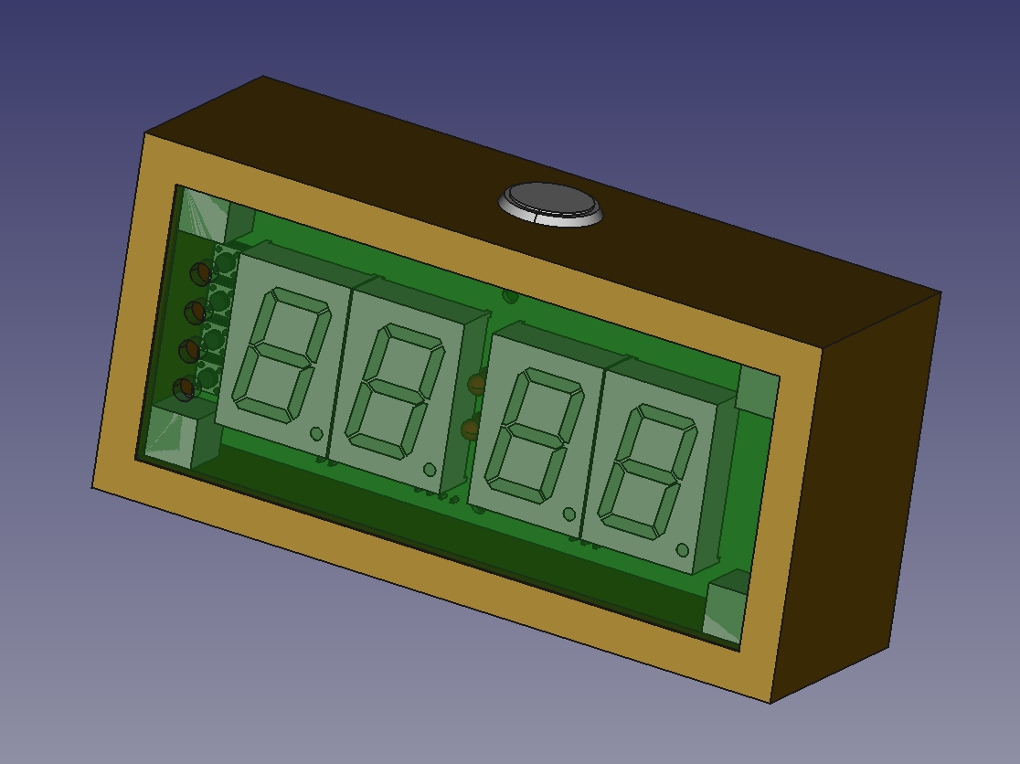

and here is a completed prototype
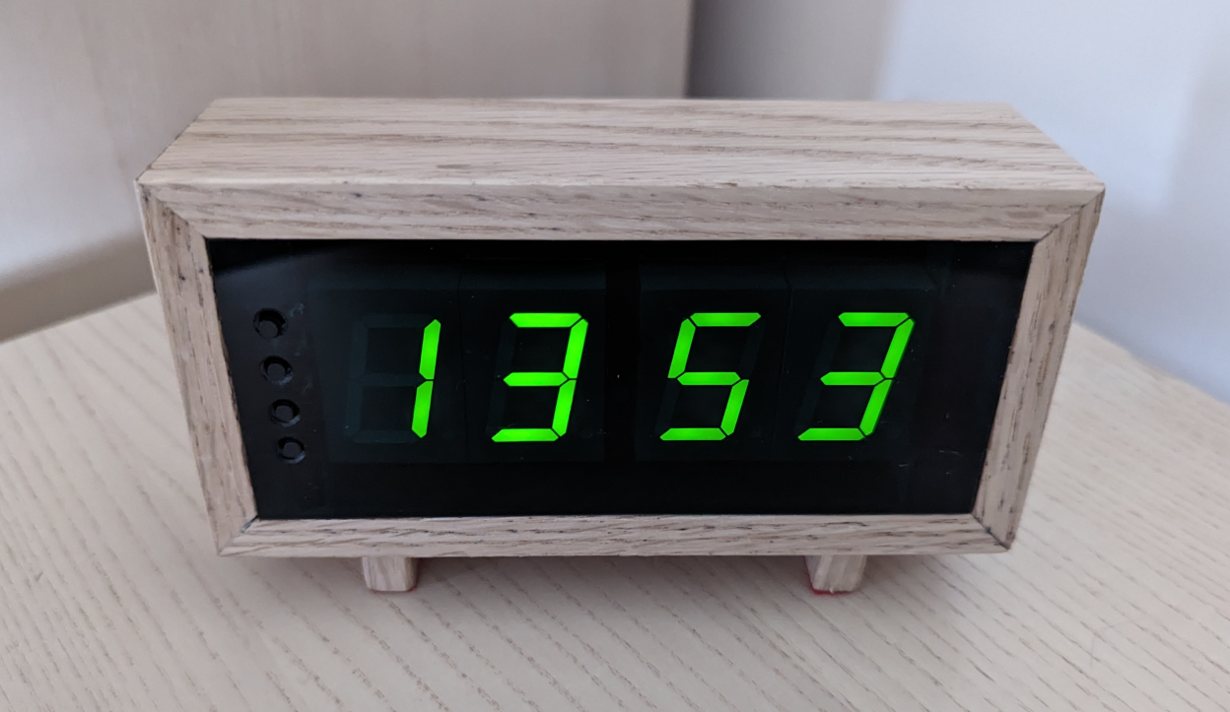

I can supply any further details should you require them.

I look forward to your views on this.

Regards

Andrew Malcolm (Ceng, MIEE)

