A long range radio modem for the Raspberry PI

Some variants of the Raspberry Pi come equipped with WiFi, which make them suitable for wireless data gathering and control applications. However, the range of WiFi is limited, and generally requires a WiFi enable router etc. to issue ip addresses.

There are a number of standards for long range wireless communications in the 868MHz license-free band which are suitable for embedded applications. One of these is LoRa, https://en.wikipedia.org/wiki/LoRa which is widely used and supported by several silicon implementations.
The silicon itself is usually packaged onto module which are available for sale in the $20 region. These modules are often further mounted on standard PCBs and offered as development kits by the silicon manufacturers and others.

I would like to present a discussion of the application of LoRa to an Raspberry PI based data control system, culminating in the design of a low-cost HAT for the Pi with integrated PCB antenna, which can be built for less that $10

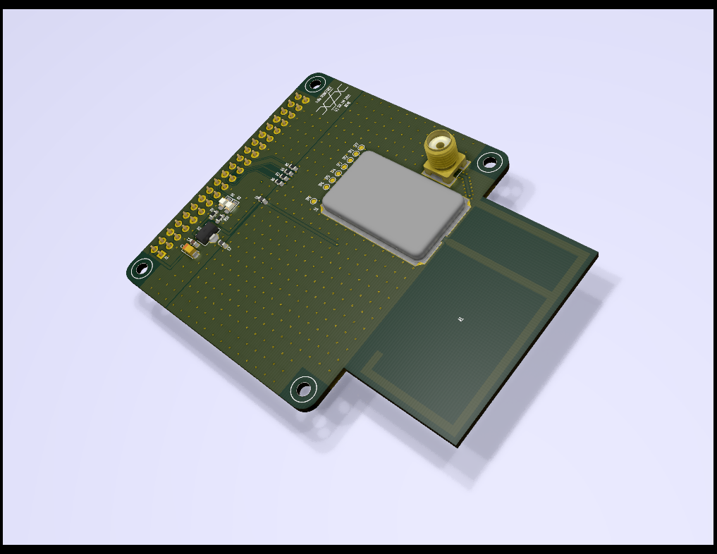

The topics I would like to cover are:

- The basics of the LoRa standard
- Antenna selection and design
- Available open-source software and device drivers
- A prototype that may be built from development modules without soldering
- The design of a low-cost modem HAT for the Raspberry Pi
- A simple control application demonstrating long-range data collection of temperature
- Links to datasheets and further reading

I anticipate the article would be 3 to 4 pages, depending on the number of photos and diagrams, and the
level of detail required.
I propose to ofer blank PCBs for design for a nominal sum so that experimenters can complete the
design. If there was demand, I could also offer completed PCBs.
Optionally I could release the hardware design in KiCad format. (KiCad is an open-source electronics
design package).

Andrew Malcolm (Ceng, MIEE)

