Methods:
Study Site
Skaneateles Lake (42°52'32.3"N 76°23'30.9"W), the second easternmost of the New York State Finger Lakes, is oligotrophic (total phosphorus=5.6 µg/L, chlorophyll-a=0.8 µg/L) relatively narrow (max width = 2.4 km), long (length = 26 km), and deep (max depth = 90 m) with a small watershed to lake area ratio (4.3:1; (Azzaino et al. 2002)). Zebra mussels and quagga mussels were first identified in the lake in 1995 and 2010, respectively (Watkins et al. 2007). Substrates of Skaneateles Lake include a portion of wave impacted channery in the nearshore zone, bedrock and cobble, and clay and silt which supported a diverse array of mollusks prior to dreissenid invasions (Harman 1972). These substrates are typically found in continuous lateral bands around the lake interrupted only by macrophyte growth. During a 1970 survey, a great deal of woody debris was also noted, along with man-made substrates such as piers, docks, pilings, and break walls (Harman 1972), ideal substrate for dreissenid mussel attachment.
Sampling Locations
Field sampling was conducted between July and October 2021 to support evaluation of semantic segmentation for dreissenid mussel surveys and to provide benthic data for lake-wide population estimation. Sampling locations were selected using a stratified transect design to ensure coverage across the lake’s primary depth gradients while ensuring robust latitudinal coverage. Eight east–west transects were established along lines of latitude spanning Skaneateles Lake (Fig. 1). Along each transect, discrete target depths were selected (1, 3, 5, 8, 11, 14, 17, 24, 31, 38, 45, and 52 m). At each site, geographic position was recorded using a Lowrance® HOOK2 chartplotter, and final sampling depth was documented in field logs. Additional sites outside the predefined transects were sampled when environmental conditions (e.g., wind or wave exposure) prevented safe or accurate sampling at planned locations, or when supplemental sampling was required to better represent substrate types encountered during the lake-wide population assessment. Nearshore transects were occasionally adjusted to avoid interference from anthropogenic features such as marinas and public beaches.
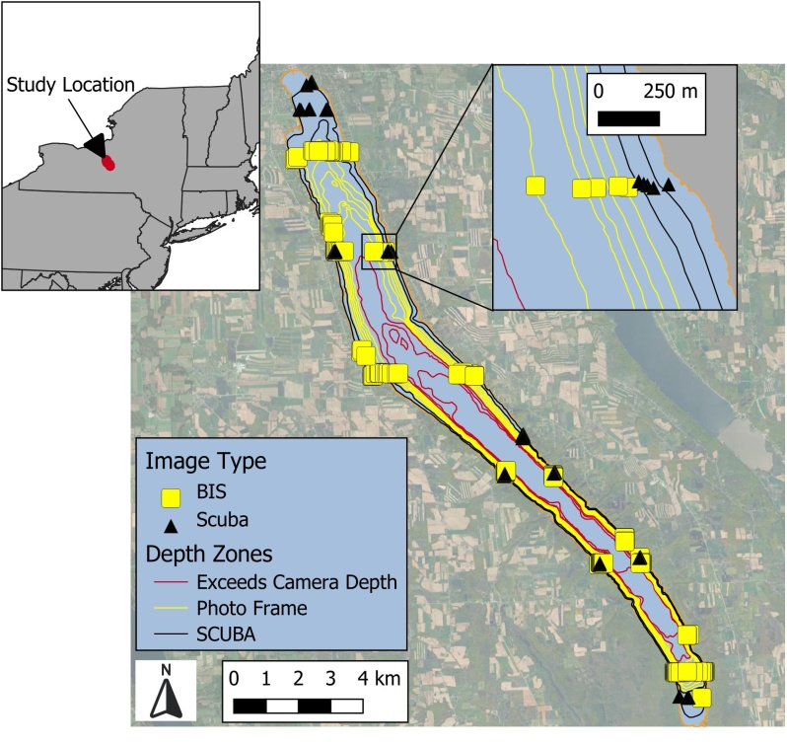
Image Acquisition and Benthic Sample Collection
Underwater video was collected using a SeaLife® Micro 3.0 camera (1080p resolution, 120 frames s⁻¹) with illumination provided by two SeaLife® Sea Dragon 2500F LED dive lights (2500 lumen, 90° underwater beam angle). Video was acquired using two deployment modes: (1) a custom surface-deployed Benthic Imaging System (BIS; Karatayev et al. 2021a) and (2) a diver-operated handheld frame used during scuba-based quadrat sampling. Both systems employed an identical imaging footprint of 21 × 26 cm to ensure consistency between imaging platforms.
Scuba-based sampling was conducted by paired divers at 81 locations. At each site, a transect line was deployed along a fixed latitude within scuba depth limits (<18 m), and divers navigated to target depths using dive computers. One diver placed the handheld imaging frame directly on the substrate while the second recorded video of the framed area. Immediately following video acquisition, all substrate within the frame footprint was collected by the camera operator using a plastic scoop (12 × 7 cm opening) fitted with a 2-mm mesh bag. Sediment was removed to a minimum depth of 4 cm and retained in color-coded bags. Hard substrates within the frame were either collected intact or, in the case of encrusted material on large objects, organisms were scraped free by hand and retained. Upon surfacing, samples were transferred to labeled plastic containers, placed on ice, and transported to the laboratory. Of the 81 scuba sites, video acquisition failed at eight locations due to equipment malfunction, and an additional ten sites were excluded because dense macrophyte growth obscured all benthic organisms. The remaining 65 sites yielded paired video imagery and physical quadrat samples.
In the laboratory, scuba-collected samples were processed on a 1-mm sieve table, and live dreissenid mussels were retained for enumeration. Mussels were spread on a white background and photographed using a Nikon Coolpix AW120 digital camera (snow mode) with supplemental illumination from two SeaLife® Sea Dragon 2500F lights. Mussel counts were obtained using global intensity thresholding to generate binary masks, followed by particle enumeration using the Analyze Particles tool in FIJI/ImageJ (Fig. X).
In addition to scuba sampling, video imagery was collected at 219 sites using the surface-deployed BIS. At each location, video recording was initiated at the surface and the BIS was lowered toward the bottom with the aid of boat-mounted sonar (Lowrance® HOOK2). As the frame approached the substrate, descent speed was reduced until contact was made, after which the BIS remained stationary for at least 10 s. Frames extracted immediately prior to bottom contact consistently provided the highest image quality; images collected after contact were frequently degraded by resuspended sediment. Video from 29 BIS sites was excluded due to dense macrophyte cover, suspended sediment, or equipment failure, yielding 190 usable images for subsequent analysis.
Image Pre-processing
Underwater video files were imported into FIJI/ImageJ as image stacks using the FFmpeg import tool (Tomar 2006), such that each stack slice corresponded to an individual video frame. For each video, a single still frame was selected for analysis based on minimal interference from resuspended sediment, macrophytes, and lighting artifacts. The imaging footprint of the BIS was manually cropped from the selected frame using a rectangular region of interest and exported as a JPEG image.
All images were subjected to a single, fixed pre-processing pipeline applied uniformly across the dataset prior to semantic segmentation. Images were first resized to a common spatial scale by resampling the longest image dimension to 1000 pixels while preserving the original aspect ratio. This standardization ensured consistency among pixel-based filters and classifier features. A mild Gaussian blur (σ = 0.6 pixels) was applied globally to suppress compression artifacts and high-frequency noise while preserving biologically relevant structure. Global contrast enhancement was then performed, allowing 0.25% of pixels to saturate, to improve overall separability of image features. Uneven illumination associated with underwater lighting was corrected using a pseudo flat-field approach, implemented via a large-radius Gaussian blur (250 pixels) to remove low-frequency brightness gradients while retaining fine-scale texture. Finally, images were further processed to suppress frame-induced artifacts such as shadows and harsh edges where the camera frame or BIS was visible. A notch filter was applied in the frequency domain following a fast Fourier transform (FFT) of the image to attenuate strong horizontal and vertical frequency components associated with frame/BIS edges and shadows. The filtered frequency-domain result was spatially constrained to only use frequency correction in the outer border of the image and blended with the original image to minimize unintended modification of benthic features. All pre-processing operations and parameter values were held constant across the full image set to avoid engineering a favorable result from semantic segmentation that would not generalize well to a different dataset.

