Report on Gun Murders

Andrew Shin

4/10/2022

# Ctrl + Alt + I to insert an Empty Code Chunk

## Warning: package 'tidyverse' was built under R version 4.1.3

## -- Attaching packages --------------------------------------- tidyverse 1.3.1 --

## v ggplot2 3.3.5 v purrr 0.3.4  
## v tibble 3.1.6 v dplyr 1.0.7  
## v tidyr 1.2.0 v stringr 1.4.0  
## v readr 2.1.2 v forcats 0.5.1

## -- Conflicts ------------------------------------------ tidyverse_conflicts() --  
## x dplyr::filter() masks stats::filter()  
## x dplyr::lag() masks stats::lag()

## Warning: package 'dslabs' was built under R version 4.1.3

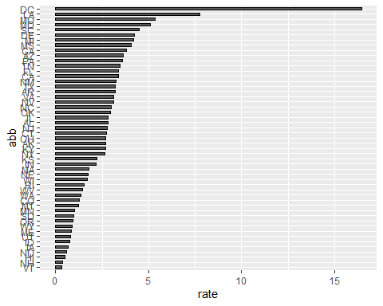

## R Markdown

This is an R Markdown document. Markdown is a simple formatting syntax for authoring HTML, PDF, and MS Word documents. For more details on using R Markdown see <http://rmarkdown.rstudio.com>.

When you click the **Knit** button a document will be generated that includes both content as well as the output of any embedded R code chunks within the document. You can embed an R code chunk like this:

summary(cars)

## speed dist   
## Min. : 4.0 Min. : 2.00   
## 1st Qu.:12.0 1st Qu.: 26.00   
## Median :15.0 Median : 36.00   
## Mean :15.4 Mean : 42.98   
## 3rd Qu.:19.0 3rd Qu.: 56.00   
## Max. :25.0 Max. :120.00

## Including Plots

You can also embed plots, for example:



Note that the echo = FALSE parameter was added to the code chunk to prevent printing of the R code that generated the plot.