CICLOS TDD

Integrantes: André Wallas Soares Costa Araújo, Cristiana Santana Silva, Gabriel Fernando Pinheiro de Oliva, Jenifer Henrique Moreira Borges

1. Teste com falha

import java.text.ParseException;
import java.util.Date;
import junit.framework.TestCase;
import org.junit.Test;

public class TesteBurnDown extends TestCase{

@Test
public void testaSprintDeveTer170HorasTotais() throws ParseException{

}

@Test
public void testaSprintDeveTer7Dias() throws ParseException{

}

@Test
public void testaDeveRetornarDataNula() throws ParseException{

}

@Test(expected=ParseException.class)
public void testaDeveRetornarExcecao() throws ParseException{

}

@Test
public void testaSprintDataInicioNula() throws ParseException {

}

@Test
public void testaSprintDataFim01Dezembro2014() throws ParseException {

Sprint sprint = new Sprint();

@SuppressWarnings("deprecation")
Date data = new Date(2014,12,01);
sprint.setDtFim(data);
assertEquals(data, sprint.getDtFim());
}

}

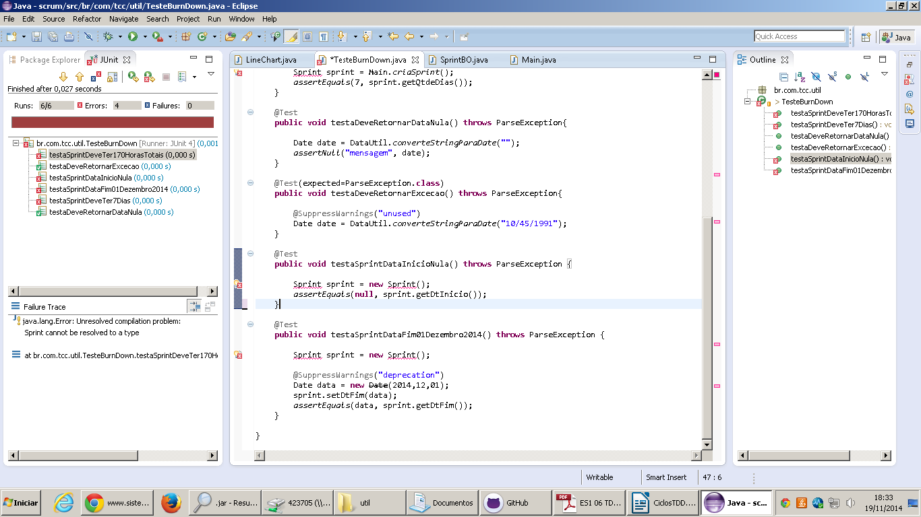

2. Teste passa

import java.text.ParseException;
import java.util.Date;
import junit.framework.TestCase;
import org.junit.Test;
import br.com.tcc.model.Sprint;

public class TesteBurnDown extends TestCase{

@Test
public void testaSprintDeveTer170HorasTotais() throws ParseException{

}

@Test
public void testaSprintDeveTer7Dias() throws ParseException{

}

@Test
public void testaDeveRetornarDataNula() throws ParseException{

}

@Test(expected=ParseException.class)
public void testaDeveRetornarExcecao() throws ParseException{

}

@Test
public void testaSprintDataInicioNula() throws ParseException {

}

@Test
public void testaSprintDataFim01Dezembro2014() throws ParseException {

Sprint sprint = new Sprint();

@SuppressWarnings("deprecation")
Date data = new Date(2014,12,01);
sprint.setDtFim(data);
assertEquals(data, sprint.getDtFim());
}

}

