**DenMAX**

User Manual 1.0



USC Lab for Neural Computation

Andrew Schreiber

Dr. Bartlett Mel

Introduction:

DenMAX is an open-source MATLAB toolkit for visualizing dendrite electrophysiological activity from simulation data. In real time see ion channel activity, axial currents, voltage, and more. DenMAX lets you record visualizations of specific time windows as .avi files to be viewed later. Use DenMAX to build intuition around your simulation data, observe subtle patterns in dendrite activity, and supplement your computational neuroscience research.

Requirements:

DenMAX is built for MATLAB R2012a and later editions. Older editions of MATLAB may encounter errors.

No additional software packages or libraries are necessary. DenMAX is fully functional using only stock MATLAB functions.

DenMAX works on Windows, OS X, and Linux.

DenMAX is designed to work with the neuron simulation package NEURON from Yale. DenMAX inputs a .mat file retrievable from a NEURON simulation.

Getting Started:

1) Download the latest version of DenMAX at <https://github.com/andrewschreiber/DendriteVisualizer> .

2) Place the DenMAX.m file in the same directory as your simulation data files

3) Open MATLAB and set the current directory as the directory containing DenMAX.m

4) Type DenMAX(‘Filename.mat’, StartTime, EndTime) in the command line, where ‘Filename.mat’ is the name of your data file, StartTime is a time in your data file that the visualization will begin at, and EndTime is a time in your data file that the visualization will end at.

5) Enjoy!

Support:

Please contact Andrew Schreiber at [aschreib@usc.edu](mailto:aschreib@usc.edu) with any questions, issues, suggestions, or feedback!

**Feature Walkthrough**

Overview:

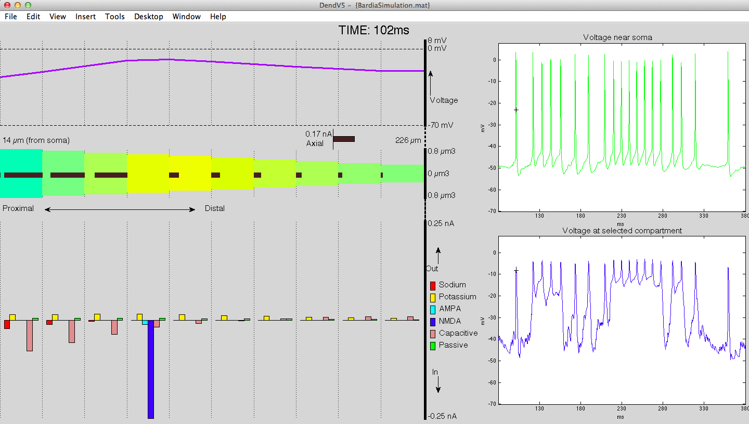

Above is a typical screenshot of DenMAX. We will get into each graph shortly. For now, observe that on the left charts we have parallel, vertically aligned dotted lines. Each vertical represents a data compartment in the simulation file.

The current time in the simulation is displayed in the top-center. All plots will update every temporal tick in the data file.

The name of the file and version number is displayed on the top bar.

Adjust general settings at line 166.

To record visualization as a .avi file, on line 175 set recordmovie=true;

Voltage Graph:

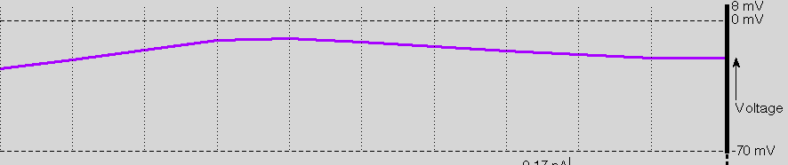

The voltage graph displays the current voltage at each compartment. On the right are the legend items, which are dynamically generated, based on the minimum and maximum voltage in the data file.

Adjust Voltage Graph settings at Line 209

Axial Graph:

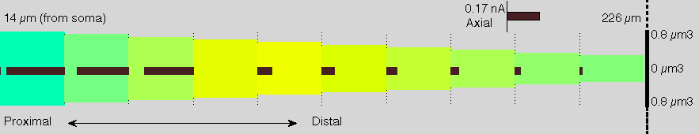

The Axial Graph displays current voltage as a colormap, with dark blue being equivalent to -80mV all the way to red being equivalent to +20mV. The bars emerging from each compartment represent the directionality and magnitude of axial current; the value of the latter can be determined based on the legend in the top-right. On the X- and Y-axis are the compartment’s distance from the soma and the diameter of each compartment, respectively. The left-most compartment is most proximal.

Adjust Axial Graph settings at line 196

Ion Channel Graph

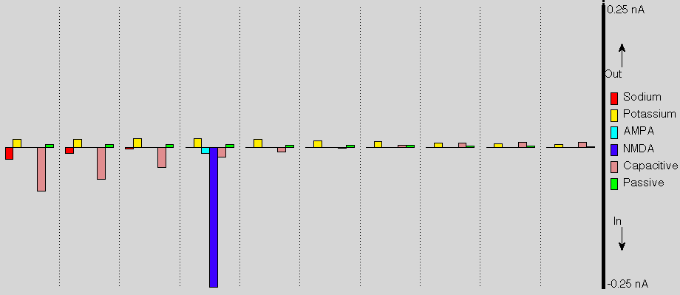

The Ion Channel Graph displays currents for major neurotransmitters at each compartment. The legend on the right is dynamically generated based on the data file. The “BarZoom” variable will increase the vertical size of each histogram and adjust the legend accordingly. Currents with magnitudes beyond the axis limits are truncated.

Adjust Ion Channel Graph settings at line 179

Soma Voltage Chart:

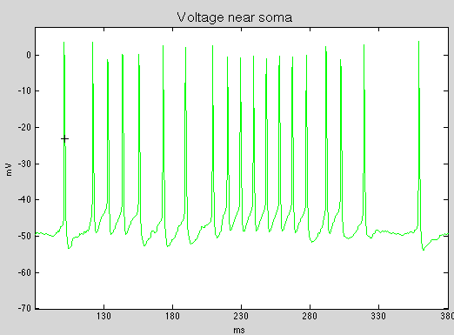

The Soma Voltage chart displays the voltage at the compartment nearest to the soma across the range of time specified in the command argument. As the visualization progresses, a small black cross traces the voltage chart.

Adjust Soma Voltage chart settings on line 226

Selected Voltage Chart

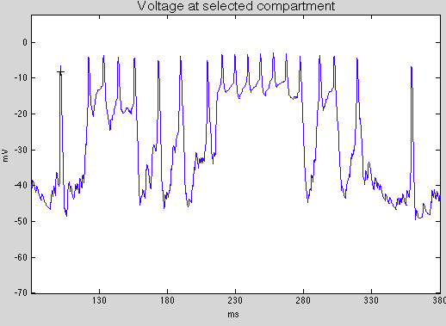

The Selected Voltage Chart works like the above Soma Voltage chart, except that the displayed compartment is chosen based on the SelectedCompartment variable. Compartments are ordered integers, with the left-most compartment as compartment 1.

Adjust Selected Voltage chart settings on line 226