**GitHub Repo**

<https://github.com/andrewssierra/ResourceMaps>

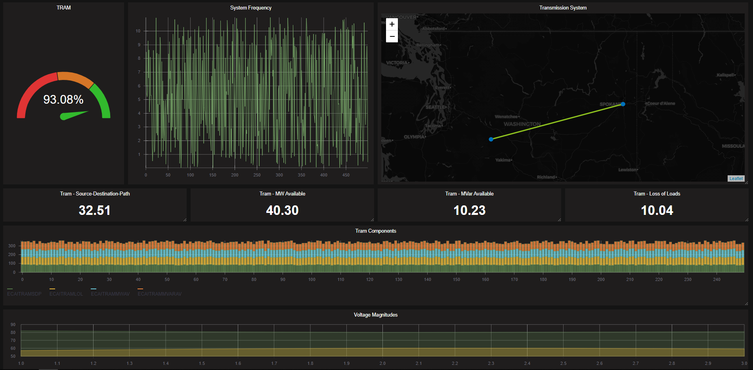

**Influx database**

Docker pull influxdb or kitematic > search > influxdb

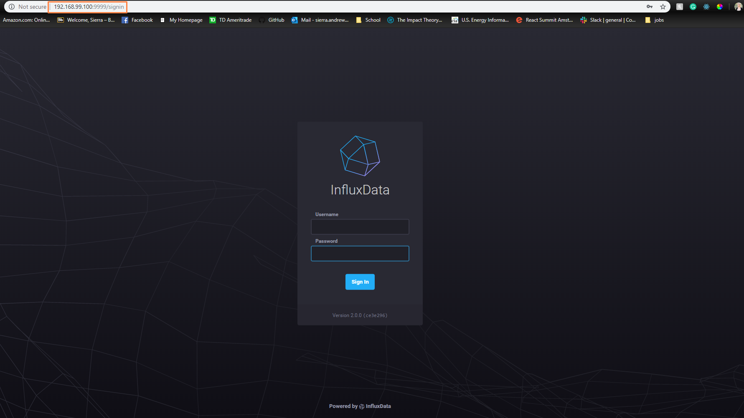

After you log in you go to load data > Buckets

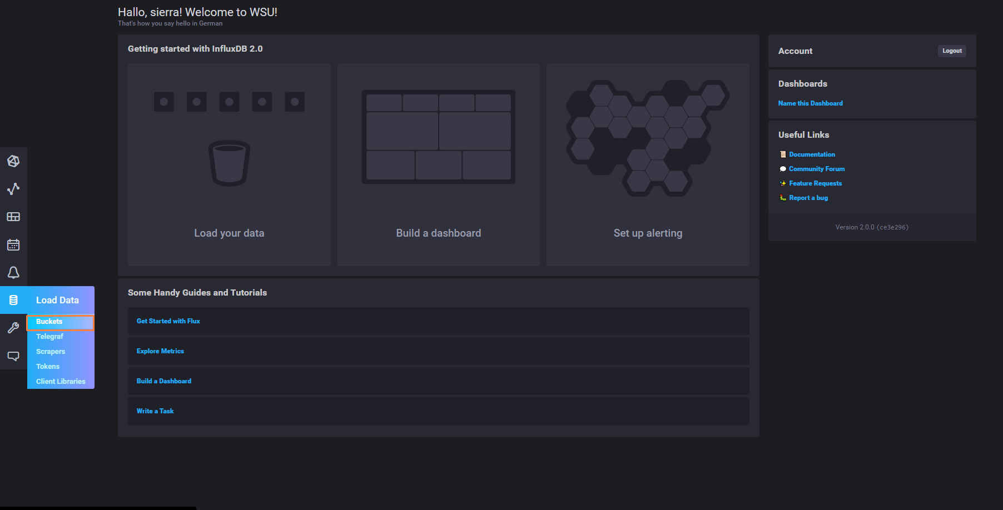



Add Data > Line Protocol

Line protocol has to be in specific format

* Device | value | time stamp (unix)
* PPA:443 value=0 1572976552167

Data adapter

long epochTicks = new DateTime(1970, 1, 1).Ticks;

long signalTime = 637085733521666000 - epochTicks;

TimeSpan convertedTime = new TimeSpan(signalTime);

“Dashboard” Configuration

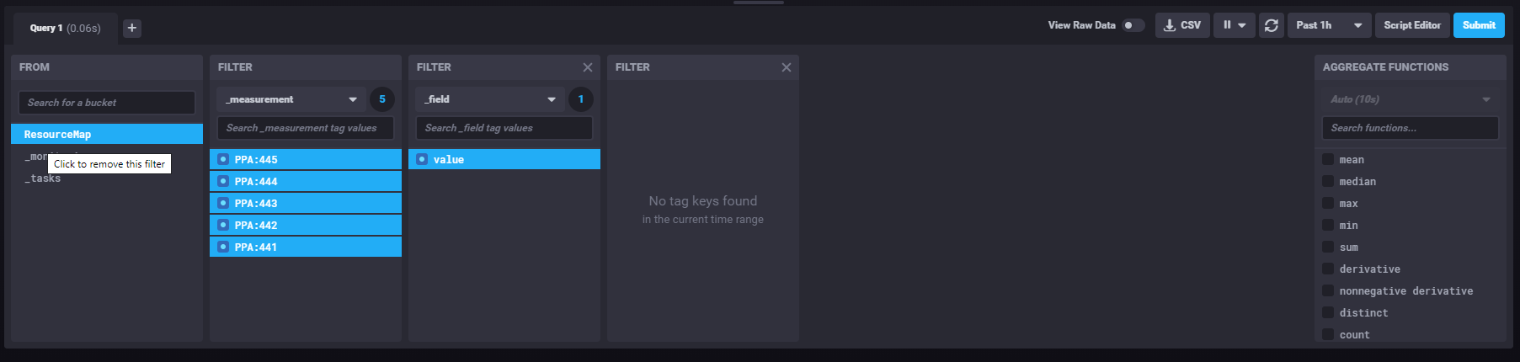

View dashboard

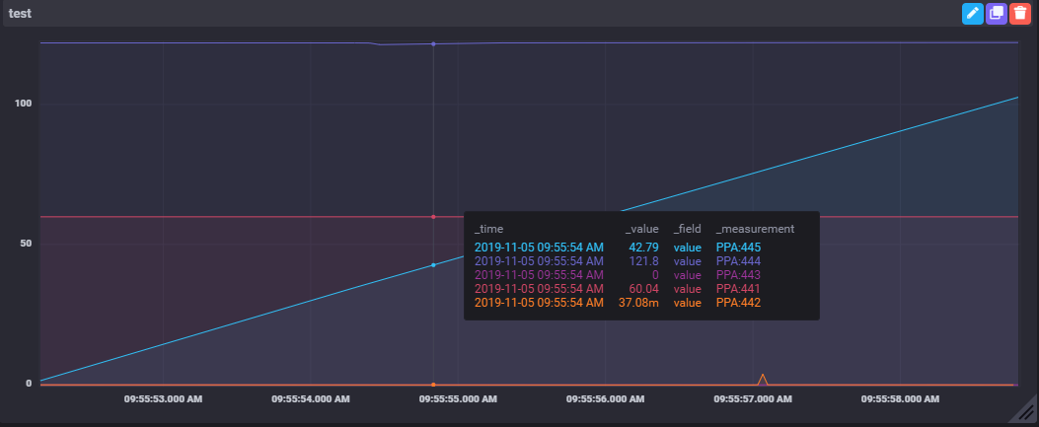

Working on Hooking up react app to influx db

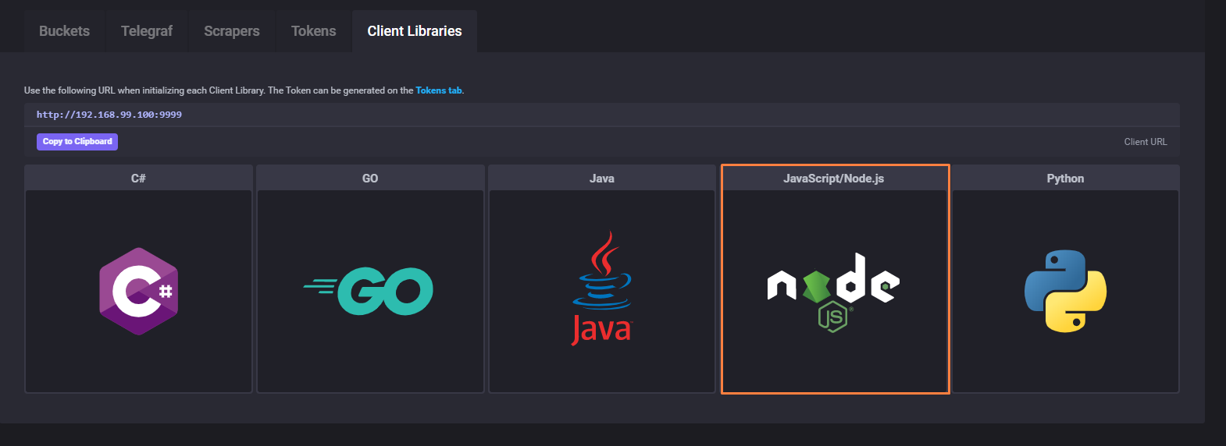

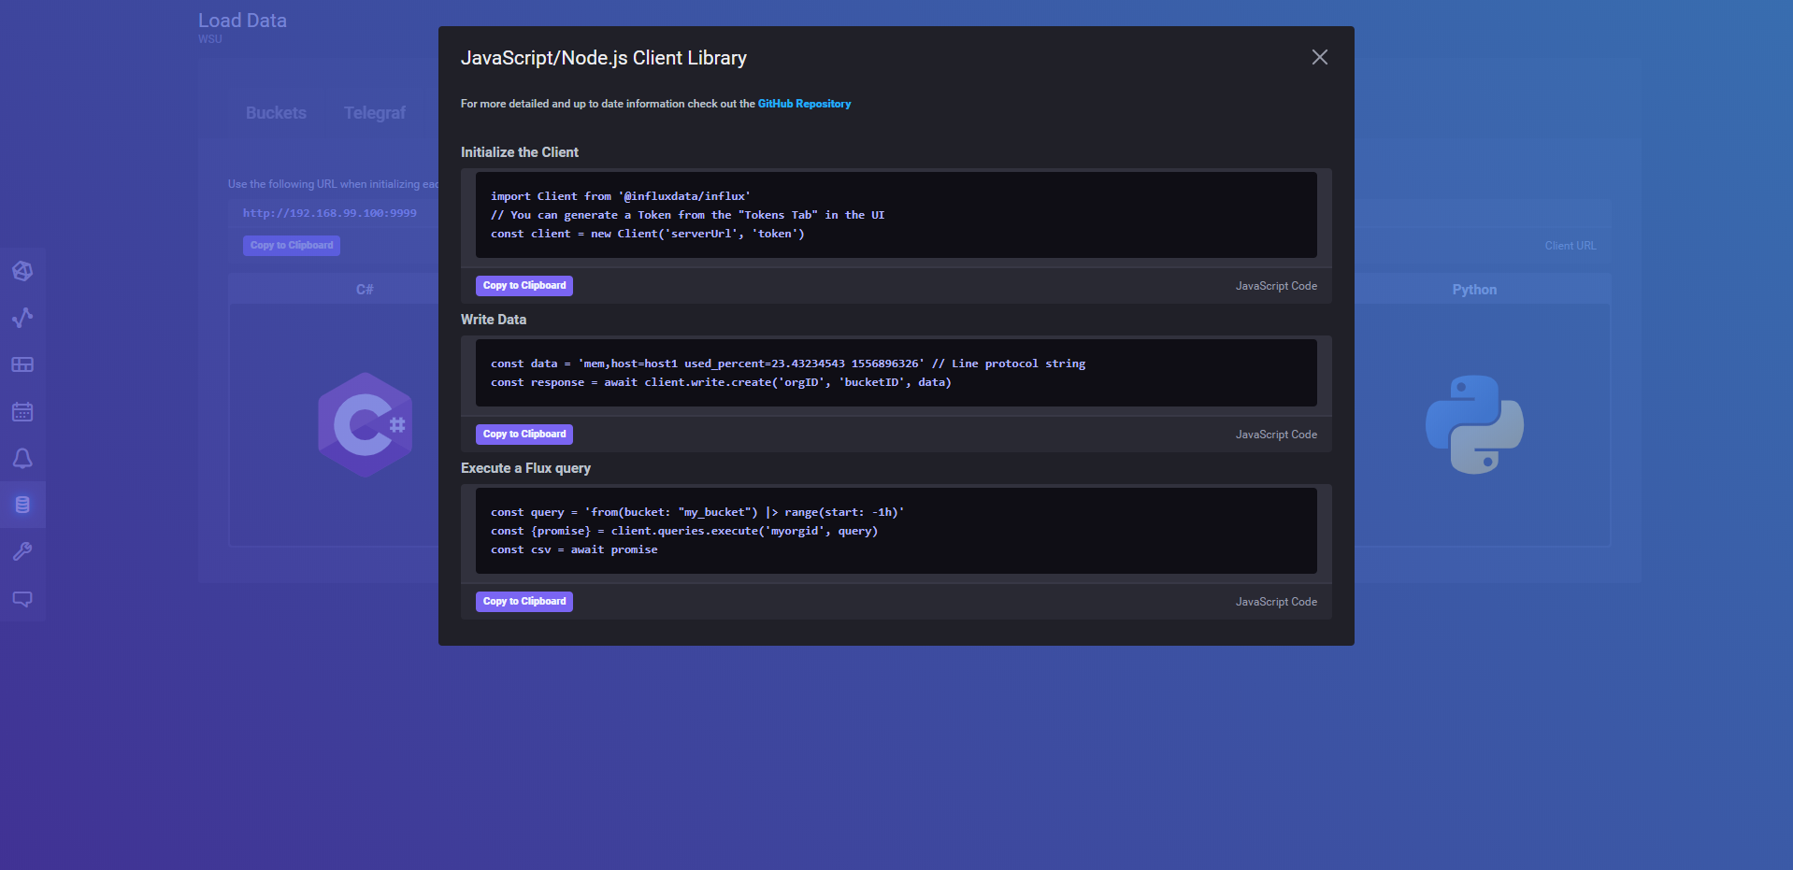

Helpful links:

See different Map designs that can easily be switched out. <https://leaflet-extras.github.io/leaflet-providers/preview/>

Used to create the grid <https://github.com/STRML/react-grid-layout>

Used to create the map <https://leafletjs.com/>

Used to create the graphs <https://github.com/uber/react-vis>

The time series database that will be used <https://www.influxdata.com/>