Ecotrend Ecologics logo

## ECOTREND APPLICATION INSTALLATION GUIDE

Important: The Ecotrend Contact Management Application requires that ASP.NET is supported by your web host. If you do not know if your web host supports ASP.NET, please contact your webhost or web operations department.

The Ecotrend Contact Management Application has been made available in a tarball and zip format.

**Web Server Installation Guide (Windows, Mac OSX, Unix)**

ASP.NET can be installed manually on a Windows, Mac OS X, or Linux operating system by following steps at <https://docs.asp.net/en/latest/getting-started/installing-on-windows.html>.

**Ecotrend Contact Management Application Installation**

Once ASP.NET is installed, the application can be installed by uploading the installation files to the root directory ‘wwwroot’ folder on your server.

The source files are contained in the ecotrend-install-files.zip. Extract the source files to the root directory of your ASP.NET web application to the ‘wwwroot’ folder.

Once you have deployed the application to the root directory of your DNS, your application will be officially live.

**Database Configuration**

The Ecotrend database contains information company name and location information that must be migrated to a new database that the Ecotrend Contact Management Application uses.

Before the migration occurs, you must run the SqlScript.txt contents in a database name of your choice. Once you have created the database and run the SqlScript.txt contents, you must configure the connection string in the Ecotrend application to reference your new database.

To reference your new database, open the ‘web.config’ file located in the root directory of the installation files.

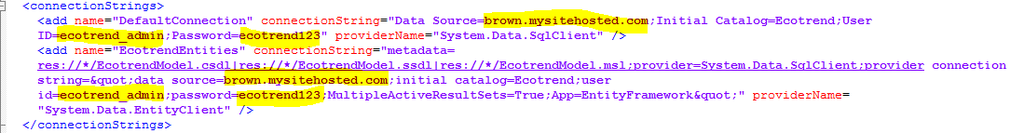Look for the ConnectionString tags. You will need to replace the yellow highlighted text with the new database address, username, and password that you recently created.

This company name and location is described in the chart below:

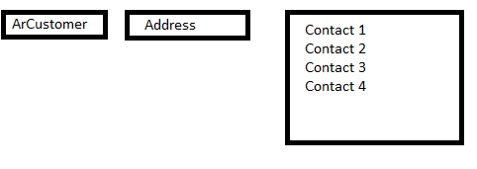

The ArCustomer and Address information must be migrated from the Ecotrend database to the Store table in the Ecotrend Contact Management Application database.

Any available from the ArCustomer table can be migrated if it fits the information in the Store table below:

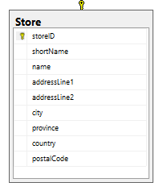

Once the migration is complete, store information will be available in the Ecotrend Contact Manager Application that allows contacts to be associated with a particular store location.

**Administrator Account Setup**

The Ecotrend application should now be running when your DNS address.

To setup the Administrator account, please follow the steps in the order below:

1. Create an test account to initialize the Ecotrend authentication tables.
   * <http://ecotrendproject.ahui09.com/Account/InitializeTables>
2. Create roles by running the script below in your newly created database.
   * INSERT INTO dbo.AspNetRoles VALUES ('admin', 'admin');  
     INSERT INTO dbo.AspNetRoles VALUES ('supplier', 'supplier');  
     INSERT INTO dbo.AspNetRoles VALUES ('salesrep', 'salesrep');
3. Create the admin account by visiting this address:
   * <http://ecotrendproject.ahui09.com/Account/Access>
4. You may now create salesrep and supplier accounts. On initialization of these accounts, your new users will be able to login to the default login screen that appears at the Ecotrend address DNS.
   * log into admin account

https://ssl.gstatic.com/ui/v1/icons/mail/images/cleardot.gif