New KiCad Project
Name → “esp32” in its own folder
Open schematic
“a” → add esp32-c3-wroom-02 (onboard antenna)
add: USB_C_Receptacle_USB2.0_16P
With footprint: HRO_TYPE-C-31-M-12
Add GND connection to GND and Shield
Add Pull-down resistors
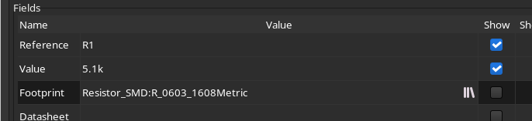
“Q” no connect SBU1 and SBU2
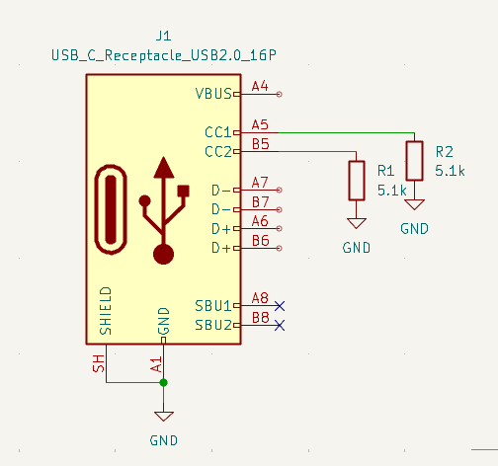

+5V flag at VBUS

PWR flag on +5V and GND

APK2112K-3.3
VIN: +5V
Decoupling cap 10uF rated at 10V to GND
Tie EN to VIN
GND TO GND
Decoupling cap 10uF rated at 10V to VOUT
Vout to 3.3V flag

D- tied together
D- is USB-
D+ tied together
D+ is USB+

Button: SW_Push
Button footprint:
Button_Switch_SMD:SW_SPST_PTS810

esp32 decoupling
3.3V to 3V3
Add 0.1u to GND, 17v rated
Add 10uF to GND, 17V too
Pull up 10k from EN to 3.3V
Add decoupling cap 1uF to EN

Io9: Pull up 10k to 3.3V
add switch to gnd

UART debugging:
Connector_Generic:Conn_01x04
Connector_PinHeader_2.54mm:PinHeader_1x04_P2.54mm_Vertical

I2C
4.7k pull up to 3.3V on Pins 2 and 8
SDA: IO2
SCL: IO8

Status LED:
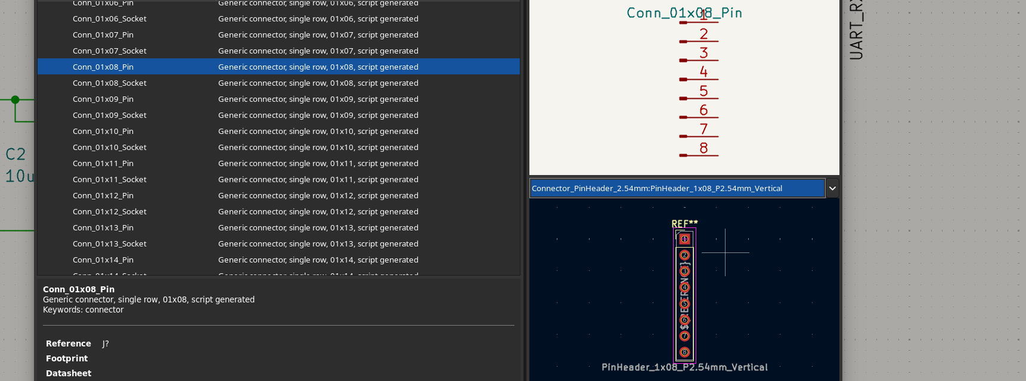
0603 and 1kohm resistor on GPIO10
ERC: Inspect → Electrical Rules Checker → Run ERC. Aim for zero errors, then read each warning instead of ignoring it. The SDA short only showed up as a warning (“Both GND and SDA are attached to the same items”), which makes it a good workshop example of why warnings matter.
- Highlight a net: select a wire and press ` (backtick) to highlight everything on that net. Click SDA and SCL in turn and make sure each lights up only its own pins. This would have caught both shorts.
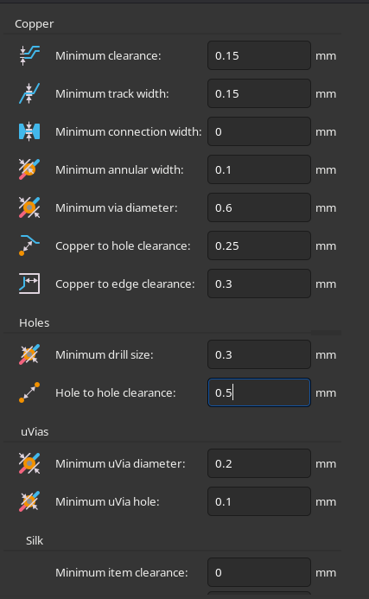
PCB EDITOR

