Influential factors analysis on visiting frequency of library websites
By Andy Tang

- Model
With the development of information technology and internet services, more and more information in paper form are changed into electric form, and shared by many people. Hence, the information on internet increases in unit of Terabytes, and begin to accelerate after entering into 21 century. Some large search engine companies, such as Google and Yahoo, begin to digitalize the books and put them into the website. Under this situation, library services must keep up with the step of the information era, combining the traditional library services with the newest information technology as soon as possible. Fortunately, many libraries have begun to melt them into this development trend positively. They build websites and put parts of digitalized information, including books, journal articles, and other information into it. Without doubt, this is definitely a right step to attract patrons and provide good services for them.
However, during investigation and survey process, aiming at the libraries which have built their websites and digital collections, many of them complain the low visiting frequency of their website by visitors. What is wrong with the library’s website? What kinds of factors affect and influence the users visiting libraries website? These are the questions which can be answered by this statistical report.

After analysis, some factors or variables which affect the library website visiting frequency are determined. The first one is the digital collection capacity which libraries hold or have. In usual, the digital collection capacity determines the number of materials, which libraries can place into the website. The second one is the evaluation on website usability by users. Many experiments prove that the interface design of website is a very important factor to affect the patrons visiting. The third one is whether the library outsources the website building task to some professional web design companies. In many occasions, web site design involves the skills on human computer interaction. Without practices on this aspect, without employing professional designers, it will result in a failure on web design and make the patrons feel disgusted and boring. Hence, these three factors are definitely the basic factors which affect and influence the library website visiting frequency.
Among the variables mentioned above, the dependent variable is “Visiting frequency on Library website, per IP address, per month”. It is affected or decided by 3 independent variables which separately are “Digital collection Capacity”, “Do libraries outsource website building to professional companies?”, and “Website Interface usability evaluation by users (1=most easy to use; 10=most difficult to use)”.

Website
Patrons Users
Visiting frequency on Library website, per IP address, per month. (DV)
Digital collection Capacity (10000)
(IV1)
Library
Website Interface usability evaluation by users (1=most easy to use; 10=most difficult to use)
(IV2)

Do libraries outsource website design to professional companies? (IV3)

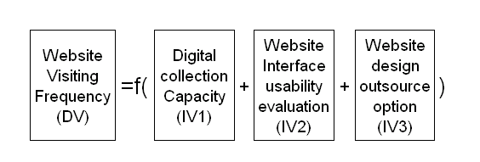

In some state, there are about 220 libraries distributed into different county. We draw a sample of 30 libraries randomly from it, hoping our research results can be a representation of whole body. Hence, the units of analysis, in this reports, is the library. After survey and investigation, the relative data are collected. Among 3 independent variables, “Website Interface Usability Evaluation” is used as the control group, with mere two values, which are “Yes”, and “No”.

- Descriptive statistic analysis on dependent variable

  - Web design outsource choice have a great influence on library website visiting frequency. (DV is cut by IV3)

Visiting Frequency
 | Outsource Choice=No | Outsource Choice=Yes
Mean | 11.73 | 22.73
Standard Error | 0.79 | 1.30
Median | 12 | 23
Mode | 12 | 22
Standard Deviation | 3.06 | 5.05
Sample Variance | 9.35 | 25.50
Kurtosis | -0.69 | -1.26
Skewness | -0.56 | -0.20
Range | 10 | 15
Minimum | 6 | 15
Maximum | 16 | 30
Sum | 176 | 341
Count | 15 | 15

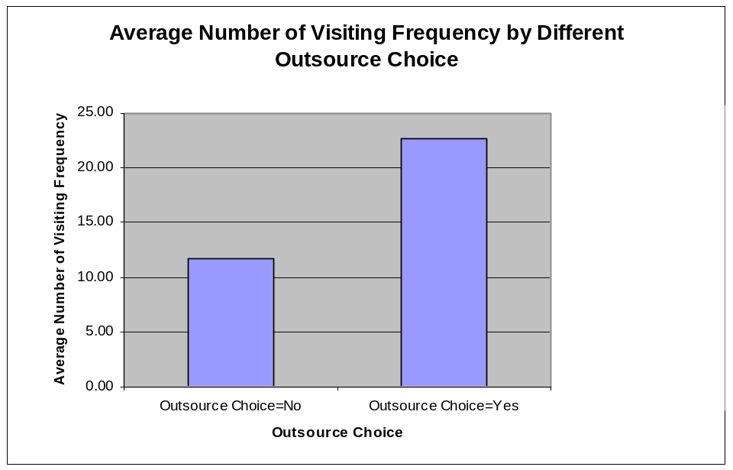

From above illustration which highlight on descriptive statistic analysis on dependent variable, when libraries choose to outsource the web design to professional companies, their average website visiting frequency is higher than the ones they choose not to outsource web design task. There is a 93.8% increase in visiting frequency on the library website when libraries choose to outsource than the ones when libraries do to outsource. Hence, it is very obvious that some professional web design companies are specialized and good at web art and human computer interaction. Compared with libraries, they are more competent on the aspect of web design, so it is very wise to outsource this task to them.
However, when library choose outsource web design task, the standard deviation on visiting frequency is 5.05, much more bigger than the situation when library choose not to outsource web design task. The reason comes from that, the levels of different web design companies have great difference. Some of them have a high level, but others not. Hence their web designs level difference lead to a big difference on visiting frequency of website.
  - Web design outsource choice seems to have an obvious influence on average digital collection capacity. (IV1 is cut by IV3)

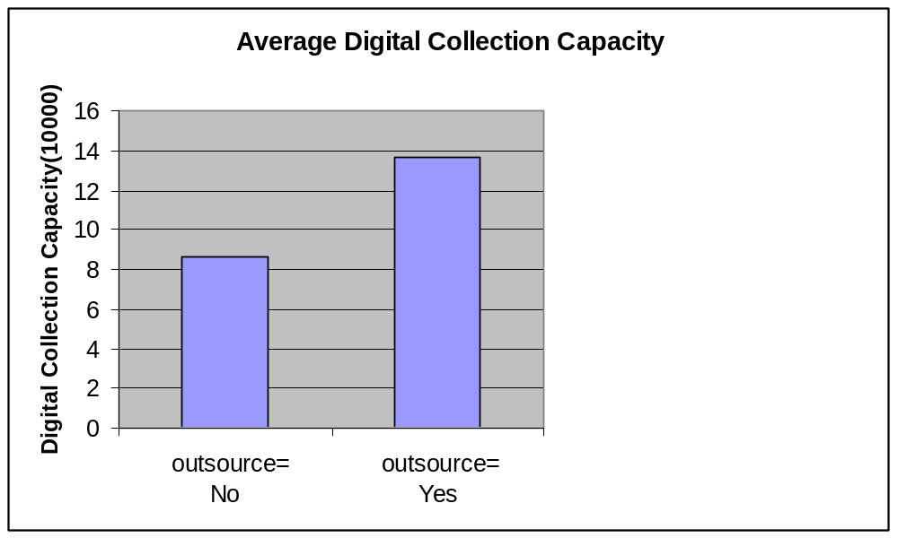
There is 57% increase on average digital collection capacity when outsource choice is "No", compared with the situation when outsource choice is "Yes". The reason maybe come from that, the libraries which choose to outsource their web design, have put too much strength into digital collection management, without strength diving into web design. Another reason may be that during digital library building process, libraries understand that the professional companies definitely have bigger predominance than libraries on web design. As a result, many libraries outsource this kinds of task to professional companies, and receive a good effect.

  - Web designs outsource have an obvious influence and effect on average website interface usability. (IV2 is cut by IV3)
There is 58% increase on website Interface usability evaluation when outsource choice is "No", compared with the situation when outsource choice is "Yes". It is very obvious that, outsourcing website design task to professional companies, increase the website quality and usability directly.

  - Visiting Frequency Distribution (DV Histogram analysis)
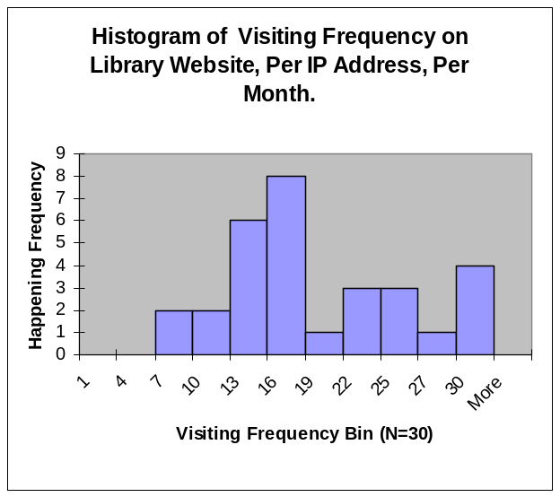

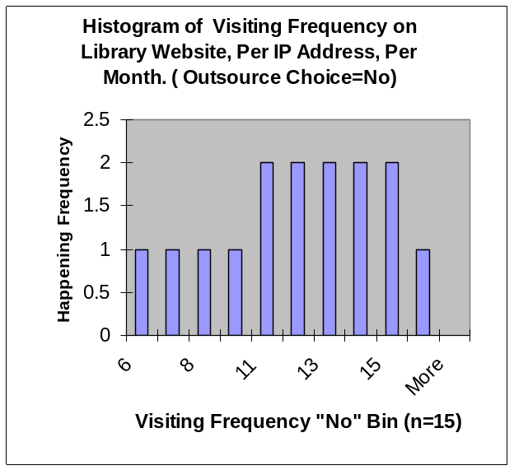

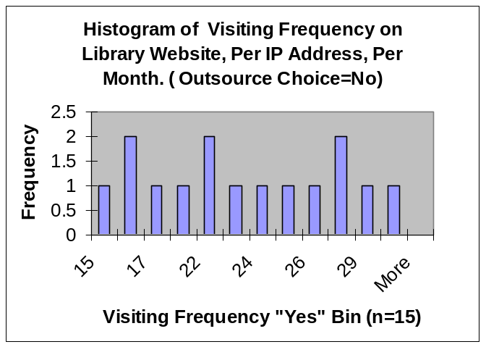

 | Visiting frequency on Library website, per IP address, per month | Digital collection Capacity(10000) | Website Interface usability evaluation by users (1=most difficult to use; 10=most easy to use)
Mean | 17.23 | 10.1 | 5.67
Median | 15.5 | 10 | 6
Mode | 15 | 12 | 7
Standard Deviation | 6.94 | 5.03 | 2.20
Sample Variance | 48.12 | 25.27 | 4.85
Kurtosis | -0.94 | -0.93 | -0.71
Skewness | 0.36 | 0.07 | 0.04
Range | 24 | 17 | 8
Minimum | 6 | 2 | 2
Maximum | 30 | 19 | 10
Sum | 517 | 303 | 170
Count | 30 | 30 | 30

From the illustration above, it is easily to identify that the distribution of sample is close to normal distribution. It is obvious that whole libraries website visiting frequency is 18 times per IP address, per month. However, when libraries choose to outsource their web design, visiting frequency by users is 23 times in average. Without outsourcing their web design task, visiting frequency of their website is merely 12 times in average. After analysis, a reasonable result comes out. Actually, the web design is a very professional job and requires acute art feeling, plus more knowledge on human computer interaction. The libraries, which build the web page by themselves, are deficient of the skill which professional companies have. So, the quality and usability of their web page is very low, directly leading to a low website visit frequency. Fortunately some libraries know about this, they outsource the web design task to some professional companies, having a good effect and attracting many users to visit the website frequently.

  - Relationship between Visiting Frequency on library website and Digital Collection Capacity. (Scatter plot on DV and IV1)

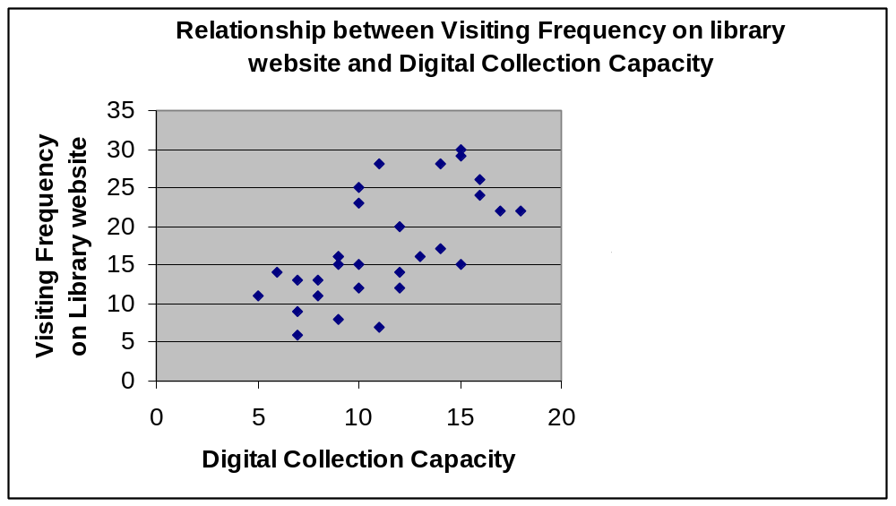
From the illustration above, it is obvious that, with the digital collection capacity increase, the visiting frequency on library website also increases. Hence, libraries should unite to solve the copyright problem, in order to increase the digital collection capacity, as soon as possible.

  - Relationship between Visiting Frequency on library website and Website Interface usability evaluation. (Scatter plot on DV and IV2)
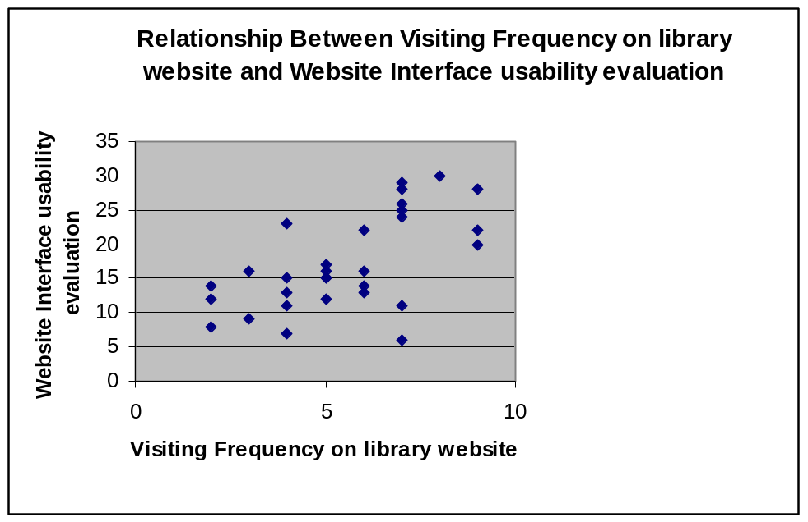
It is obvious that, with the website interface usability evaluation improving, the visiting frequency on library website also increases. An easy used website definitely attracts users to visit it frequently.

  - Relationship between digital collection capacity and website Interface usability evaluation by users. (Scatter plot on IV1 and IV2)
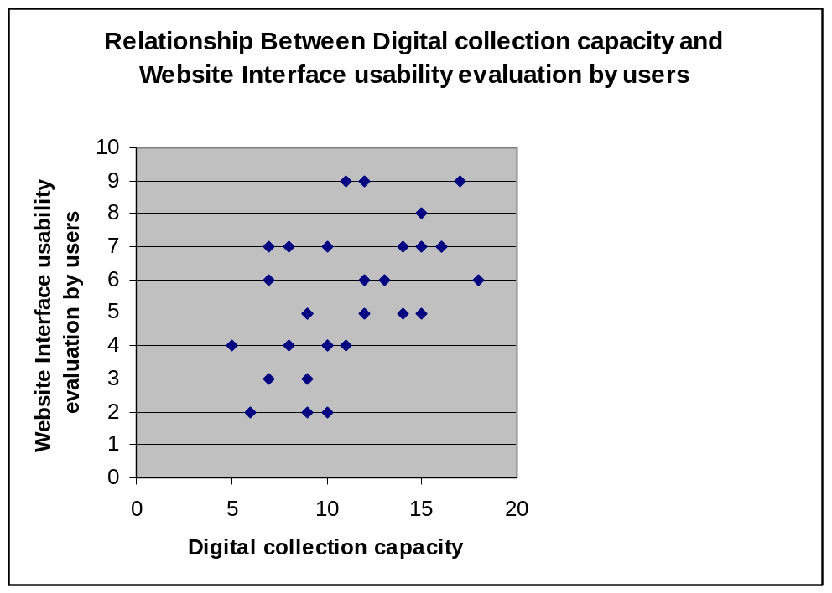
From the sample data, it is obvious that with digital collection capacity increasing, the website interface usability evaluation by users also increases. The reason maybe come from that, the library which put their efforts to enlarge digital collections, also knows the importance of web design.
In total, visiting frequency on Library website definitely are affected and influenced by 3 variables, which are separately “Digital Collection Capacity”, “Web Design Outsource Choice”, and “Web Interface Usability Evaluation”. On the paper2, the correlation between different variables will be calculated to measure the close degree of them.

