# Groundwater flow and transport interactive exercise

Andy Banks and Mary Hill

In this project you will be managing a subsurface hydrologic system with contaminants and a single pumping well. You will be provided some prior knowledge of the hydrologic characteristics of the system. Using this prior knowledge, your objective is to estimate maximal pumping rates such that no more than 50% of the contaminants enter the well.

MODFLOW and MODPATH (both distributed by the U.S. Geological Survey) will be used to simulate groundwater flow and particle advection, respectively. MODFLOW is a modular finite difference flow model based on the groundwater flow equation. MODPATH is a post-processor that simulates particle advection based on models of groundwater flow produced in MODFLOW.

The interface you will be using was developed in MATLAB, and provides the capability to alter certain elements of the input files used by MODFLOW and MODPATH.

***NOTE – the* interface was developed using MATLAB R2015a on a Windows machine. If you need to download MATLAB Runtime, get version 2015a. The interface was not tested on Macintosh or Linus OS.**

## Preliminary Steps

Install the directory on your computer from the supplied zip drive. Try executing the program InteractiveGroundwaterModule.exe by double clicking the name from the Files Explorer window. If the first and then the second image shown in Figure 1 are produced, you can skip to the next section. Otherwise, proceed with one of the alternatives described next in this section.

|  |  |
| --- | --- |
| C:\Users\a561b615\Desktop\Modules\v1OUT\end_user\splash.png |  |

Figure 1. If executing the program InteractiveGroundwaterModule.exe produces the first and then the second image, it is working properly.

To run the interface, you will need a version of MATLAB ***or*** a free software package called [MATLAB Runtime](https://www.mathworks.com/help/compiler/deployment-process.html). This section helps you make sure you have what is needed on your computer.

### Use MatLab already Installed on Computer

If you already have a version of MATLAB on your computer, start MatLab and enter “mcrinstaller” into the Command Window, as shown in Figure 2A. If the output looks like this, you can proceed to the next section of this file if the results are as shown in Figure 2B.

A

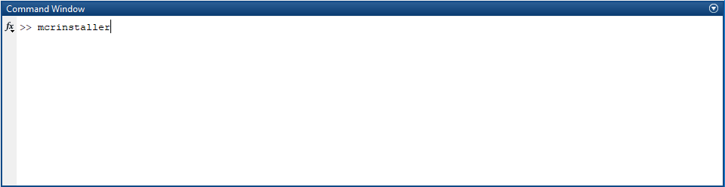

B

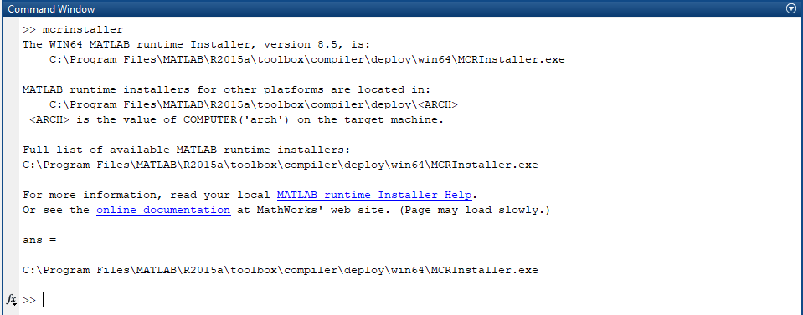

Figure 2. MATLAB command windows showing (A) The command to enter, and (B) results that indicate you are ready to proceed.

### Use free software package called [MATLAB Runtime](https://www.mathworks.com/help/compiler/deployment-process.html)

You need administrator privileges on your computer to install MATLAB Runtime.

To install MATLAB-runtime, do one of the following.

1. Navigate to <https://www.mathworks.com/products/compiler/matlab-runtime.html> and download/install version R2015a (or later) of MATLAB Runtime. Save the file and double click to execute it.

Or

1. Double click the already downloaded 01-MyAppInstaller\_mcr.exe file. Follow the installation process. This can take a few minutes.

## Start the Exercise

Once you have MATLAB Runtime installed, download the files associated with this exercise and navigate to the directory …\GWM\_project.

Double click 02-*InteractiveGroundwaterModule.exe*. If the program launches, you will see the left image appear. When the program has finished loading, the right window will appear

Explore any of the six tabs near the top of the window.



Each tab contains information about the model you are constructing. As you click the tabs the images will be in map view.

Zoom, pan and rotate the any model image using the toolbar right above the tabs. The labels on the pumping well are readable from any angle except map view.



A brief explanation of each tab is as follows.

**Boundary Conditions** tab: Shows a graphical representation of the model boundary conditions. In this project, the boundary conditions cannot be changed.

**Initial Conditions** tab: Shows information about the initial guess for hydraulic heads input to MODFLOW. This is a user defined and does not reflect a solution of the groundwater flow equation. Note the unrealistic abrupt head change at one end and the completely flat head distribution over the rest of the model. Such a head distribution would not be able to conserve mass as required by the groundwater flow equation! This tab also provides the option to change the thickness of the aquifer, and the option to specify whether the aquifer is confined or unconfined.

**Parameters** tab: Modify the hydraulic conductivity, specific storage, specific yield and porosity.

**Pumping and Recharge** tab: Modify surface recharge and pumping rates.

**Run MODFLOW/MODPATH** tab: Modify time discretization. This tab also provides a model summary.

When you’re ready to run the model, go to the **Run MODFLOW/MODPATH** tab and click “Run MODFLOW/MODPATH” button.



Two terminal windows will open sequentially and you should see that MODFLOW and MODPATH have executed. This may take a moment depending on the abilities of your computer.

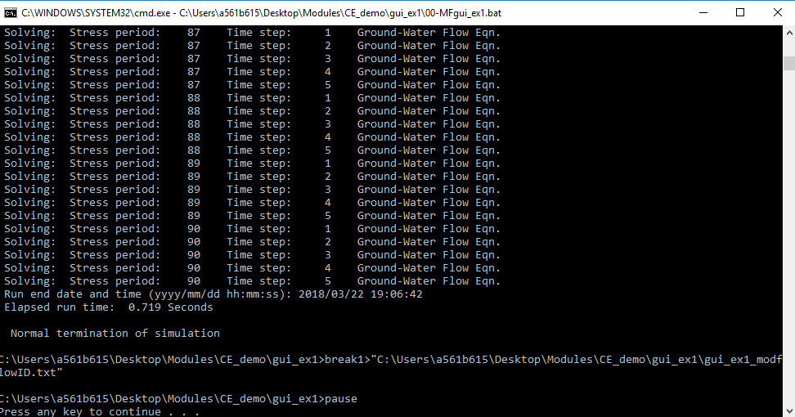 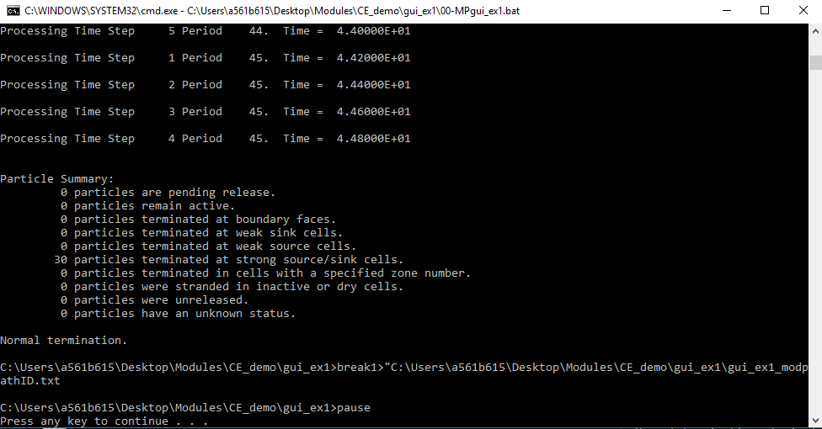

After MODPATH and MODFLOW have run, a second interface window should appear. This one should have two tabs, **Hydraulic Head** and **Particle Tracking**. Use the sliders and other features on each tab to see the time-evolution of the hydraulic head distribution, and particle trajectories.

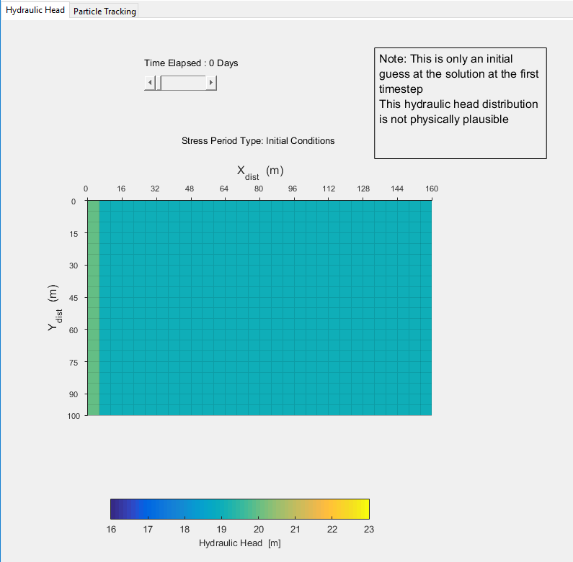

## Problem for the Exercise

You are a consulting a commercial bean farmer named Jillie. Jillies farm manages (~6000 acres total) that require a cumulative total of no less than .0016 m of water per unit area, per day, over the course of 360 days to grow properly. This results in a cumulative total of 0.58 m (22'') over the area of the bean crop. In the past, precipitation has been sufficient to keep her beans watered. However, in recent years, drought conditions have decreased her yield significantly. To compensate, Jillie drilled a water well on her property which provides water for irrigation. Unfortunately, she failed to account for the proximity of her water well to several nearby zones of contaminated groundwater. Jillie needs to know the highest rate she can pump water without capturing too much contaminated water.

Last year, only 11 inches of precipitation fell. To supply the remaining ~11 inches/acre of water, she will need to extract a daily minimum of 75,000 cubic meters per day of water, over the course of 360 days. (to provide 11 inches of water over the area farmed) Using this value as a constraint on the minimal pumping rate, your task is to use the interface to determine the maximal possible pumping rate while capturing no more than 50% of contaminants in the system.

You know a-priori that the area receives a uniform recharge rate of 0.05 (+- 0.01) meters per day. Based on data you previously acquired from the USGS, you have estimates of specific storage (10-6, uniform), specific yield (0.2 or 20%, uniform) and porosity (0.25 or 25%, uniform).

The Aquifer in this region is known to have a saturated thickness between 180 and 200 m, with a surface elevation of 300 m. Question 0: Is this a confined or unconfined aquifer? Using this answer, is the head surface a water table or potentiometric surface?

A problem is that we do not know the value of hydraulic conductivity precisely. We do know that it is within an order of magnitude of 10 m/day, and that the anisotropy factor is 1. We do not know whether any heterogeneity is present, but for now we will assume K is homogenous (make sure case 1 and case 2 are UNCHECKED).

1. When first accessed under the Initial Condition Tab you will see the following, the system shown is unconfined. Why is this obvious? Identify the water table.

\*\*\*

1. In this exercise, you will be changing Q and K to different values and performing simulations for each set of values. Find where the values of K is controlled in the Parameters and Q is controlled in the Pumping and Recharge tab.

To ensure that wells do not become too polluted by a substance being transported through the aquifer, change K and Q to find the highest rate the well can be pumped while capturing no more than 50% of the particles. Consider K values ranging between 10 and 100 m/day. You should see that larger pumping rates can be achieved using higher K values. For this problem, verify the following results.

ANS for K = 10 m/day Q >= -1.08x104 m3/d

ANS for K = 100 m/day Q = -9.83 x104 m3/d

1. The same analysis is repeated in a very similar area owned by Jillie’s friend Billy, but in this valley there is layer of fine floodplain silt that creates an aquifer 100 m thick. You can simulate this system by lowering the elevation of the top of the aquifer. Do this in the Initial Conditions tab. Repeat question 1 under these conditions.
2. Yet another neighbor, Kelly, has land where there is a high K unit along the length of the valley. In her area the aquifer is unconfined as it was for Jillie’s farm. Repeat questions 1 under these conditions.