Results

Summary Statistics:

Total number of articles containing each of the keywords at least once in each year. This can also be done by month. All articles is the total of number of articles returned by a search that does not specify a keyword, which is assumed to be the overall total.

|  |  |  |  |  |
| --- | --- | --- | --- | --- |
| Year | ‘System’ | ‘Systematic’ | ‘Systemic’ | All ARticles |
| 2007 | 499 | 92 | 16 | 4186 |
| 2008 | 488 | 101 | 22 | 4015 |
| 2009 | 535 | 119 | 24 | 4065 |
| 2010 | 532 | 107 | 29 | 3852 |
| 2011 | 547 | 119 | 34 | 3889 |
| 2012 | 539 | 120 | 40 | 3758 |
| 2013 | 563 | 128 | 40 | 3737 |
| 2014 | 552 | 125 | 35 | 3771 |
| 2015 | 551 | 131 | 58 | 3816 |
| 2016 | 320 | 77 | 29 | 3585 |
| 2017 | 336 | 92 | 20 | 3534 |
|  |  |  |  |  |
| total | 5462 | 1211 | 347 | 42208 |
|  |  |  |  |  |

Upward trend and then a correction. Correcting for total number of articles flattens pattern but still distinct.

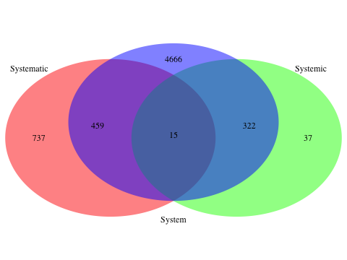

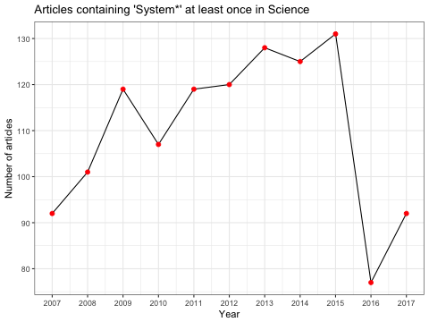

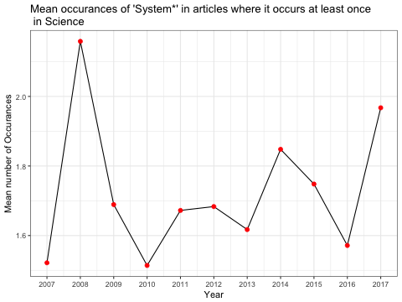

No apparent pattern in mean number of occurrences. Similar for other keywords. Possible data issues, remove 2016/2017?