MOBILE app using IONIC 2.0 and Angular 2.0
Author: Andrew Ton, April 2017

This document contains the screen shot of a mobile app I wrote, which I use IONIC 2.0 with Angular 2.0 (ECMAv6). It therefore a hybrid mobile app that can run on all three mobile platforms, Iphone IOS, Android Phone, and Windows phone. IONIC 2.0 allow you to access native device features, without have to write native in each of three platform separately.

This App have Search capability (asset by barcode), it can geolocate a base on Google map, it can filter all asset belong to a base, and most important is that user can edit/update data in “offline” mode and later sync via Rest to central NodeJS MongoDB when connectivity is available. This is very important when user is in secure environment where connectivity is in black out mode.

The sync feature is being implemented, and those screen will be available soon. I also create a video demo of this app running live, so I will upload the video to Google Drive and link will be available.

All data and scenario in this app is fictional, but practical, so informations here are not classified. Please forward any question of this app and my development service to andrewtonibm@gmail.com, 858-280-9940

Video demo of this app avail at: [to be upload soon]

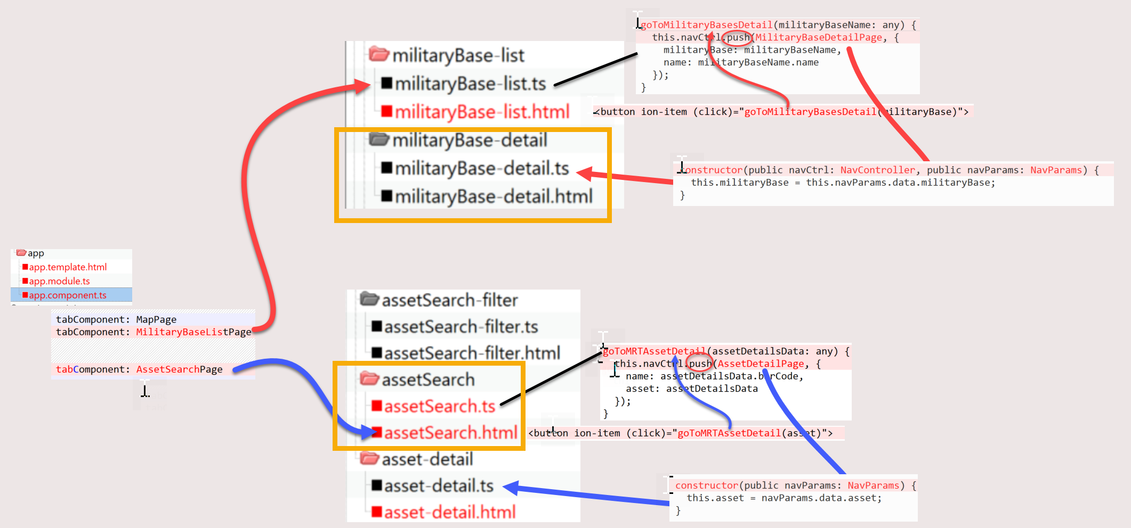
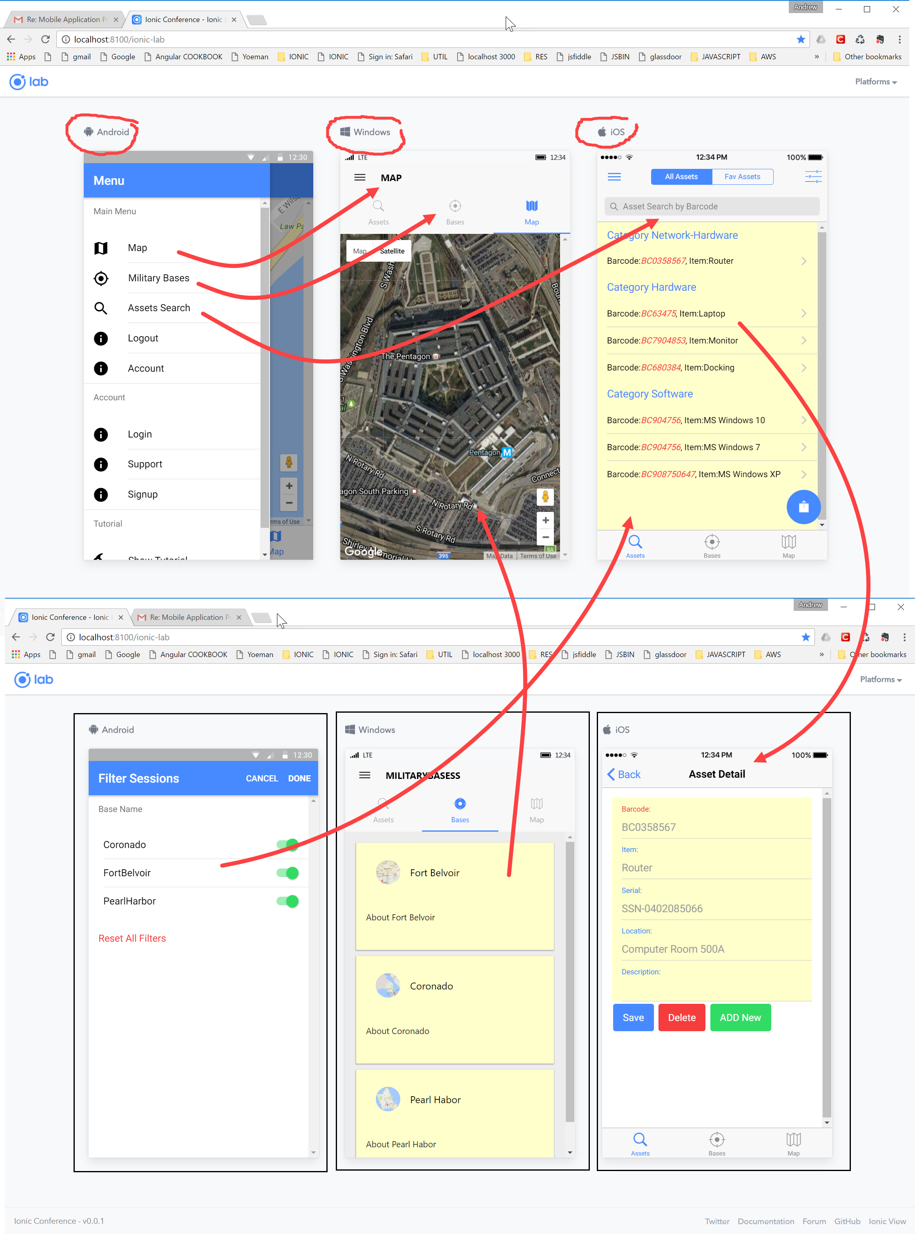
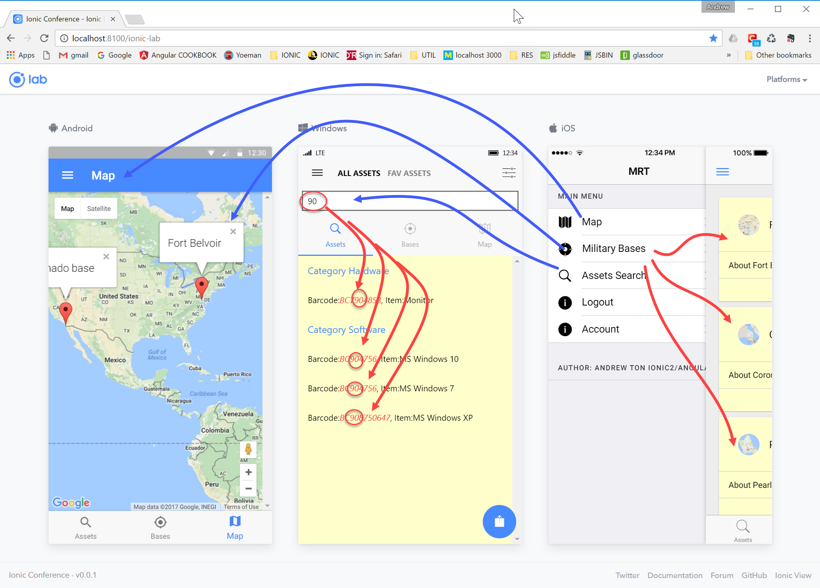
SYNC Button for marking this record needing to be sync automatically when connectivity is available

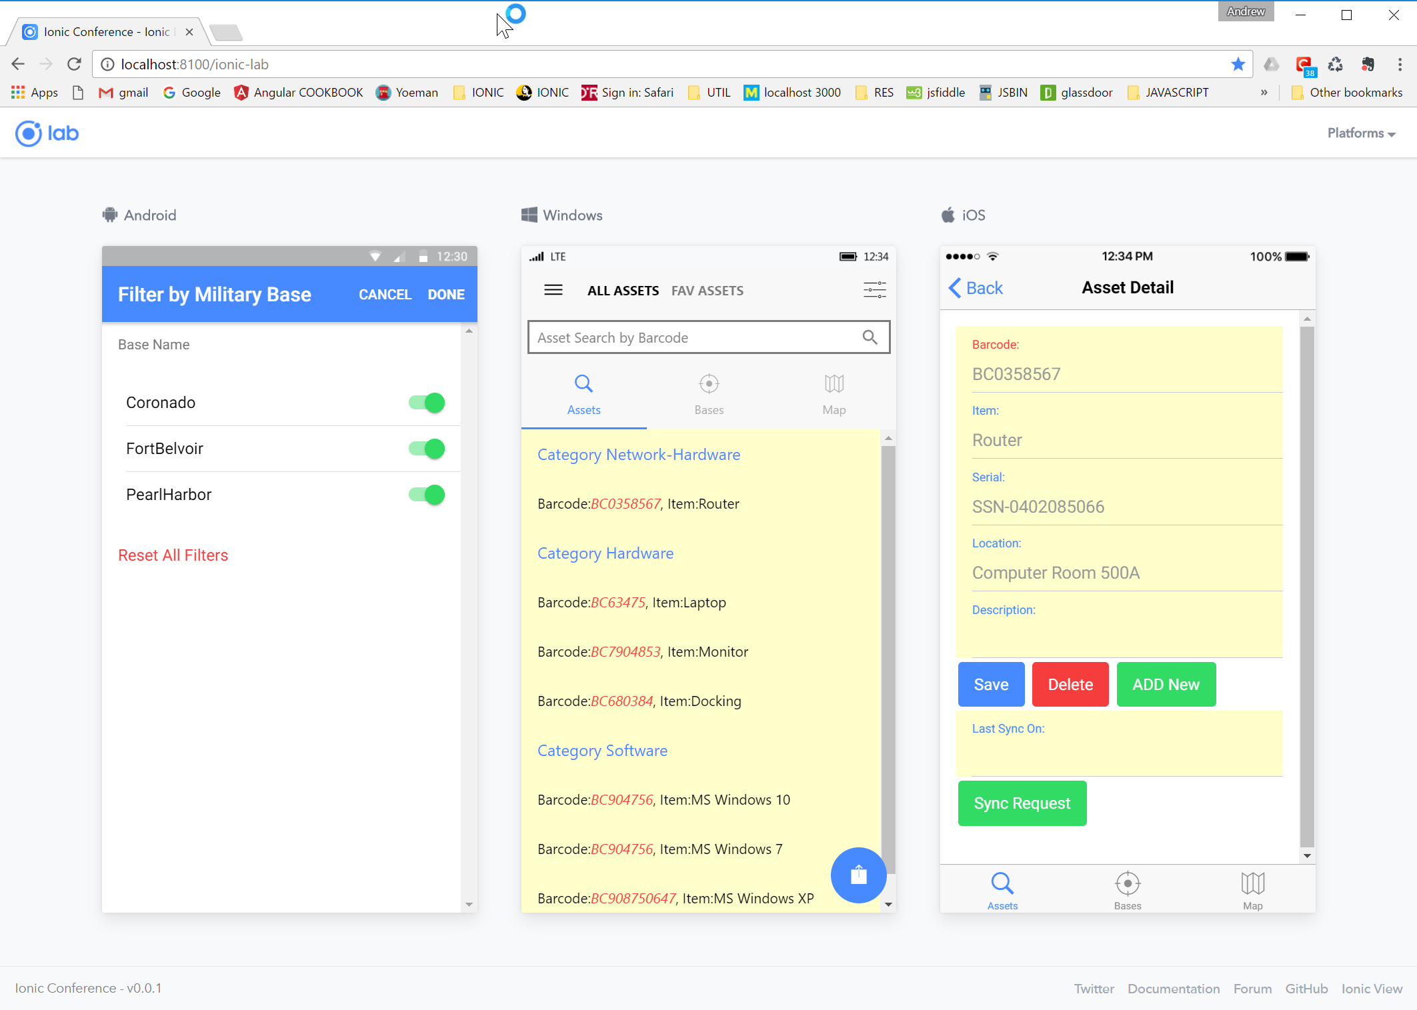
SEARCH for all match barcode with “7”

