Daniel Zhang

Lab Partner: Logan Codella

9/6/11

Effect of the Arm Length on the Period of the Pendulum

In class, Dr. Sohl was talking about her grandmother clock. She said the pendulum in her clock was swinging too slow. Groups came up with changing the bob mass, arm length, angle of release, and bob shape to make the pendulum swing faster. The question is whether a change in the arm length would affect the period of the pendulum, the amount of time it takes for the pendulum to swing forward and back. It seems logical that the shortening the arm length would reduce the period, because the pendulum would have less distance to travel. Thus, it was hypothesized that if the arm length is shorter, the period is faster because it has less distance to travel. The independent variable is the arm length. The dependent variable is the period time. The bob mass, angle of release, and the way it is release are all constants. In the experiment, the period was measured three times for a 30 cm arm length. The arm length was shortened each time to a 25 cm, 20 cm, and 15 cm arm length.

|  |
| --- |
| Effect of Arm Length on Period |
| |  |  |  |  |  | | --- | --- | --- | --- | --- | |  | 30 cm | 25 cm | 20 cm | 15 cm | | Trial 1 | 1.1 s | 0.9 s | 0.9 s | 0.7 s | | Trial 2 | 1.1 s | 0.7 s | 0.7 s | 0.5 s | | Trial 3 | 0.9 s | 0.8 s | 0.6 s | 0.5 s | | Average | 1.03 s | 0.8 s | 0.73 s | 0.57 s | |

The pendulum was hung against a cabinet and the period was measured with a stopwatch. Materials required were tape, a protractor, a meter stick, stop watch, scissors, and a pendulum. Using a meter stick, 50 cm of string was measured out so that there are extra. One end of the string was taped to a weight and the other end was taped to the top of a cabinet so 30 cm of string was hanging down. Pendulum was released at a 30° angle and the period was measured three times. The string was then reduced to 25 cm and the process was repeated. Then it was repeated for 20 cm and 15 cm. As a safety precaution, wear closed toe shoes in case if the pendulum falls on someone’s foot.

Clearly the graph shows a trend in the period as the length of the string is reduced. The period time is faster when the string is shorter. Although there was human error in the timing, they weren’t enough to alter the results.

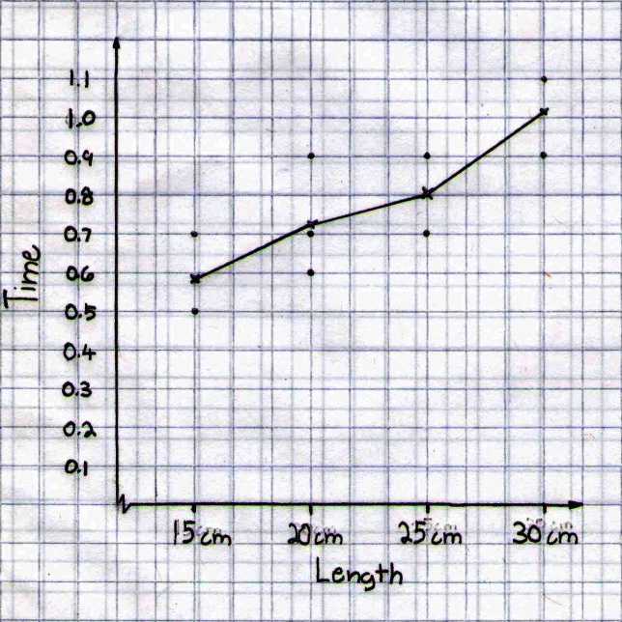The data showed that if the arm length of a pendulum is reduced, the period time is reduced. The data in the other people’s experiment also showed a trend. The other people’s results did show a few errors in timing, but there is still a trend. There were no errors in the procedures, because they were perfectly executed. The only error in the experiment was the timing. Sometimes the reaction was too early or too late and that affected the data a little bit. However, the errors weren’t enough to change the results because the averages show that a steady rising. The groups that test angle of release said that release angle has no effect on the period because if there’s a higher release angle, it goes faster but has more distance to travel. If it’s a lower release angle, it goes slower but has less distance to travel and they balance out. The results that came from the groups that tested bob all contradicted each other. The weights were different shapes and they had different surface area and that may have affected their results. If they had materials of density they could have used them and the bobs would be the same shape but different mass. The group that tested bob shape came up with the conclusion that the normally released pendulum was the fastest. The results aren’t convincing enough unless there are more trials and there are more shapes. In conclusion, the data does support the original hypothesis that the arm length is shorter, the period is faster. In real life, people can use this to fix their pendulum in their grandfather clock and tell the time.