**Analysis of Quantizer Performance**

|  |  |
| --- | --- |
| Date: | 21 January 2017 |
| Compiled by: | Andrew van der Byl |
| Position: | Signal Processing Engineer |
| Department: | CBF |
| Compiled for: | CBF |
| Release Status: | Internal |
| Revision: | 0.2 |

**Introduction:**

This documents serves as a summary of analysis of the quantizer block as found in the F-Engine. All tests were performed in Matlab/Simulink using the same quantizer as found in an F-Engine. The document will cover:

* Histogram testing
* Linearity testing

**Quantizer Specifications (F-Engine):**

Test input word length: 8 x 10 bit (17 bit fractional) words per polarization.

Output word length: 8 x 8 bit (7 bit fractional) words per polarization

Test vector length: 16384 samples

Test vector magnitude range: 0.125 (case 1)* and 1 (case 2)*

Test vector tone frequency: 49.94726563MHz (bin center) + 20989Hz (offset)

Test vector noise dithering: 0.001

Equalizer scale: 8 (real) (case 1)* and 1 (real) (case 2)*

**Histogram Testing:**

The aim of the histogram test is to determine if all bits are used in correct proportions when a sinusoidal input is applied. This test is applied through two test cases to illustrate the effects. In each case the EQ values per polarization are set depending on the scale of the input tone and are real valued only.

Case 1:

Test vector scale: 0.125

EQ: 8 (real)

Histogram bins = 128

To ensure the input is correct, the test is applied to the input test vector. The results are shown in Figure 1.

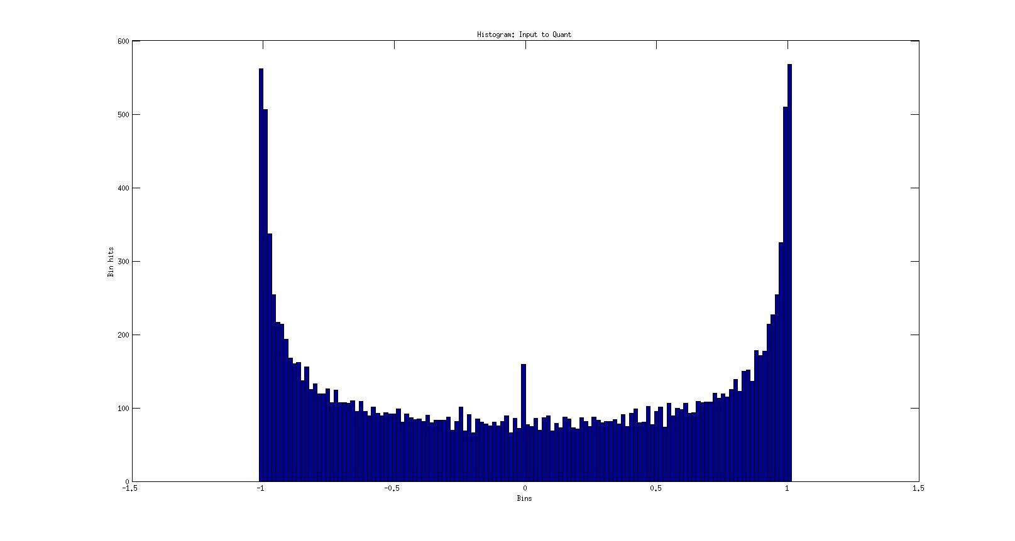

Figure 1: Histogram on the input test vector. The vector length is a power of 2 (length 214) as is the number of bins (27) used in the histogram. It is expected to see ‘peaks’ in the histogram for bins corresponding to the values which are near the peak values of the sinusoid as the number of occurrences is the largest. The input vector also has AWGN added. The ‘spike’ occurring slightly off center is due to the combination of zero and 2-6 valued samples. As will be discussed shortly, the bin ranges change as the samples are passed through the quantizer resulting in slight changes to the distribution.

In this case, the input tone is set to a scale of 0.125. For the tone to reach full scale, the EQ is set to 8 (real). The histogram is shown in Figure 2.

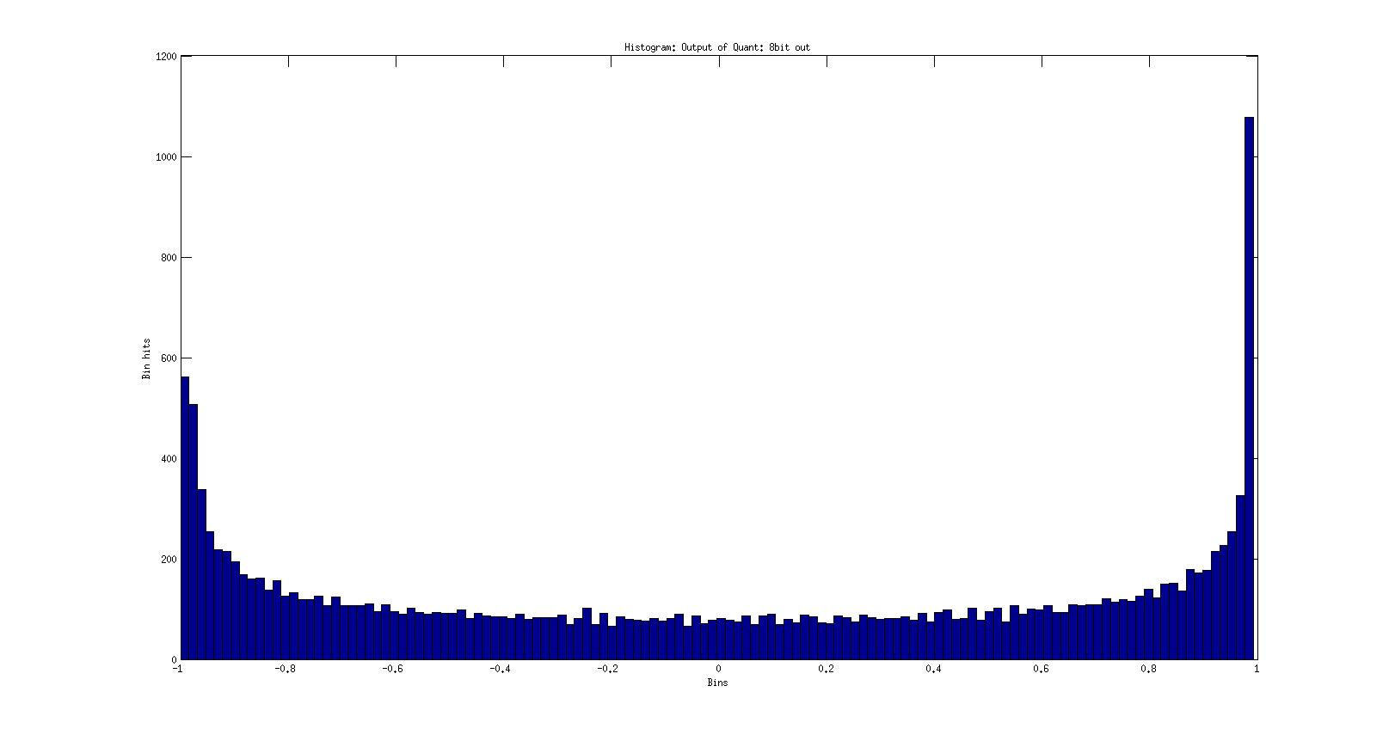

Figure 2: Histogram of the output of the quantizer. This is before any 2-(N-1)-1 correction.

Figure 2 illustrates the quantizer output before any value correction(-1 changed to 2-(N-1)-1). The histogram has the characteristic shape as would expected except has the bias where -1 can be represented where +1 cannot for a signed fixed point representation of 8.7 bits (7 bits allocated to fractional representation, and the 8th bit is sign). Figure 3 represents the histogram of the bias corrected vector.

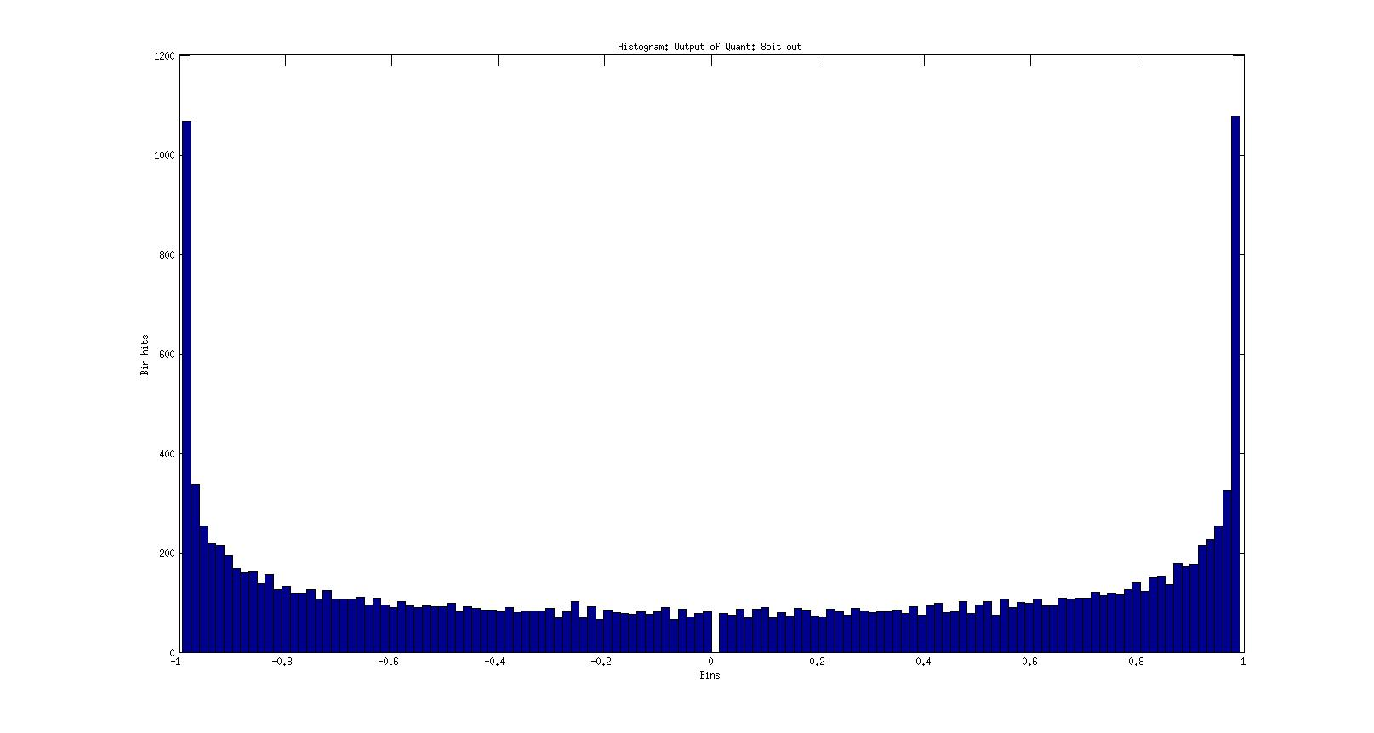

Figure 3: Histogram of the bias corrected vector. The histogram shape is correct except for the bin 0 which is of zero value.

Figure 3 represents the histogram of the bias corrected vector. As can be seen, bin 0 has a zero hit rate. To understand this condition, it is necessary to take a closer look at the range values attributed to the zero bin and the adjacent bins. Figure 4 illustrates this.

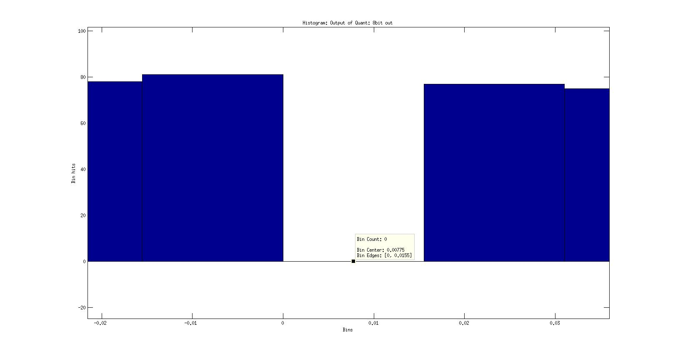

Figure 4: Close up vies of bin 0. The hit rate is shown to be zero for (0 < sample <= 0.0155). It should be noted that a sample of zero *is not* included in this bin hit count.

Taking a closer look shows that bin 0 has a range of 0 to 0.0155. The adjacent bin to the left covers samples with values -0.0155 to 0. The import thing to note here is that an exact value of 0 is allocated to the left adjacent bin, and *NOT* bin 0. That means bin 0 is inclusive of values greater than 0 but less than but equal to 0.0155. For a value count of zero for bin 0 means the least significant bits in the final quantizer output is not toggling exclusively (after the bias correction)(i.e. while all other bits remain zero). This in itself appears problematic, but in this case the EQ value is of significance. For a signal to be represented in full scale (±1), the EQ is required to be set to 8 as the input is set to a value of 0.125. An EQ of 8 is an equivalent of a bit shift to the left by 3 bits. As a result, any sample that is valued 2-7 natively is bit shifted to the left by 3 bits. Looking at this through histogram representation reveals this situation as the bin covering the range 0 to 0.0155 has zero hits.

A question arises: Why is the output of the quantizer before the bias correction appear ‘correct’ (i.e. Figure 2)? The answer: It isn’t – a closer inspection will reveal this. Taking a closer look at Figure 2 (the same bin region as Figure 4) reveals a subtle difference (Figure 5): The bin ranges differ. This causes a difference is visual representation.

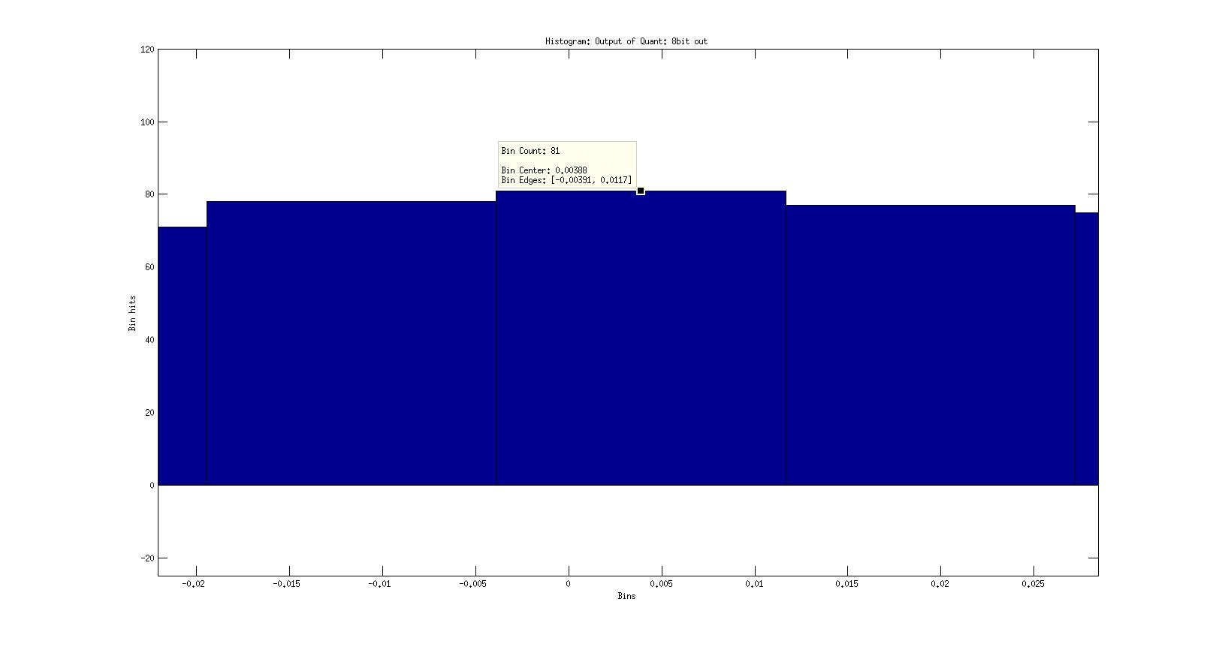

Figure 5: The center and adjacent bins. The center bin in this case is not zero valued as the edge limits of the bins has changed. In this case the center bin limit is -0.00391 to 0.0117. A sample value of zero would therefore be allocated to this bin.

Figure 5 shows a close-up view of the output of the quantizer before bias correction. The bin edges are however different when compared to the edges of the output after bias correction. The bin edge change for the bias corrected output occurs due to the change in full scale that occurs in bias correction. The full range output of the quantizer before correction ranges from -1 to 0.9922 (bin resolution 0.0155640625). After correction the full range output is changed to -0.9922 to 0.9922 (bin resolution 0.015503125). The range difference changes the bin edge limits which result in sample allocations to different bins.

Case 2:

Test vector scale: ±1

EQ: 1 (real)

Histogram Bins: 128

To prove the lower bits are in use, a vector with an initial range covering -1 to 1 is used. The EQ set to 1. The histogram is shown in Figure 6.

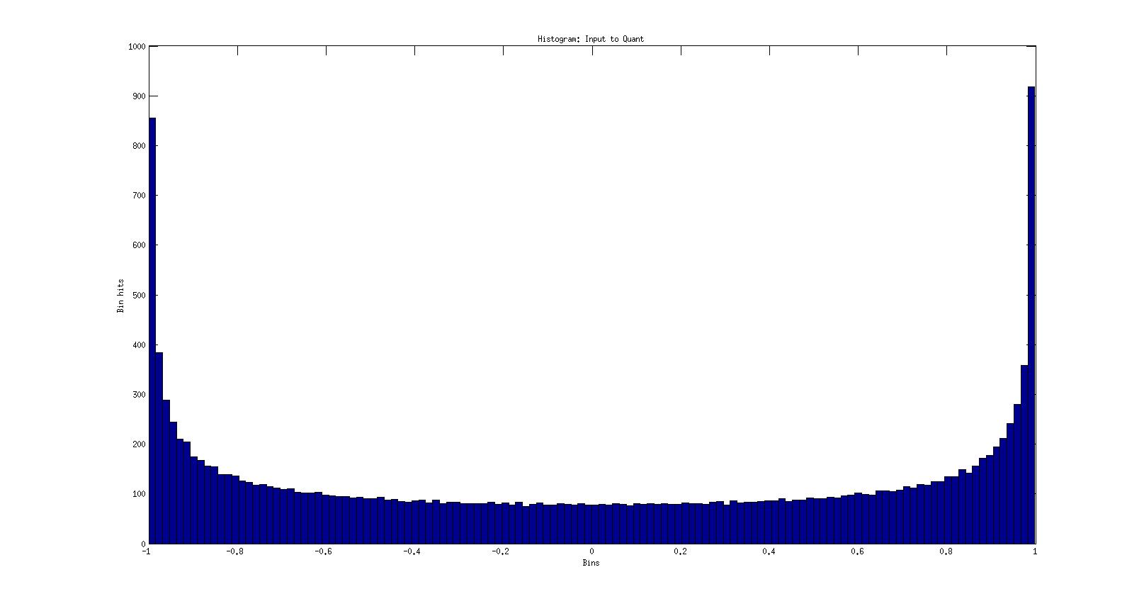

Figure 6: Input vector to the quantizer. The input scale is set to 1.

The histogram before vector bias correction is shown in Figure 7. As expected, the histogram is shows sample values covering the full range. The picture changes when viewing the histogram of the quantizer output after bias correction.

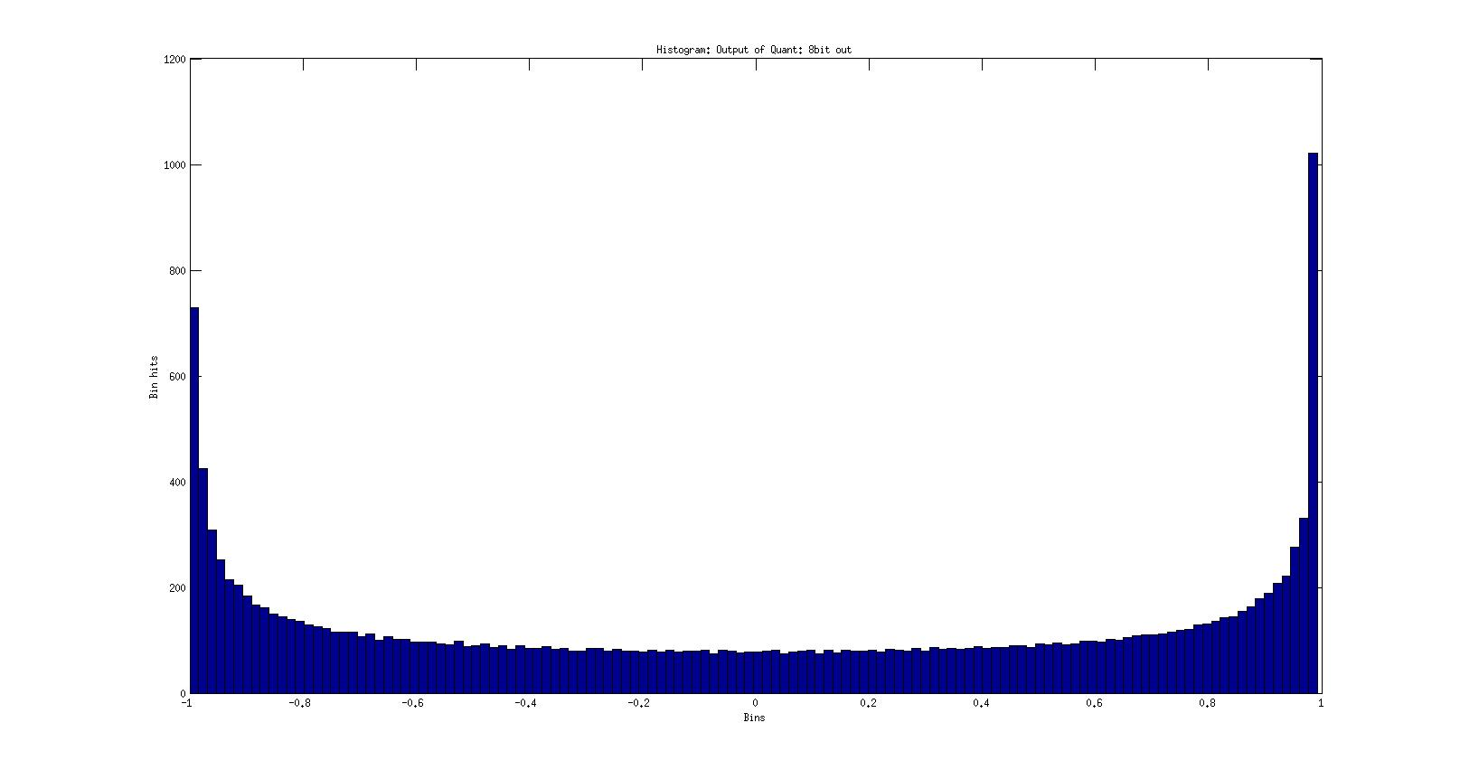

Figure 7: Histogram output of the quantizer before bias correction.

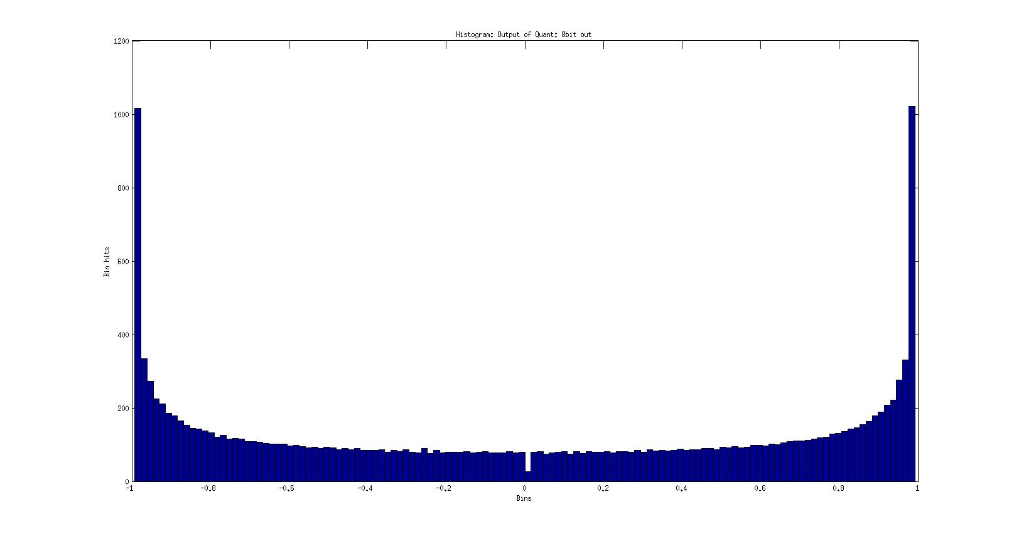

Figure 8: Histogram output of the quantizer after bias correction. A similar result as found in Figure 3 is shown for bin 0, except the bin value is not zero. This indicates that samples with values of 2-6 do occur.

The reason values occur in bin 0 (unlike in Figure 3) is due to the EQ scaling. In this case the EQ is 1 (real) and the initial input scale is 1 so no bit shifting occurs. Figure 8 also shows what appears as an unusual ‘gap’ for bin 0 as it does not reach similar levels of adjacent bins. This can again be explained as due to bin range values. Figure 9 provides a closer look at the ‘gap’ region in Figure 8. In this case the hit count is 26 and applies to a bin range of 0 to 0.0155. As noted earlier, a sample value of 0 is not allocated to this bin, but rather to the adjacent bin to the left. The hit count of 26 applies to any samples of value 2-7 (the bin edge of 0.0155 is lower than the next bit level of 2-6, so only 2-7 applies).

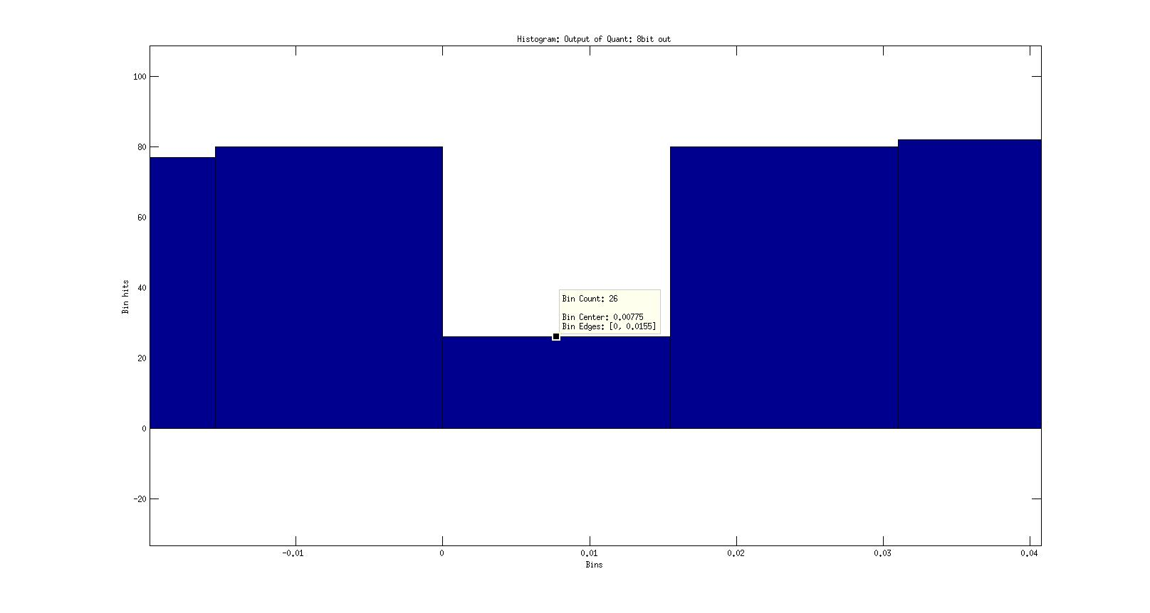

Figure 9: Bin 0 with a bin range of 0 to 0.0155. This histogram applies to the output of the quantizer *after* bias correction. A sample of zero is allocated to the adjacent bin to the left, so only a value of 2-7 applies to this bin range.

The question is why the bin 0 hit count is lower than adjacent bins. It turns out this is matter of bin ranges. If the histogram of the output of the quantizer is viewed before bias correction, the histogram bin levels are as expected (Figure 7). Taking a closer look at the same region of Figure 7 shows the bin ranges (Figure 10).

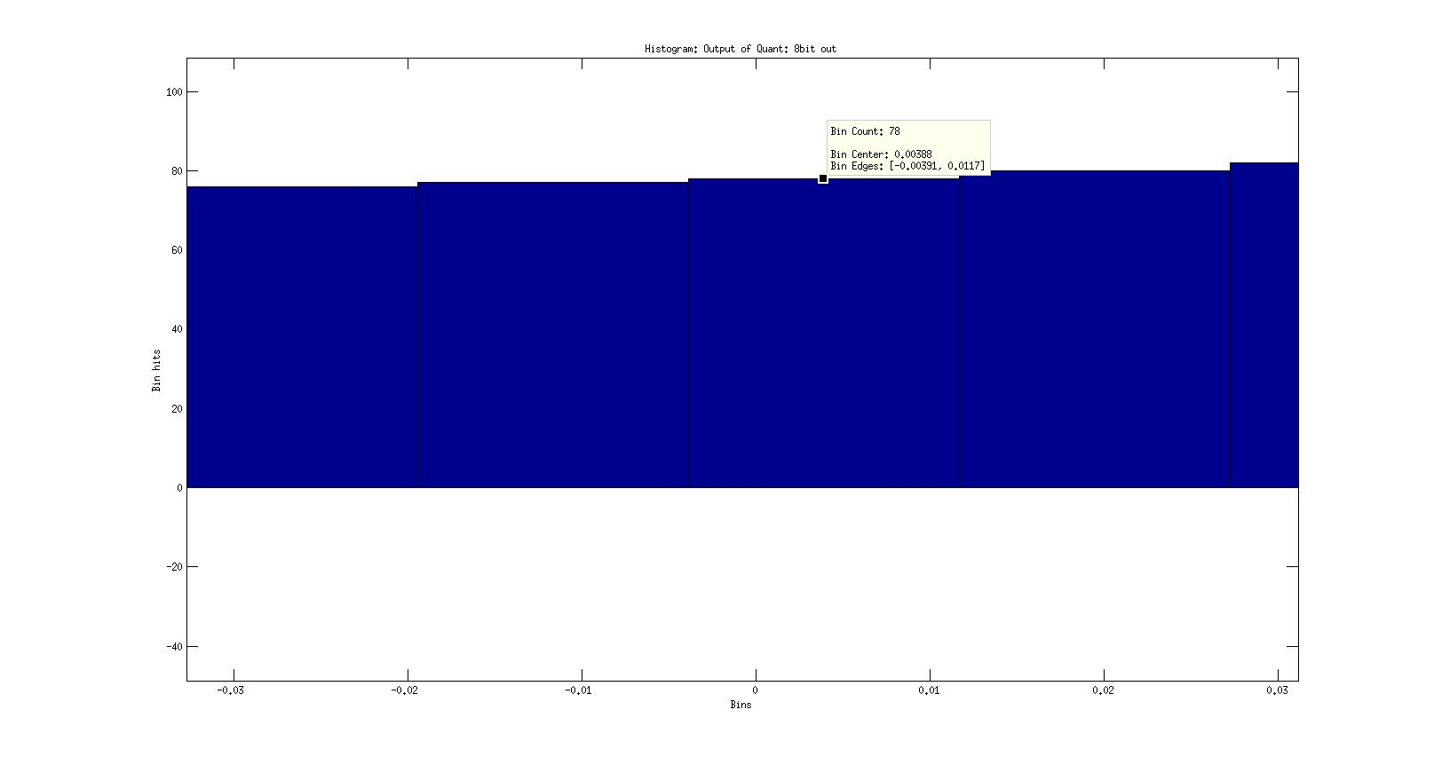

Figure 10: Close up view of bin 0 for the output of the quantizer before bias correction. Bin 0 in this covers all samples of value 0 and 2-7.

The bin ranges for bin 0 (before bias correction) are -0.00391 to 0.0117. This range is inclusive of any zero valued samples as well as samples of 2-7. As seen in Figure 9, the hit count for 2-7 samples was 26. Running a count of all zero valued samples for the output of the quantizer gives a result of 52. The hit count therefore for 0 and 2-7 is therefore 52 + 26 = 78. This is the same as seen in Figure 10.

Case 3:

Test vector scale: ±1

EQ: 1 (real)

Histogram Bins: 128 - 1 (The -1 compensates for the bias correction as the full scale range is no longer used).

In this test case the number of histogram bins is reduced by -1 as after bias correction, the full range for a sample spans -0.9922 to 0.9922. Computing the histogram on the bias corrected output with 127 bins provides Figure 11.

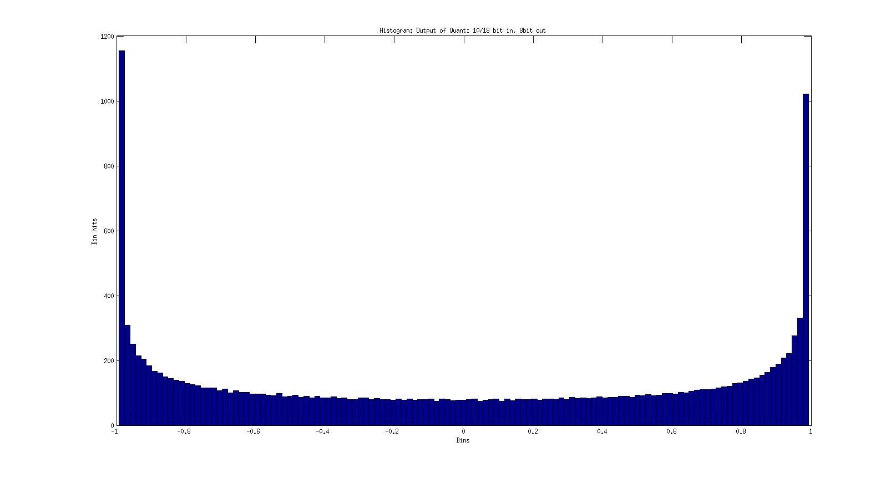

Figure 11: In this case the number of histogram bins is set to 127. This compensates for the reduced range and prevents unusual bin edge ranges. As can be seen, the hit counts for all bins are expected values for a sinusoidal input.

Case 4:

Test vector scale: ±0.125

EQ: 1 (real)

Histogram Bins: 128 - 1 (The -1 compensates for the bias correction as the full scale range is no longer used).

In this test case the number of histogram bins is reduced by -1 as after bias correction, the full range for a sample spans -0.9922 to 0.9922. Computing the histogram on the bias corrected output with 127 bins provides Figure 12.

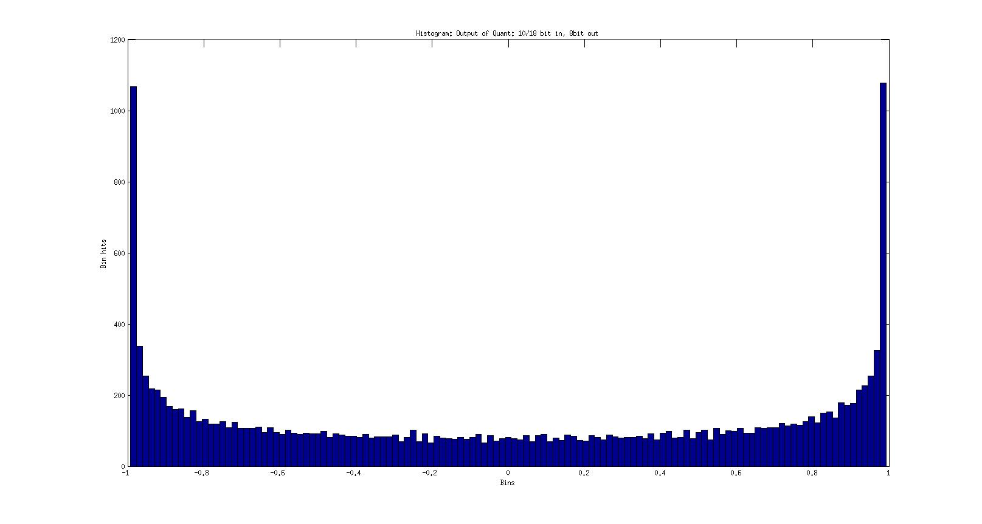

Figure 12: In this case the number of histogram bins is set to 127. This compensates for the reduced range and prevents unusual bin edge ranges. As can be seen, the hit counts for all bins are expected values for a sinusoidal input. This should be compared to Figure 3 where bin 0 was zero. The non-zero hit for bin zero is as a result of the change on bin edge rages as the number of bins has been reduced.

Taking a closer look at bin 0 (Figure 13), it can be seen the bin edge ranges span -0.00781 to 0.00781 making it inclusive of sample values 0 and 2-7(0.0078125). Previously the edges spanned 0 to 0.0155, but 0 was not included, and no samples had values of 2-7 due to the 23 bit shift of the EQ.

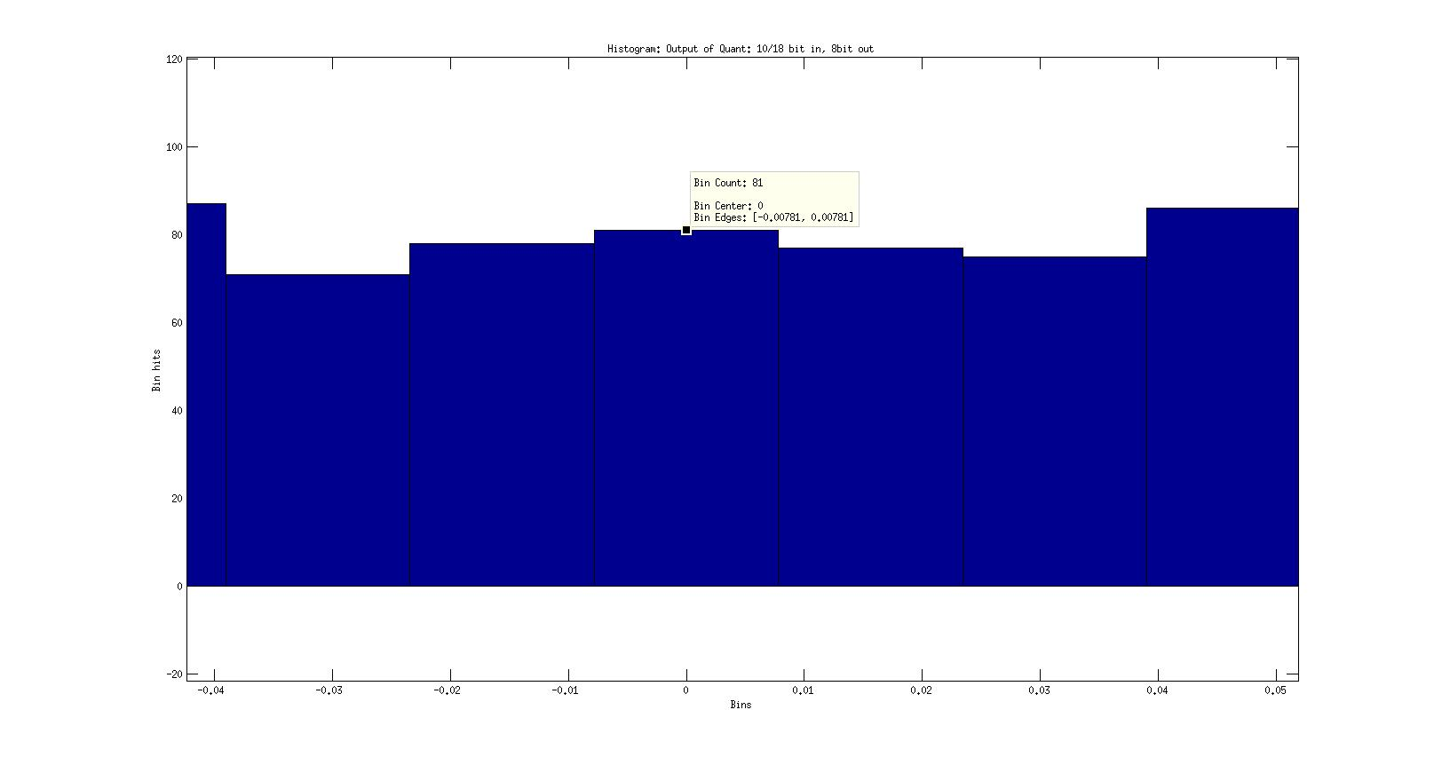

Figure 13: A close up view on bin 0 using the reduced histogram bin range (128-1). Bin zero is not zero as the edge ranges span -0.00781 to 0.00781 and now includes zero-valued samples.

**Linearity Testing:**

To perform linearity testing, the same model is used except the input vector scale needs to be adjusted. For this test the vector length is 4096 samples per scale iteration. After 4096 samples, the scale is divided by 2 on each iteration. For each scale setting, the absolute value of the 4096 samples is computed, followed by the mean. The output is plotted in dB (Figure 14).

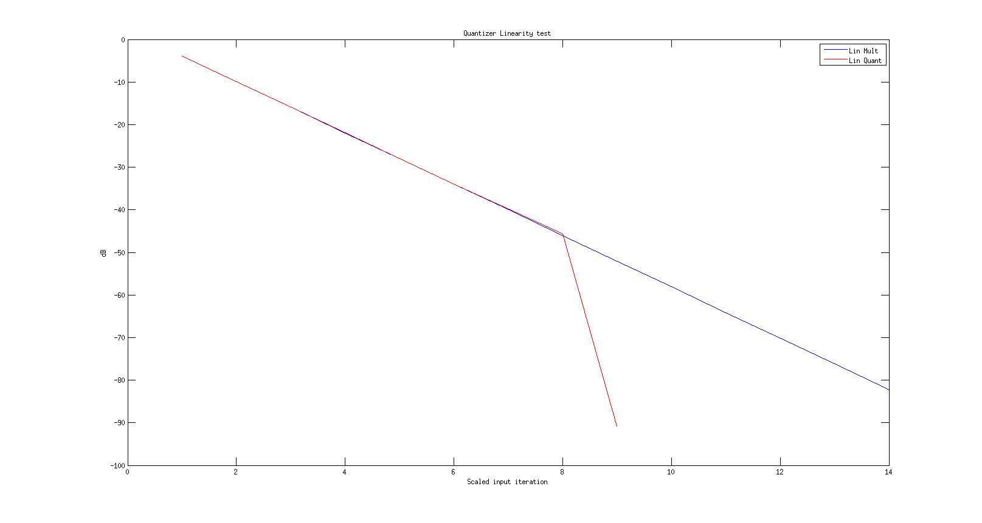

Figure 14: Linearity test of the quantizer. This data is captured on the final output of the quantizer after bias correction.

Figure 14 illustrates the results of the linearity testing of the quantizer. As could be expected, the output is linear, and deviates only for the 8 bit quantized output once the input has reached a level that can no longer be correctly represented using 8 bits fixed-point. The additional ‘blue’ trace is the output of the multiplier used for EQ adjustment. This remains linear as the output is represented using 54 bits.

**Final Remarks:**

This report has set out to investigate and assess the results obtained for the quantizer in the F-Engine. Initial findings appeared incorrect, however it has been found reasonable explanations can be provided to the results obtained. From these findings it would appear the quantizer is operating as expected.