Lab 1 — Build Your First OCI Environment
Egypt Summer Internship Program 2026 — Cloud Build Track (OCI & Terraform)
Week 1 — OCI Foundations & Terraform Basics
Intern | Andrew Hany
Compartment | intern-04-andrew-hany-cmp
Region | me-jeddah-1 — Saudi Arabia West (Jeddah)
Tenancy | ociejada
Date | 5 August 2026

1. Objective
Deploy a complete, working OCI environment manually through the OCI Console, then attach persistent storage:
- A Virtual Cloud Network (VCN) with a public subnet and internet connectivity
- A Linux compute instance reachable over SSH
- A block volume attached over iSCSI, formatted, and mounted
- A file storage file system mounted over NFS
This is the manual build required by Lab 1. Lab 2 reproduces the same environment as Terraform code.

2. Resource Summary
Region | me-jeddah-1 (Saudi Arabia West — Jeddah)
Compartment | intern-04-andrew-hany-cmp
VCN | lab1-vcn — CIDR 10.0.0.0/16
Public subnet | public subnet-lab1-vcn — CIDR 10.0.0.0/24
Gateways | Internet, NAT, Service (from VCN Wizard)
Compute instance | lab1-instance — Oracle Linux 9
Shape | VM.Standard.E5.Flex — 1 OCPU / 12 GB RAM
Availability domain | AD-1
Public IP / user | 144.24.212.9 / opc
Block volume | lab1-blockvol — 50 GB · iSCSI · /dev/sdb -> /mnt/lab1vol (ext4)
File system export | /FileSystem-20260805-2016-40 -> /mnt/lab1fss
Mount target | MountTarget-20260805-2016-34 — IP 10.0.0.84

3. Deployment Steps

Step 0 — Work in the correct compartment
All resources are created inside the personal intern compartment intern-04-andrew-hany-cmp (never the tenancy root), so they stay isolated and easy to clean up.
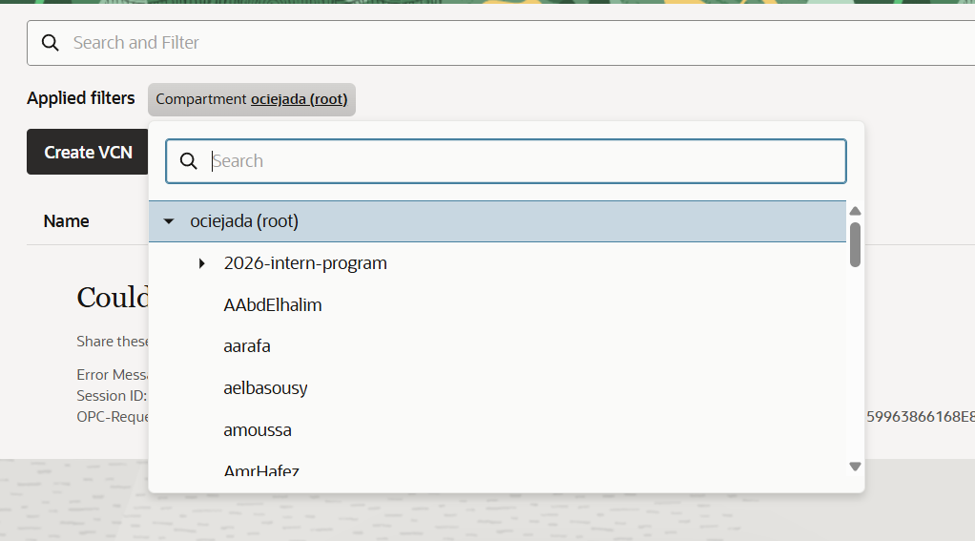
Figure 1 — Selecting the intern compartment

Step 1 — Create the VCN (VCN Wizard)
Networking -> Virtual Cloud Networks -> Start VCN Wizard -> Create VCN with Internet Connectivity. Named lab1-vcn, kept the default CIDRs. The wizard creates the VCN, a public subnet, an internet gateway, a route table, and security lists in a single step.

Step 2 — Launch the compute instance
Compute -> Instances -> Create instance. Image Oracle Linux 9, shape VM.Standard.E5.Flex (1 OCPU), placed in lab1-vcn / public subnet-lab1-vcn with Assign public IPv4 address = Yes, and an auto-generated SSH key pair (both keys downloaded).
The review below confirms the networking is correct — the single most important setting for SSH access:
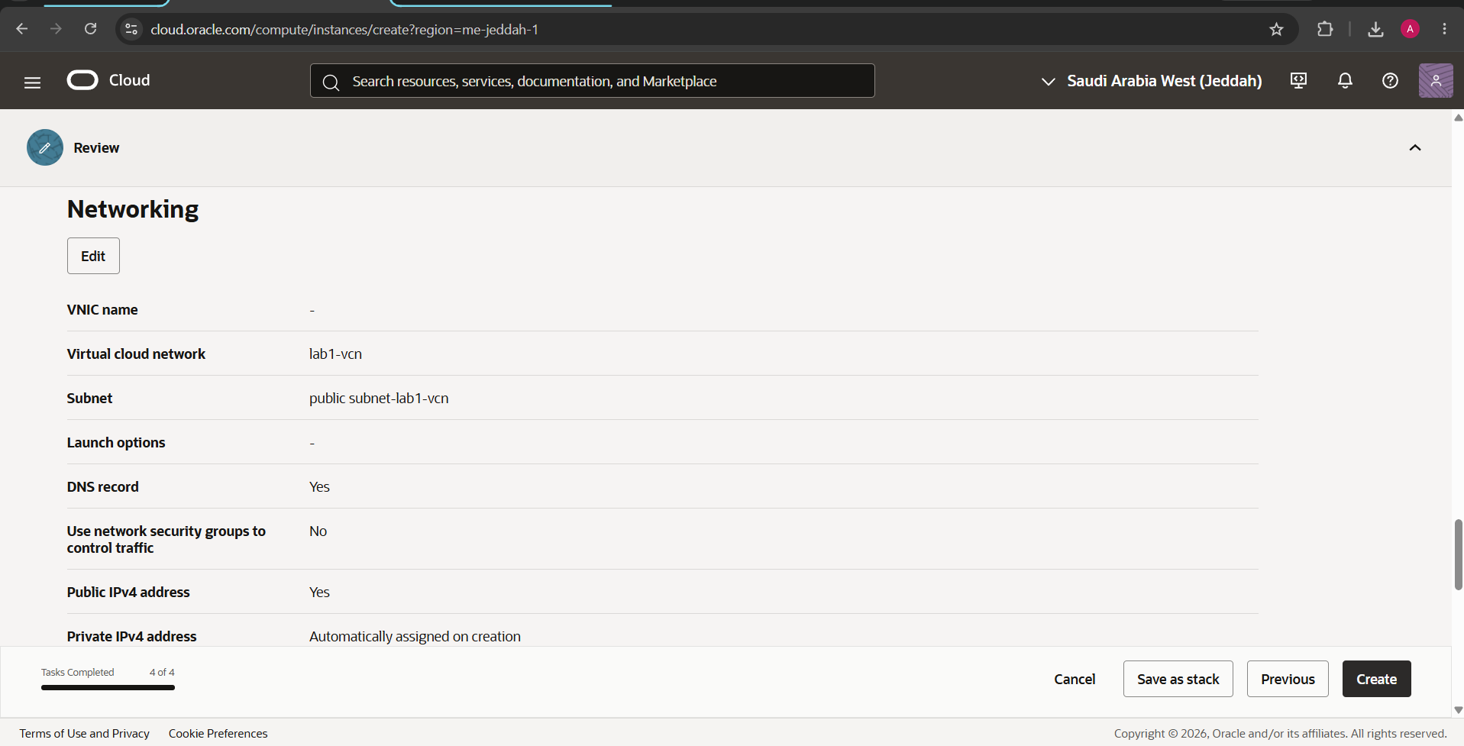
Figure 2 — Instance networking review: VCN, public subnet, Public IPv4 = Yes
After creation the instance reached RUNNING with a public IP:
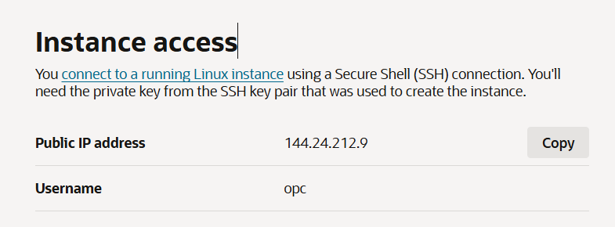
Figure 3 — Instance access: public IP 144.24.212.9, user opc

Step 3 — Connect over SSH
The private key was copied to an NTFS path and locked to the current user, because Windows/OpenSSH refuses a key that other users can read (and an exFAT/FAT32 drive cannot enforce that restriction):
icacls ssh-key-2026-08-05.key /inheritance:r
icacls ssh-key-2026-08-05.key /grant:r "$($env:USERNAME):R"
ssh -i ssh-key-2026-08-05.key opc@144.24.212.9
A successful login lands at the [opc@lab1-instance ~]$ prompt (visible in the terminal screenshots below).

Step 4 — Create, attach, and mount the block volume
Storage -> Block Volumes -> Create Block Volume in AD-1. The default size was 1024 GB; I switched to Custom and set 50 GB to right-size for the lab and avoid wasting shared credits (cost awareness / FinOps):
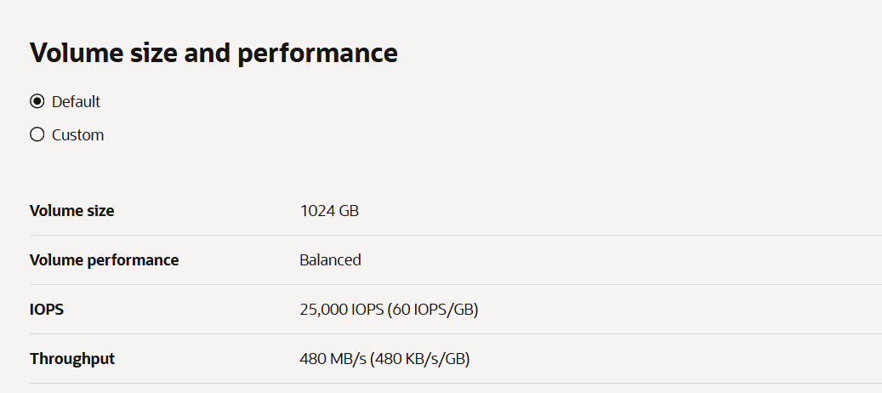
Figure 4 — Block volume size (set to Custom 50 GB)
Then attached it to the instance as iSCSI. The Console shows the post-attach instructions:
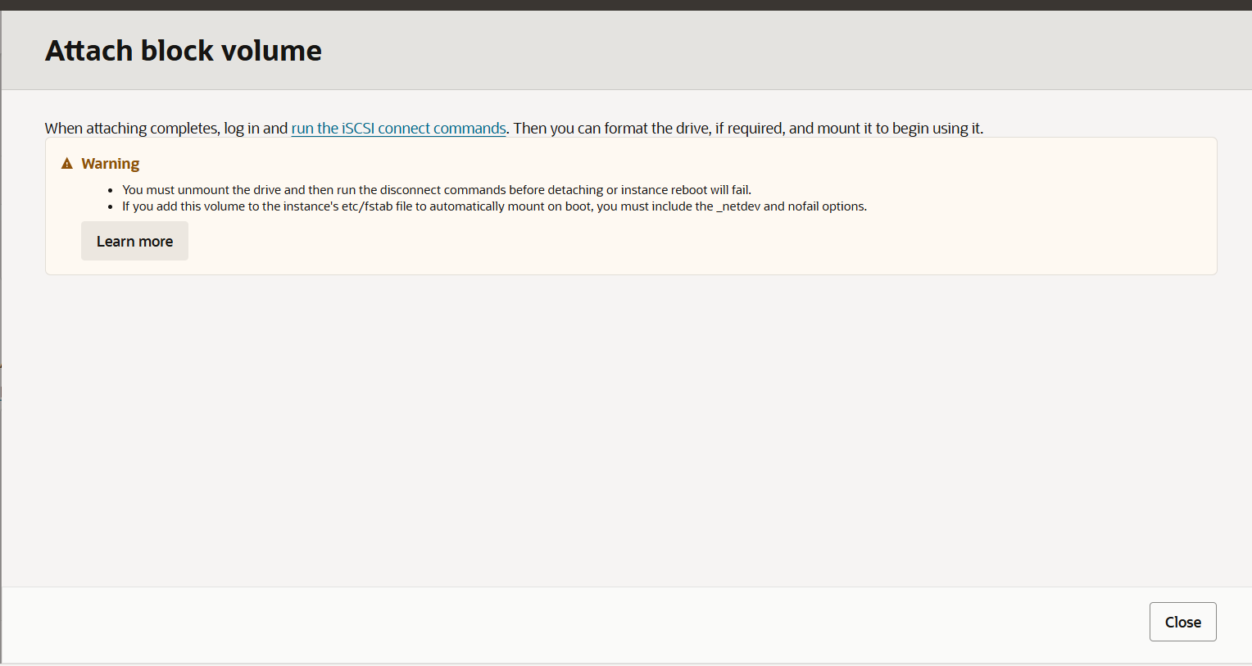
Figure 5 — Attach block volume dialog
On the instance, I ran the iSCSI Connect commands (from the volume's iSCSI commands and information panel):
sudo iscsiadm -m node -o new -T <target-iqn> -p 169.254.2.2:3260
sudo iscsiadm -m node -o update -T <target-iqn> -n node.startup -v automatic
sudo iscsiadm -m node -T <target-iqn> -p 169.254.2.2:3260 -l
lsblk then shows the new 50 GB disk as sdb (boot disk is sda):
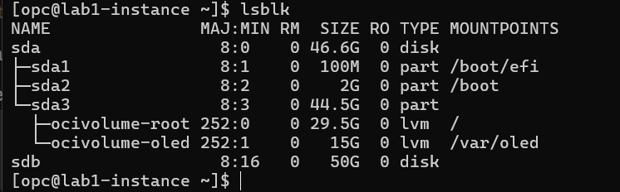
Figure 6 — lsblk showing the new sdb disk
Format with ext4, create a mount point, mount, and verify:
sudo mkfs.ext4 /dev/sdb
sudo mkdir /mnt/lab1vol
sudo mount /dev/sdb /mnt/lab1vol
df -h
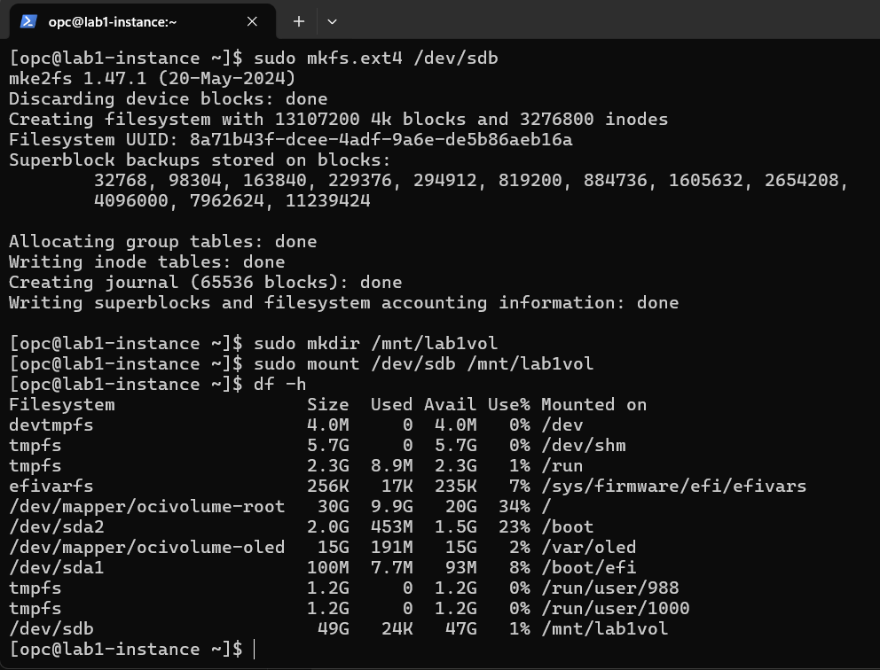
Figure 7 — Block volume formatted and mounted at /mnt/lab1vol
What iSCSI does: the block volume lives elsewhere in the data center and is presented to the instance over the network as though it were a locally attached disk.

Step 5 — Create and mount file storage (NFS)
Storage -> File Systems -> Create File System, with a mount target in lab1-vcn / public subnet-lab1-vcn. The export path and mount target came out Active:
Figure 8 — File system export path and mount target
- Export path: /FileSystem-20260805-2016-40
- Mount target IP: 10.0.0.84
NFS traffic then has to be allowed on the subnet's security list. The default rules already open SSH (22) and ICMP; I added a stateful rule allowing intra-VCN TCP from 10.0.0.0/16, which covers the NFS ports (111 and 2048-2050) between the instance and the mount target:
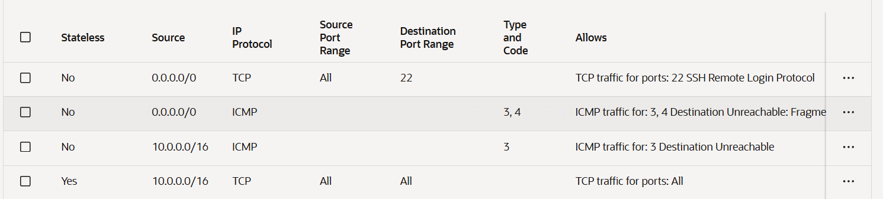
Figure 9 — Security list rules, including the intra-VCN TCP rule for NFS
Finally, install the NFS client, create a mount point, and mount the file system:
sudo yum install -y nfs-utils
sudo mkdir -p /mnt/lab1fss
sudo mount 10.0.0.84:/FileSystem-20260805-2016-40 /mnt/lab1fss
df -h

4. Verification
df -h confirms both storage types mounted — block volume at /mnt/lab1vol and file storage at /mnt/lab1fss:
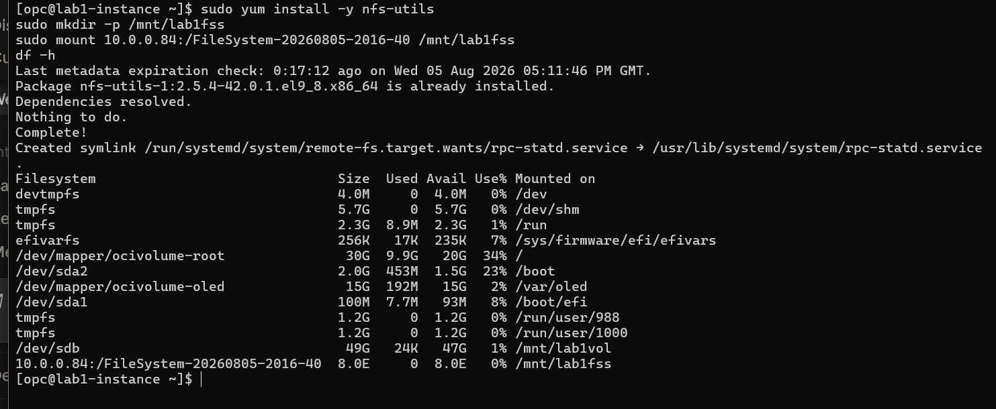
Figure 10 — df -h showing block volume and file storage both mounted
8.0E is how OCI File Storage reports capacity — it is thin-provisioned, so you only pay per GB actually stored.
Lab 1 result: VCN, public subnet, Linux instance, SSH access, block volume, and file storage — all completed and verified.

5. Cleanup (mandatory after review)
Cloud resources bill for as long as they exist, and this is a shared tenancy, so everything is removed after the mentor review. Order matters — storage must be released before the instance is terminated:
sudo umount /mnt/lab1fss
sudo umount /mnt/lab1vol
sudo iscsiadm -m node -T <target-iqn> -p 169.254.2.2:3260 -u
Then in the Console, delete in this order:
- Detach and delete the block volume (lab1-blockvol)
- Delete the file system and mount target
- Terminate the instance (lab1-instance) — tick "delete boot volume"
- Delete the VCN (lab1-vcn) last

6. What I Learned
- Region -> Availability Domain -> Fault Domain is a strict hierarchy; a VCN and its subnets are regional, and resources live inside a compartment.
- The VCN Wizard wires up subnet + gateways + route table + security list together — exactly the pieces a server needs to be reachable.
- Security lists are the gate: SSH worked out of the box (port 22 open by default), but NFS required explicitly allowing the file-storage ports within the VCN.
- Storage is attached, not built-in: a block volume connects over iSCSI (a network disk that behaves like a local one); file storage connects over NFS (a shared network drive). Both must be formatted/mounted before use.
- Building this by hand makes the upcoming Terraform version straightforward — every resource here maps directly to a Terraform block.

