Lab 2 — Provision an OCI Compute Instance with Terraform
Egypt Summer Internship Program 2026 — Cloud Build Track (OCI & Terraform)
Week 1 — Terraform Basics
Intern | Andrew Hany
Compartment | intern-04-andrew-hany-cmp
Region | me-jeddah-1 — Saudi Arabia West (Jeddah)
Tenancy | ociejada
Date | 7 August 2026

1. Objective
Reproduce the Lab 1 compute instance as Infrastructure as Code using Terraform. Per the Week 1 brief, the network (VCN, public subnet) is reused from the Lab 1 Console build; this lab focuses on installing Terraform, configuring OCI access, and writing Terraform code that creates a compute instance.
- Install Terraform
- Configure API-key access to OCI
- Write Terraform code that provisions a compute instance into the existing public subnet
- Verify by SSH, then tear down with a single command

2. Step 1 — Install Terraform
Installed the Terraform CLI on Windows with one command:
winget install --id Hashicorp.Terraform -e
After reopening the shell, verified the install: Terraform v1.15.8.

3. Step 2 — Configure OCI access (API key)
Terraform authenticates to OCI with an API signing key, not a password. Generated one under Profile -> User settings -> Tokens and keys -> Add API key -> Generate API key pair, then copied the configuration preview (user OCID, fingerprint, tenancy OCID, region):
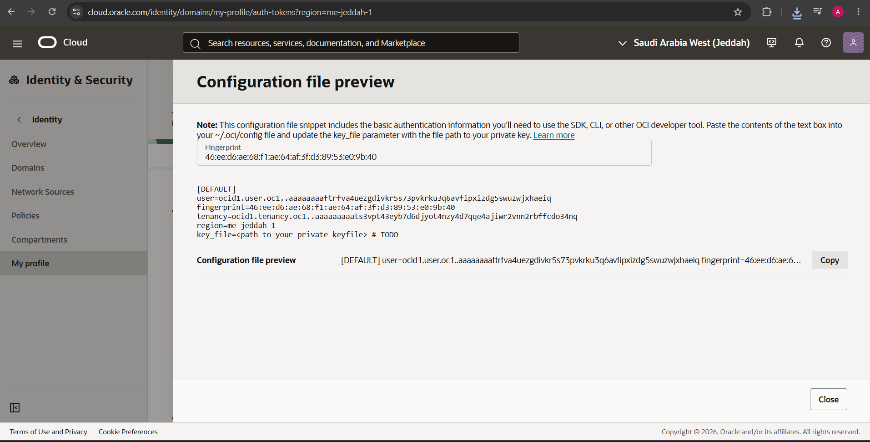
Figure 1 — OCI API key configuration file preview
Moved the private key to a dedicated folder outside the repo so it is never committed, as C:\Users\HP\.oci\oci_api_key.pem:
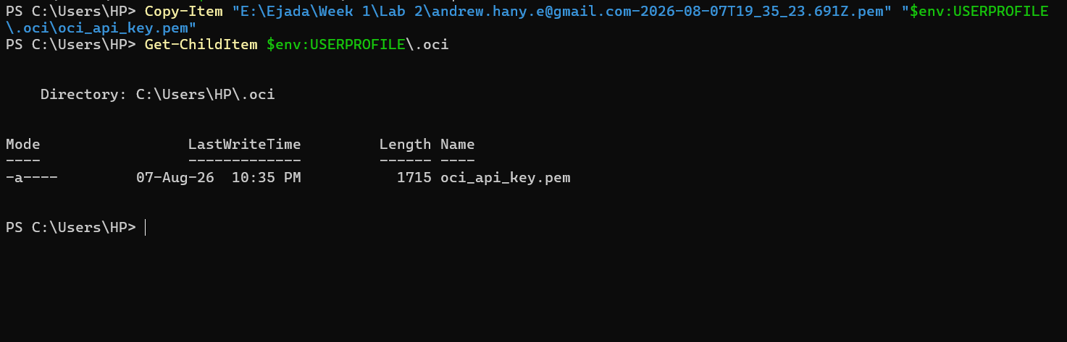
Figure 2 — Private key placed in the .oci folder

4. Step 3 — The Terraform code
The configuration is split into provider.tf, variables.tf, terraform.tfvars, main.tf, and outputs.tf. The core resource and its data-source lookups:
data "oci_core_subnet" "lab" {
subnet_id = var.subnet_ocid
}

locals {
compartment_ocid = data.oci_core_subnet.lab.compartment_id
}

data "oci_core_images" "ol9" {
compartment_id = local.compartment_ocid
operating_system = "Oracle Linux"
operating_system_version = "9"
shape = var.instance_shape
sort_by = "TIMECREATED"
sort_order = "DESC"
}

resource "oci_core_instance" "lab2" {
compartment_id = local.compartment_ocid
availability_domain = data.oci_identity_availability_domains.ads.availability_domains[0].name
display_name = var.instance_name
shape = var.instance_shape
shape_config { ocpus = 1 memory_in_gbs = 12 }
source_details { source_type = "image" source_id = data.oci_core_images.ol9.images[0].id }
create_vnic_details { subnet_id = var.subnet_ocid assign_public_ip = true }
metadata = { ssh_authorized_keys = var.ssh_public_key }
}
Design note: the only value supplied by hand is the subnet OCID. Terraform derives the compartment from the subnet and uses data sources to resolve the availability domain and the newest Oracle Linux 9 image automatically.

5. Step 4 — Initialize
terraform init
Downloads the OCI provider (v8.26.0) and prepares the working directory:
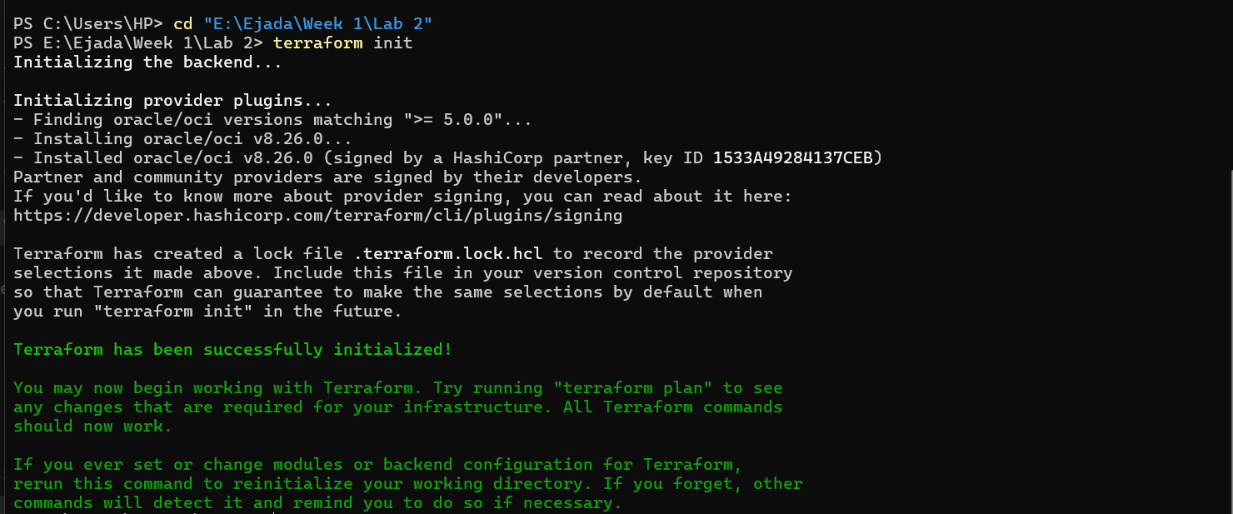
Figure 3 — terraform init succeeded

6. Step 5 — Plan (dry run)
terraform plan
Authenticates, runs the lookups, and previews exactly one resource to create — nothing is built yet:
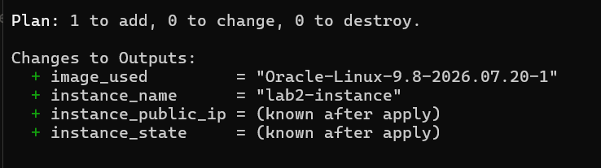
Figure 4 — terraform plan: 1 to add
The plan confirms availability domain oXVt:ME-JEDDAH-1-AD-1, image Oracle-Linux-9.8-2026.07.20-1, shape VM.Standard.E5.Flex (1 OCPU / 12 GB), public IP enabled.

7. Step 6 — Apply
terraform apply # answer: yes
Terraform creates the instance in 27 seconds and prints the outputs, including the public IP:
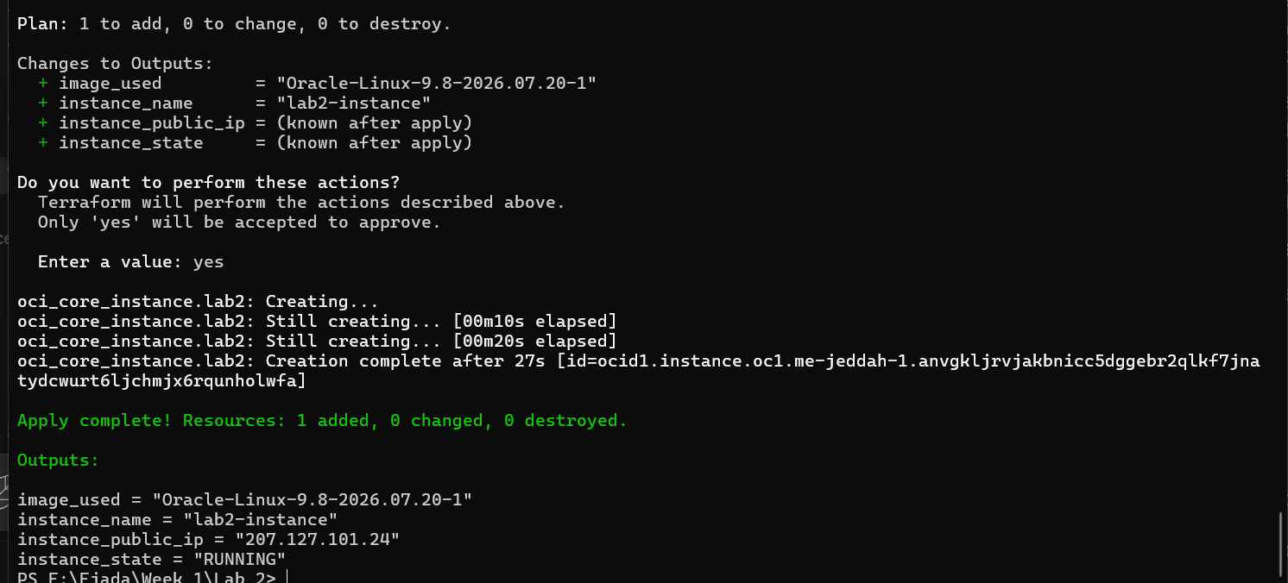
Figure 5 — terraform apply complete (public IP 207.127.101.24, RUNNING)

8. Step 7 — Verify (SSH)
Connected to the Terraform-built instance using the same key pair from Lab 1:
ssh -i $env:USERPROFILE\.ssh\ssh-key-2026-08-05.key opc@207.127.101.24
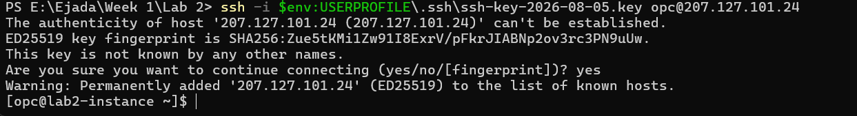
Figure 6 — SSH into the Terraform-built instance
Landing at [opc@lab2-instance ~]$ confirms the instance is real and reachable.

9. Cleanup
Because this is a shared tenancy, the instance is torn down after review with a single command — no manual, ordered deletes:
terraform destroy # answer: yes
This removes only the lab2-instance Terraform created; the Console-built network is read-only in this configuration and is left untouched.

10. Lab 1 vs Lab 2 — why Infrastructure as Code
Aspect | Lab 1 (Console) | Lab 2 (Terraform)
Create instance | ~15 min of clicking | terraform apply — 27 s
Repeatable | No — manual each time | Yes — identical every run
Documented | Screenshots after the fact | The code is the documentation
Teardown | Delete each resource in order | terraform destroy — one command
Doing Lab 1 by hand first made every block in this code recognizable — the value of IaC is that the environment is now versionable, repeatable, and disposable.

