**CHANGE MYSQL DATADIR TO EXTERNAL HARD DRIVE**

1. **Mount hard disk drive to rasp:**
2. List all disk available

* **Lsblk**

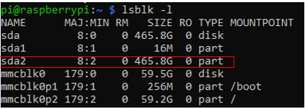

1. Format hard disk to ext4 format

**mkfs.ext4 /dev/sda2**

1. Create directory that hard disk will be mouted

**Mkdir /mnt/mysql_db**

1. Check hard disk partuuid

* **blkid**



1. Add a line to **/etc/fstab** as bellow:



* **/mnt/mysql_db** is directory hard disk will be mounted
* **Ext4** is hard disk format
* **Default** is option
* **0** for <dump> and <pass>

1. Reboot system
2. List all disk again and check mountpoint

**Lsbkl**

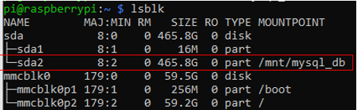

1. **Move Mysql data directory to external hard drive**
2. Stop mysql service

* **Sudo service mysql stop**

1. Create directory as new mysql data directory

* **mkdir /mnt/mysql_db/mysql**

1. Copy all file, directory from /var/lib/mysql/ to new data directory

* **cp -R /var/lib/mysql/* /mnt/mysql_db/mysql**

1. Change owner and group for /mnt/mysql_db/mysql

* **Sudo chown -R mysql:mysql /mnt/mysql_db/mysql**

1. Edit **/etc/mysql/mariadb.conf.d/50-server.cnf**

Replace **datadir = /var/lib/mysql** to **datadir =** **/mnt/mysql_db/mysql**

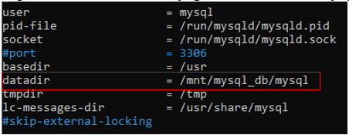

1. Restart mysql service

* **Sudo systemctl restart mysql**

**CHECK MYSQL DATADIR**

**grep -r datadir /etc/mysql/**



**mysql -u root -p -e "SELECT @@datadir;"**

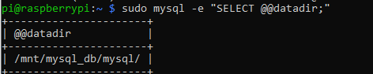

**################## DONE ##################**

**References:**

[**https://www.raspberrypi.org/forums/viewtopic.php?t=25978**](https://www.raspberrypi.org/forums/viewtopic.php?t=25978)

**…**