* **UART (UART to TTL 🡪 USB):**
* **Cài PySerial:**
  + Mở file **2.Serial_setup.pdf** và làm theo, nhớ xài python3 chứ kp python
  + Hoặc:
  + *Sudo apt-get install python3-serial*
  + *Cd /boot*
  + *Sudo nano config.txt*
  + Search for (or add new to the end of the file): *enable_uart = 1*
  + Reboot
  + ls /dev/tty* 🡪 liệt kê tất cả các cổng uart đang có
  + ls /dev/serial/by-* 🡪 liệt kê thông tin chi tiết của các peripherals đang cắm vào rasp
  + lsusb 🡪 liệt kê tất cả các cổng usb đang kết nối
  + Code mẫu:
  + 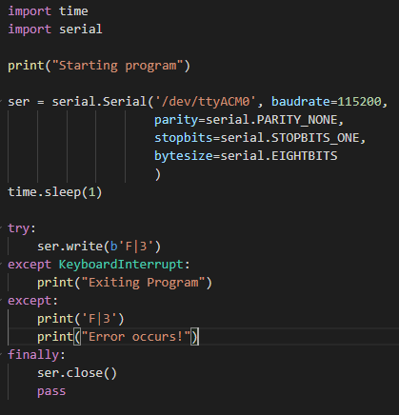
  + python -m serial.tools.list_ports will print a list of available ports. It is also possible to add a regexp as first argument and the list will only include entries that matched.
* <https://pyserial.readthedocs.io/en/latest/shortintro.html#opening-serial-ports>

The connection of both devices:

[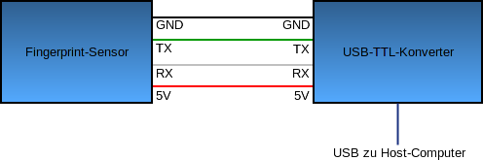](https://sicherheitskritisch.de/images/verbindung-fingerprint-sensor-konverter.png)

We connect the power supply (red wire) to the 5V pin of the converter, the ground (black wire) to ground/GND pin. The transceiver data wire (green wire) of the sensor to the TX pin of the converter and the receiver data wire (white wire) to the RX pin.

**Note:** The data wires of some USB-TTL converting boards (specifically the USB-wire versions) must be connected the other way round. If no communication happen, simply try to exchange the data wires.

If you connect the fingerprint sensor via converting board with your Raspberry Pi, the device should become available via the path "/dev/ttyUSB0". For default only the root user is able to use serial devices. To make sure that the normal user (e.g. "pi") is able to use the fingerprint sensor, you have to add him to the user group "dialout":

~$ sudo usermod -a -G dialout pi

Now your have to **restart** your system.

**NOW YOU CAN USE THE OUTSIDE CODE TO PLAY!**

**REFERENCES:**

<https://github.com/bastianraschke/pyfingerprint>

<https://sicherheitskritisch.de/2015/03/fingerprint-sensor-fuer-den-raspberry-pi-und-debian-linux-en/>