**Requirements:**

1. Four different pages

* Home page aka index.html
  + Link your resume here?
* My favourite things
* About me
* Rare wiebes

2. Must contain at least one list, one table, one image

- list on favourites 🡪 some of my favourite movies

- table on favourites 🡪 numbers and their cool factor

- images 🡪 rare wiebes

3. Must contain a stylesheet

- just make styles.css and style yo website brah

4. Our CSS must use 5 different properties and at least 5 different selectors. Use #id at least once, and .class at least once.

- use id for table

- use class for titles of rare wiebes

5. Must include one mobile responsive @media query, something changing the style when you’re on a smaller screen.

- Go into a dark mode if you’re on mobile

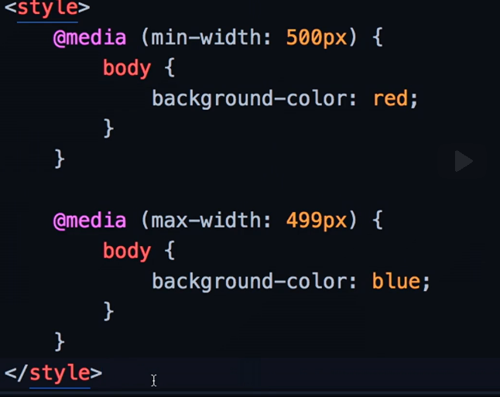

6. Use at least one bootstrap component, at least two columns for layout purposes using grid model.

- Use alerts to troll

- Use navbar to navigate website

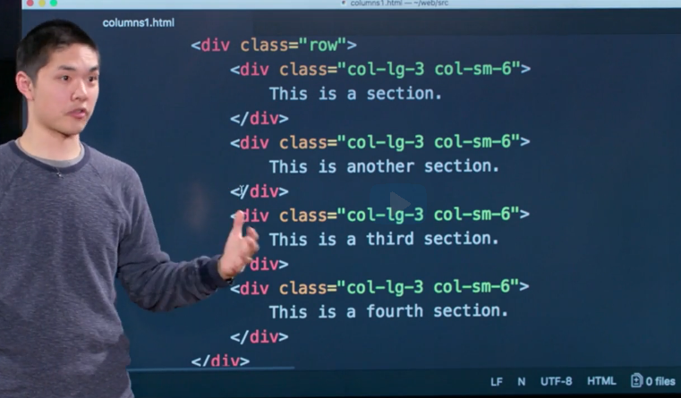

7. Use at least one SCSS variable, at least one example of nesting, at least one example of inheritance

- sss