I have given you a simplified version of the FD database structure. The goal is to make a web interface with a front-end to view and edit and a backend to store DB entries and connections. Use the provided mock databases to infer the required fields and data types.

There is not necessarily a right way to do this!

Below I explain what the function of each database is and what is contained within.

🧬Construct Database (CON)
- A construct is the specific design of a protein that we want to make.
- Constructs are protein sequences (a string of amino acid letters).

🧬 Plasmid Database (PL)
- A construct needs a way to be made, so are housed in plasmids. A plasmid is the physical DNA vehicle used to produce the protein (construct) in a cell.
- A single construct may be assigned to multiple plasmids, but each plasmid contains only one construct.
- The database contains the metadata for each plasmid and construct housed.

📁Plasmid Files
- The PL database does not contain DNA sequence, but has a field that points to plasmid files, which contains the sequence. These are genbank files (.gb or .gbk), allowing scientists to view and edit plasmid DNA sequences in external software such as SnapGene.

📝Experiment Database (EXP)
- This is where experimental detail is recorded by scientists.
- Each experiment has its own 📁Experiment Folder, which contains lab notes and relevant data generated.
- Each experiment references one or more plasmids. Constructs are not linked to experiments directly. At the experimental level, scientists think in terms of plasmids; the construct is effectively metadata for interpreting results.

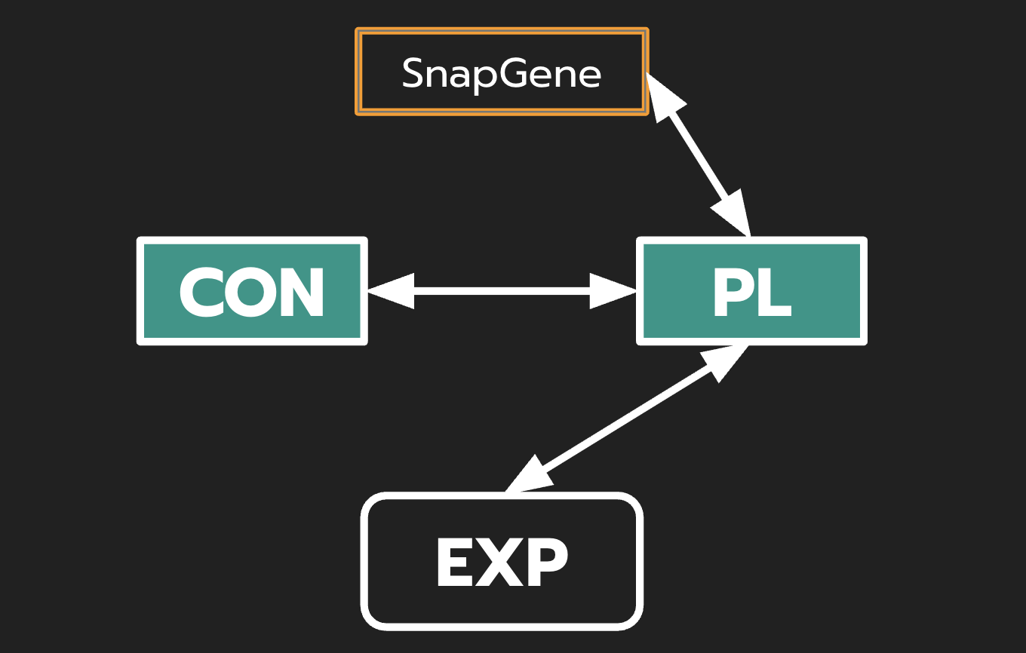

Task Output: a compressed folder we can run and open the frontend in a browser to view and edit anything in the mock database, and trace the connection between entries (e.g. from an experiment, view all plasmids used; from a plasmid, view all experiments it appears in).

