For Li-Ion charger TP4056 chip is used.

To allow simultaneous charging and loading pMOSFET and Schottky Diode are used.

The base of solution was taken from <https://www.best-microcontroller-projects.com/tp4056-page2.html>

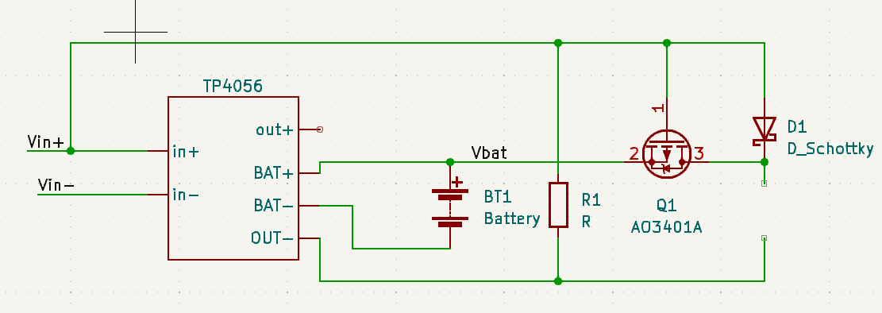

Vg = Vin

If Vin > 4V then tp4056 will work and charge BT1 battery. Battery charge is from 2.7V to 4.2V so

So Vgs = Vg-(Vb - 0.4V) is more than 0.2V (for highest 4.2V of battery). So Q1 is off. So load is powered by Vin.

If Vin < 4V then tp4056 is not charging the battery. But only when Vgs will be less then -0.55V(typically) then

Q1 will turn on and battery will power the load. So typically Vb-Vg will be > 0.15V.

Note 1: some times on charger board 03962A both red(charging) and blue(standby) LEDs are ‘on’. (while it’s expected that only one of them is ‘on’). I assume that it’s because of high wire resistance the voltage on battery is less than 4.2V, so battery is not fully charge, so when tp4056 stops charging, I is dropped, so IR(voltage) on wires drops, so

More voltage falls on battery so it can pull more current for charging. So tp4056 start charging again. But then it returns to previous condition with higher IR on wires. So it’s toggling between these 2 states causing 2 LEDs to blink very fast, and it looks like they are always ‘on’.