adc sample of stm32f10x

for using semihost with jlink read "common_public/c/hw_drivers/arch/ARM/semihosting/connect_jlink_with_semihosting.txt"

Debugging:

uncomment following line in main.c(in measurements_thread_func())

before entering hibernation:

//while(1){os_delay_ms(1000);} // to remove, for dbg only

**1. debugging with J-link**

**! Cloned J-link are not stable, disconnect after 5-10sec. Better to use Mini Edu official J-link!**

to test JLINK:

for SW thar runs from flash: set BOOT0 and BOOT1 to 1

"C:\Program Files (x86)\SEGGER\JLink\JLink.exe" -device STM32F103C8 -if SWD -speed 4000

to connect to CPU in JLINK cmd line run:

connect

some times board needs to be reset(button) few times before it can connect.

to connect jlink gdb server run:

"C:\Program Files (x86)\SEGGER\JLink\JLinkgdbserver.exe" -device STM32F103C8 -if SWD -speed 4000

to connect from eclipse.

a) install GDB SEGGER J-Link debugger

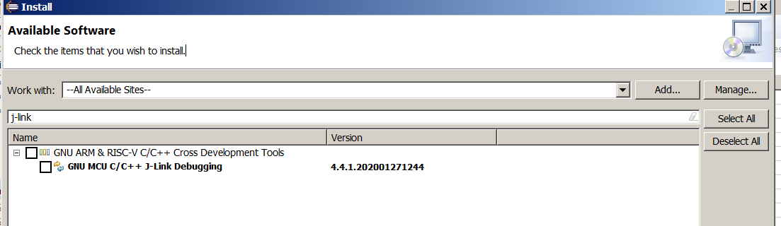

b) make sure to disable auto build

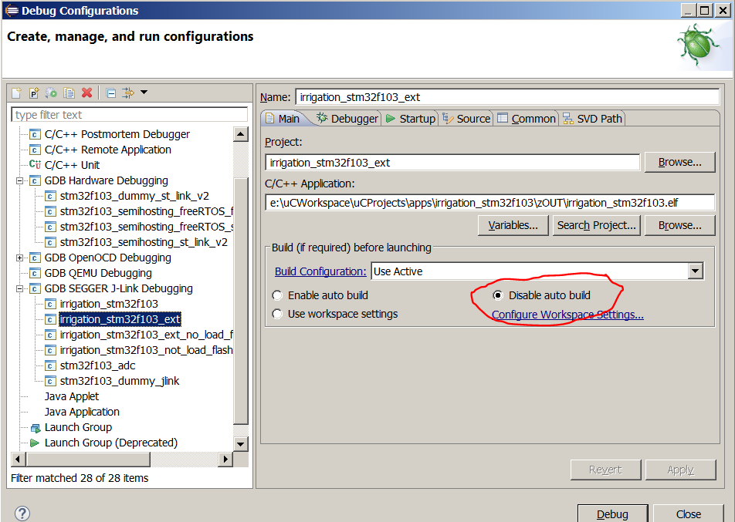

c) make sure to use the same gdb version as compiler version

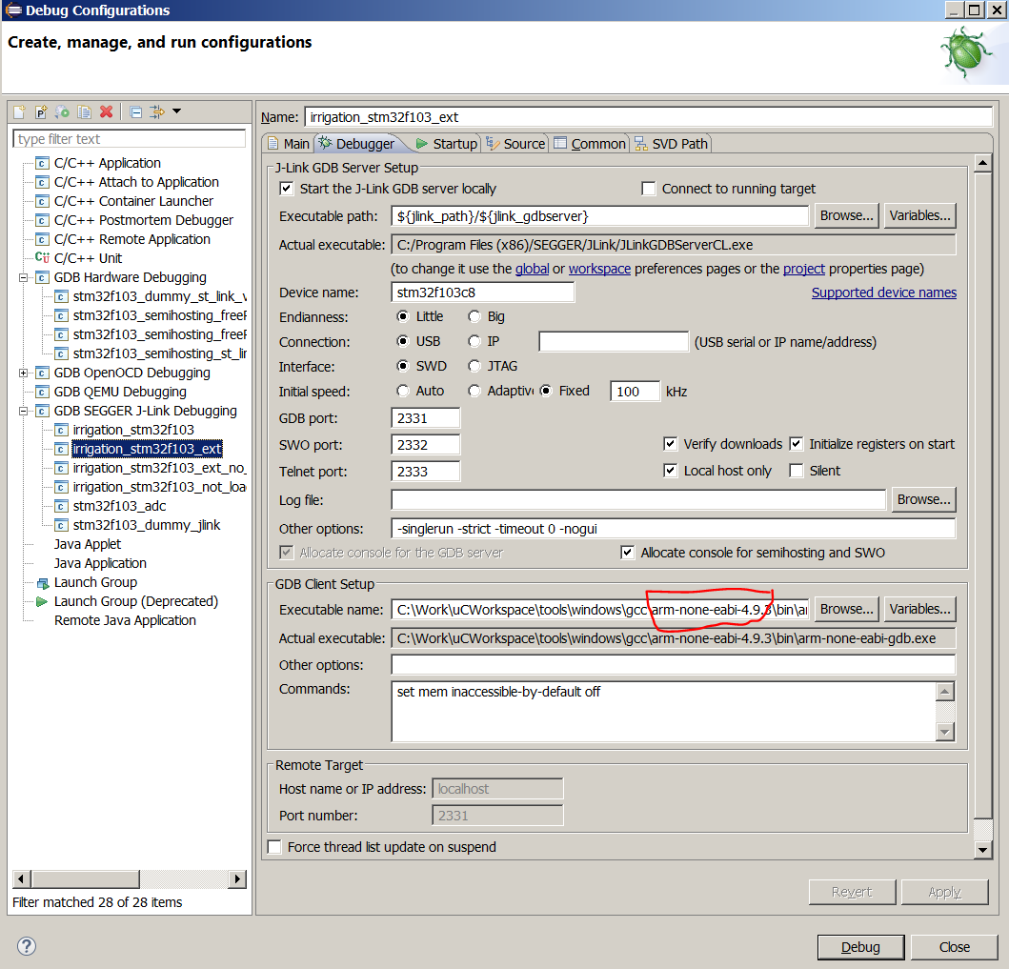

d)

