Joseph Rocaberte

Andrew Toufas

Andrew Long

Gian Santos

Job Finder App Final Report

EmployMe:

The purpose of this app is to make the job search easier for both employers and potential employees. The app does this by setting up a tinder-like environment where employers and candidates can swipe right or left on each other’s cards. The cards display information of the candidate or employer. When both an employer and candidate swipe right on each other, they have a match and can proceed to message each other.

Database:

We used Firebase as our database for this app. The firebase database allows developers to do queries in an object oriented like manner instead of using traditional query statements. The database is a table named “users” that contains the information of all the registered users of the app. The table looks like this:

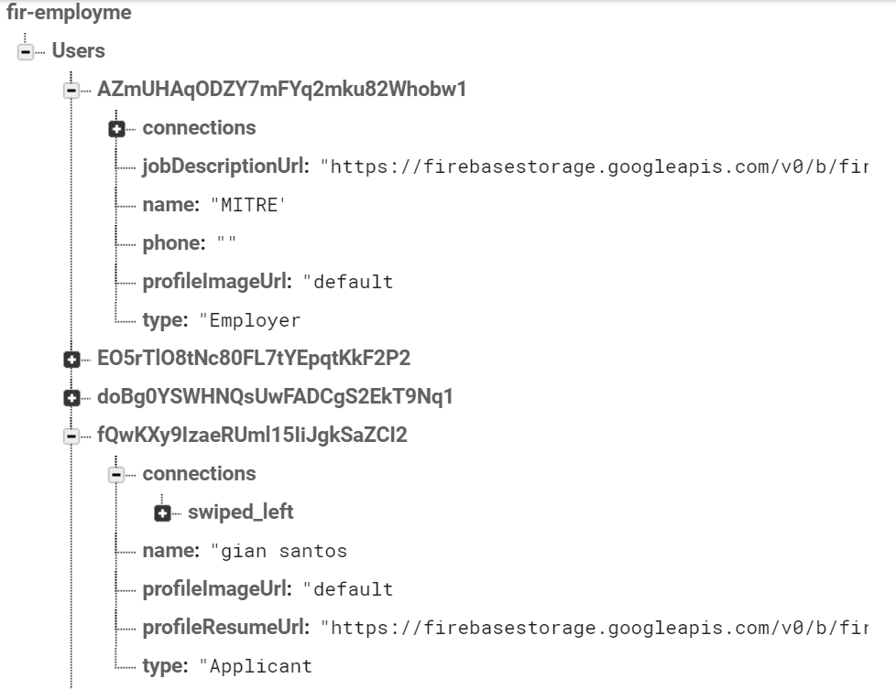

Employers and Candidates have different fields to fill out, but both have a table containing the users they have swiped left and swiped right on. This is how we keep track of matches.

Authentication:

The application is required to verify a user’s identification when logging in to the app. The authentication is implemented into the app using the Firebase SDK Authentication. Firebase stores each user information using an identifier, its provider(s), creation date, last login date, and a user UID. Within the Firebase console, we can select which providers to allow for login to the application, such as email, Google, Facebook, Twitter, Github, etc. Currently, users use their email and password to log in to the application, as all other forms of login are disabled.

Structure:

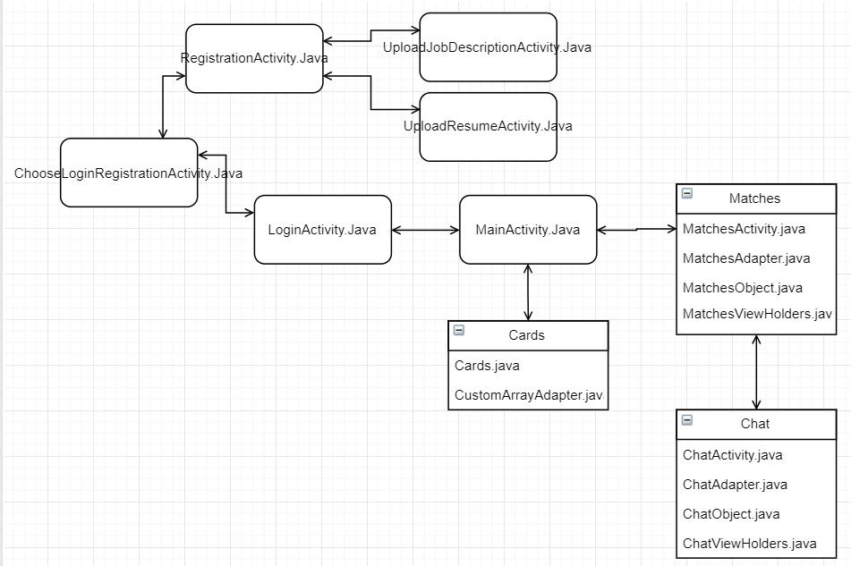

The app is structured and transitions as shown in the figure above. The Firebase API is used throughout the app to authenticate users in the LoginActivity, create new users in the RegistrationActivity, and to retrieve and update information from the database to be used in the MainActivity. After login, the user will transition to the MainActivity where cards of either candidates or employers will be displayed to be swiped. The user can then go to their Matches to switch to the MatchesActivity. Choosing a match will then send the user to the ChatActivity where they can send messages to their Matches.

Work Distribution:

Joseph Rocaberte: Firebase implementation, registration and login

Gian Santos: Matches java files and Matches queries

Andrew L.: Chat and Cards java files

Andrew T: Upload resume and Upload Job Description and UI

Resolved Issues:

* Problems with uploading and viewing PDF files.
* Problems with retrieving data from Firebase.