How to Schedule a Power Automate Desktop Flow with Task Scheduler

A step by step guide for automating your desktop flows at a specific time or interval

# Overview

Power Automate Desktop is a tool that allows you to create and run automation flows on your desktop. One of the features of Power Automate Desktop is that you can trigger a flow with a keyboard shortcut, which means you can start a flow by pressing a combination of keys on your keyboard. This guide will show you how to use this feature to schedule a Power Automate Desktop flow to run at a specific time or interval. The steps are as follows:

* Step 1. Define a keyboard shortcut for your flow in Power Automate Desktop
* Step 2. Create a PowerShell script that sends the keyboard shortcut
* Step 3. Use Task Scheduler to run the PowerShell script on a schedule

# Step 1

* Launch Power Automate Desktop on your computer, locate the flow you intend to execute on a schedule, right-click on it, and select its properties.

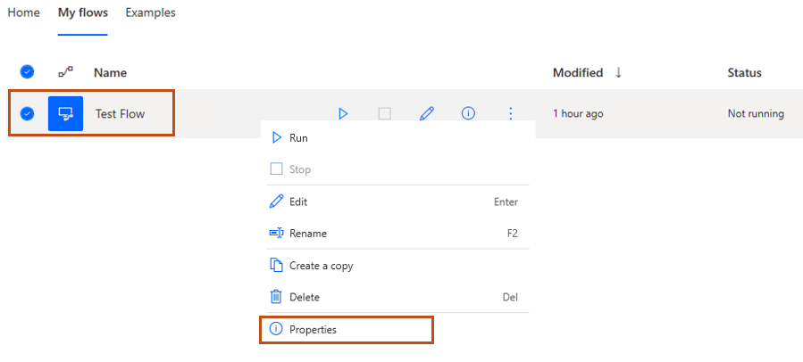

* In the properties tab, set the keyboard shortcut you wish to trigger your flow. Then hit the **Save** button.

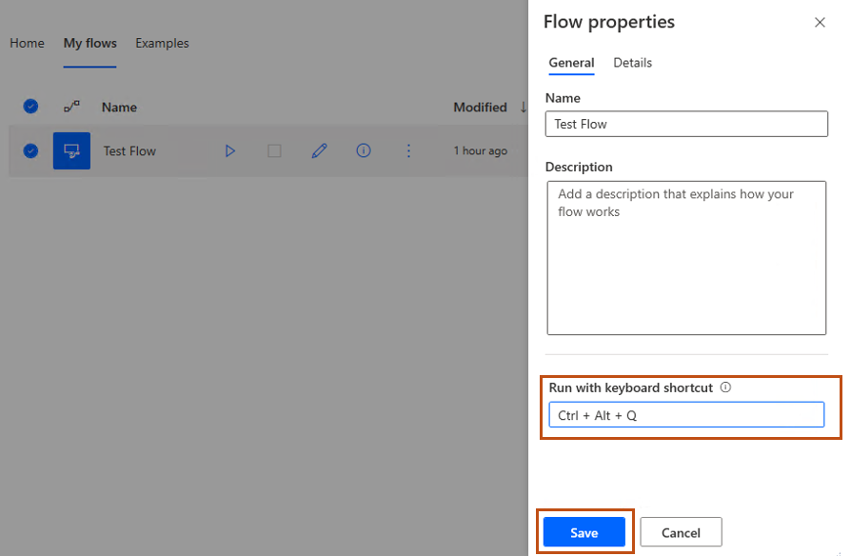

# Step 2

* Make a directory on your computer to store script files, for instance, **C:\PowerAutomateRunScripts**.
* Navigate to the URL <https://github.com/andrey-belokozov/power-platform-samples/tree/main/power-automate-desktop-task-scheduler> and download the **send-keys-combination.ps1** script into the folder you created earlier.
* While not required, it's recommended to rename this file to match the flow it executes. Avoid spaces in the name, like '**TestFlow.ps1**'.

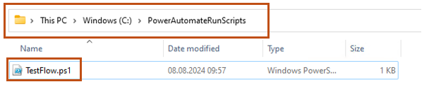

* Edit the script in a text editor to match the key combination set in Step 1 for activating your flow. After adjusting the keystroke expression, save your changes.

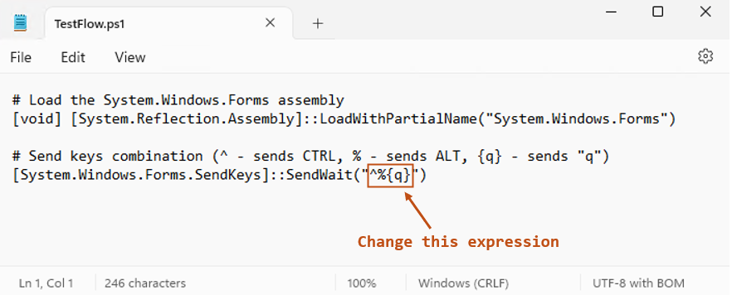

# Step 3

* Navigate to the Task Scheduler and set up a new folder designated for tasks that will execute Power Automate Flows (Action > New Folder).

* Proceed to the **Create Task** section and assign a name to your task.

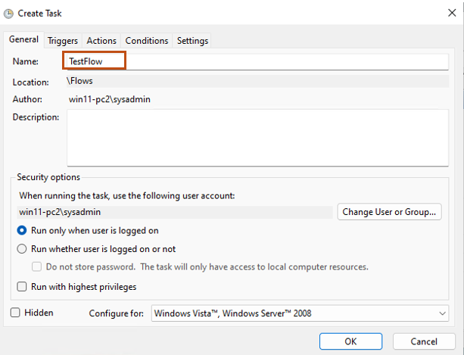

* Navigate to the **Triggers** Tab to set up a schedule for running this script.

* Navigate to the **Actions** Tab and create a new action with parameters below:
  + Program/script:

powershell

* + Add arguments (replace the file path with the actual path of your script):

-ExecutionPolicy Bypass -File C:\PowerAutomateRunScripts\TestFlow.ps1

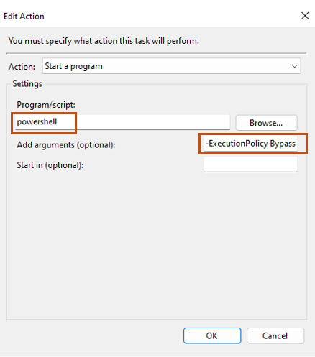

* Click **OK** two times to close all open windows, then attempt to manually execute your task to confirm that everything is functioning correctly.