(props) => {}
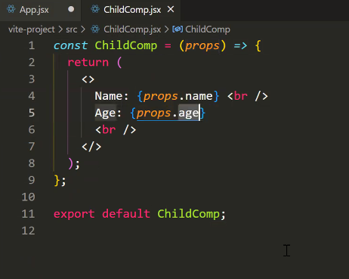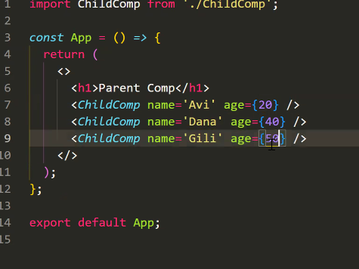

Style importing + style using:
<dev className={} style={ { } }><dev/>
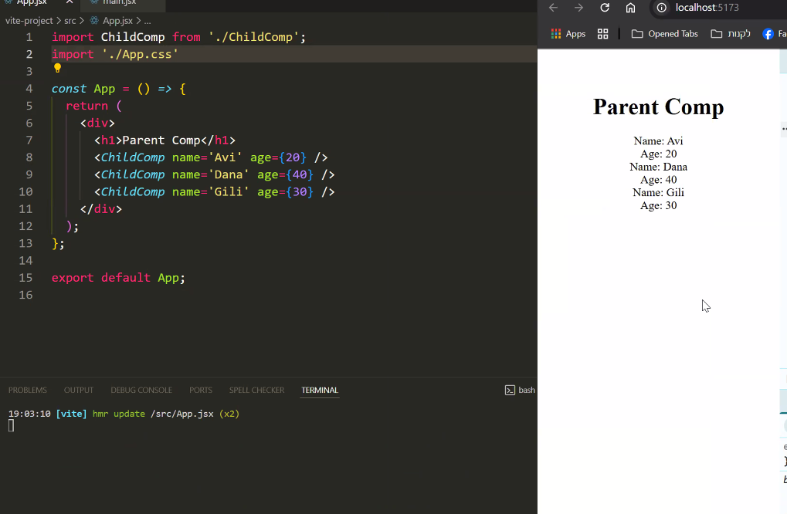

Events + logic using:
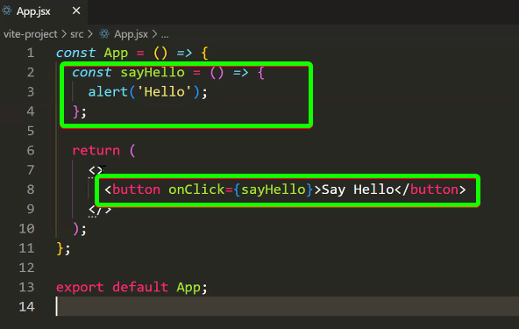
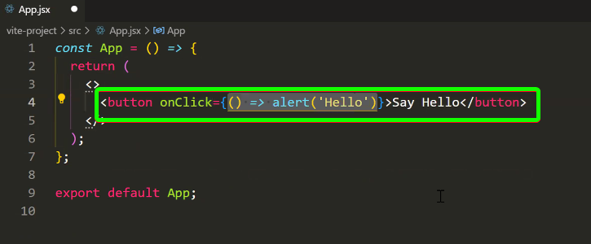

Events:
- All run events has object (event) parameter as default argument
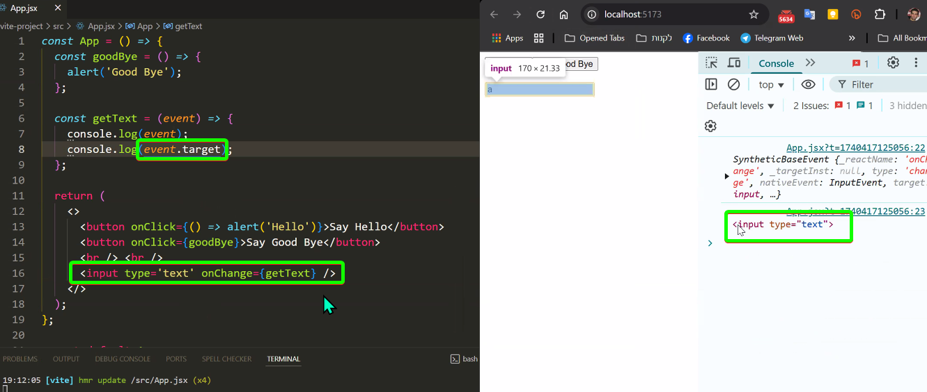
Use State (Destructuring) \ משתנה מצב: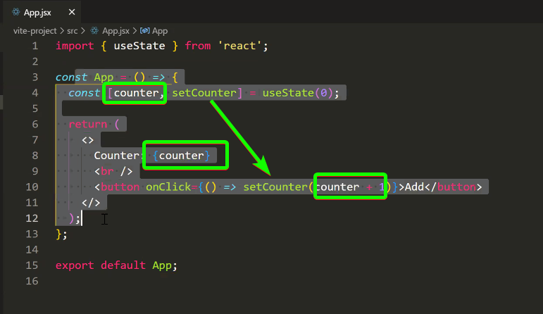
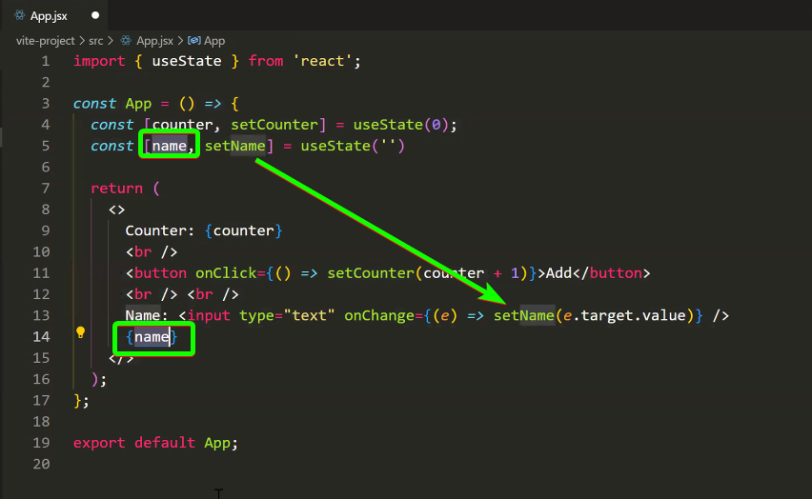
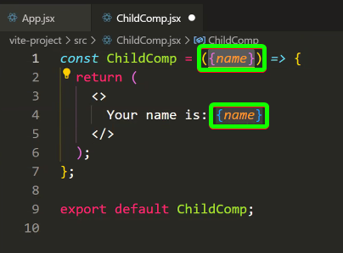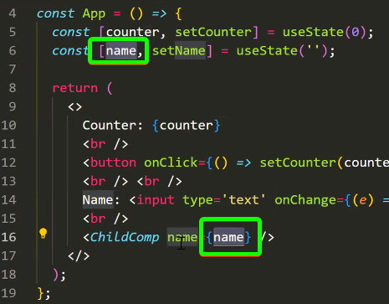
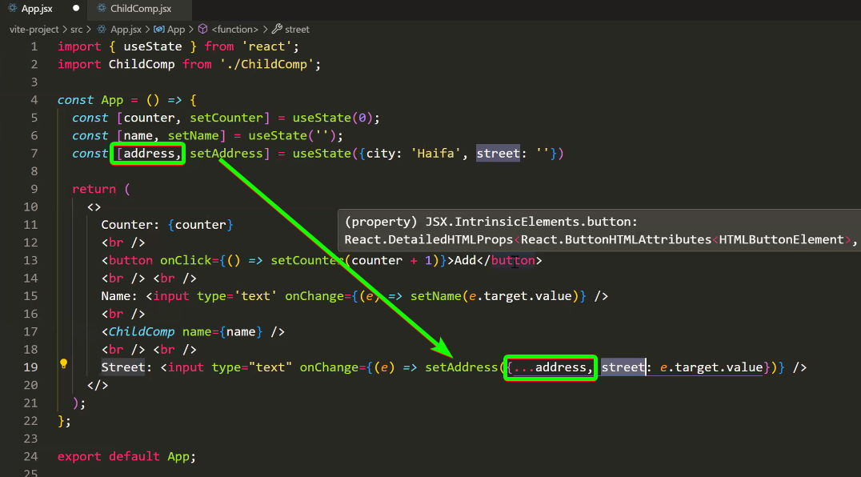

Dynamic rendering:
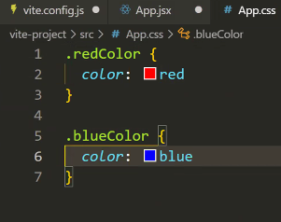

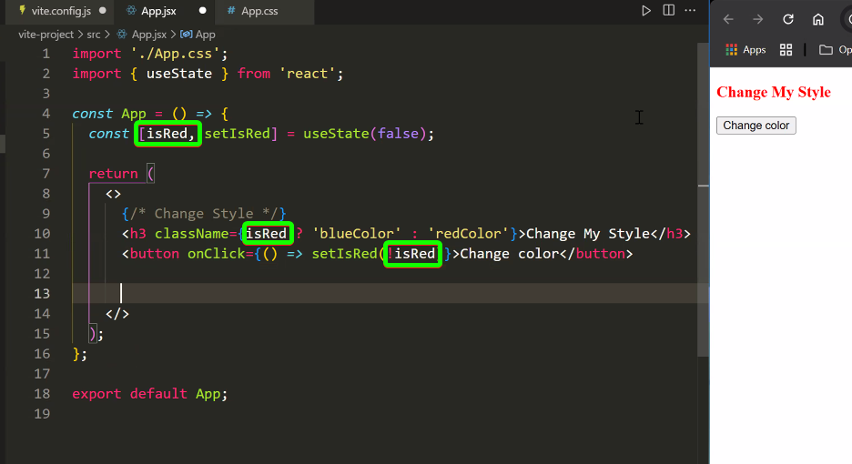
Short Circuit Condition: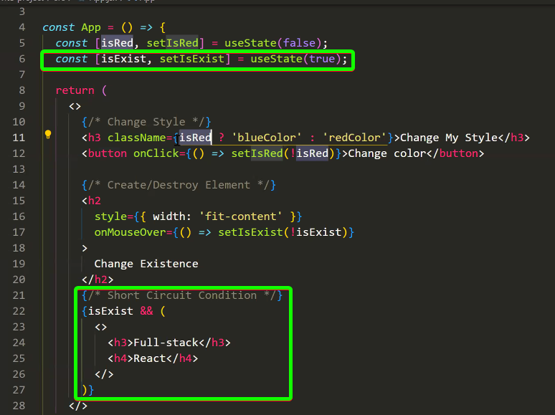


Repeater (JS Loop + HTML element):
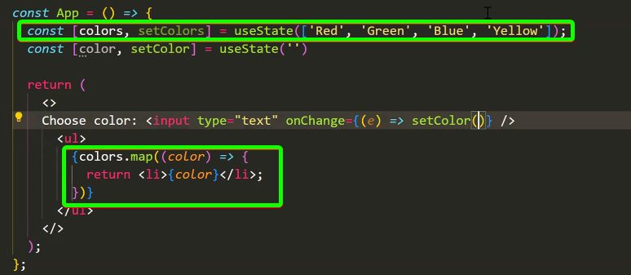
Adding dynamic value to object with repeater + unique key:
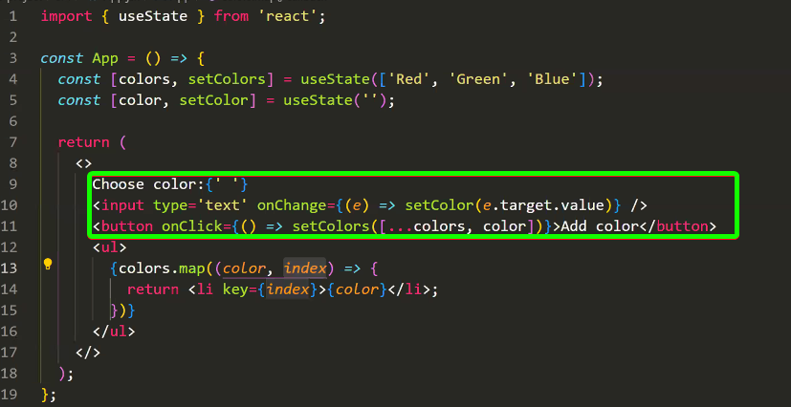

Lifting state Up (From child to father) => record between 18:05 – 18:25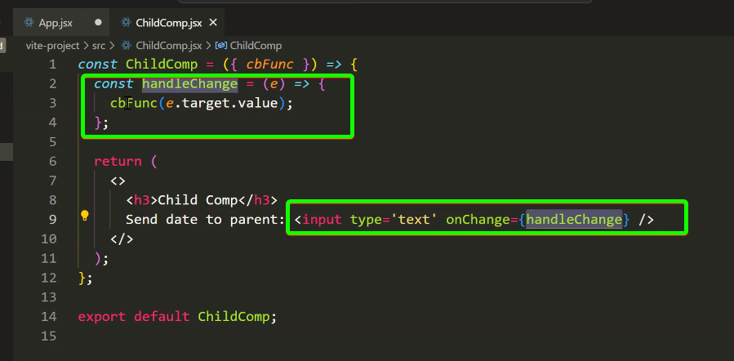

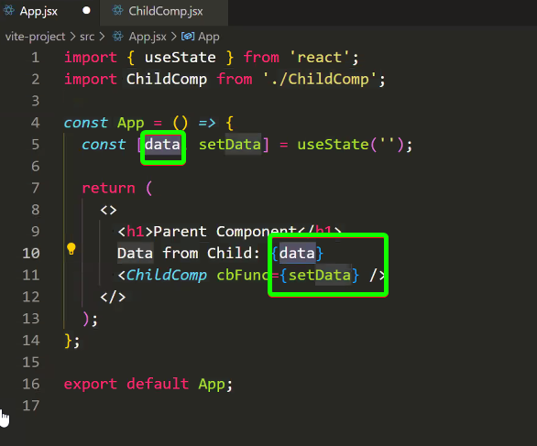

HTTP Requests (Axios library):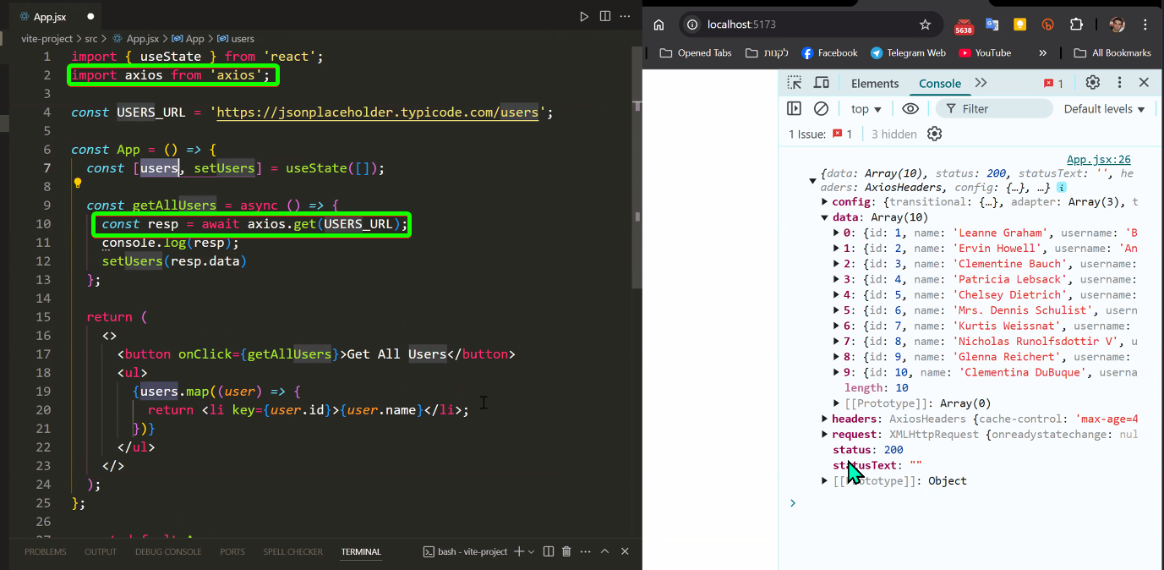

Interface in React:
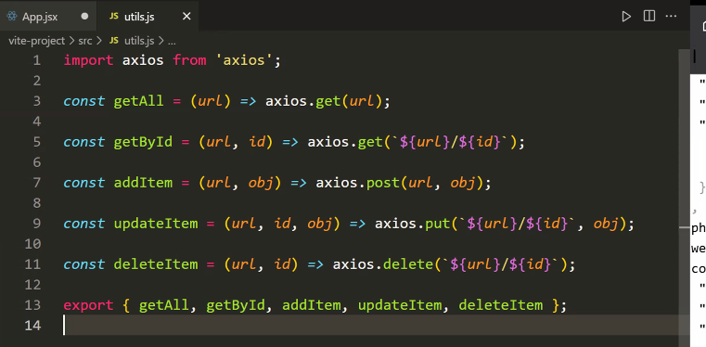

useEffect \\ Add On Change || On Load:
useEffect -CAN NOT BE ASYNCHRONIC
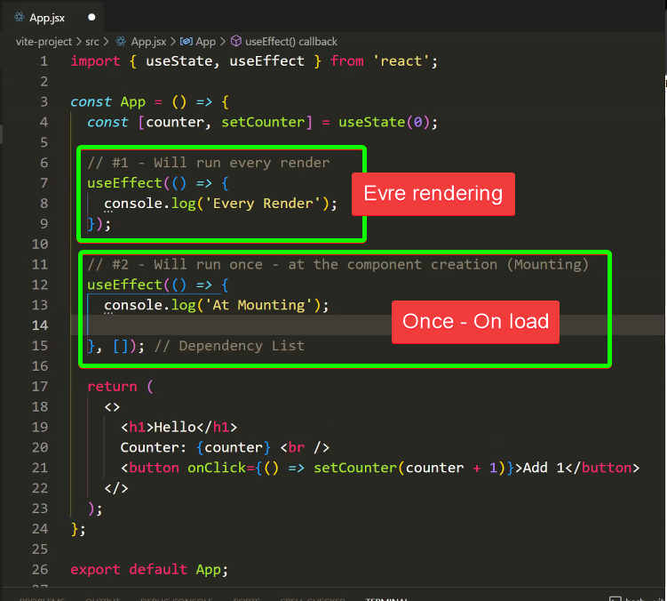
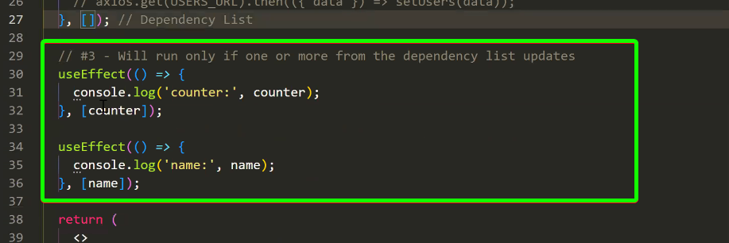

Async func into sync func (useEffecnt):
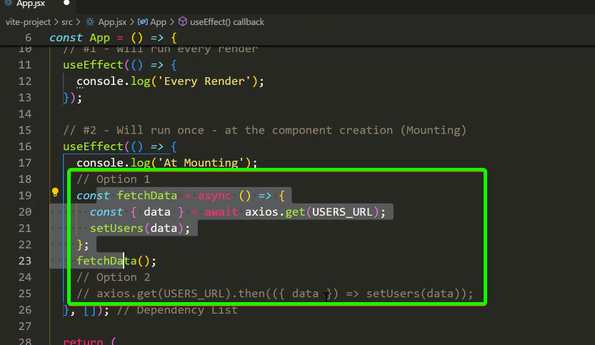

Routing:
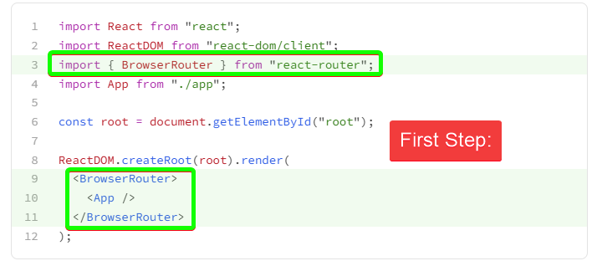
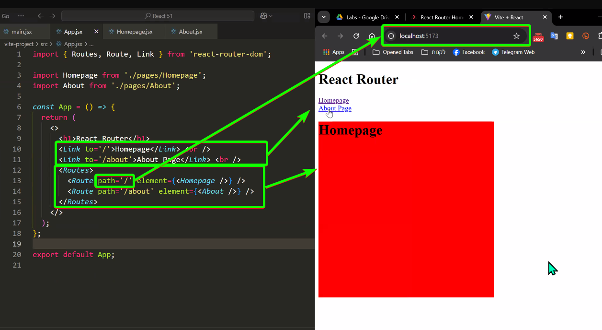

Navigate:
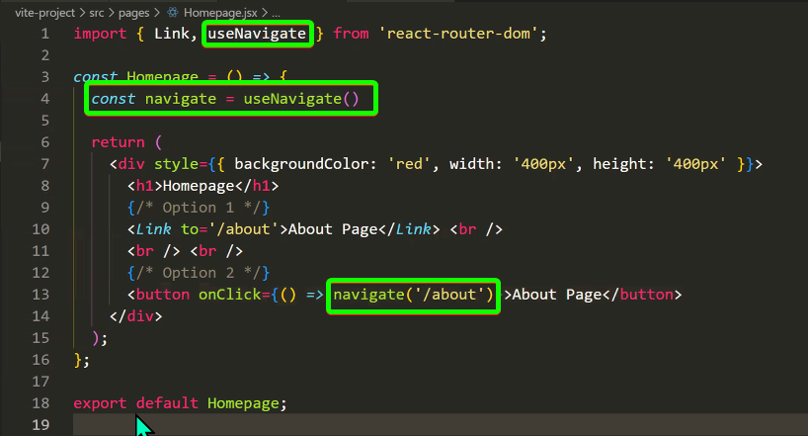

Nested Routing:
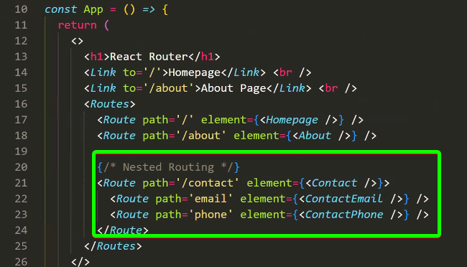
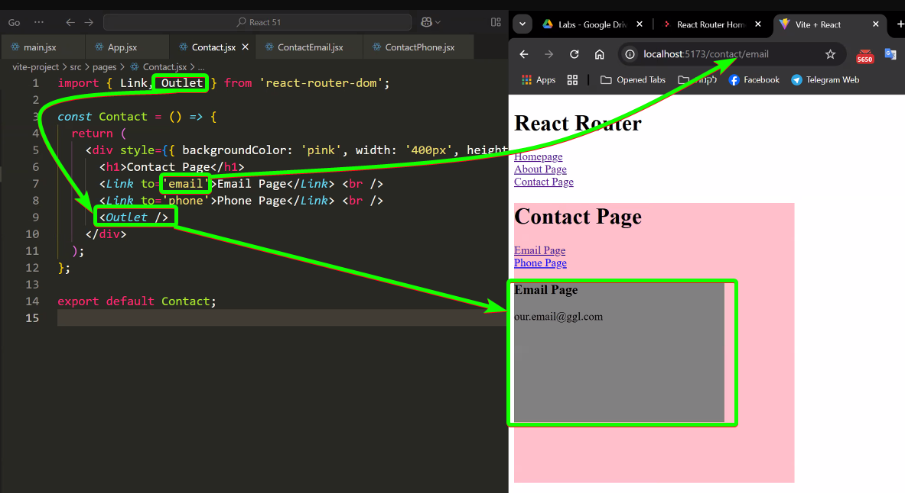

Redux – כלי ניהול דאטא
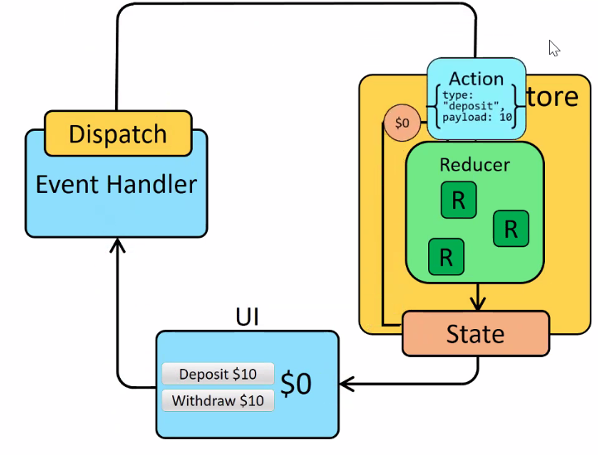
State – name of prop (counter)
Action -> action include what and how do with state

Importing: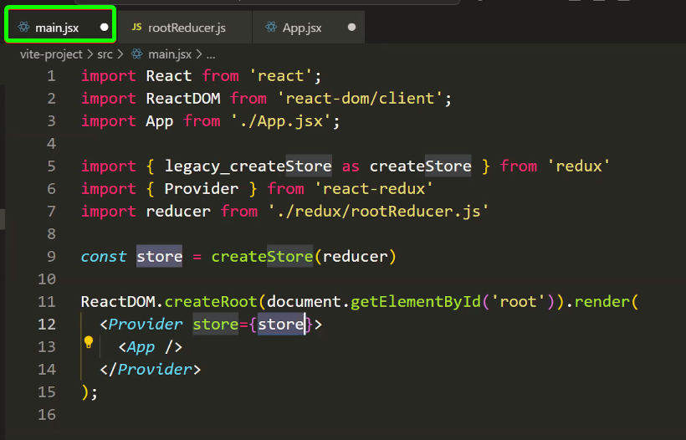
rootReducer – This reducer is the main reducer, he is call to other reducers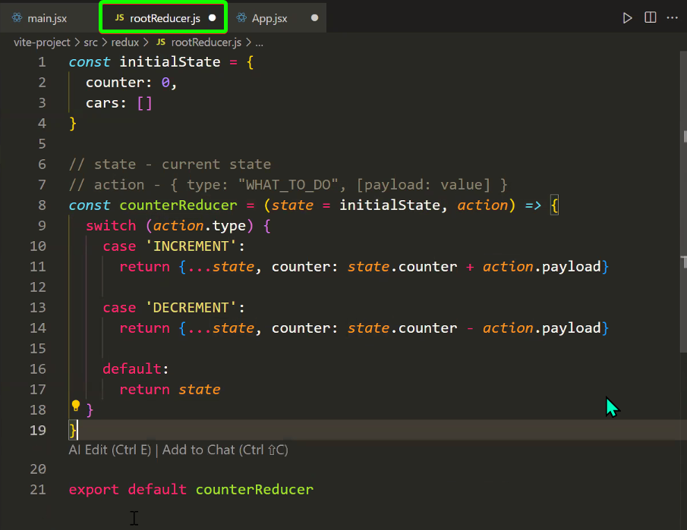
Get reduce data (useSelector):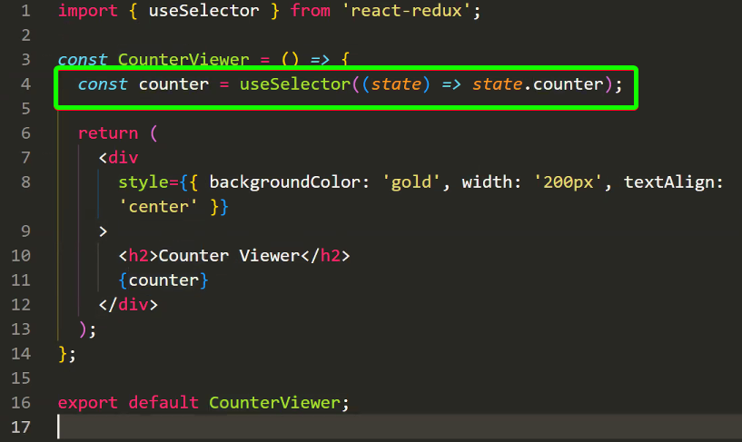
Update reduce data (useDispatch) : 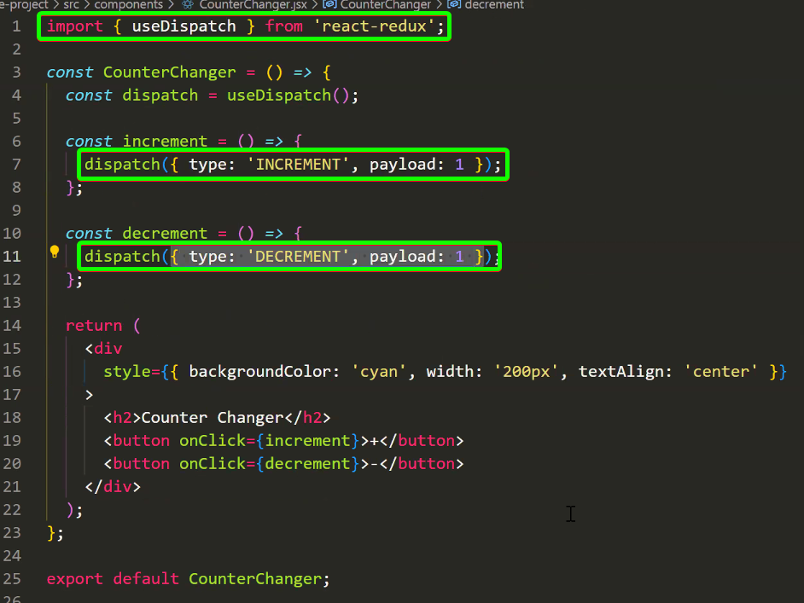

Firebase to React =>
- Create configurations file “firebase.js”: (firebase => project => project settings 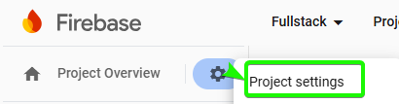 )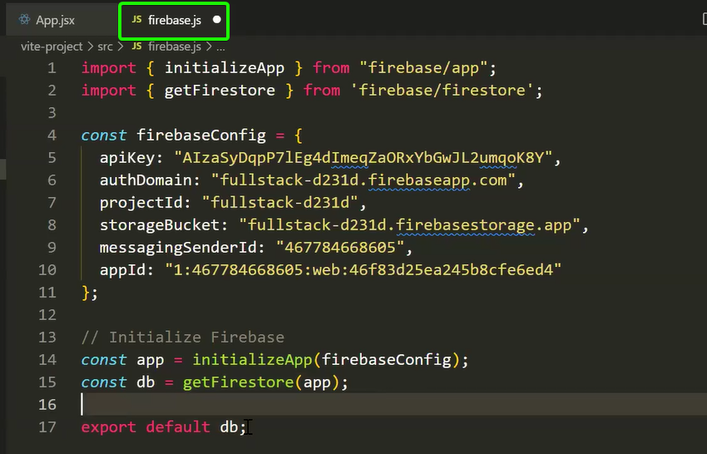
- Import the “db” to the component :
  - 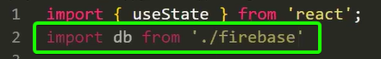
- Get data from firebase (firestore):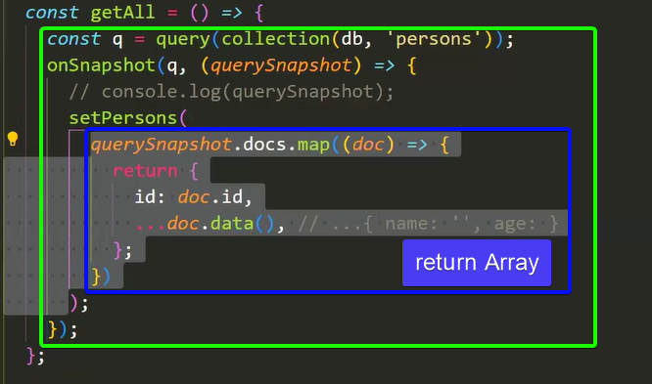
- Update doc into collection: 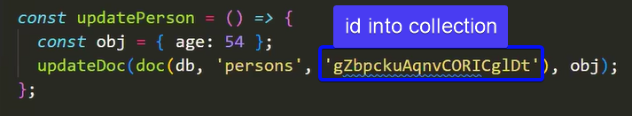
- Delete from collection: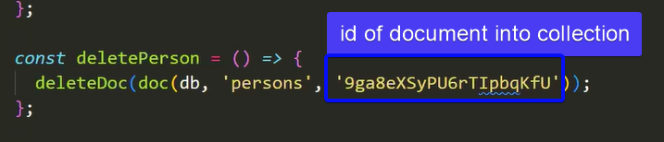
UseMemo -> For the sake of improving performance
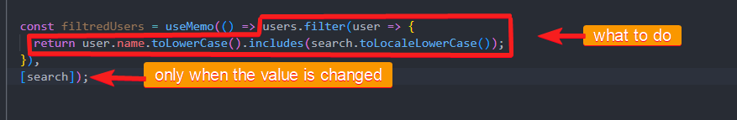

Memo -> For stopping a double rendering of pages:

GIT – It’s a app version manager.
Git terminal (Git Bash ) commands: 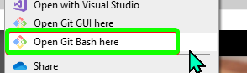
pwd | Present working directory
ls | Content of current directory
cd | Change directory
mkdir {folder name} | Make directory – for creating new folder
touch {file name} | For creating new file
git init | To Initialize a GIT as part of folder
git config user.name {“your name”} | Set user as owner of build
git config user.email {“your email”}
git status | Retrieve an information about files\folders with a GIT take them to next steps
git add . | Include the all files and folder into current location to git
git add {filename} | Include the specific file or folder into current location to git
git commit -m “Message to up with” | Commit \ save all changes => checkpoint
git log | Get list of all comments with he’s id’s  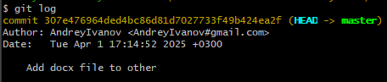
git checkout {commit ID} | Pick this version. Set all folder data to be as saved into commit READ ONLY -Not really set a previous version
git checkout {branch name (master)} | For getting a las updated version from git
git branch | Show list of active branches (master, main, ...)  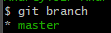
git branch {new branch name} | To create a new branch
git checkout {branch name} | For change a main branch name (master to dev1)
GITHUB
git branch -M superMaster | For set the new main branch
git remote add {name of connection} {Url to github repository} | For connect the current folder to GitHub  name of connection – origin
git push {name of connection} {branch name} | For upload all changes to github  name of connection – origin  branch name - superMaster
git pull {name of connection} {branch name} | To get all new changes from github  name of connection – origin  branch name - superMaster

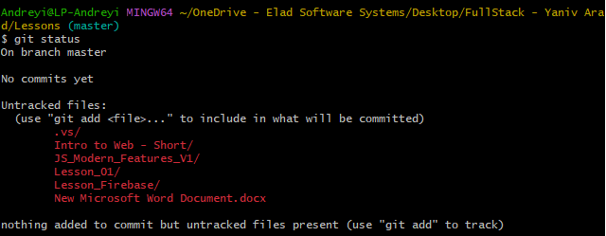
Git life cycle: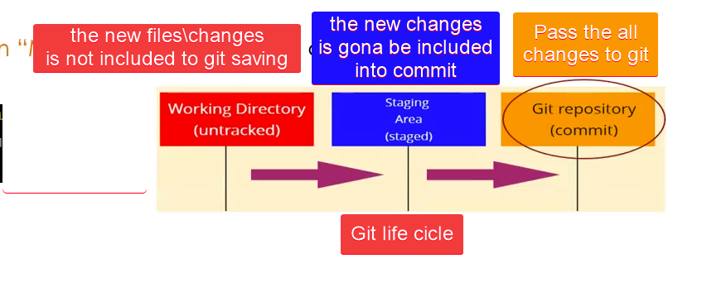

GIT 1. Save the new changes on the previous version:
  - Create a new branch - git branch ‘new branch name’
  - Do your changes
  - Add all changes to git – git add .
  - Commit the all changes – git commit -m “Commit comments”.
GIT 2. Adding a changes to master branch + save:
Fast forward merge – merge without conflicts
- Do all steps from GIT 1.
- When you on a main branch insert – git merge {branch name with changes} .

GitHub:
Fork the project you need to work into github. || Cope not your project to your repository
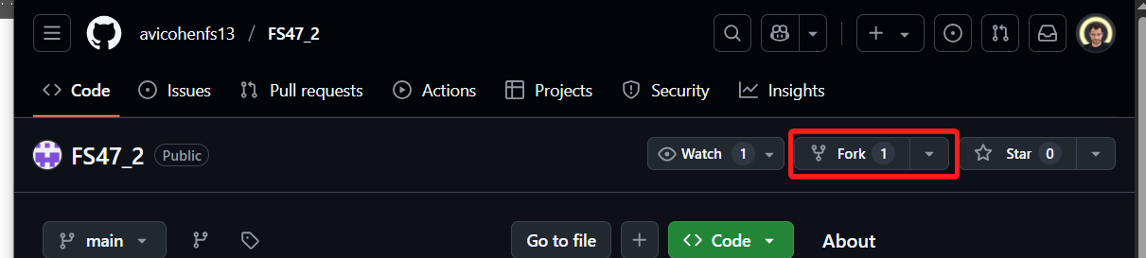

Rafce – fast creation of .jsx component
React-Router-Dom - Routing
If a url is “http://localhost:5173/products”:
- <Route path=’/contact’ element={<Contact/>} />
  - http://localhost:5173/contact
- <Route path=’contact’ element={<Contact/>} />
  - http://localhost:5173/products/contact
Axios library - Library for HTTP requests.
Template Literals – `${value} simple string`.
Optional chaining - Account?.address?.street?.streetSinonim
Computed property name - obj["name"]
Spread operator - [...nums] ; {...obj}
Destructuring - 