Lesson_01
Promise: Promise.then()
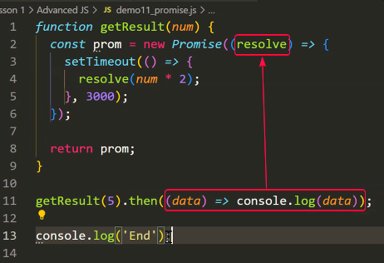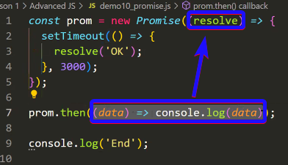
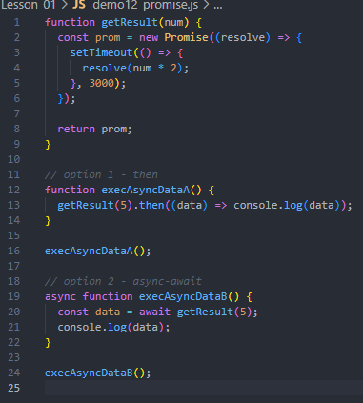

Promise.then().catch()
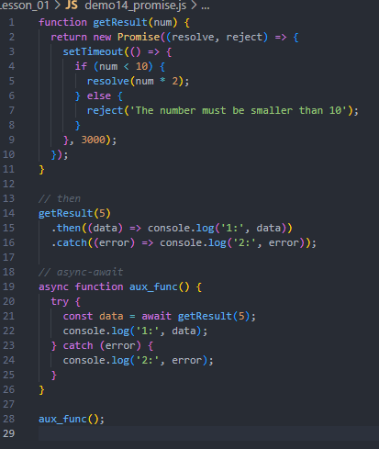

Node JS
– Export from Module (file):
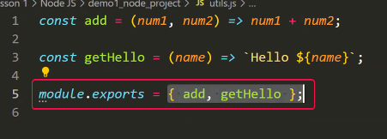
- Impot from Modules to another file:
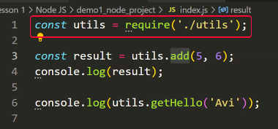

JSONfile library -> ‘npm i jsonfile’ for instal
- For managing an JSON data
Using:
- Install to project
- Import to file for using:
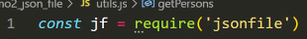
- Use:
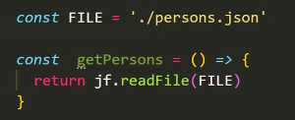

Concepts dictionary:
Anonymous function |  | 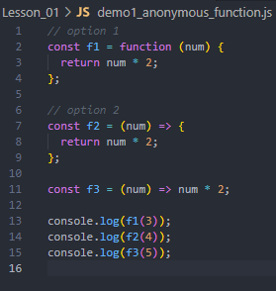
Hight Order Function | Function who gets other function (callback function) as parameter | 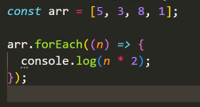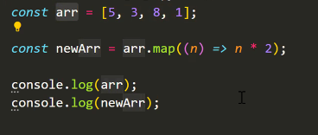  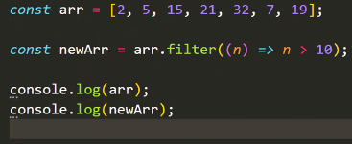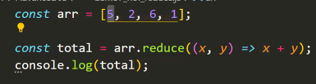
 | Function Pointer | 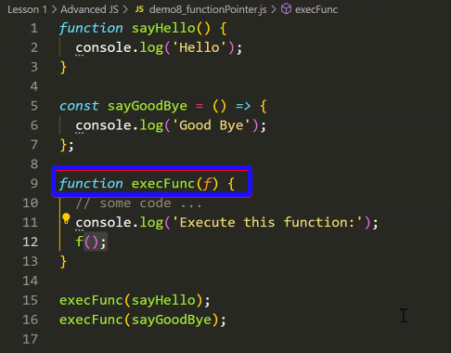
 | Initialize a new NODE project | npm init -y

