**Install**

1. Unarchive folder with project
2. Open it in your IDE
3. Open new terminal tab
   1. symfony serve
   2. p.s. on my laptop project starts at port 8000
4. Open new terminal tab
   1. docker-compose up
5. Open new terminal tab
   1. php bin/console --no-interaction doctrine:migrations:migrate
   2. php bin/console --no-interaction doctrine:fixtures:load

Step 5.a will take a bit of time, because there are API requests for currency rates, also fake Transactions generation.

After all migrations don’t and fixtures installed all currencies rates will be loaded, 250 transactions (125 for EUR accounts and 125 for USD account) will be also created.

**Usage**

1. You can visit http://127.0.0.1:8000/ here you can find list of created clients and list of created accounts.
2. You can visit <http://127.0.0.1:8000/api/doc> to find documentation, also you can test requests from here. To do it you must to login and get Bearer token. You can do it in any type you want, I prefer to use Postman.
   1. Auth path: <http://127.0.0.1:8000/api/v1/auth/login>
   2. Method: POST
   3. Raw object: {"username":"test@test.lv","password":"123456"}

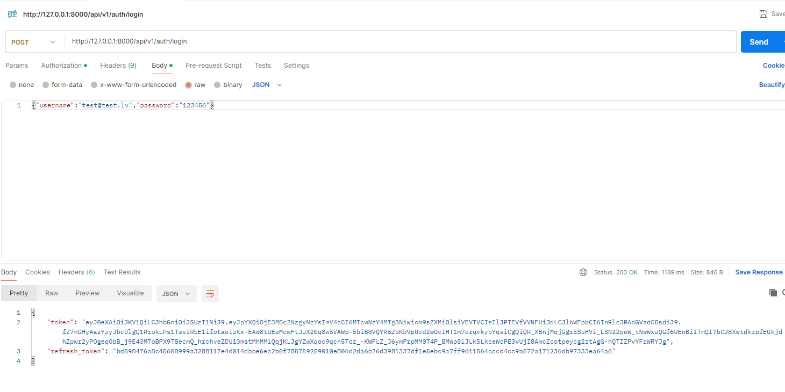

1. Now, when you get a token, you can paste it in <http://127.0.0.1:8000/api/doc> page

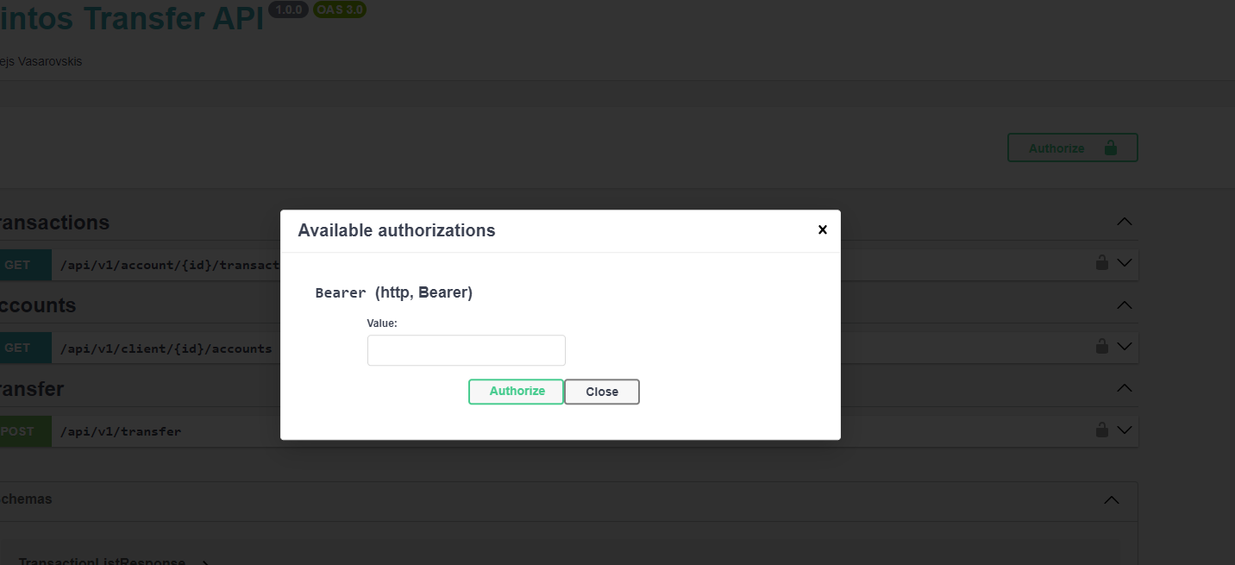

1. Try to do some requests from doc page.

P.S. <http://127.0.0.1:8000/> is created for easier debug process. Here you can see ids needed for request, also you can see balance changing after transactions, just refresing the page.