MACHINE LEARNING · METHODOLOGY
Building a Churn Model
With a Dunnhumby database
How the label is defined, why raw associations mislead, and what a one-column rule is for. A reasoning companion to a retail churn prediction notebook.

Figo Data · August 2026 · v1.0

Introduction
This document accompanies a churn prediction project built on a public grocery retail dataset covering roughly 2,500 households over two years of transactions. It sets out the reasoning: the decisions taken before any model was fitted, the tests used to decide whether a signal was real, and the conclusions that changed as evidence arrived.
The motivation is that churn modelling on transactional data is unusually easy to get wrong in ways that look like success. A model can score near-perfectly and have learned nothing. Most of the work below is concerned with making that outcome detectable.

Defining the Label
Transactional datasets rarely contain a churn column. There is no cancellation event in grocery retail: a customer who stops shopping simply stops appearing. The analyst has to invent the definition, and that invention determines everything downstream.
The working definition here is that a household has churned if it made no purchase during a fixed 28-day window following a chosen cutoff point in time. The subtlety is not the 28 days. It is the cutoff.

Why the cutoff is not optional
The intuitive approach is to label churn over the final weeks of the data and compute features from the full history. This fails, and it fails silently.
Consider recency, the number of days since a household's last purchase, measured at the last day of the dataset. If that value exceeds the length of the label window, the household by definition bought nothing during the label window. The feature and the label are the same fact written twice. A model trained this way reproduces an arithmetic identity and reports it as accuracy.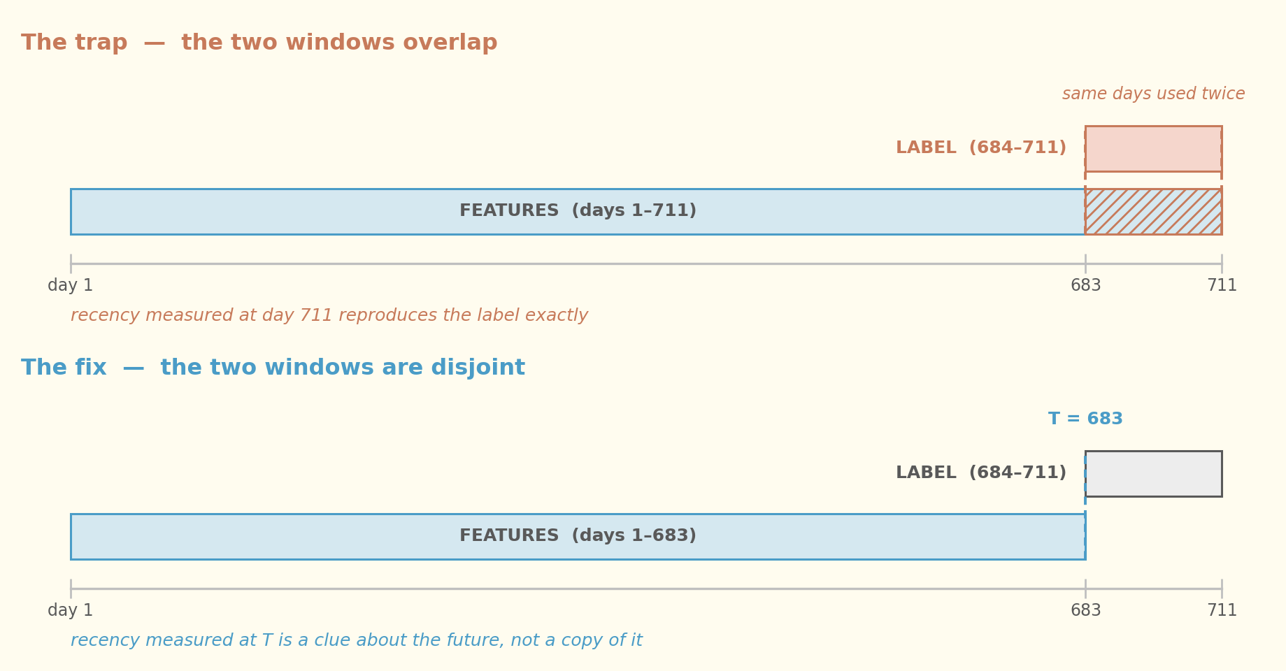
Overlapping windows make the strongest feature a restatement of the label.
Splitting time into two non-overlapping windows resolves it. Everything before the cutoff produces features; everything after produces the label. Recency remains a strong predictor, but two households with identical recency can now receive different labels, because what happens after the cutoff is genuinely unknown at the time the features are measured.
The practical form of this rule is a filter that appears in every aggregation: no row dated after the cutoff may contribute to a feature. Enforcing it in one place, inside a single feature-building function, is what makes the rule auditable rather than aspirational.

Population and Event Are Separate Questions
A second decision, easy to leave implicit, is who the question is being asked about. A household that last shopped eighteen months ago is not at risk of churning; it has already gone. Including such cases mixes two different questions into one label: who is about to leave, and who already left.
The consequences are concrete. The already-departed are trivially predictable, so they inflate any metric computed across the whole population. Worse, they are unreachable: a retention budget spent on the highest-risk decile would go almost entirely to people who will not return, while the recoverable customers sit below the threshold.
The project therefore defines an eligible population separately from the churn event, restricting scoring to households with recent activity before the cutoff. The threshold chosen is a judgement, not a fact, and is stated as such. The point is that every study has a population; leaving it undeclared does not remove the choice, it hides it.

Two Cuts, Two Purposes

The cutoff in time is often confused with the train and test split. They operate on different axes and defend against different failures.
 | What it separates | What it protects against
Cutoff in time | Past from future, within each customer | Predicting the present using the present
Train / test split | Customers from customers | Memorising individuals instead of learning patterns

The order matters. Once the cutoff has produced one row per customer, time has been compressed into the feature values and the problem becomes ordinary tabular classification. The customer-level split happens after that, and it happens before exploratory analysis, so that the held-out set is physically absent from every chart and summary that follows.
Holding out a test set early is a defence against the analyst, not the algorithm. Humans are excellent pattern detectors, including of patterns that exist only in one sample. Deciding what to build after seeing the evaluation data contaminates the evaluation even when no code is shared between them.

Choosing the Metric Before Seeing Results
With a minority class near one in six, accuracy is unusable: predicting that nobody leaves scores well above eighty percent. The choice is between two ranking metrics, and it is a choice about what the model is for rather than about the data.
ROC-AUC divides false positives by the total number of negatives, which is a large denominator when the positive class is rare. It is therefore flattering. Precision-recall AUC asks instead: of the customers flagged, how many actually left. That is the question a retention budget answers to.
The difference is not academic. Evaluated on the same one-column rule, the two metrics differ by more than a third of the available scale. Had the flattering metric been adopted, the project would have begun from an apparently strong position with little visible room to improve, and the modelling work would have looked unnecessary.
Fixing the metric in writing before any model is fitted removes the option of selecting, after the fact, whichever number happens to favour the result obtained.

The Baseline as a Unit of Measurement

Before any model, a single rule was scored: rank customers by how long they have been absent. No fitting, no parameters, one column. Its purpose is to convert model scores from absolute numbers into meaningful ones.
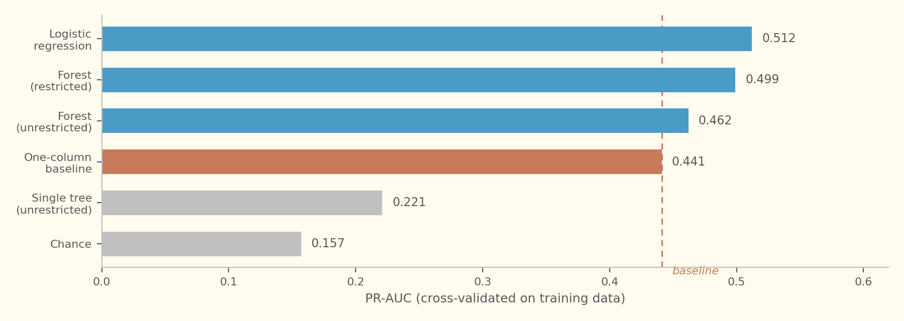
Model families measured against the one-column rule. The tree scores below it.
Three things become legible only against that line. An unrestricted decision tree scores roughly half the baseline, which shows that complexity without control actively destroys performance. Restricting the forest recovers most of the gap, identifying variance rather than insufficient capacity as the problem. And the margin the best model wins by, once visible, turns out to be modest.
That modesty is informative rather than disappointing. It sets a reasonable expectation for what the remaining work can achieve, and it establishes in advance the level at which a result would be suspicious instead of impressive.

Why the Simple Model Won
The linear model narrowly outperformed a tuned ensemble, which inverts the usual expectation. The explanation is sample size rather than algorithm quality.
Model error decomposes into bias, from being too rigid to capture real structure, and variance, from changing too much as the training sample changes. Variance grows with model flexibility and shrinks with data volume. With a positive class numbering in the low hundreds, a deep tree partitions the data until its final decisions rest on a handful of individuals; swap a few customers and the tree is different.
The evidence is in the spread across cross-validation folds, which is a direct measurement of variance. The linear model returned nearly the same score regardless of which customers it trained on. The ensemble did not.
A grid search over the regularisation parameters improved on hand-picked values by an amount smaller than the fold-to-fold spread. When tuning cannot beat noise, the constraint is not the hyperparameters.

A Raw Association Is Not Evidence

The most transferable part of this project is the protocol applied to every candidate feature. Four signals were proposed on plausible business reasoning: fuel purchases at the retailer's forecourt, coupon redemption, campaign exposure, and concentration of shopping across store locations.
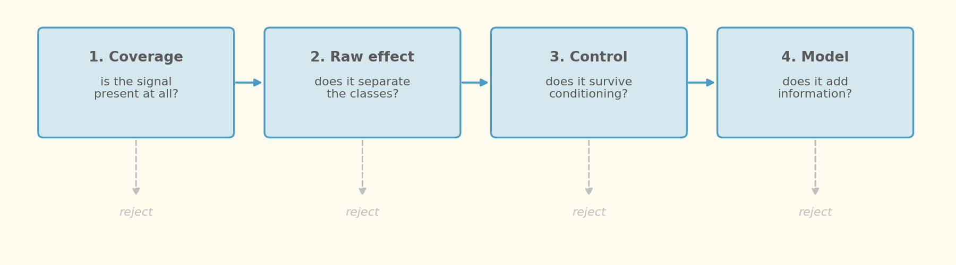
Every candidate passes the same four gates before it is adopted.
All four cleared the first two gates convincingly, showing separations between three and five times the base rate. None survived to adoption.

Gate three: conditioning on the obvious explanation
Customers who buy fuel, redeem coupons or receive campaigns are, overwhelmingly, customers who visit often. Visit frequency independently predicts retention. The aggregate association may therefore be entirely compositional, and the way to find out is to compare like with like: split the population into bands of visit frequency and check whether the effect persists inside each band.
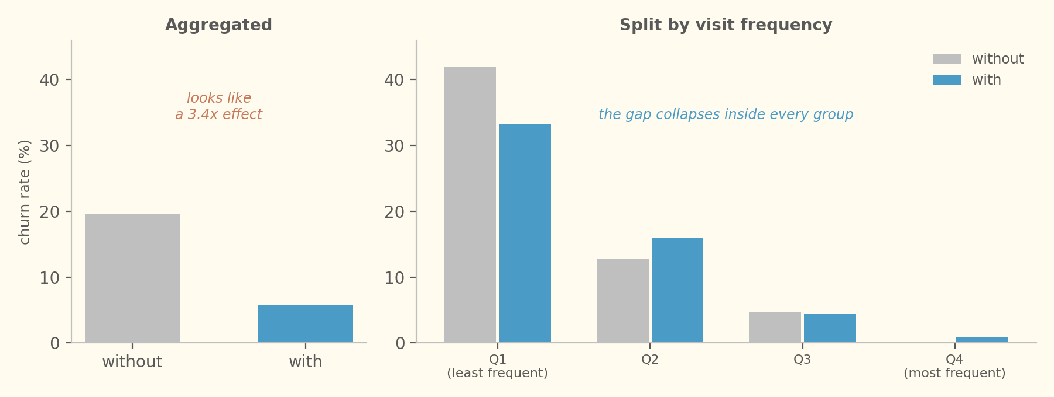
The same signal, aggregated and then conditioned on visit frequency.
For fuel purchases the effect vanished and in one band reversed. This is Simpson's paradox, a reversal of an association when a confounding variable is accounted for, and it is the single most common failure mode in churn analysis on transactional data. Coupon redemption failed the same way, more extremely: redeemers were roughly twenty-five times more concentrated in the most frequent band than in the least.

Gate four: real is not the same as new
Two candidates did survive conditioning. Campaign exposure held up among infrequent shoppers, and single-store shopping held up across two bands with several hundred cases each. Both were then added to the model, and neither moved the score.
Campaign exposure carries a further caution that behavioural features do not. It records a retailer decision, not customer behaviour. If campaign targeting policy changes, the column changes meaning and any model relying on it degrades with no signal that it has done so.
This distinction deserves emphasis, because it is where the protocol earns its keep. A feature can encode a genuine effect and still add no predictive information, because the existing features already represent that effect by another route. Causal importance and predictive contribution are different questions, and answering the first does not answer the second.

Reading the Final Number

The held-out set was opened once, after the model had been selected. The result was materially above the cross-validated estimate, which is the wrong direction and warrants suspicion before celebration.
The diagnostic that resolved it was comparing what moved. A leak inside the feature-building code would lift the model while leaving the one-column baseline untouched, since the baseline consumes a raw column. Both rose together, by similar amounts, and the feature distributions of the two sets were nearly identical. The held-out sample was simply slightly easier, which is expected when it is smaller than a single cross-validation fold.
A single evaluation on a small positive class carries a wide interval. The defensible claim is that the model generalises and retains its advantage over the baseline, not that the observed figure is its true performance.

Translating for the business
Ranking metrics compare models; they do not describe actions. Converting the model output into a ranked contact list and reading precision and recall at several list lengths produces the operational picture. In this case returns fell away sharply beyond the first fifty households, which is a concrete recommendation: an expensive retention action should stop there, while a cheap one can be extended further down the list.

Overview Summary

Most of the value in this project came from decisions taken before modelling and from tests designed to reject ideas rather than confirm them. Separating the feature window from the label window removes an identity that would otherwise masquerade as accuracy. Declaring the eligible population separates the question of who might leave from the question of who already has. Fixing the metric in advance removes the option of choosing one that flatters the outcome.
A one-column baseline converts model scores into interpretable quantities and exposed, immediately, that an unrestricted tree performed worse than no model at all. Four candidate features that looked strong on raw association were rejected: two because the association was compositional, and two because a real effect turned out to carry no information the existing features lacked. Hyperparameter search improved on hand-picked values by less than the noise between folds.
Taken together these results point at the binding constraint. It is not feature coverage, and it is not model sophistication; both were tested and neither moved the ceiling. It is the number of positive cases available to learn from, which suggests that generating labels at several cutoff dates, rather than one, is the direction with the most left in it.
The transferable practice is narrow enough to state in a sentence. Treat every promising association as a confounding hypothesis until it has been conditioned on the obvious explanation, and treat every surviving effect as an open question about predictive value until it has been added to a model and measured.

Useful Links
- Source dataset, dunnhumby The Complete Journey (Kaggle): https://www.kaggle.com/datasets/frtgnn/dunnhumby-the-complete-journey
- Original kernel that work forks (GitHub): https://github.com/omerfarukeker/The-Complete-Journey
- My Notebook:
https://www.kaggle.com/code/andreydesousa/end-to-end-churn-analytics-from-deep-eda-to-cv

