Andrey Kurenkov

LCC 2500 - Intro to Film Studies

Navarro, Vinicius

7/30/2012

**David Lynch as a Preeminent Film Auteur**

Few modern filmmakers have produced art as distinct or unprecedented as the movies of David Lynch. His movies are an undeniable testament to the existence of authorship in film, and Lynch is thus rightfully considered a preeminent “film auteur”. This weighty term derives from auteur theory, which was first developed by french film critics in the 1950s and emphasizes specific filmmakers as essentially being authors of their work. Such “film authors” create films with recurrent and distinct characteristics that are seen as being primarily shaped by that person. Following the tradition of truly unique authors before him such as Kafka and Orwell, Lynch has even spawned the adjective “Lynchian” which self-evidently implies he is film auteur. The rich thematic, stylistic, and narrative connotations of the term also define both Lynch as an artist and the components comprising the whole concept of a film auteur.

Often the most consistent and notable quality of film auteurs are the overriding themes found throughout their work. In his essay on Lynch, David Foster Wallace offered a possible definition of “Lynchian” to be “[a term that] refers to a particular kind of irony where the very macabre and the very mundane combine in such a way as to reveal the former's perpetual containment within the latter” [1]. This kind of irony can be seen and forms the thematic backbone in most of Lynch’s feature-length works: the horrifying realizations of conformist metropolitan life in *Eraserhead*, the hidden perversions and secrets of seemingly normal societies in both *Blue Velvet* and *Twin Peaks,* and the twisted anxieties and repressed desperation of normal suburban residents in *Lost Highway* and *Mulholland Drive*. A more general expression of the singular theme found in various forms throughout both his short and feature length work could be “suppressed or hidden feelings forced into surreal and cataclysmic expression.” There are many notable examples of auteurs with a similar broad theme such as Spike Lee and his social commentary or Tarkovsky and his spiritual quests. However, there also exist important counter-examples such as Kubrick in whose films the approach to filmmaking and persistent formal aspects are more important qualities than a persistent theme.

A second quality of auteurs having great importance is the cinematic style consistently found in their work. Style is a broad concept encompassing an auteur’s overall approach to filmmaking with respect to cinematography, editing, the mis-en-scene, and all other formal aspects of film. Precisely because of a greater tendency for experimentation and originality, auteurs often develop a unique style that becomes recognizably theirs. Some auteurs, Lynch included, develop several stylistic periods within their work as their style evolves over time. For Lynch, his attempt at crafting an expensive mainstream blockbuster with 1984’s *Dune* was a major creative failure [1] that drove him to change much of his defined style. Prior to *Dune*, his movies are notable for being largely black and white, combining surreal animation and animatronics with live-action, and using very distinct sound effects such as wind. Eraserhead’s iconic worm baby and overall aesthetic exemplifies Lynch’s early style (see fig. 1.). After *Dune* and his disillusionment with the mainstream hollywood system, Lynch turned to using lavish color, much more seemingly normal settings, and more varied music. Perhaps the most well known example of his latter style is the red room from *Twin Peaks*, a tv series that nevertheless unmistakebly showcases Lynch’s cinematic style (see fig. 1.).

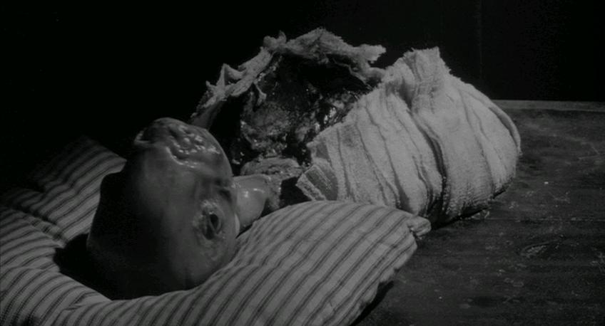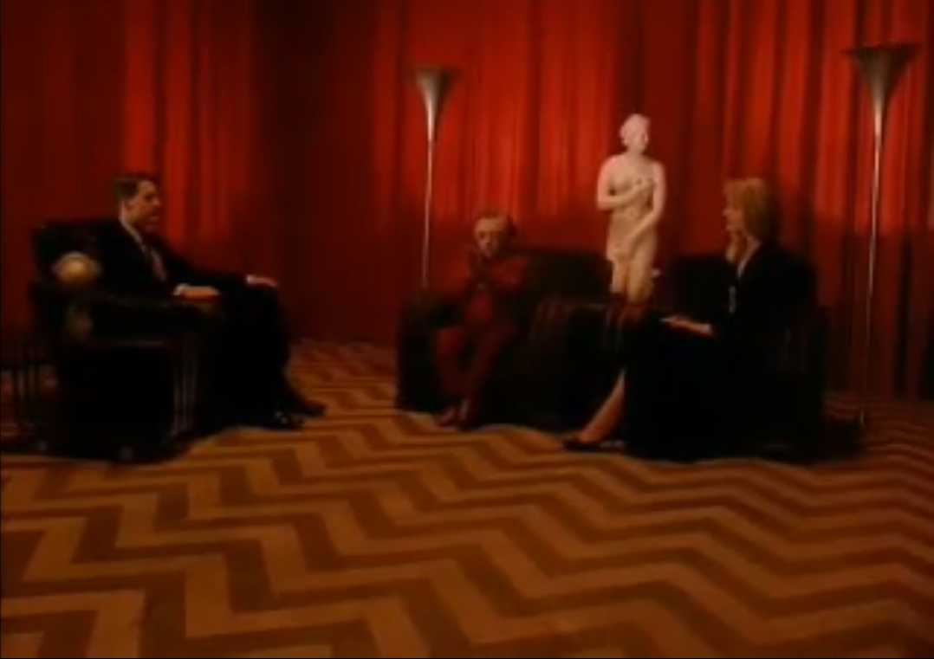

Fig. 1. Left, the worm baby from Erasehead contrasting with the right, the red room from Twin Peaks[2] Despite the clear stylistic progression that followed *Dune*, there have also been visual motifs used consistently throughout all of his work: yellow lamps for lighting, fog accompanying intense feelings, the significance of physical deformities, and perhaps most importantly the existence of a single visually distinct room that either contains most of the plot or progresses it significantly (as in Fig. 2.).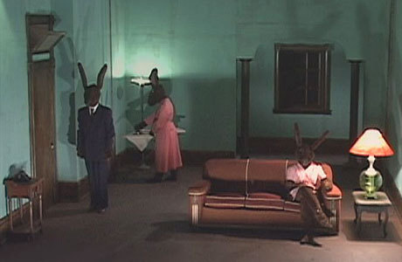

Fig. 2. One of the two camera angles from Rabbits, a shorter form work posted online. [2]

Also in contradiction to the two distinct periods, ever seen *Mulholland Drive* Lynch has been transitioning to a third stylistic period marked by the use of digital technology and a return to primarily short form work. *Rabbits*, an episodic work filmed with a digital camera and posted on his website exemplifies this newest style(see fig. 2.). Lynch’s varied style shows him to be an auteur not just because it is consistently found in his films, but also because no other filmmakers have quite the same style or could have made films mistakable for Lynch’s. Like Lynch, many auteurs have a defined style that evolves and changes while still being recognizably theirs throughout their whole careers.

Besides to filmmakers’ thematic and formal approaches to telling stories, the stories they tell can also distinguish them as visionary artists. Like many film auteurs, Lynch is a writer-director and takes direct control over what he tells in addition to how he tells it. Lynch’s films following *Dune* consistently explore his typical themes within the narrative context of Americans’ idealized lifes: *Blue Velvet* explores the deceptively pure view of 1950’s American society, *Twin Peaks* indulges in both subverting and celebrating the stereotypes of small-town Americana, *Lost Highway* shows the disappointing lives of a modern suburban couple and offers the youthful 1950’s as a false escape, and finally *Mulholland Drive* satirizes the naive Hollywood dreams of actresses and filmmakers alike. His work before and after this period of distinctly American narrative elements is not as cohesive, but much of Lynch’s work is recognizable by the setting and characterization of America. However, even more important to recognizing his work and to auteurs in general is the precise tone of the shown narrative. Auteurs typically have a certain combination of seriousness, contemplation, playfulness, and other qualities that comes to be the way their movies feel to watch, or their tone. In Lynch’s case that tone is “Lynchian” - the tone of surreal and macabre strangeness superimposed with deceptively innocent normality. Perhaps more than anything else, tone makes the viewer feel like they are watching a movie that is specifically owned by a particular auteur and could not have been someone else.

Certainly, David Lynch exemplifies the concept of a film auteur by consistently employing distinct thematic, formal, and narrative conventions to making movies that are unmistakably his. However, it’s infeasible to confine Lynch or any auteur to just those conventions as there are bound to be exceptions. For example, two years before *Mulholland Drive* Lynch directed the surprisingly conventional *The Straight Story* that was Lynchian only in that it explored Americana. Furthermore, one of the most widely recognized auteurs, Stanley Kubrick, directed a wide variety of movies that differ significantly in their thematic, formal, and narrative aspects. It is thus pertinent to acknowledge that the most fundamental aspect of film auteurs is the control they exert visibly over their work. This control is what allows them to truly shape their work and thus embed their favored themes, cinematics techniques, and narrative into it. After the debacle of the mainstream studio-controlled production that was *Dune* Lynch stated that: “I learned I would rather not make a film than make one where I don't have final cut" [1]. It is the combination of such absolute artistic control with his consistent and utterly unique vision that makes Lynch the preeminent and exemplary film auteur that he is.

Works Cited

[1] "David Lynch Keeps His Head." *Lynchnet.com*. N.p., n.d. Web. 29 July 2012. <http://www.lynchnet.com/lh/lhpremiere.html>.

[2] *YouTube*. YouTube, n.d. Web. 29 July 2012. <http://www.youtube.com/>.