Andrey Kurenkov

LCC 2500 - Intro to Film Studies

Navarro, Vinicius

7/30/2012

**Marwencol: Success Through Simplicity**

Ever since the rise of deconstructionism and postmodernism, many works of modern art have strived to explore the nature and purpose of art; one such work is *Marwencol*, the 2010 documentary that portrays artist Mark Hogancamp. The film has been critically hailed[1], though unlike many recent high-profile documentaries the greatness of *Marwencol* lies in its simplicity and honesty. As with any true documentary it has a statement to make, and yet unlike recent high profile documentaries such as Michael Moore’s works, *Supersize Me*, and *An Uncomfortable Truth* it does so without righteous directorial involvement or reliance on impersonal compilations of evidence. Instead, the film uses a simple narrative structure combined with basic documentary techniques to plainly tell Mark’s story. This approach allows the story and personality of Mark make their own point clear: the argument for art as the artist’s therapy and later for the importance of having the freedom and courage to openly be yourself.

*Marwencol’s* titled chapters linearly tell the simple narrative arc of Mark’s start as an artist through to his breakthrough and recognition. In parallel to this arc, his art and identity are increasingly revealed to the audience. The film opens with vividly life-like photographs (see fig. 1.) of soldier figurines in a ⅙ scale miniature WWII era city called Marwencol*,* yet unknown to the audience as Mark’s creation*.* After this short intro, the film starts its narrative by explaining the catalyst for Marwencol’s existence in a chapter titled “The Attack.” This catalyst is revealed to be pain: a brutal assault against Mark resulted in a brief comma and lasting brain damage that erased his memories and ability to perform basic human acts such as walking. 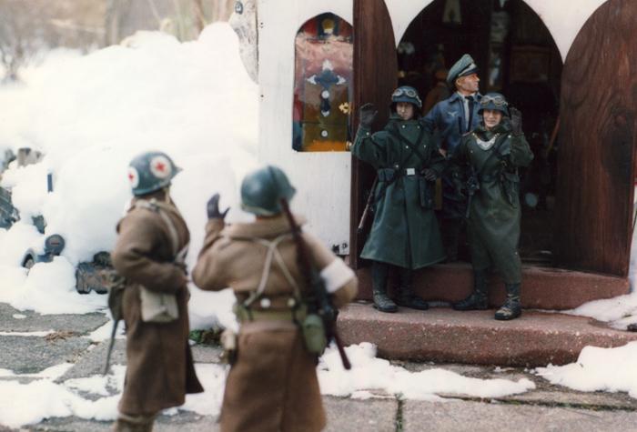 Fig. 1. A photograph of soldiers in front of the church of Marwencol displaying the enforced peace [2].

The documentary lets this as well as Mark’s subsequent struggles be told by Mark and his close friends. In this manner the audience is shown that despite the horrendous nature of this experience, Mark persevered and began the struggle to recover. Unable to pay for traditional therapy, Mark invented his own form of emotional and physical therapy: *Marwencol*. He built this miniature town and populated it by barbie dolls that serve as alter egos for both Mark and those close to him. Although he is damaged to the point of being limited and isolated in real life, Mark’s alter ego can do what he cannot: start a bar, get married, and violently defeat the villainous SS. With this the movie makes its first statement: through reflecting the artist’s personal experience, art can be a form of therapy. The courage and capability of his alter ego strengthens Mark, and the existence of other alter egos in the town alleviates his feelings of loneliness and isolation. As an even stronger reflection of real life, Marwencol’s Mark eventually also has to recover the trauma after being assaulted by a group of 5 SS soldiers and heals from the attack with the help of his community (see fig. 2.).

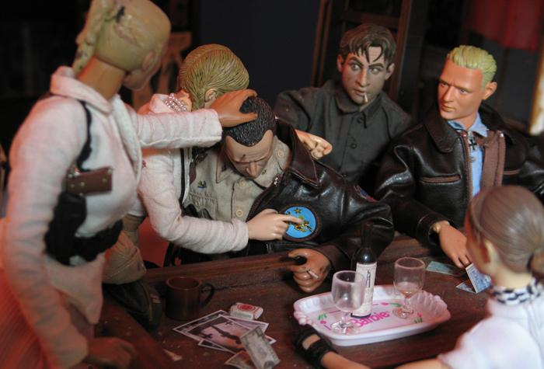

Fig. 2. Mark’s alter ego also has to deal with depression and trauma, and gets support from the city’s residents [3].

The narratives of both *Marwencol* the movie and Marwencol the town deal largely with the therapeutic nature of art until the third act of the documentary, at which point the narrative shifts to focus on the importance of having the courage to accept both ourselves and other people for what they are. This happens after second act introduces a fellow photographer who discovered Mark’s work and soon organizes a major art show to display it. As the show approaches, the reason for “The Attack” is revealed to be prejudice, specifically against Mark’s innate desire to wear women's’ clothing. Having come to know and accept Mark, its hard to imagine any audience member not supporting him in his dual struggle to gain the courage to both attend the show outside the safety of his home and overcome his closeted existence as a crossdresser. Despite difficulty, Mark ultimately succeeds in both attending the art show and revealing his true nature without the pain and suffering that has caused him in the past. Though the word has become trite, Mark’s achievement is nevertheless nothing less than inspiring and implicitly makes a strong case that such honesty and acceptance are necessary for happiness.

What sets *Marwencol* apart from many other recent documentaries is the simplicity and pleasantness of its rhetorical approach. Although as sophisticated as any modern documentary with respect to technical matters such as its soundtrack or editing, the movie has a very simple rhetorical strategy: present Mark Hogancamp through interviews with him and people who know him and in parallel show the unfolding story of Marwencol through images and Mark’s narration. This form of argument relies almost entirely on the ethos that exists due to the charm of Mark’s character and work. Any pathos that is there exists inherently in the story with only some encouragement from the music, and the argument is so personal that it does not rely on any logos whatsoever. Such rhetorical simplicity adds to the overall impression of honesty that other devices also help create: interviews are shot plainly with the subject speaking directly to a static camera (see Fig. 3.), the director never reveals himself or directly interjects his own opinion, and the camera work usually displays pertinent action directly instead of striving for impressive staged shots. This simple honesty is a refreshing change from the aforementioned other documentaries and serves to reinforce the ethos of the similarly direct Mark and his unambiguously heartfelt work. Likewise, because it is not condemning, satiric, threatening, offensive, or otherwise aggressively confrontational the movie is pleasant and agreeable in ways that other recent documentaries have not been. The same pleasant nature is again paralleled in Mark, whose intense likeability and personal courage in the face of fear serve as the backbone of *Marwencol*’s rhetoric.

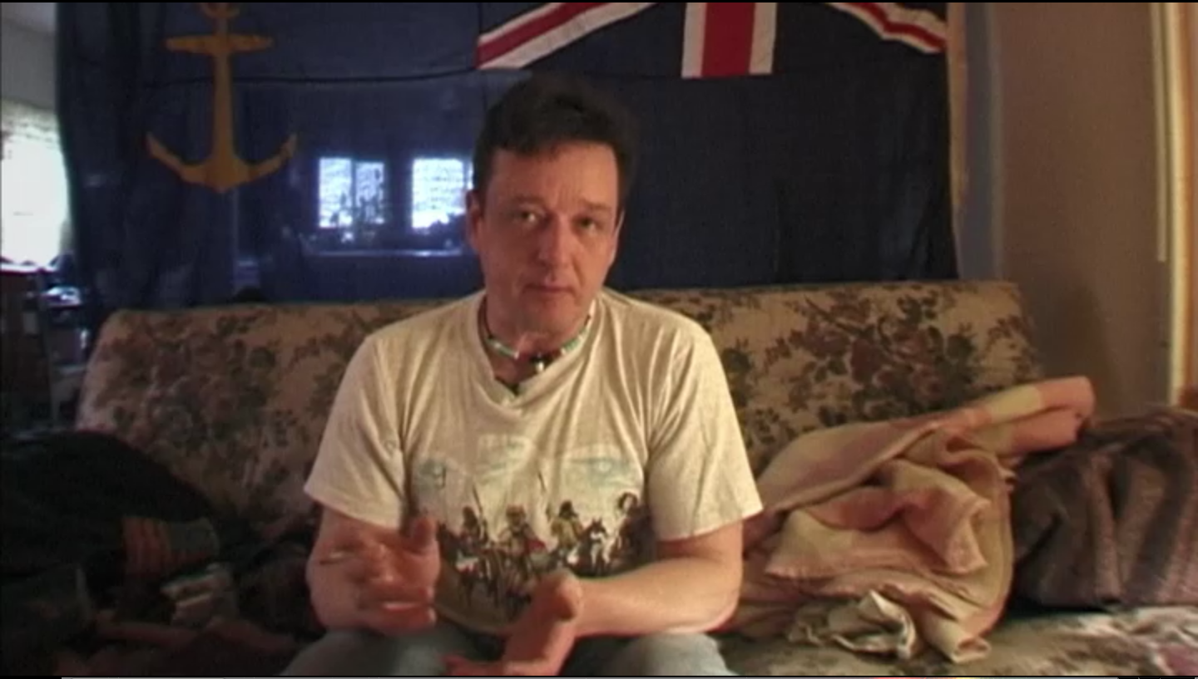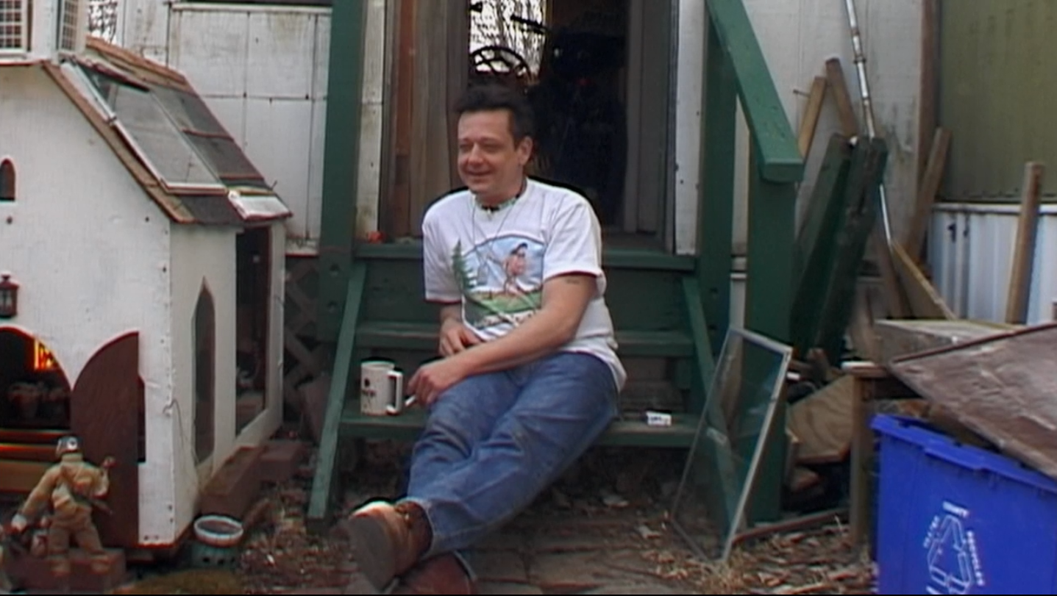

Fig. 3. Recurring settings and shots for interviews with Mark showing the plain interviewing style.

The film concludes, somewhat open endedly, on Mark’s return to work in Marwencol after the success of his art show. In its poetic last scene, the narrative of the town of Marwencol continues with Mark’s alter ego starting to build his own miniature city to cope with the trauma of his SS assault. The viewer is left feeling the Mark Hogancamp is a real person who has achieved remarkable self-healing through art, and whose struggle is an inspirational reminder that humans should strive to be accepted by others for who they really are just as much as they should strive to accept and understand others.

Works Cited

[1] "Marwencol (2010)." *rottentomatoes.com*. N.p., n.d. Web. 30 July 2012.

[2] *Marwencol - Official Site*. Digital image. *Marwencol - Official Site*. N.p., n.d. Web. 30 July 2012.

[3] *Marwencol*. Dir. Jeff Malmberg. Open Face, 2010. Netflix. Web. 28 July 2012.